International Data Explorer Help Guide

NCES IDE Team

2024-04-05

Table of Contents

International Data Explorer Help Guide 8

1 Overview of the International Data Explorer (IDE) 8

1.1 What is the IDE? 8

1.2 How do I access the IDE? 9

1.3 NCES data usage agreement 9

1.4 Computer requirements for the IDE 9

2 PISA IDE Walkthrough 10

2.1 1. Select Criteria 10

2.1.1 1.A. Overview 10

2.1.2 1.B. Choose Subject 11

2.1.3 1.C. Choose Year 11

2.1.4 1.D. Choose Measure 12

2.1.5 1.E. Choose Jurisdiction 12

2.2 2. Select Variables 13

2.2.1 2.A. Overview 13

2.2.2 2.B. Search Using Category and Sub Category Lists 14

2.2.3 2.C. Search Function 16

2.3 3. Edit Reports 17

2.3.1 3.A. Overview 17

2.3.2 3.B. Preview Report 18

2.3.3 3.C. Edit Report 19

2.3.4 3.D. Create New Variables 20

2.3.5 3.E. Create New Report 22

2.3.6 3.F. Format Options 23

2.3.7 3.G. Statistics Options 25

2.3.8 3.H. Select Reports to Build 27

2.4 4. Build Reports 28

2.4.1 4.A. Overview 28

2.4.2 4.B. View Reports as Data Tables 28

2.4.3 4.C. Charts 29

2.4.4 4.D. Create Charts 29

2.4.5 4.E. Create Charts – Chart Options 30

2.4.6 4.F. Significance Tests 35

2.4.7 4.G. Gap Analysis 39

2.4.8 4.H. Regression Analysis 41

2.4.9 4.I. Export Reports 44

3 PIRLS IDE Walkthrough 45

3.1 1. Select Criteria 47

3.1.1 1.A. Overview 47

3.1.2 1.B. Choose Subject 48

3.1.3 1.C. Choose Measure and Year 48

3.1.4 1.D. Choose Jurisdiction 49

3.2 2. Select Variables 50

3.2.1 2.A. Overview 50

3.2.2 2.B. Search Using Category and Subcategory Lists 51

3.2.3 2.C. Search Function 53

3.3 3. Edit Reports 54

3.3.1 3.A. Overview 54

3.3.2 3.B. Preview Report 56

3.3.3 3.C. Edit Report 57

3.3.4 3.D. Create New Variables 58

3.3.5 3.E. Create New Report 60

3.3.6 3.F. Format Options 61

3.3.7 3.G. Statistics Options 63

3.3.8 3.H. Select Reports to Build 66

3.4 4. Build Reports 67

3.4.1 4.A. Overview 67

3.4.2 4.B. View Reports as Data Tables 68

3.4.3 4.C. Charts 69

3.4.4 4.D. Create Charts—Data Options 70

3.4.5 4.E. Create Charts—Chart Options 71

3.4.6 4.F. Significance Tests 75

3.4.7 4.G. Gap Analysis 79

3.4.8 4.H. Regression Analysis 83

3.4.9 4.I. Export Reports 86

4 TIMSS IDE Walkthrough 87

*1. Select Criteria* 88

1.A. Overview 88

1.B. Choose Subject 89

1.C. Choose Grade 89

1.D. Choose Year 89

1.E. Choose Measure 90

1.F. Choose Jurisdiction 90

*2. Select Variables* 91

2.A. Overview 91

2.B. Search Using Category and Sub Category Lists 92

2.C. Search Function 93

*3. Edit Reports* 94

3.A. Overview 94

3.B. Preview Report 96

3.C. Edit Report 96

3.D. Create New Variables 97

3.E. Create New Report 100

3.F. Format Options 101

3.G. Statistics Options 103

3.H. Select Reports to Build 105

*4. Build Reports* 106

4.A. Overview 106

4.B. View Reports as Data Tables 107

4.C. Charts 108

4.D. Create Charts—Chart Options 108

4.E. Significance Tests 111

4.F. Gap Analysis 115

4.G. Regression Analysis 118

4.H. Export Reports 121

5 PIAAC IDE Walkthrough 122

5.1 1. Select Criteria 123

5.1.1 1.A. Overview 123

5.1.2 1.B. Display 124

5.1.3 1.C. Choose Year/Study(s) 125

5.1.4 1.D. Choose Measure(s) 125

5.1.5 1.E. Choose Jurisdiction(s) 126

5.2 2. Select Variables 127

5.2.1 2.A. Overview 127

5.2.2 2.B. Search Using Category and Sub Category Lists 128

5.2.3 2.C. Search Function 130

5.3 3. Edit Reports 131

5.3.1 3.A. Overview 131

5.3.2 3.B. Preview Report 132

5.3.3 3.C. Edit Report 133

5.3.4 3.D. Create New Variables 134

5.3.5 3.E. Create New Report 136

5.3.6 3.F. Format Options 138

5.3.7 3.G. Statistics Options 139

5.3.8 3.H. Select Reports to Build 142

5.4 4. Build Reports 143

5.4.1 4.A. Overview 143

5.4.2 4.B. View Reports as Data Tables 144

5.4.3 4.C. Charts 145

5.4.4 4.D. Create Charts 145

5.4.5 4.E. Significance Tests 149

5.4.6 4.F. Gap Analysis 154

5.4.7 4.G. Regression Analysis 156

5.4.8 4.H. Export Reports 159

6 TALIS IDE Walkthrough 160

6.1 1. Select Criteria 161

6.1.1 1.A. Overview 161

6.1.2 1.B. Choose a Subject 162

6.1.3 1.C. Choose an Education Level 162

6.1.4 1.D. Choose Year(s) 163

6.1.5 1.E. Choose Measure(s) 163

6.1.6 1.F. Choose Jurisdiction(s) 163

6.2 2. Select Variables 164

6.2.1 2.A. Overview 164

6.2.2 2.B. Select Variables using Category and Sub Category Lists 165

6.2.3 2.C. Select Variables using the Search Function 166

6.3 3. Edit Reports 167

6.3.1 3.A. Overview 167

6.3.2 3.B. Preview Report 169

6.3.3 3.C. Edit Report 169

6.3.4 3.D. Create New Variables 171

6.3.5 3.E. Create New Report 173

6.3.6 3.F. Format Options 174

6.3.7 3.G. Statistics Options 176

6.3.8 3.H. Select Reports to Build 179

6.4 4. Build Reports 180

6.4.1 4.A. Overview 180

6.4.2 4.B. View Reports as Data Tables 180

6.4.3 4.C. Charts 181

6.4.4 4.D. Create Charts 182

6.4.5 4.E. Create Charts – Chart Options 183

6.4.6 4.F. Significance Tests 188

6.4.7 4.I. Export Reports 197

7 ICILS IDE Walkthrough 198

7.1 1. Select Criteria 199

7.1.1 1.A. Overview 199

7.1.2 1.B. Choose Display 199

7.1.3 1.C. Choose Year 200

7.1.4 1.D. Choose Measure 200

7.1.5 1.E. Choose Jurisdiction 200

7.2 2. Select Variables 201

7.2.1 2.A. Overview 201

7.2.2 2.B. Search Using Category and Sub Category Lists 202

7.2.3 2.C. Search Function 203

7.3 3. Edit Reports 204

7.3.1 3.A. Overview 204

7.3.2 3.B. Preview Report 206

7.3.3 3.C. Edit Report 206

7.3.4 3.D. Create New Variables 207

7.3.5 3.E. Create New Report 210

7.3.6 3.F. Format Options 210

7.3.7 3.G. Statistics Options 212

7.3.8 3.H. Select Reports to Build 215

7.4 4. Build Reports 216

7.4.1 4.A. Overview 216

7.4.2 4.B. View Reports as Data Tables 217

7.4.3 4.C. Charts 218

7.4.4 4.D. Create Charts 218

7.4.5 4.E. Create Charts – Chart Options 220

7.4.6 4.F. Significance Tests 223

7.4.7 4.G. Gap Analysis 228

7.4.8 4.H. Regression Analysis 230

7.4.9 4.I. Export Reports 233

8 IDE definitions by study 234

8.1 PISA IDE 235

8.1.1 Criteria 235

8.1.2 Variables 238

8.1.3 Statistics Options 241

8.1.4 Cross-tabulations 242

8.1.5 Statistical Notations and Other Notes 242

8.2 PIRLS IDE 244

8.2.1 Criteria 244

8.2.2 Variables 246

8.2.3 Statistics Options 247

8.2.4 Cross-tabulations 248

8.2.5 Statistical Notations and Other Notes 249

8.3 TIMSS IDE 250

8.3.1 Criteria 250

8.3.2 Variables 253

8.3.3 Statistics Options 254

8.3.4 Cross-tabulations 256

8.3.5 Statistical Notations and Other Notes 256

8.4 PIAAC IDE 262

8.4.1 Criteria 262

8.4.2 Variables 264

8.4.3 Statistics Options 266

8.4.4 Cross-tabulations 267

8.4.5 Statistical Notations and Other Notes 267

8.5 TALIS IDE 268

8.5.1 Criteria 268

8.5.2 Variables 270

8.5.3 Statistics Options 270

8.5.4 Cross-tabulations 271

8.5.5 Statistical Notations and Other Notes 271

8.6 ICILS IDE 273

8.6.1 Criteria 273

8.6.2 Variables 275

8.6.3 Statistics Options 276

8.6.4 Cross-tabulations 276

8.6.5 Statistical Notations and Other Notes 277

9 Resources 278

# International Data Explorer Help Guide



# 1 Overview of the International Data Explorer (IDE)

## 1.1 What is the IDE?

The National Center for Education Statistics (NCES) has made it easy to explore and analyze large-scale international education study data via various tools, including the international Data Explorer (IDE). The IDE is an interactive online tool with data from the following studies:

* [Program for International Student Assessment (PISA)](https://nces.ed.gov/surveys/pisa/)
* [Progress in International Reading Literacy Study (PIRLS)](https://nces.ed.gov/surveys/pirls/index.asp)
* [Trends in International Mathematics and Science Study (TIMSS)](https://nces.ed.gov/timss/)
* [Program for the International Assessment of Adult Competencies (PIAAC)](https://nces.ed.gov/surveys/piaac/index.asp)
* [Teaching and Learning International Survey (TALIS)](https://nces.ed.gov/surveys/talis/)
* [International Computer and Information Literacy Study (ICILS)](https://nces.ed.gov/surveys/icils/)

The IDE provides a wide set of functions, including:

* Explore student and adult performance on international assessments
* Explore survey questionnaire data for thousands of variables
* Find data for the United States and more than 80 foreign education systems
* Create tables, charts, and maps
* Calculate averages, percentages, standard deviations, percentiles, and performance/proficiency levels
* Run statistical tests, including gap analyses

## 1.2 How do I access the IDE?

1. Visit the IDE home page <https://nces.ed.gov/surveys/international/ide/>.
2. Select the assessment or survey of interest and start exploring. View “What does this IDE provide?” under each study to learn more

Exhibit 1-1. IDE Landing Page 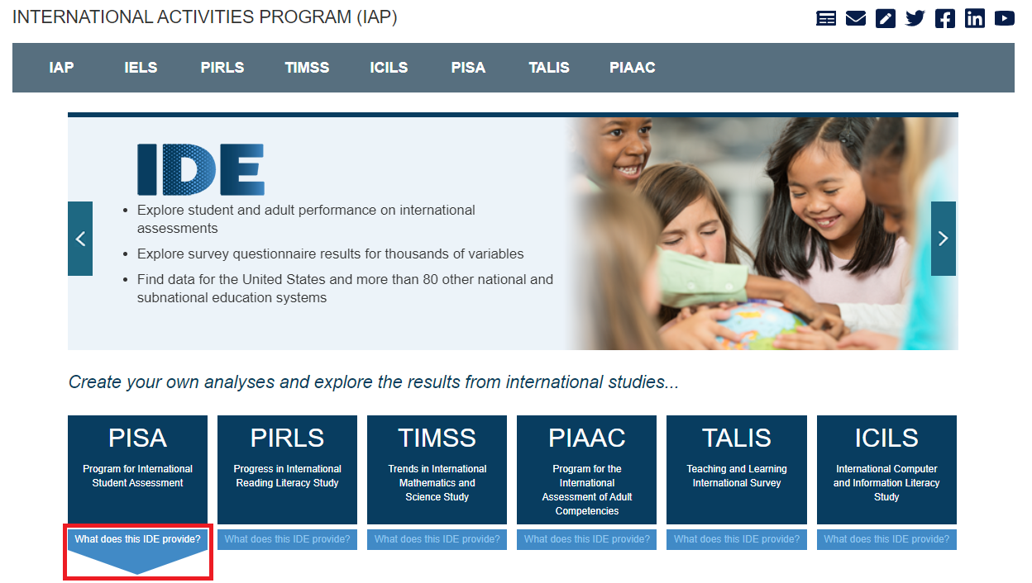

## 1.3 NCES data usage agreement

In order to be able to enter the IDE, it is necessary to review and agree to the terms of the NCES Data Usage Agreement. You may see the following screen when visiting each of the IDE page from the IDE home page. After you click on the button agreeing to the terms, you will be taken to the Data Explorer. If you do not do this, you will be redirected to the IDE home page.

Exhibit 1-2. IDE Landing Page 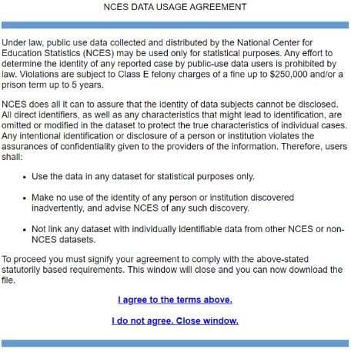

## 1.4 Computer requirements for the IDE

The IDE performs best under the following requirements.

* Screen resolution should be 1024 x 768 pixels or higher.
* Browsers: Google Chrome, Apple Safari, Internet Explorer (IE) version 10 or higher, FireFox 3.0 or higher.
* Enable JavaScript and pop-ups in your browser.
* Exports of files to Microsoft Office can be opened with Office 2003 or later.
* Exports of files to PDF can be read with Adobe Acrobat Reader.
* Screen reader software should be JAWS 8.0 or higher.

# 2 PISA IDE Walkthrough

There are four general steps for exploring each IDE page (see exhibit 2-1). Each step is described in more detail in the following sub-sections.

Exhibit 2-1. What you will see in the IDE environment and what each step entails 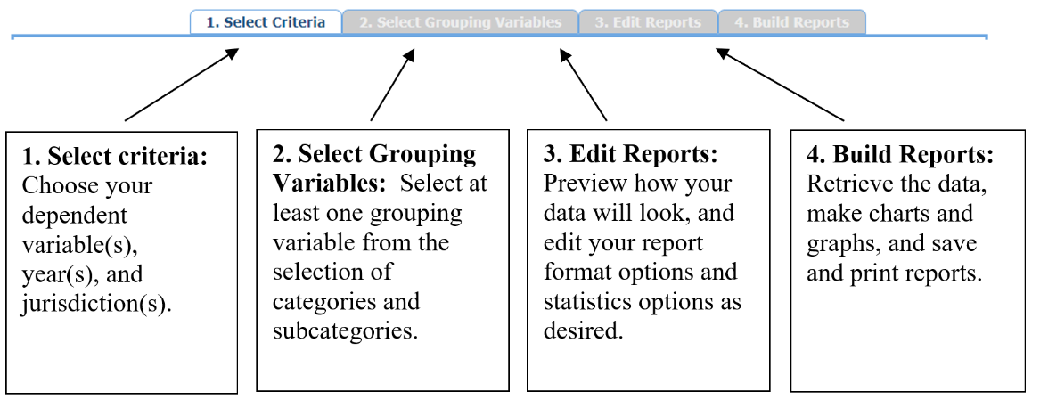

## 2.1 1. Select Criteria

### 2.1.1 1.A. Overview

Your data query in the PISA IDE begins on the **Select Criteria** screen (see exhibit 2-2).

Select a **Language** from the drop-down menu and then select a **Subject** from the drop-down menu. Once the screen resets, you can choose one or more **Years**, **Measures,** and **Jurisdictions** for the data you wish to view or compare. Use the **Reset** button, located in the upper-right portion of the screen (just below the **Help** button), to cancel your selections and begin again.

Click on a blue sideways-facing arrow (►) to open up a category and click on a blue downward-facing arrow (▼) to close a category.

Exhibit 2-2. Selecting criteria

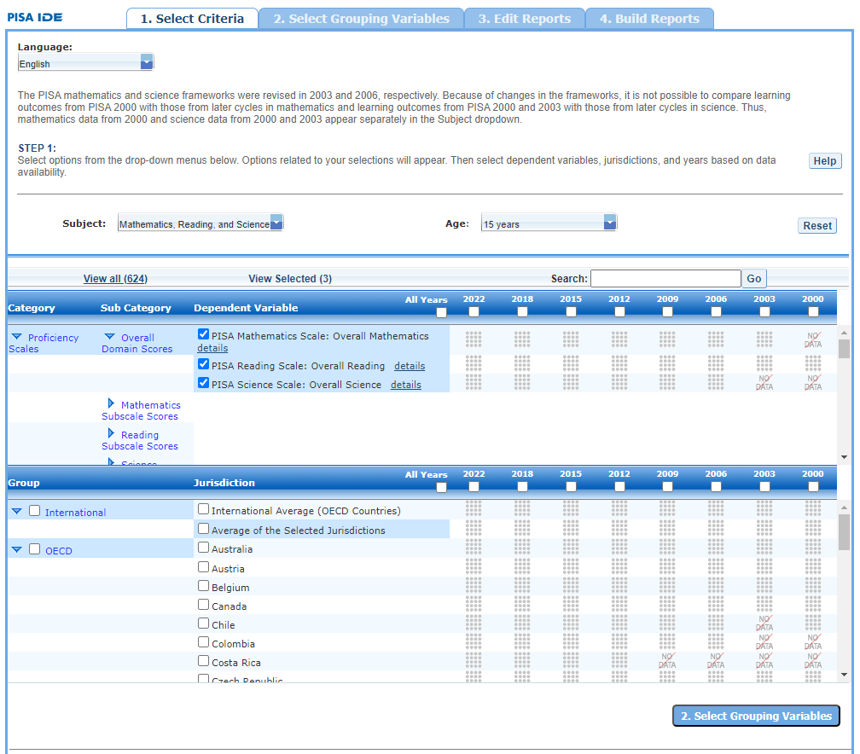

Exhibit 2-2 is a screenshot from the PISA IDE tool showing the Select Criteria tab.

### 2.1.2 1.B. Choose Subject

Under **Subject**, you have the choice of **Mathematics, Reading, and Science**; **Financial Literacy**; **Collaborative Problem Solving; Problem Solving**; **Science (2003)**; **Science (2000)**; or **Mathematics (2000)**. Once a subject is chosen, the screen resets and you can select **Year**(s), **Measure**(s), and **Jurisdiction**(s).

The PISA mathematics and science frameworks were revised in 2003 and 2006, respectively. Because of changes in the frameworks, it is not possible to compare learning outcomes from PISA 2000 with those from later cycles in mathematics and learning outcomes from PISA 2000 and 2003 with those from later cycles in science. Thus, mathematics data from 2000 and science data from 2000 and 2003 appear separately in the Subject dropdown.

### 2.1.3 1.C. Choose Year

At the top of the **Measure** and **Jurisdiction** sections, you have the choice of selecting 2018, 2015, 2012, 2009, 2006, 2003, and/or 2000 by checking the appropriate box. To include data from all years, check the “All Years” box to the left of the individual years. Reading, mathematics, and science data are available for all years. Currently, problem-solving data are available for 2012, collaborative problem-solving data are available for 2015, and financial literacy data are available for 2012, 2015, and 2018.

### 2.1.4 1.D. Choose Measure

After choosing a subject, you can choose between the overall scale and/or any of the subject’s subscales. However, subscales are only available for the subject area that was the major domain in a particular year. Note that the overall scale is the default.

In addition, there are a number of continuous variables other than scale scores that you may choose as a measure of analysis. These variables fall under different categories, such as Student and Family Characteristics and School and Classroom Climate, and include variables such as student age in years, size of class, and an index of computer availability.

### 2.1.5 1.E. Choose Jurisdiction

With your **Measure**(s) and **Year**(s) selected, next choose at least one **Jurisdiction.**

Jurisdictions are found under the following groups: **OECD**, **Non-OECD**, and **US States and Territories.** There is also a group category called **International,** with options to display the **International Average (OECD Countries)** and the **Average of the Selected Jurisdictions.**

The general procedures for selecting one or more jurisdictions are as follows:

1. To open or close jurisdictions, click on the arrow. Jurisdictions in the group are open and can be selected when the blue arrow points down (see exhibit 2-3).
2. Click the checkboxes next to the specific jurisdictions that you are interested in, or uncheck those jurisdictions that you wish to deselect. If you click the checkbox next to the group name (e.g., “OECD”), you will select all the jurisdictions within that group. If desired, uncheck the group name to deselect all.
3. If you want to close a group (for example, close the list of OECD countries in order to readily see the non-OECD jurisdictions), click the blue arrow next to the group name. The closed group’s arrow points to the right. Be advised that closing the group will not deselect your choices.

Exhibit 2-3. Choosing jurisdictions



Exhibit 2-3 is a screenshot from the PISA IDE tool showing jurisdictions available in the Select Criteria tab.

To continue in the IDE, click the **Select Variables** button at the bottom right of the page or the tab at the top of the page to go to the next screen (see exhibit 2-3).

## 2.2 2. Select Variables

### 2.2.1 2.A. Overview

Step 2, **Select Variables,** can only be accessed after choosing criteria at step 1, **Select Criteria**.

To continue your data query and edit a report, *you must choose at least one variable on this screen.* You can browse for variables using the **Category** and **Sub Category** lists or by using the **Search** function (see exhibit 2-4). You can return to this screen to change variable selections at any time.

Exhibit 2-4. Select variables overview

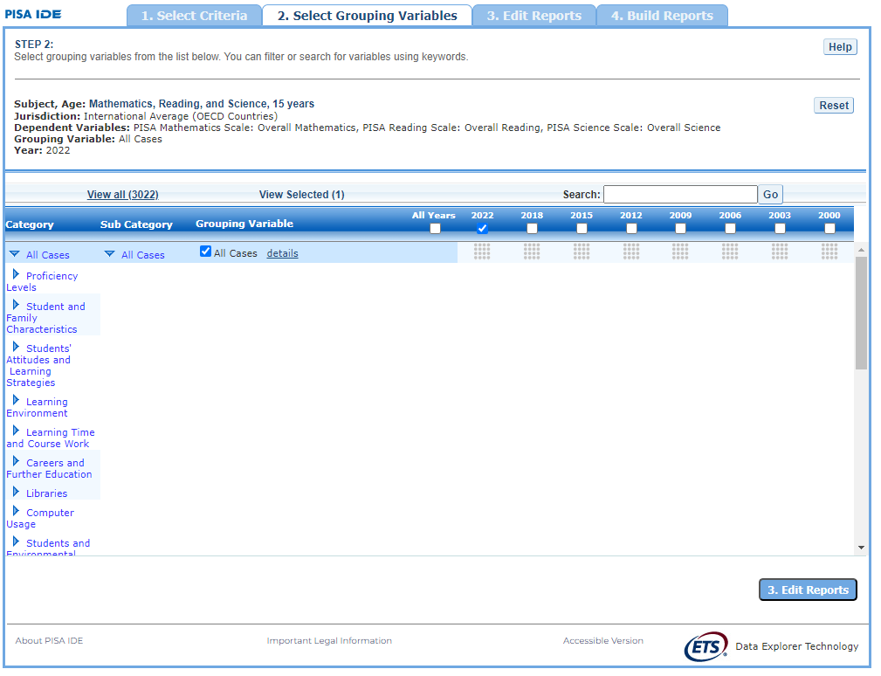

Exhibit 2-4 is a screenshot from the PISA IDE tool showing an overview of the Select Variables tab.

### 2.2.2 2.B. Search Using Category and Sub Category Lists

On the **Select Variables** screen, choose at least one variable for your report. One way to do this is to search for variables using the **Category** and **Sub Category** lists. If you don’t wish to choose from any of the specified categories and subcategories, then select **All students** in the **All Students** category.

The variables shown are tied to the criteria you selected at step 1 (**Measure, Year,** and **Jurisdiction**), which are indicated at the top of the screen. To change any of these criteria, return to step 1, **Select Criteria**.

To browse for variables, get details about them, select them, and view them:

1. Click the blue arrows to open and close categories and subcategories of variables (see exhibit 2-5).
2. Click **details** or **hide details** to show or hide the full title of a given variable, the PISA ID, and the values (i.e., value labels). Note that some variables have the same or similar short titles, but comparing details will show you how they differ. See the example in exhibit 2-5, which shows two **Grandparents** variables (SU002004 and SU012305). The differences between these two variables are described in the details.
3. Click the checkbox next to a variable to select it for your analysis/report. You will see the count increase next to **View Selected**.
4. Click the **View Selected** tab to see the variables you have chosen. To return to the full list of variables by category, click the **View All** tab.
5. Remember to select the year for which you wish to build a report and make sure that data are available for your chosen year and variables.
6. Searching variables is an option from the **Search** box. See Section 2.C Search Function for more details about this function.

Exhibit 2-5. Select variables using category and sub category lists

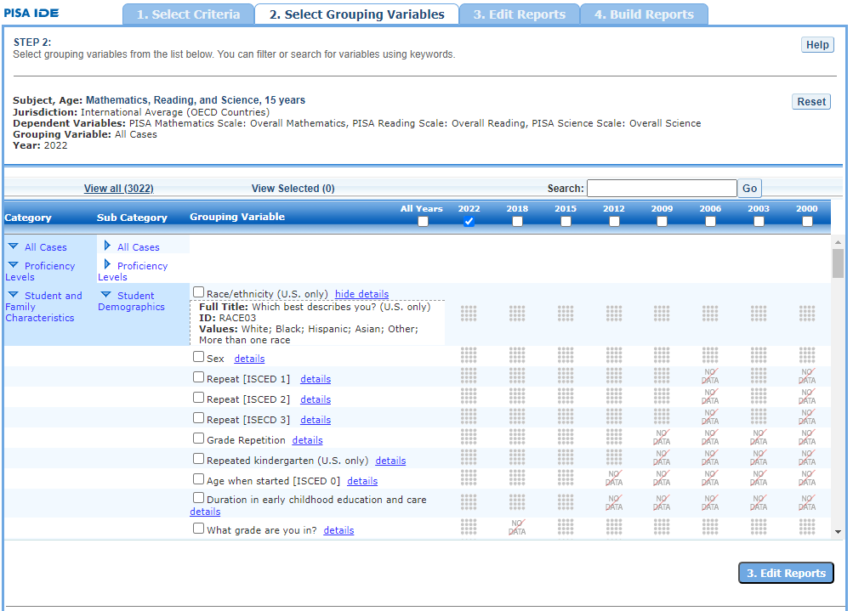

Exhibit 2-5 is a screenshot from the PISA IDE tool showing how to select a variable from the categories and sub categories listed in the Select Variables tab.

When selecting **Financial Literacy** as the subject, additional student questionnaire items will appear under the category **Students’ Financial Awareness and Experiences.** These items address key areas related to students’ experience and exposure to financial literacy including access to information and education, access to money and financial products, and spending and saving behaviors.

When you have selected the variable(s) you want to include, continue by clicking the **Edit Reports** button at the bottom of the page or the tab at the top of the page to go to the next screen.

### 2.2.3 2.C. Search Function

The second way to search for variables is to use the **Search** function on the **Select Variables** screen.

Type a term in the **Search** box and click **Go** (or hit “Enter” on your keyboard) to find variables by keywords in the question and/or details for the variable (see exhibit 2-6). If you use multiple keywords, “and” is assumed. You can narrow your search by using “or,” “not,” or “and not.” The search function operates on an exact phrase if it is contained in quotes. The variable(s) that include the search term(s) in the question or its details will be listed.

Exhibit 2-6. Select variables using the search function

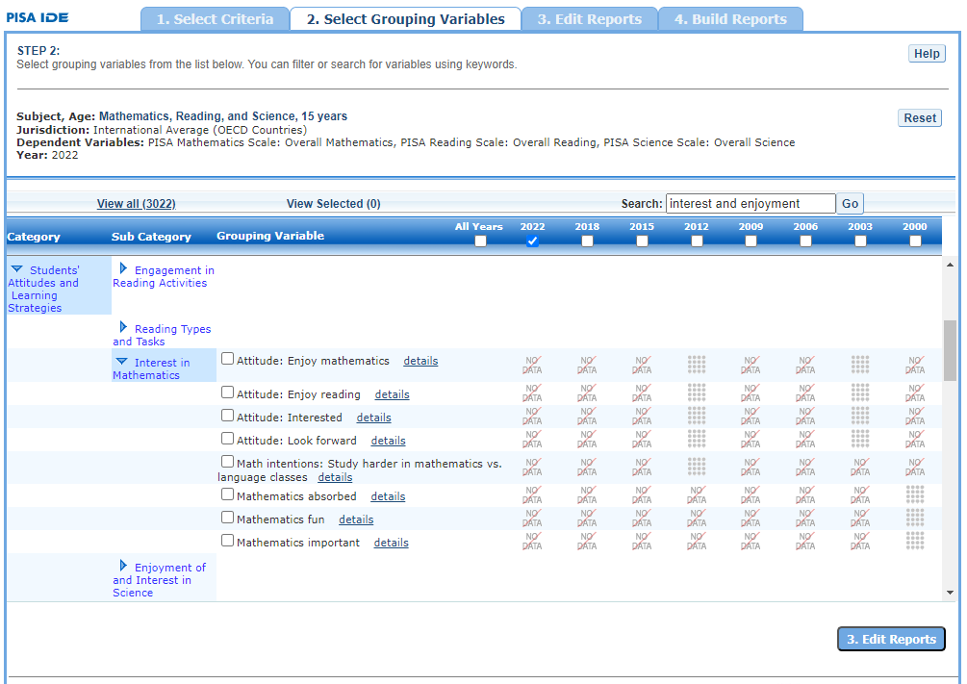

Exhibit 2-6 is a screenshot from the PISA IDE tool showing how to select a variable using the search function.

When you have selected the variable(s) you want to include, continue by clicking the **Edit Reports** button at the bottom of the page or the tab at the top of the page to go to the next screen.

## 2.3 3. Edit Reports

### 2.3.1 3.A. Overview

You can access step 3, **Edit Reports,** after choosing criteria at step 1, **Select Criteria**, and choosing variables at step 2, **Select Variables**. The IDE will automatically build reports based on your selections from steps 1 and 2. However, at step 3, the **Edit Reports** phase, you may modify your selections for each report.

At this step, you can

* preview and edit the layout of your reports;
* copy reports or create new reports based on the variables selected;
* change formatting options, such as number of decimal places to display, for all reports (these may also be changed in individual reports, but format options can overwrite previous edits);
* change statistics options, such as averages, for all reports (these may also be changed in individual reports, but statistics options can overwrite previous edits);
* select reports to be built into tables and charts at step 4, **Build Reports**; and
* delete reports.

Using your chosen criteria, the IDE will return a separate data report for each variable you have chosen. If you have selected two or three variables (not counting **All Students**), you will also see a cross-tabulated report for these variables. If you have chosen four or more variables you will get tables for each variable, but you won’t get the cross-tabulation. If your selected criteria include more than one measure (e.g., overall mathematics scale and one or more subscale or continuous variable), a separate set of data reports will be generated for each measure (see exhibit 2-7).

Exhibit 2-7. Edit reports overview

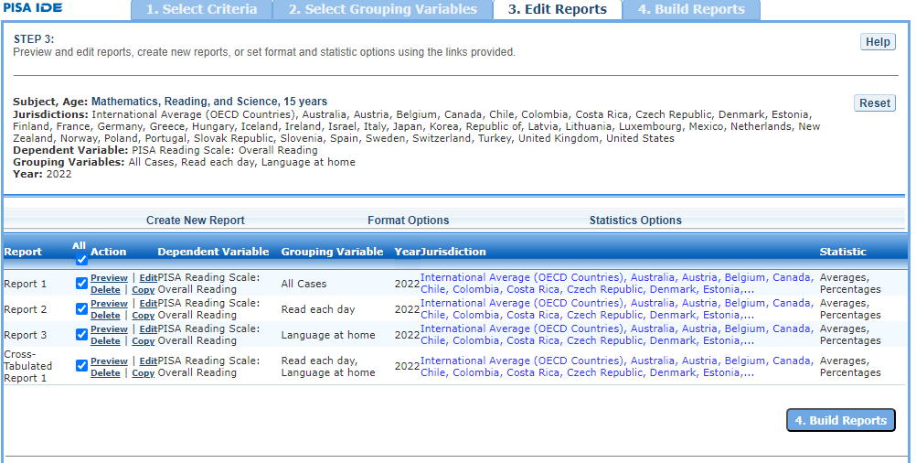

Exhibit 2-7 is a screenshot from the PISA IDE tool showing an overview of the Edit Reports tab.

The **Edit Reports** step shows detailed information on the layout of your reports. The **Report** column indicates the report, or cross-tabulation report, number based on the variable(s) chosen during the criteria selection. Under the **All** tab, reports may be chosen for the report-building phase, either by selecting **All** or selecting individual reports. The **Action** column gives you the option to **Preview**, **Edit, Delete**, or **Copy** the report. The **Measure** column shows which measure the report will portray. The **Variable** column indicates the variable(s) included in the report. The **Year** column shows which years you have selected for comparison. The **Jurisdiction** column shows the countries and subnational education systems selected for comparison, and the **Statistic** column provides the type of statistic output that will be generated in the report-building phase.

### 2.3.2 3.B. Preview Report

Select **Preview,** in the **Action** column (see exhibit 2-7), to see how your report will be laid out. The preview will not provide actual data but will show how the data will be arranged in rows and columns (see exhibit 2-8). You can select **Preview** at any time to see how your changes will affect the report’s final layout.

Exhibit 2-8. Using preview report

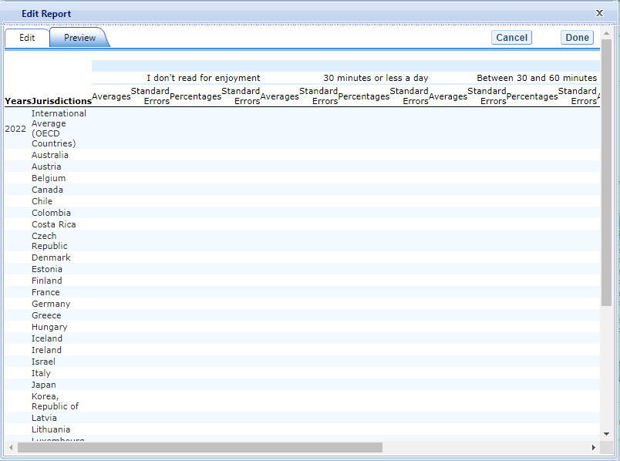

Exhibit 2-8 is a screenshot from the PISA IDE tool showing an example of the preview function that is available in the Edit Reports tab.

### 2.3.3 3.C. Edit Report

To edit the report, select the **Edit** command, in the **Action** column, next to the report number (see exhibit 2-7). (Another way to edit a report is to select the **Edit** tab when you are previewing a report.) The following can be done using the edit function (see exhibit 2-9):

1. Name your report. You have the option of giving each report a distinctive name, up to a limit of 50 characters, using only letters, numbers, spaces, underscores, and hyphens. (Otherwise, by default, the report is named Report 1, Report 2, etc., or Cross-Tabulated Report 1, Cross-Tabulated Report 2, etc.)
2. Select a measure. You can choose a measure if more than one was selected at step 1.
3. Select which jurisdictions, variables, years (if applicable), and statistics to include (out of the selections previously made at steps 1 and 2). You can select up to two statistics options from the following: averages, percentages, standard deviations, and percentiles. (For further information, see Section 3.G. Statistics Options.)
4. To create a new variable while editing a report, click on **Create New…** under the **Variable** heading. Section 3.D below explains the process for creating a new variable.
5. Change the table layout by dragging elements to determine which items will appear in rows and which will appear in columns. Some of the arrangements will not be permissible, but a pop-up alert will explain this.

Exhibit 2-9. Editing reports

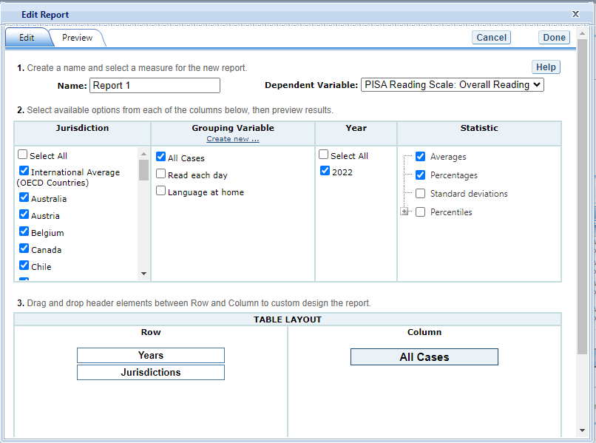

Exhibit 2-9 is a screenshot from the PISA IDE tool showing an example of the editing report function that is available in the Edit Reports tab.

To save changes, make sure to select **Done** in the upper-right portion of the screen before closing the **Edit Report** window.

### 2.3.4 3.D. Create New Variables

To create a new variable, select **Edit,** in the **Action** column, and select **Create new…** under **Variable** (see exhibit 2-9). The new variable is created by combining values for an existing variable. The steps are as follows:

1. Click **Create new...** under the **Variable** heading.
2. Select the variable for which you wish to combine values.
3. Select the values you want to combine by checking the boxes to the left of the values (see exhibit 2-10).
4. Create a name for the new value, and press **Create**. The collapsed values will appear in gray to indicate that they have already been used.
5. Wait for the screen to refresh, and press **Done**.
6. The new variable will appear in the **Variable** list in the **Edit Report** window or **Create New Report** window, designated as “collapsed.”
7. Check the box next to the new variable to view it in the report. You can click **Preview** to see how the table will be laid out before retrieving data.

Exhibit 2-10. Creating new variables

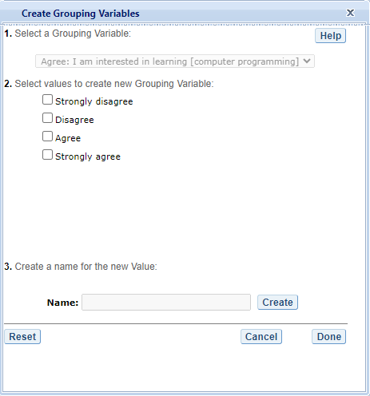

Exhibit 2-10 is a screenshot from the PISA IDE tool showing an example of the creating new variable function that is available in the Edit Reports tab.

A new variable that you create is applicable only to a specific report; it does not apply to the other reports listed on the **Edit Reports** screen. For example, if you selected multiple measures of science literacy for analysis, then you would need to create the new variable for each measure, or create a copy of the report and edit it accordingly. To do the latter, click on **Copy** report on the **Edit Reports** screen (copied reports appear at the end of the list of reports) and then, for the new copy, click on **Edit** (using the above example, you can change the measure and give the report a new name).

You can repeat the process and combine different values of a variable to create additional new variables. Using the **Create New Report** function, you can create a new report for each new variable that you create. (For further information, see section 3.E. Create New Report, below.)

If you selected two or three variables from which to create new variables, you can repeat the process for each of them. Using the **Create New Report** or **Edit Report** function, these collapsed variables will be listed and available for cross-tabulation (see exhibit 2-11). If you have chosen four or more variables (not counting **All Students**) you won’t get the cross-tabulation. You can click **Preview** to see how the table will be laid out before retrieving data.

Exhibit 2-11. Edit reports with collapsed variables

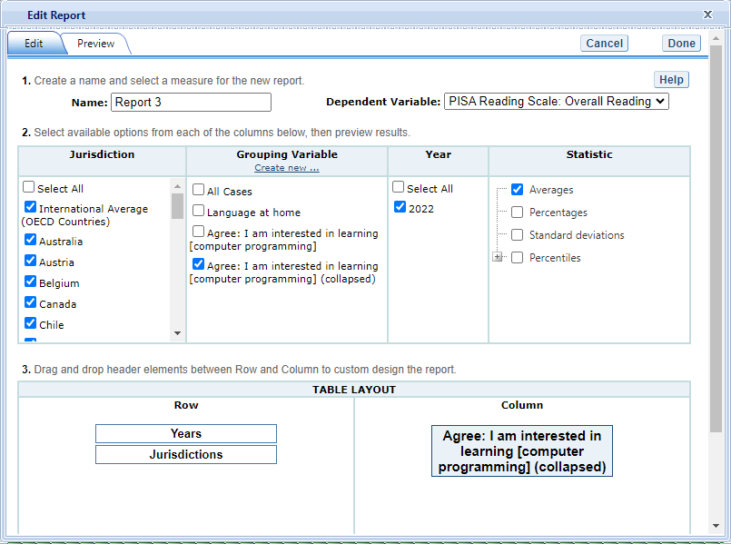

Exhibit 2-11 is a screenshot from the PISA IDE tool showing an example of the editing report with collapsed variables function that is available in the Edit Reports tab.

### 2.3.5 3.E. Create New Report

From the main **Edit Reports** screen, clicking on **Create New Report** brings up the same options as **Edit Report**, but with no checkboxes marked and without any new variables you may have created. Thus, **Create New Report** provides a clean slate for your selections from the first two steps, **Select Criteria** and **Select Variables** (see exhibit 2-12). Each new report you create will appear at the end of the list of reports. If you do not give the report a specific name, it will be called “New Report”.

Exhibit 2-12. Creating new reports

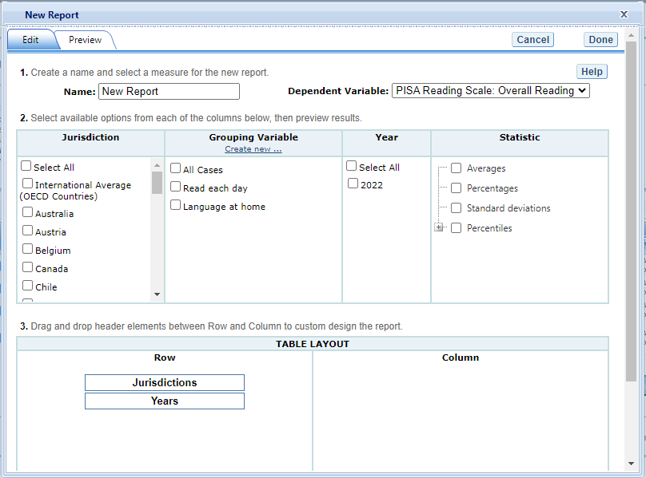

Exhibit 2-12 is a screenshot from the PISA IDE tool showing an example of the creating new report function that is available in the Edit Reports tab.

### 2.3.6 3.F. Format Options

From the main **Edit Reports** screen, clicking on **Format Options** will allow you to make formatting changes applicable to all the reports listed. The following formatting options are available using this function (see exhibit 2-13):

1. **Variable Labels (Long)** displays a more detailed description of the variables selected in a query than the default short label. For variables from questionnaires, the full text of the question is displayed. Be advised that the length of the extra detail may sometimes interfere with table formatting.
2. **Show data for values categorized as “missing”** will include the percentage of students in the total sample or in a reporting group for whom membership in a particular response category is unknown because no response was given by the students, their teacher, or their school. The percentage of “missing” will be shown in the right-most table column. Missing data are available only for queries that involve percentages as the statistic type. Unless you check this option, the default is for missing responses not to be included in the percentage distribution shown.
3. **Decimal Places** allows you to specify the level of precision for a particular statistic. Depending on the value range of the dependent variable (for example, the dependent variable “PISA Mathematics Scale: Overall Mathematics $PVMATH$” ranges from 0 to 1,000; the dependent variable “Index economic, social and cultural status $ESCS15$” ranges from -5 to 5), the default decimal places for a report could be from zero to three. Also, standard errors will be shown to one more decimal place than is shown for their respective statistic. For example, if you request that average scores be displayed to one decimal place (by default, the average scores are rounded to the nearest whole number), the corresponding standard errors will display two decimal places. If you export to Excel, you will be able to increase the number of decimal places in most cases. Note that only integer-level precision is allowed for percentages; that is, the number of decimal places is fixed at “none” for percentages and the corresponding standard errors are shown to one decimal place.
4. **Include** gives you the option of showing standard errors. By default, standard errors are shown inside parentheses, but you can choose to show them without parentheses*.* You can preview the effects of your selection in the **Sample Display** area (see the blue-shaded box at the bottom of exhibit 2-13 below).

Exhibit 2-13. Format options

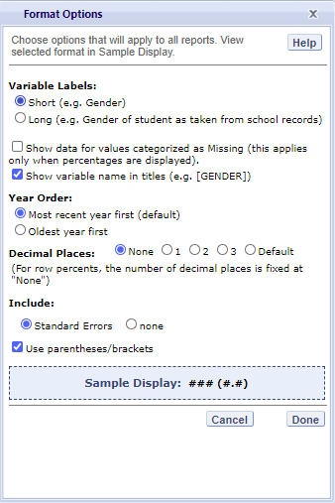

Exhibit 2-13 is a screenshot from the PISA IDE tool showing an example of the format options available in the Edit Reports tab.

Be advised that the choices you make in the **Format Options** window will apply to all reports and cannot be changed for individual reports. Use the **Reset** button, located in the upper-right portion of the main **Edit Reports** screen (just below the **Help** button), to restore the **Format Options** to the default settings (although caution is advised, as this will also delete any new reports that you have created).

### 2.3.7 3.G. Statistics Options

Available only from the main **Edit Reports** screen, clicking on **Statistics Options** allows you to designate up to two statistics. The selections you make are applicable to all the reports listed, although you can also change the statistics for an individual report when you edit it. (For further information, see Section 3.C. Edit Report.)

The following statistics options are available (see exhibit 2-14):

1. **Averages.** This statistic provides the average value for a selected continuous variable or score (i.e., overall score or subscale score). For the PISA assessment, student performance is reported on scales that range from 0 to 1,000. By default, the standard errors of the scores are shown in parentheses.
2. **Percentages.** This statistic shows the percentage of students as a row percentage. For example, if the first column lists countries, then each country will display its own percentage distribution across its row. By default, percentage distributions do not include missing data. For information on how to show data for values categorized as missing, see Section 3.F. Format Options.
3. **Standard deviations.** The standard deviation is a measure of how widely or narrowly dispersed scores are for a particular dataset. Under general normality assumptions, 95 percent of the scores are within two standard deviations of the mean. For example, if the average score of a dataset is 500 and the standard deviation is 100, it means that 95 percent of the scores in this dataset fall between 300 and 700. The standard deviation is the square root of the variance.
4. **Percentiles.** This statistic shows the threshold (or cutpoint) score for the following:
   * 10th percentile – the bottom 10 percent of students
   * 25th percentile – the bottom quarter of students
   * 50th percentile – the median (half the students scored below the cutpoint and half scored above it)
   * 75th percentile – the top quarter of students
   * 90th percentile – the top 10 percent of students

Exhibit 2-14. Statistics options

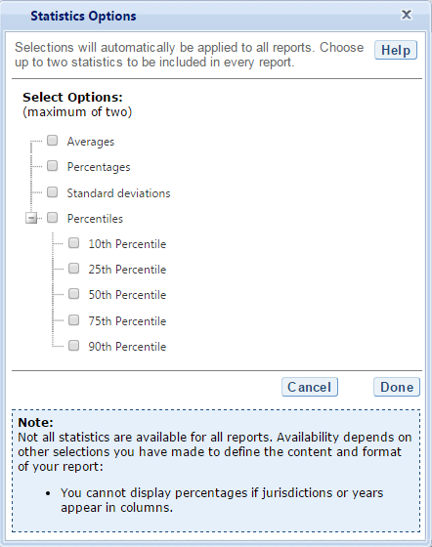

Exhibit 2-14 is a screenshot from the PISA IDE tool showing an example of the statistics options available in the Edit Reports tab.

As previously noted, the selections you make in **Statistics Options** will be applied automatically to all reports, although you can change the statistics for an individual report when you edit it. Be advised that if you use **Statistics Options** after editing the statistics in one or more of your individual reports, the statistics options selected will overwrite your previously edited selections. If you wish to use the same criteria and variables in a report with a different selection of statistics, consider using the **Create New Report** function to generate a new report with different statistics. (For further information, see Section 3.E. Create New Report.) You can also make a copy of an individual report.

You can use the **Reset** button, located in the upper-right portion of the main **Edit Reports** screen (just below the **Help** button), to restore the **Statistics Options** to the default setting, which is averages for all reports (this will also delete any new reports that you created).

Not all statistics are available for all reports. Their availability depends on other selections you have made to define the content and format of your report:

* Percentages will not display if jurisdictions or years appear in columns.
* If proficiency levels are selected in the variable section, only average scores and percentages will be displayed.

Please note that the statistics produced by the IDE may not match the statistics in reports published by the OECD due to differences in certain statistical standards. In particular, NCES and the OECD may differ in the minimum sample sizes required for publishing estimates. In the IDE, statistics for a group are suppressed if they are based on less than 62 cases. In the OECD reports, statistics are suppressed if there are fewer than 30 students or fewer than 5 schools with valid data.

### 2.3.8 3.H. Select Reports to Build

As you edit your reports, you can give them distinct names (up to 50 characters) to differentiate them, as well as make changes to the jurisdictions and variables previously selected, the statistics, and the layout of the rows and columns. (For further information, see section 3.C. Edit Report.) You may make copies of reports with these changes. In order to proceed to step 4, **Build Reports**, each report for which you want to retrieve data should be previewed using the **Preview** function. To decrease processing time as you move to step 4, you can uncheck any reports for which you do not wish to retrieve data. By default, all reports are checked. To uncheck one or more reports, you can either uncheck the reports individually or click on the **All** box. (Doing the latter will uncheck all of the reports and allow you to check only those for which you wish to retrieve data.) In the example that follows (see exhibit 2-15), data will be retrieved for all reports.

Exhibit 2-15. Selecting reports to build 

If you wish to delete a report from the list of reports, click **Delete** (see 1 above) in the **Action** column. Use the **Reset** button (see 2 above), located in the upper-right portion of the screen (just below the **Help** button), to restore the deleted reports (although caution is advised, as this will also delete any new reports that you created and restore the **Format Options** and **Statistics Options** to the default settings).

To continue to the last step in the IDE, click the **Build Reports** button at the bottom of the page (see 3 above) or the tab at the top of the page to go to the next screen.

## 2.4 4. Build Reports

### 2.4.1 4.A. Overview

You can access step 4, **Build Reports**, after choosing criteria at step 1, **Select Criteria**, in which case the default report built will provide data for just averages and for the **All Students** variable. After step 1, you may also go on to steps 2 and 3, where you can select additional variables and edit reports, before moving on to **Build Reports**. In **Build Reports**, you can do the following:

1. Generate a data table for each report as shown in the **Select Report** drop-down feature (see 1 in exhibit 2-16). By default, all reports are checked at step 3, although you can uncheck any reports for which you do not wish to retrieve data. (For further information, see section 3.H. Select Reports to Build.)
2. Export and save data tables into various formats using the **Export Reports** button (see 2 in exhibit 2-16). The output formats include HTML (print-friendly), Microsoft Excel, Microsoft Word, and Adobe PDF.
3. Select the **Chart** tab (see 3 in exhibit 2-16) to create and customize charts for each report and save them for export in the above formats.
4. Select the **Significance Test** tab (see 4 in exhibit 2-16) to run a significance test on your results, customize it, and export it.

Exhibit 2-16. Building reports overview 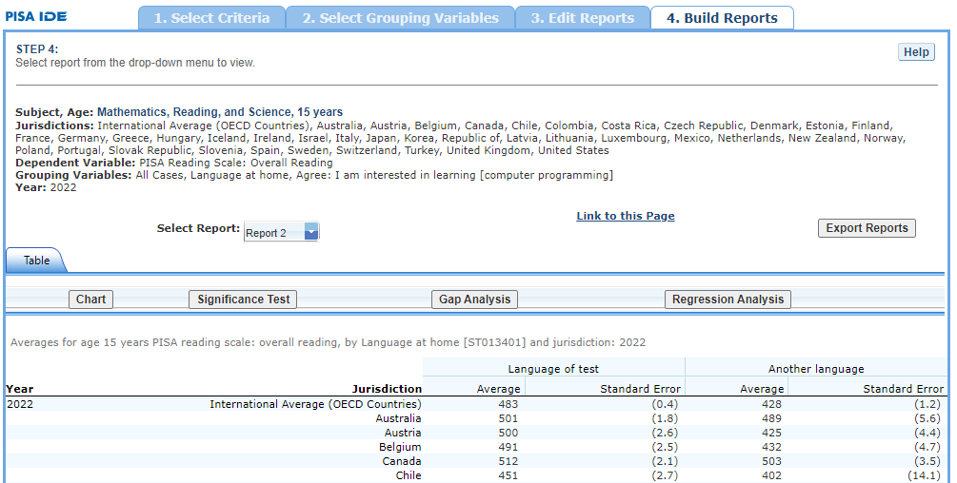

### 2.4.2 4.B. View Reports as Data Tables

Some reports will take longer than others to process, so please do not hit the “Back” button on your browser once you click on **Build Reports** (see exhibit 2-17). Your table will appear once the processing is complete. To select a different table to view, go to the **Select Report** drop-down menu (see 1 in exhibit 2-16) and choose the table of interest. To change the formatting or statistics options of a table or to generate a table from a report not included in your selection, return to step 3, **Edit Reports**.

Exhibit 2-17. Processing data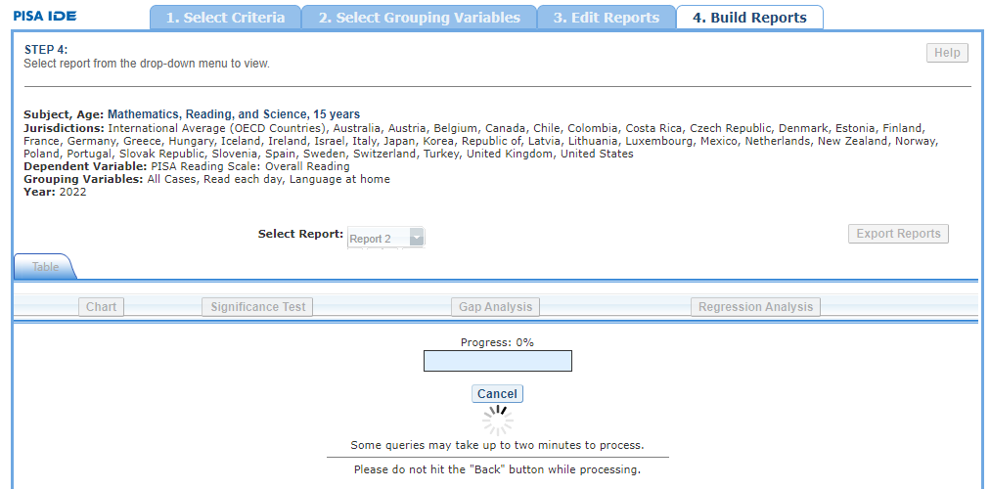

### 2.4.3 4.C. Charts

To create a chart, go to **Select Report** on the **Build Reports** screen to choose the report of interest from the drop-down menu, and then click the **Chart** link (see exhibit 2-18).

You will be able to create many types of charts and customize them. Section 4.E. Create Charts – Chart Options provides a summary of the available features and how they can be customized.

Exhibit 2-18. Viewing reports as charts 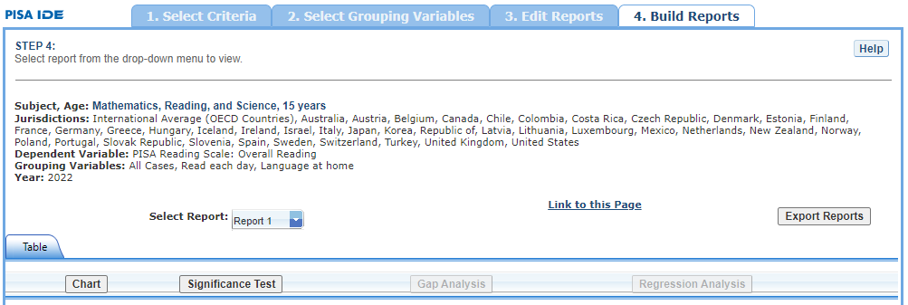

### 2.4.4 4.D. Create Charts

When you click **Chart,** you will first make selections pertaining to **Jurisdiction, Year/Study, and** **Statistic** (see exhibit 2-19). All **Jurisdictions** and **Studies** are selected by default, while you can only choose one **Statistic**. Uncheck any of the criteria that you do not wish to chart, as long as you have one selected in each category.

Only the statistics option(s) used to report data in the previous step will be presented, and only one statistics option can be selected at a time. For example, **Percentiles** will appear as the only data option to build the chart if the table created in the previous step is reporting data with only percentiles selected as the statistics option.

Once you are finished with the Data Options, click the **Create** **Chart** button in the lower-right corner of the screen.

Exhibit 2-19. Data options for charts

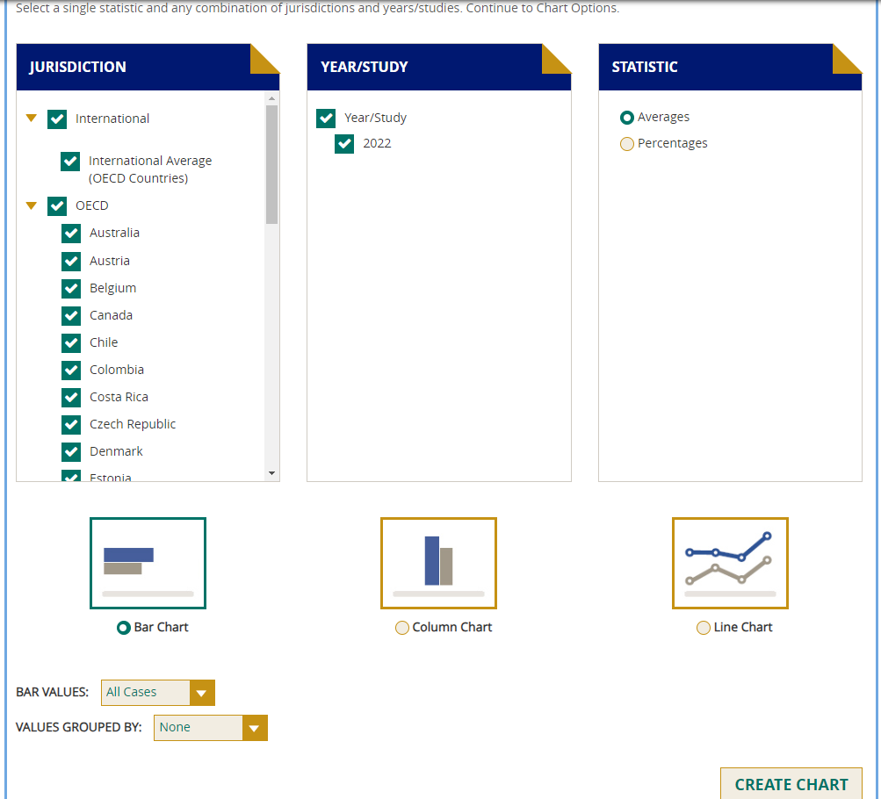

Exhibit 2-19 is a screenshot from the PISA IDE tool showing the data options available in the chart creating function in the Build Reports tab.

### 2.4.5 4.E. Create Charts – Chart Options

Next, you can make selections regarding the chart options located below on the same page.

1. Select **Bar Chart**, **Column Chart**, or **Line Chart** (see 1 in > exhibit 2-20). If the Percentiles Statistic is selected, you can > also select from a **Percentiles Chart** option.
2. After selecting a chart type, change any data dimensions from the > drop-down menus for **Bar**, **Column**, or **Line Values** and > **Values Grouped by** (see 2 in exhibit 2-20). Any new variables > that you created at step 3, **Edit Reports**, will be available > for selection, but only if you selected the variables (by clicking > the checkbox next to them) and pressed **Done** after you edited > the report.
3. Create your chart by clicking the **Create Chart** button in the > lower-right corner (see 3 in exhibit 2-20).

Exhibit 2-20. Chart options



Exhibit 2-20 is a screenshot from the PISA IDE tool showing the chart options available in the chart creating function in the Build Reports tab.

While previewing your chart, you can do the following (see exhibit 2-21 as an example of a **Percentile Chart** and exhibit 2-22 as an example of a **Bar Chart**):

1. Use the drop-down menus to change the jurisdiction and other > variables as applicable.
2. Place your cursor over the bars of the chart to see the data points > and value label(s).

Exhibit 2-21. Percentile chart 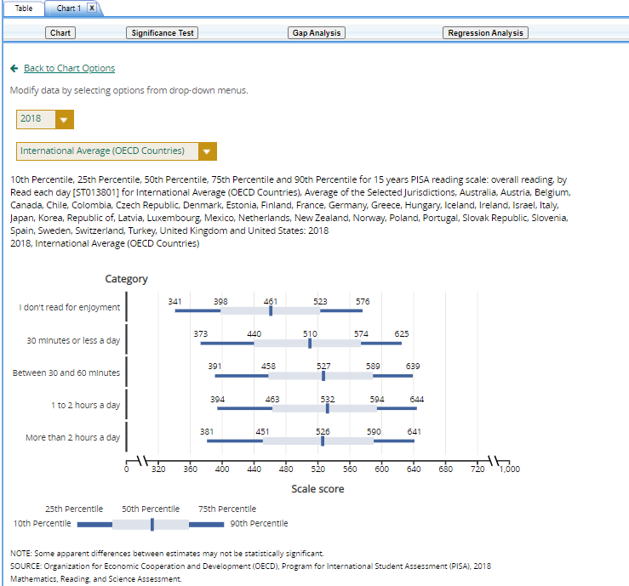

Exhibit 2-22. Bar chart

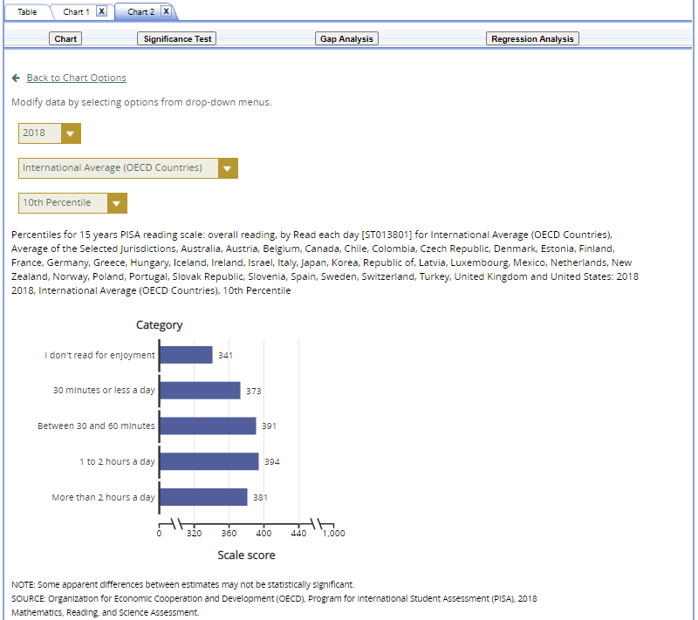

Exhibit 2-22 is a screenshot from the PISA IDE tool showing a preview of a bar chart in the chart creating function in the Build Reports tab.

You can choose **“Back to Chart Options”** (located in the upper-left corner, below the **Chart** link) to make more changes.

To make an additional chart from the same report or table, click the **Chart** link on the **Build Reports** screen. It is recommended that you provide a new chart name (the default is Chart 1, Chart 2, etc.). If you don’t start the process again by clicking the **Chart** link, the new chart will overwrite the previous one.

If you wish to make charts from other reports, select another report in the **Select Report** drop-down list. If other reports were not checked in step 3, **Edit Reports**, go back to step 3 and check the ones you want. Then, when you advance to step 4, **Build Reports**, the reports will appear in the **Select Report** drop-down list. If you need to create new reports, go back to step 1, **Select Criteria**, and/or step 2, **Select Variables**. Remember to export any completed charts you want to save by clicking **Done** and using the **Export Reports** function before leaving the **Build Reports** screen. (For further information, see **Section 4.I. Export Reports**.)

### 2.4.6 4.F. Significance Tests

Tests for statistical significance indicate whether observed differences between estimates are likely to have occurred because of sampling error or chance. “Significance” here does not imply any judgment about absolute magnitude or educational relevance. It refers only to the statistical nature of the difference and whether that difference likely reflects a true difference in the population.

With your report of interest selected, click the **Significance Test** link, which is located to the right of the **Chart** link (see exhibits 2-16 and 2-23). You first need to decide which variable you want to test and the criterion by which you want to test it (i.e., between jurisdictions, within variables, or across years). You will compare or look across the variable’s range of values, so it must have more than one value. You can look across jurisdictions for a variable (that is, compare between two or more jurisdictions) or you can look across the values within a variable for a single jurisdiction. For example, with the variable shown in exhibit 2-23, you could choose to compare scores of female students between countries and subnational education systems, or you could choose to compare scores of female students and male students.

The general steps for running significance tests are as follows (see exhibit 2-23):

1. In the **Significance Test** window, select either **Between Jurisdictions**, **Within Variables**, or **Across Years**. Then, select the appropriate jurisdiction(s), variable(s), year(s), and statistic(s). For **Between Jurisdictions**, select at least two jurisdictions. For **Within Variables**, select one or more jurisdictions. For **Across Years**, more than one year needs to be selected.
2. You can enter a **Test Title** limited to 25 characters, using only letters, numbers, spaces, underscores, and hyphens (otherwise, by default, the test is named “Sig Test 1”).
3. Select the output type as either **Table** or **Map**. The table option will show the significance test results as a matrix. The map option will show the significance test results on a world map, highlighting countries and subnational education systems that have been selected. The map output is only available when **Between Jurisdictions** is selected in the first step.
4. Additional options allow you to select **Show Score Details** to display the estimates and standard errors for the table cells. If you selected a map, this option is not applicable, as the map will automatically show score details.
5. Click the **Preview** tab located in the upper-left corner, or the **Preview** button located in the bottom-left corner.
6. Click the **Edit** tab in the upper-left corner of the screen if you wish to go back and make changes to the selections you made for running the significance tests.
7. Click the **Done** button in the upper- or lower-right corner of the screen to run the significance tests.

Exhibit 2-23. Significance test options

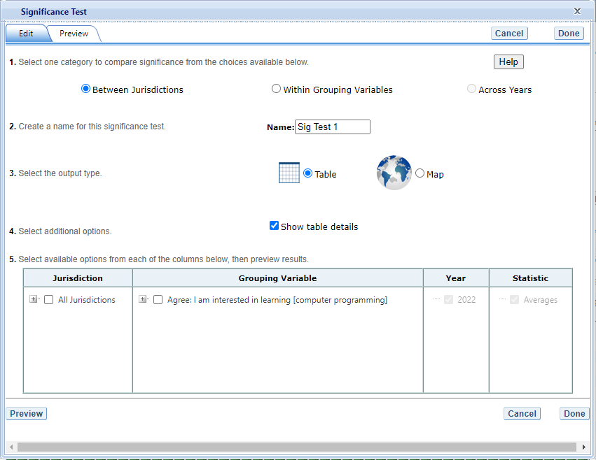

Exhibit 2-23 is a screenshot from the PISA IDE tool showing the significance test options available in the Build Reports tab.

When the table option is selected, you will get a significance test matrix in which you will see the differences and *p* values. Using the symbols shown in the legend of the matrix, an indication is also provided of whether one estimate is significantly lower or higher than another estimate or whether there is no significant difference (see exhibit 2-24).

The alpha level for all *t*-tests is .05. All comparisons within a jurisdiction, within the same year, are made using dependent *t*-tests. Comparisons between jurisdictions are treated as independent. Non-achievement comparisons across years are treated as independent. Comparisons of achievement across years are made using independent *t*-tests with a linking error taken into account. A part-whole adjustment is implemented for comparisons between a jurisdiction and a group that the jurisdiction is part of (e.g. International Average (OECD Countries)).

PISA assessments are linked across years. That is, the sets of items used to assess mathematics, reading, and science across years include a subset of common items, referred to as link items. To establish common reporting metrics for PISA, the difficulty of the link items, measured on different occasions, is compared. The comparison of the item difficulties on the different occasions is used to determine a score transformation that allows the reporting of the data on a common scale. As each item provides slightly different information about the link transformation, it follows that the chosen sample of link items will influence the estimated transformation. The consequence is an uncertainty in the transformation due to the sampling of link items, just as there is an uncertainty in country means due to the sampling of students. The uncertainty that results from the link-item sampling is referred to as linking error, and this error must be taken into account when making certain comparisons using the PISA assessment data. As with sampling errors, the likely range of magnitude for the errors is represented as a standard error. Significance tests for scores across years within the IDE take into account the linking errors applicable to each subject.

Exhibit 2-24. Significance test table output

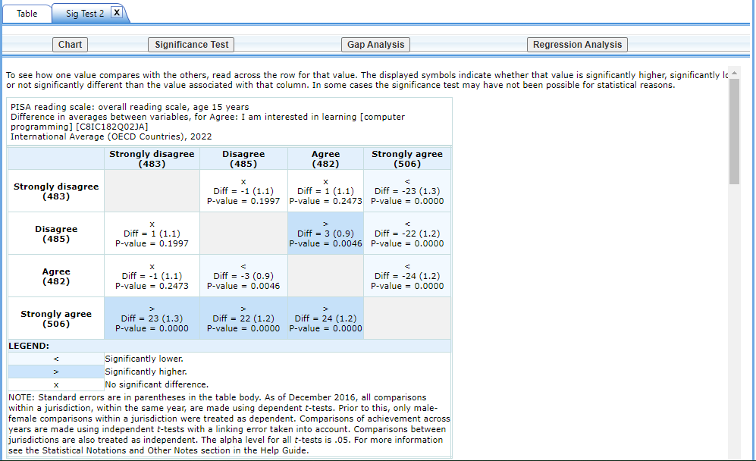

Exhibit 2-24 is a screenshot from the PISA IDE tool showing an example of a significance test table output in the Build Reports tab.

When the **map option** is selected, a global map is shown with the countries and subnational education systems selected shaded (see exhibit 2-25). The focal jurisdiction is shaded in teal green, with all other countries compared to it. The other countries are shaded in colors that indicate whether they are higher, lower, or not significantly different from the focal jurisdiction on whatever measure has been selected. (Note that a light shade of gray is the default color for jurisdictions not selected for comparison.) When you hover over a jurisdiction, a text bubble displays the numerical difference in estimates between that jurisdiction and the focal jurisdiction. At any point, you may choose a different focal jurisdiction by clicking on another country. You may also choose a different variable category for comparison by using the drop-down menu above the map.

Exhibit 2-25. Map of significance tests 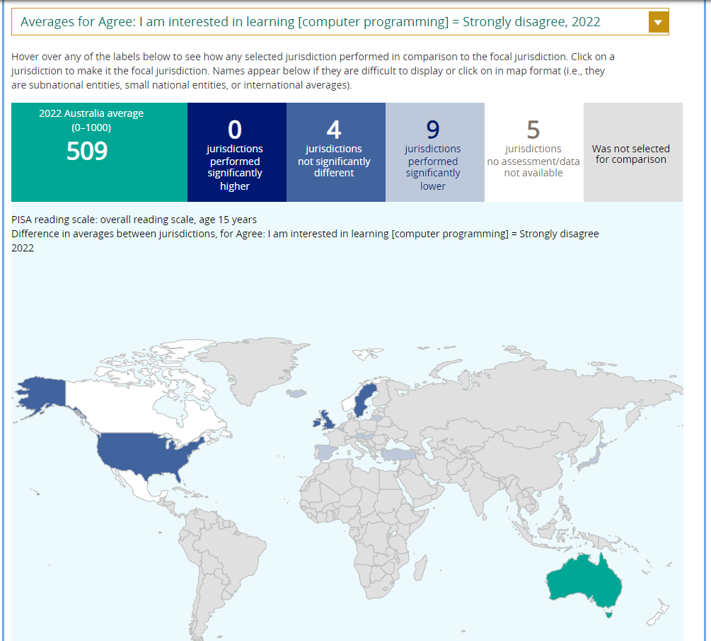

Please note that the IDE does not apply adjustments for multiple comparisons. This is consistent with current NCES statistical standards and practice. However, the U.S. PISA 2000 national report published by NCES, and the PISA 2000 international report published by the OECD, did adjust for multiple comparisons in significance testing (using the Bonferroni method). Therefore, results from significance testing obtained from the IDE may not match those in the NCES and OECD PISA 2000 reports.

### 2.4.7 4.G. Gap Analysis

Gap Analysis is included in the IDE to compare differences in gaps shown in a map, table, or chart. These gap differences can be compared between jurisdictions and/or across years.

Exhibit 2-26. Gap analysis link selection

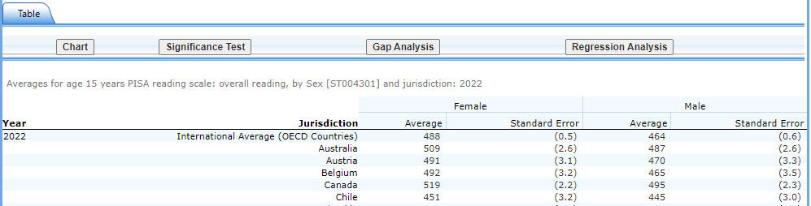

Exhibit 2-26 is a screenshot from the PISA IDE tool showing how to select the gap analysis function in the Build Reports tab.

With your report of interest selected, click on the **Gap Analysis** link, which is located to the right of the **Significance Test** link (see exhibit 2-26). You will need to decide which variable you would like to test (e.g., gender) and the criterion by which you want to test it (i.e., between jurisdictions or across years). The difference measure, or gap, can be viewed between groups, between years, between groups and years, or between percentiles within the selected variable. For example, if you compute average mathematics literacy scores for two countries at two time points for males and females, you can:

* at one time point, compare the male-female gap in one country to the male-female gap in another country;
* compare the male-female gap at two time points within a country;
* compare the difference between the male-female gap at two time points in one country to the difference between the male-female gap at two time points in another country; or
* compare the gap for females at two time points in one country to the gap for females at two time points in another country.

Exhibit 2-27. Gap analysis options

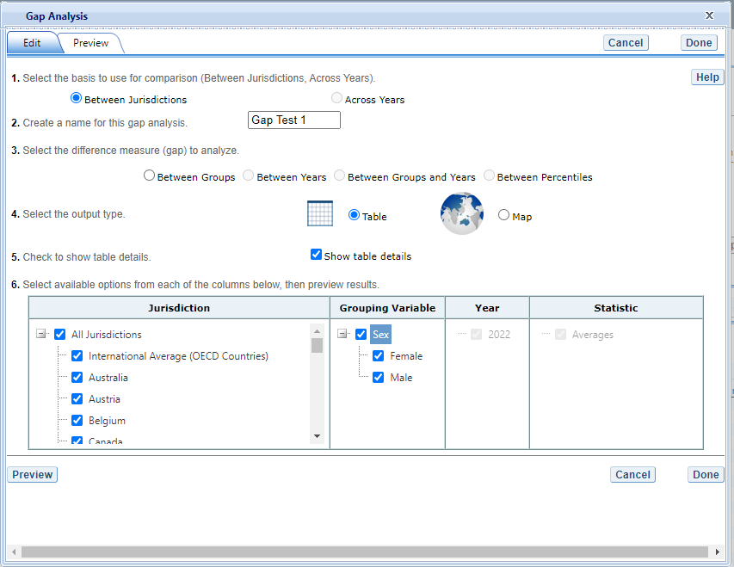

Exhibit 2-27 is a screenshot from the PISA IDE tool showing the gap analysis options available in the Build Reports tab.

The steps for running a gap analysis are similar to those for conducting a statistical significance test (see exhibit 2-27). Thus, to run a gap analysis, follow the instructions under section **4.F. Significance Tests**, noting the following differences:

1. The **Gap Analysis** link should be selected, not the **Significance Test** link.
2. The gap analysis does not have a **Within Variables** option for analysis; the options are **Between Jurisdictions** and **Across Years.**
3. The difference measure (gap) of analysis must be selected from the following: **Between Groups, Between Years, Between Groups and Years,** and **Between Percentiles** (if variables are selected for which a difference measure is not feasible, the difference measure option will not appear as available in the Gap Analysis menu).

The gap analysis output is presented in a format similar to that of the significance test output, with one difference: the difference estimate shown in the output is the difference between the gaps selected for analysis. Note that you will still see the significance of these differences, just like in a significance test. For example, exhibit 2-28 shows cross-national differences between male-female score gaps.

The gap analysis function computes and statistically tests differences between score, percentage, or percentile gaps. For gap analysis tables, all comparisons are independent tests with an alpha level of 0.05. Note that the reference group for the gaps is kept constant during the analysis, as opposed to taking the absolute value of the gaps. Therefore, the gap analysis tests whether the magnitude of the gaps differ from each other only when the gaps go in the same direction (e.g., comparing a 5-point gender gap favoring females in one country with a 15-point gender gap favoring females in another country).

Exhibit 2-28. Gap analysis output

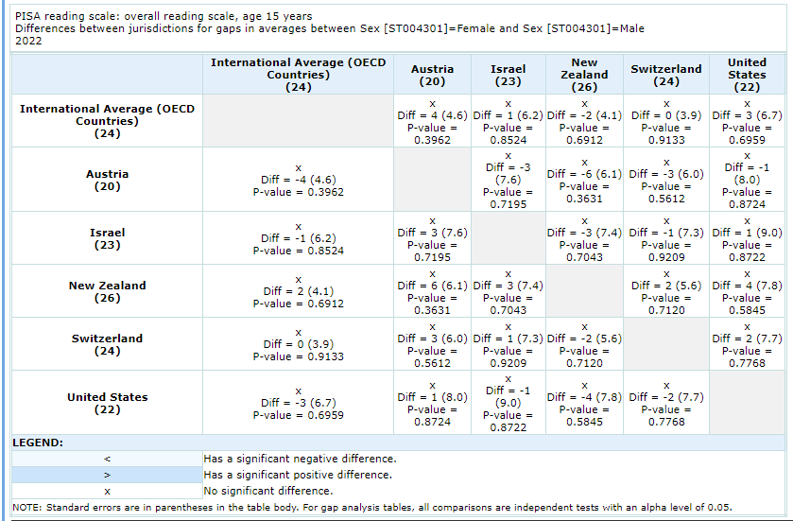

Exhibit 2-28 is a screenshot from the PISA IDE tool showing an example output report based on the gap analysis options.

Note that a gap analysis across years cannot be combined with the Between Years or Between Groups and Years difference measures, so you will select the difference measure Between Groups, or, if you have selected percentiles as one of your statistics, you may choose Between Percentiles.

### 2.4.8 4.H. Regression Analysis

Regression Analysis is included in the IDE to test for the relationship between one or more independent variables with a dependent variable, with the independent variables controlling for each other. The type of analysis performed in this feature of the IDE is referred to as linear regression, with the dependent variable being a continuous variable selected at step 1. To run a regression, first go to **Build Reports** and choose the report of interest from the drop-down **Select Report** menu. Then click on the **Regression Analysis** link, which is to the right of the **Gap Analysis** link (see exhibit 2-29).

Exhibit 2-29. Regression analysis link selection

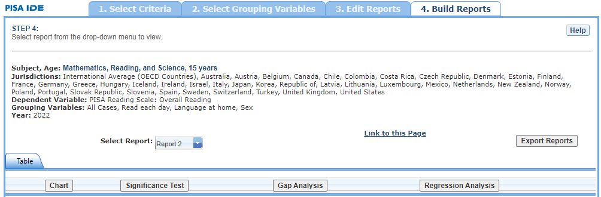

Exhibit 2-29 is a screenshot from the PISA IDE tool showing how to select the regression analysis function in the Build Reports tab.

The general steps for running a regression analysis are as follows (see exhibit 2-30):

1. In the **Regression Analysis** pop-up window, you can enter a **Name** limited to 25 characters, using only letters, numbers, spaces, underscores, and hyphens (otherwise, by default, the test will be named “Regression 1”).
2. Select the appropriate jurisdiction, year, and variable(s) for analysis. Please note that you may only choose one jurisdiction and year at a time, but you may choose up to three independent variables to be in your report. In order to use up to three independent variables, you must have already created and selected a cross-tabulated report (by selecting three variables in Step 2, **Select Variables**).
3. Click the **Preview** tab located in the upper-left corner to view the table format into which your output will be populated. In the Preview tab, an “X” denotes where the output will display.
4. Click the **Edit** tab in the upper-left corner of the screen if you wish to go back and make changes to the selections you made for running the analysis.
5. Click the **Done** button in the upper- or lower-right corner of the screen to run the regression analysis.

Exhibit 2-30. Regression analysis options

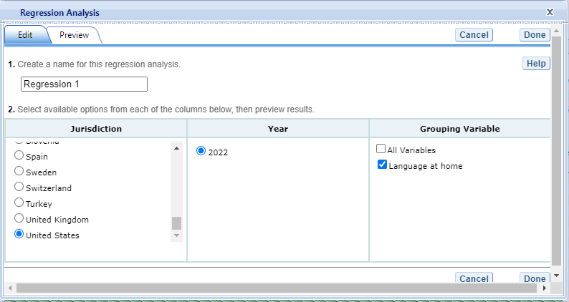

Exhibit 2-30 is a screenshot from the PISA IDE tool showing the options for the regression analysis output.

After you have clicked **Done**, your regression analysis output will load onto the screen (see exhibit 2-31). A 0-1 contrast coding is used to code the independent variable, where the first subgroup of the independent variable is the reference group. Using dummy-coded variables in a linear regression is useful for comparing each subgroup against a reference group. For example, in exhibit 2-31, if the subgroup “Native” is the reference group for the independent variable **Index immigration status (IMMIG)**, the IDE creates a “Second Generation” dummy variable (1 for respondents who answered “Second Generation,” 0 otherwise), a “First Generation” dummy variable (1 for respondents who answered “First Generation,” 0 otherwise). Reference group “Native” is excluded from the regression analysis.

Exhibit 2-31. Regression analysis output

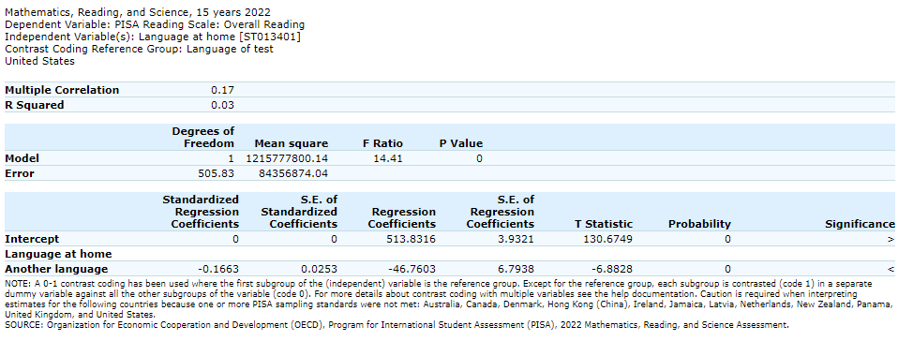

Exhibit 2-31 is a screenshot from the PISA IDE tool showing an example of the regression analysis output.

Using the output from exhibit 2-31, you can compare the average mathematics literacy scores of first- and second-generation students to scores of native-born students. When a single dummy-coded variable is used in a regression, the *intercept* is the mean of the reference group (e.g., 510.009), and the *regression coefficient* is the difference between the mean of the reference group and the group identified (coded 1) with the dummy-coded variable (e.g., 1.8959 for second generation and -31.2536 for first generation.) Since the regression coefficients are presented with a standard error and a *t* value, they can be used to test whether a difference between means is statistically significant. Under the Significance column in the output you will see three possible signs: (1) < signifies a significant negative difference, (2) > signifies a significant positive difference, and (3) x signifies the difference is not statistically significant.

### 2.4.9 4.I. Export Reports

Click on the **Export Reports** button/arrow located on the right side of the **Build Reports** screen to save or print your tables, charts, and significance tests. The report names that appear in the **Export Reports** window are those that were checked off at step 3, **Edit Reports**.

Check the files you want to export and select one of the file formats: **HTML** (print-friendly), **Excel, Word,** or **PDF** (see exhibit 2-32). All reports that you select at the same time will be exported in one file. In the Excel format, you will be able to increase the visible decimal places visible wherever more precision is available. Because there are many different operating systems in use, you may get an error message with Excel or one of the other formats. Usually this will not affect your ability to export, so please wait for the software errors to resolve.

Exhibit 2-32. Export report options

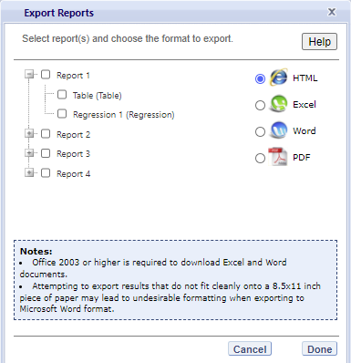

Exhibit 2-32 is a screenshot from the PISA IDE tool showing the export options, including HTML, Excel, Word, and PDF.

# 3 PIRLS IDE Walkthrough

There are four general steps for exploring each IDE page (see exhibit 3-1). Each step is described in more detail in the following sub-sections.

<<<<<<< Updated upstream Exhibit 3. What you will see in the IDE environment and what each step entails <<<<<<< HEAD  ======= Exhibit 3-1. What you will see in the IDE environment and what each step entails  >>>>>>> Stashed changes =======  >>>>>>> main

## 3.1 1. Select Criteria

### 3.1.1 1.A. Overview

Your data query in the IDE (International Data Explorer) begins on the **Select Criteria** screen (see exhibit 3-2).

Choose one **Subject**, and one or more **Measures, Years,** and **Jurisdictions** for the data you wish to view or compare.

Use the **Reset** button located in the upper right portion of the screen (just below the **Help** button) to erase your choices and begin again.

Click on a blue sideways facing arrow (►) to open up a category and click on a blue downward facing arrow (▼) to close a category.

Exhibit 3-2. Select criteria

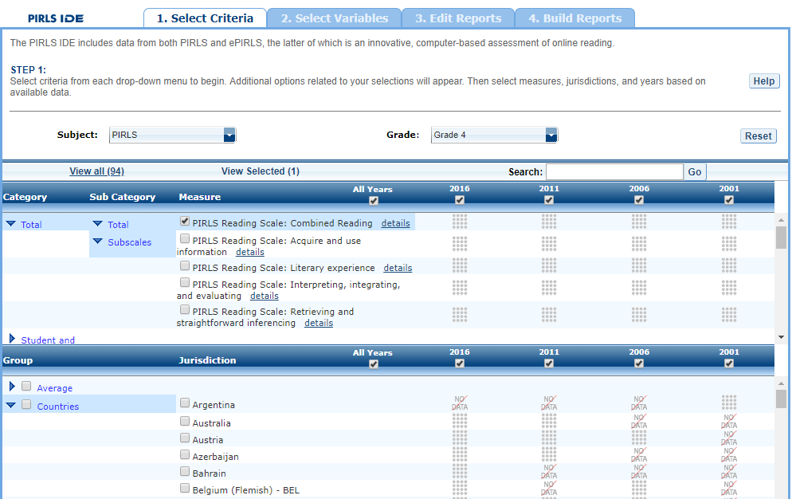

Exhibit 3-2 is a screenshot from the PIRLS IDE tool showing the Select Criteria tab.

### 3.1.2 1.B. Choose Subject

Under **Subject**, you have the choice of **PIRLS** or **ePIRLS**. Once a subject is chosen, the screen resets and you can select **Year**(s), **Measure**(s), and **Jurisdiction**(s).

### 3.1.3 1.C. Choose Measure and Year

Under **Measure,** you can choose the combined reading scale and/or any of the reading subscales. Note that the combined reading scale is the default (as shown in exhibit 3-2). The 2001 and 2006 reading subscales have been rescaled to allow for comparisons to 2011 and later years.

In addition, there are a number of variables other than scale scores that you may choose as a measure (see exhibit 3-3). These variables—such as age, teaching experience, and class size—are all continuous variables and are used as a measure of analysis.

You may also choose the survey year (All years, 2016, 2011, 2006, or 2001) at the top of either step 1 or 2. Notice for which years a measure, jurisdiction, or variable data are available by looking below each year for the grid of dots (which means data are available) or the “No data” slash.

Exhibit 3-3. Measures

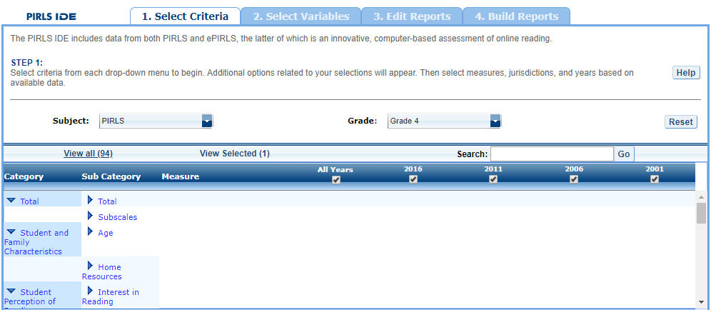

Exhibit 3-3 is a screenshot from the PIRLS IDE tool showing how to select measures in the Select Criteria tab.

### 3.1.4 1.D. Choose Jurisdiction

With your measure selected, next choose at least one **Jurisdiction.**

Jurisdictions are found under the following groups: **Country** and **Benchmarking jurisdictions,** and **Off-Grade Level Participants.** There is also a group category called **Average,** with options to display the **Average of Countries** and the **Average of Selected Countries/Participants.** Please note that selecting **Average of Countries** or **Average of Selected Countries/Participants** may produce an error message in the **Build Reports** step due to the high volume of information contained in these groups.

The general procedures for selecting one or more jurisdiction are as follows:

1. To open or close jurisdictions, click on the arrow. Jurisdictions in the group are open and can be selected when the blue arrow points down (see exhibit 3-4).
2. Click the checkboxes next to specific jurisdictions that you are interested in, or uncheck those jurisdictions that you wish to deselect. If you click the checkbox next to the group name (e.g., “Country”), you will select all the jurisdictions within that group. If desired, uncheck the group name to deselect all.
3. If you want to close a group (for example, close the list of countries in order to readily see the benchmarking jurisdictions), click the blue arrow next to the group name. The closed group’s arrow points to the right. Be advised that closing the group will not deselect your choices.

Exhibit 3-4. Choosing jurisdictions

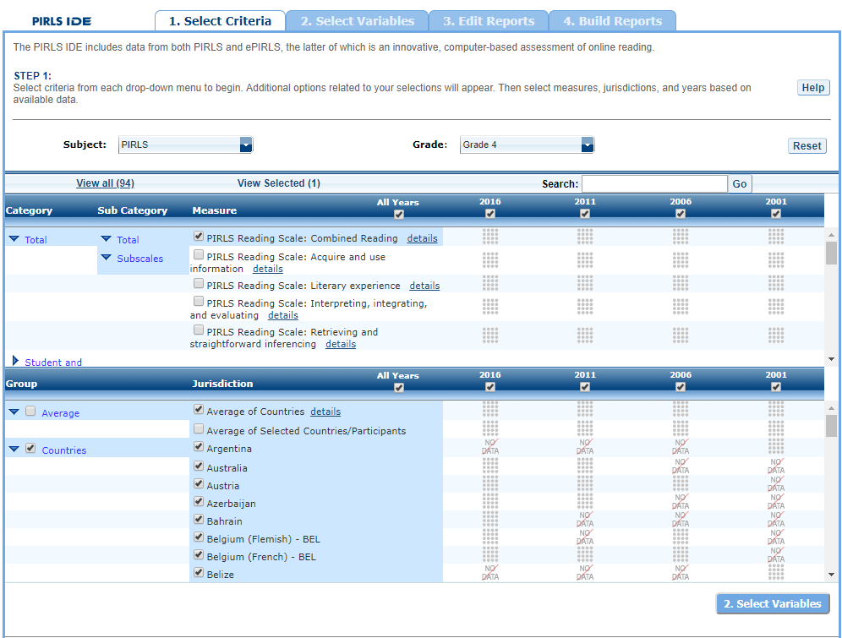

Exhibit 3-4 is a screenshot from the PIRLS IDE tool showing jurisdictions available in the Select Criteria tab.

To continue in the IDE, click the **Select Variables** button at the bottom of the page or the tab at the top of the page to go to the next screen (see exhibit 3-4 above).

## 3.2 2. Select Variables

### 3.2.1 2.A. Overview

Step 2, **Select Variables,** can only be accessed after choosing criteria at step 1, **Select Criteria**.

To continue your data query and edit a report, *you must choose at least one variable on this screen.* You can browse for variables either by using the **Category** and **Sub Category** lists or by using the **Search** function (see exhibit 3-5). You can return to this screen to change variable selections at any time.

Exhibit 3-5. Selecting variables overview

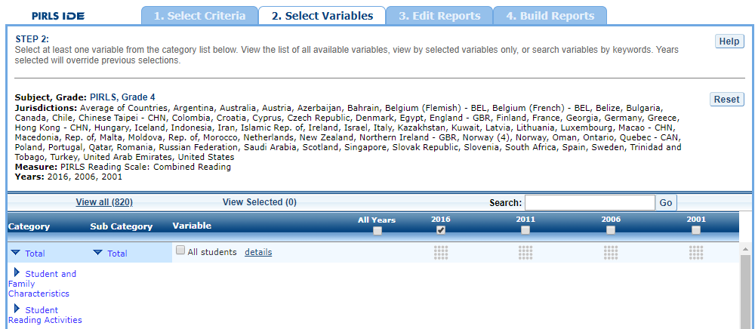

Exhibit 3-5 is a screenshot from the PIRLS IDE tool showing an overview of the Select Variables tab.

### 3.2.2 2.B. Search Using Category and Subcategory Lists

Choose at least one variable on this screen for your report. One way to do this is to search for variables using the **Category** and **Sub Category** lists. If you don’t wish to choose from any of the specified categories and subcategories, then select **All students.**

The variables shown are tied to the criteria you selected at step 1 (**Measure, Year** and **Jurisdiction**), which are indicated at the top of the screen. To change any of these criteria, return to step 1, **Select Criteria**.

To browse for variables, get details about them, select them, and view them:

1. Click the blue arrows to open and close categories and subcategories of variables  
   (see exhibit 3-6).
2. Click **details** or **hide details** to show or hide the full title of a given variable, the PIRLS ID, and the values (i.e., variable labels). Note that some variables have the same or similar short titles but comparing details will show you how they differ. See the example in exhibit 3-6, which shows general things in the student’s home (ASBGBOOK and ASBGTA1).
3. Click the checkbox next to a variable to select it for your analysis/report. You will see the count increase next to **View Selected**.
4. Click the **View Selected** tab to see the variables you have chosen. To return to the full list of variables by category, click the **View All** tab.
5. Remember to select the year for which you wish to build a report and make sure that data are available for your chosen year and variables.
6. Searching variables is an option from the Search box. See section 2.C, page 12, for more details about this function.

Exhibit 3-6. Select variables using category and subcategory lists

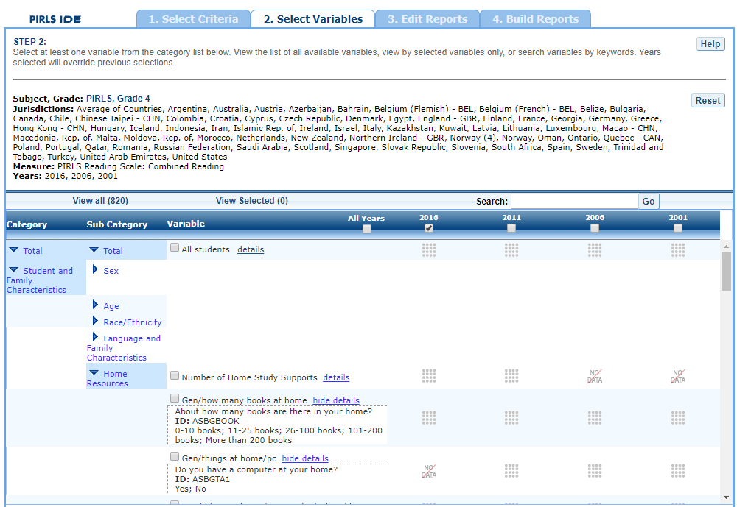

Exhibit 3-6 is a screenshot from the PIRLS IDE tool showing how to select a variable from the categories and sub categories listed in the Select Variables tab.

When you have selected the variable(s) you want to include, continue by clicking the **Edit Reports** button at the bottom of the page or the tab at the top of the page to go to the next screen.

### 3.2.3 2.C. Search Function

The second way to search for variables is to use the **Search** function on the **Select Variables** screen.

Type a term in the **Search** box and click **Go** (or hit “Enter” on your keyboard) to find variables by keywords in the question and/or details for the variable (see exhibit 3-7). If you use multiple keywords, “and” is assumed. You can also narrow your search by using “or,” “not,” or “and not.” The search function operates on an exact phrase if it is contained in quotes. The variable(s) that include the search term(s) in the question or its details will be listed.

See Section 2.B. Search Using Category and Subcategory Lists (page 11) for information on how to get details about variables, selecting variables, and viewing variables.

Exhibit 3-7. Select variables using the search function 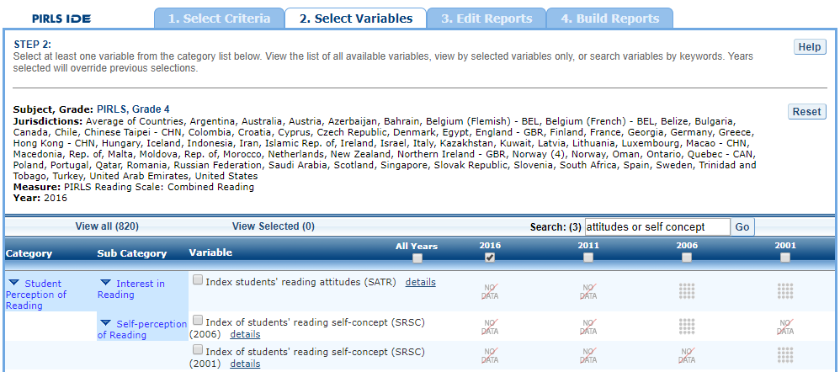

When you have selected the variable(s) you want to include, continue by clicking the **Edit Reports** button at the bottom of the page or the tab at the top of the page to go to the next screen.

## 3.3 3. Edit Reports

### 3.3.1 3.A. Overview

You can access step 3, **Edit Reports,** after choosing criteria at step 1, **Select Criteria**, and choosing at least one variable at step 2, **Select Variables**. The IDE will automatically build reports based on your selections from steps 1 and 2. However, at step 3, the **Edit Reports** phase, you may modify your selections for each report.

At this step, you can:

* Preview and edit the layout of your reports;
* Copy reports or create new reports based on the variables selected;
* Change formatting options, such as the number of decimal places to display, for all reports (these may also be changed in individual reports, but formatting options can overwrite previous edits);
* Change statistics options, such as averages and achievement levels, for all reports (these may also be changed in individual reports, but statistics options can overwrite previous edits);
* Select reports to be built into tables and charts at step 4, **Build Reports**; and
* Delete reports.

Using your chosen criteria, the IDE will return a separate data report for each variable you have chosen. If you have selected two or three variables (not counting **All Students**), you will also see a cross-tabulated report that crosses these variables. If your selected criteria include more than one measure (e.g., combined reading scale and age), a separate set of data reports will be generated for each measure (see exhibit 3-8, page 14).

Exhibit 3-8. Edit reports overview

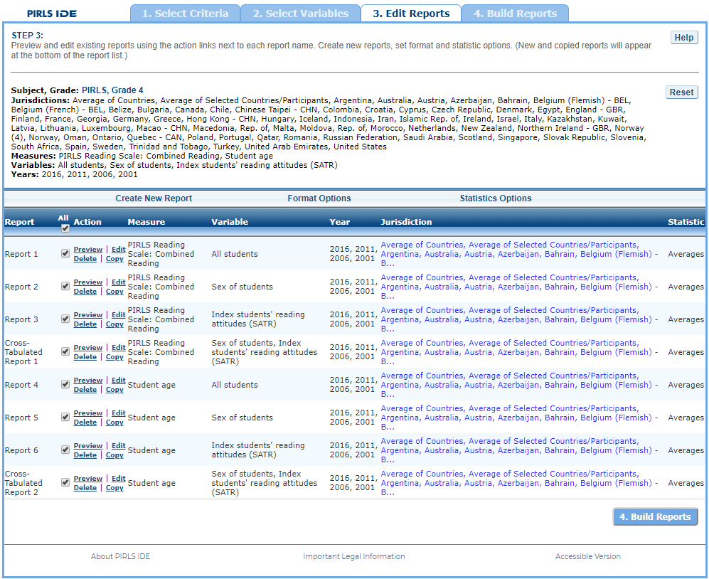

Exhibit 3-8 is a screenshot from the PIRLS IDE tool showing an overview of the Edit Reports tab.

The **Edit Reports** step shows detailed information on the layout of your reports (see exhibit 3-8). The **Report** column indicates the report, or cross-tabulation report, number based on the variable(s) chosen during the criteria selection. The **Action** column gives you the option to **Preview**, **Edit, Delete**, or **Copy** the report. Here, reports may be chosen for the report-building phase under the **All** tab, either by selecting **All** or selecting individual reports. The **Variable** column indicates the variable(s) included in the report. The **Year** column shows which years you have selected for comparison. The **Jurisdiction** column labels the countries and subnational education systems for comparison, and the **Statistic** column provides the type of statistic output that will be generated in the report-building phase.

### 3.3.2 3.B. Preview Report

Select **Preview** under the **Action** column to see how your report will be laid out (see exhibit 3-8). The preview will not provide actual data, but will show how the data will be arranged in rows and columns (see exhibit 3-9, page 15). You can select **Preview** at any time to see how your changes will affect the report’s final layout.

Exhibit 3-9. Using preview report

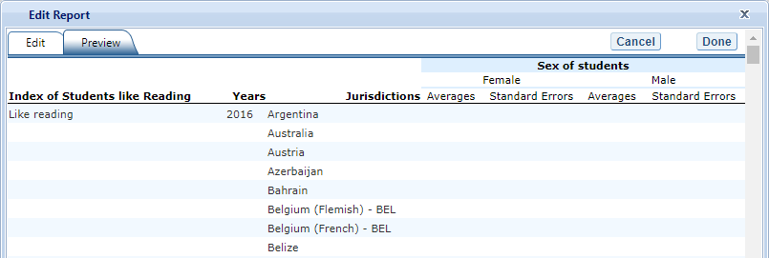

Exhibit 3-9 is a screenshot from the PIRLS IDE tool showing an example of the preview function that is available in the Edit Reports tab.

### 3.3.3 3.C. Edit Report

To edit the report, select the command under the **Action** column next to the report (see exhibit 3-8 above). Another way to edit a report is to select the **Edit** tab when you are previewing a report. The following can be done using this function (see exhibit 3-10).

Exhibit 3-10. Editing reports

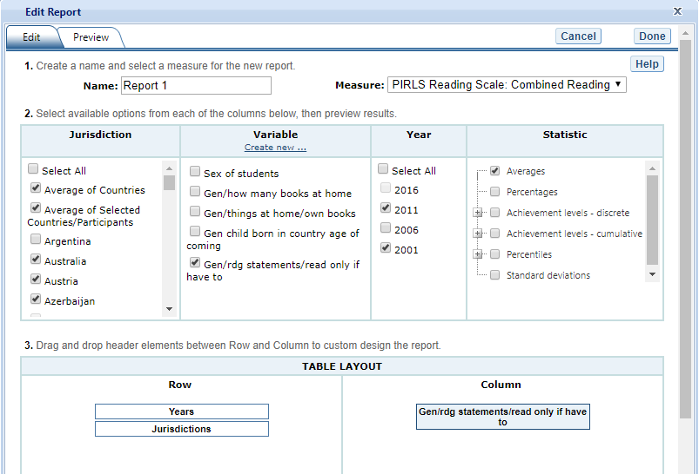

Exhibit 3-10 is a screenshot from the PIRLS IDE tool showing an example of the editing report function that is available in the Edit Reports tab.

1. Name your report. You have the option of giving each report a distinctive name, up to a limit of 50 characters, using only letters, numbers, spaces, underscores, and hyphens. (Otherwise, the default name is Report 1, Report 2, etc., and Cross-Tabulated Report 1, Cross-Tabulated Report 2, etc.).
2. Select a measure. You can choose a measure if more than one was selected at step 1.
3. Select which jurisdictions, variables, years (if applicable), and statistics to include (out of the selections previously made at steps 1 and 2). You can select up to two statistics options from the following: averages, percentages, achievement levels—discrete, achievement levels—cumulative, percentiles, and standard deviations. (For further information, see Section 3.G. Statistics Options, page 19.)
4. To create a new variable while editing a report, click on **Create New…** under the **Variable** heading. Section 3.D below further explains the process for creating a new variable.
5. Change the table layout by dragging elements to determine which items will appear in rows and which will appear in columns. Some of the arrangements will not be permissible, but a pop-up alert will explain this.

To save changes, make sure to select **Done** in the upper or lower right portion of the screen before closing the **Edit Report** window.

### 3.3.4 3.D. Create New Variables

To create a new variable, select **Edit** under the **Action** column and select **Create new…** under **Variable** (see exhibit 3-10). The new variable is created by combining values for an existing variable. The steps are as follows:

1. Click **Create New** under the **Variable** heading.
2. Select the variable for which you wish to combine values.
3. Select the values you want to combine by checking the boxes to the left of the values (see exhibit 3-11).
4. Create a name for the new value, and press **Create**. The collapsed values will appear in gray to indicate that they have already been used.
5. Wait for the screen to refresh, and press **Done**.
6. The new variable will appear in the **Variable** list (in the **Edit Report** window, if you access it that way, or else in the **Create New Report** window) with the new variable name designated as “(Collapsed)”. How the new variable displays will depend upon how it was created originally from the two options mentioned above.
7. Check the box next to the new (collapsed) variable to view it in the report. You can click **Preview** to see how the table will be laid out before retrieving data.

Exhibit 3-11. Creating new variables

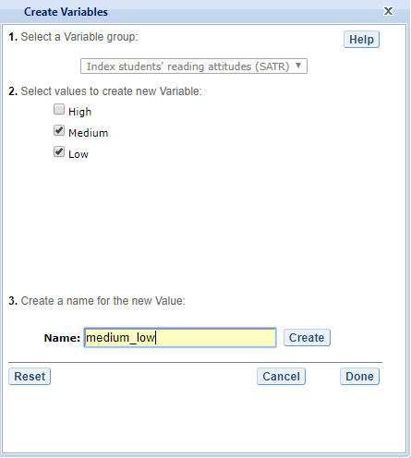

Exhibit 3-11 is a screenshot from the PIRLS IDE tool showing an example of the creating new variable function that is available in the Edit Reports tab.

A new variable that you create is applicable to that specific report; it does not apply to the other reports appearing in the **Edit Reports** screen. For example, if you selected multiple measures of reading literacy for analysis, then you would need to create the new variable for each measure or create a copy of the report and edit it accordingly. To do the latter, click on **Copy** report in the **Edit Reports** screen (copied reports appear at the end of the list of reports) and then **Edit** the new copy (using the above example, you can change the measure and give the report a new name).

You can repeat the process and combine different values of a variable to create additional new variables. Using the **Create New Report** function, you can create a new report for each new variable that you create. (For further information, see Section 3.E. Create New Report, page 19.)

If you selected two or three variables from which to create new variables, you can repeat the process for each of them. Using the **Create New Report** or **Edit Report** function, these collapsed variables will be listed and available for cross-tabulation (see exhibit 3-12). You can click **Preview** to see how the table will be laid out before retrieving data.

Exhibit 3-12. Edit report with collapsed variables

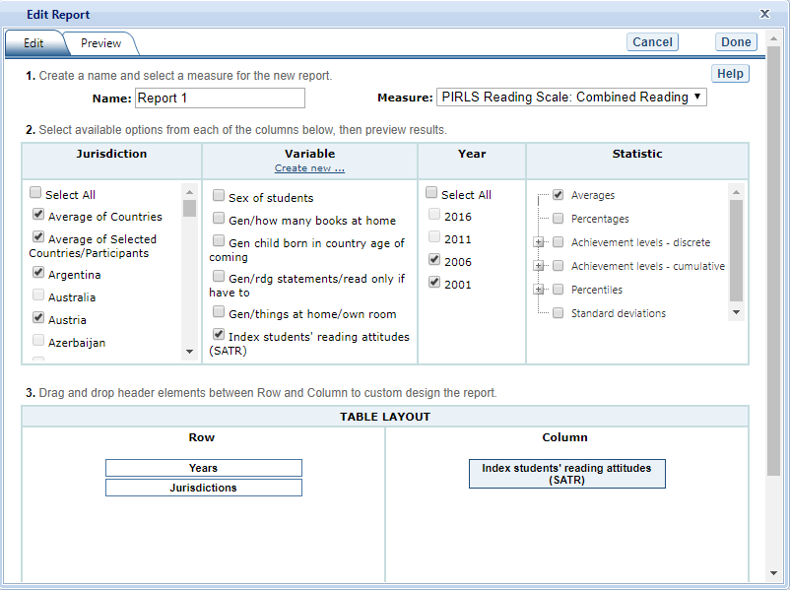

Exhibit 3-12 is a screenshot from the PIRLS IDE tool showing an example of the editing report with collapsed variables function that is available in the Edit Reports tab.

### 3.3.5 3.E. Create New Report

From the main **Edit Reports** screen, clicking on **Create New Report** brings up the same options as **Edit Report**, but with no checkboxes marked and without any new variables you may have created. Thus, **Create New Report** provides a clean slate for your selections from the first two steps, **Select Criteria** and **Select Variables** (see exhibit 3-13). Each new report you create will appear at the end of the list of reports. If you do not give the report a specific name, it will be called “New Report.”

Exhibit 3-13. Creating new reports

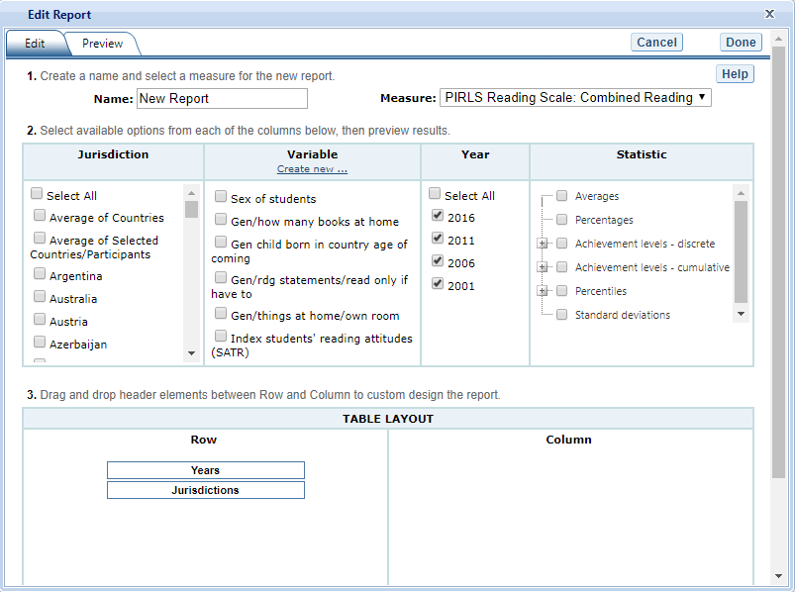

Exhibit 3-13 is a screenshot from the PIRLS IDE tool showing an example of the creating new report function that is available in the Edit Reports tab.

### 3.3.6 3.F. Format Options

From the main **Edit Reports** screen, clicking on **Format Options** will allow you to make formatting changes applicable to *all* the reports listed. The following formatting options are available using this function (see exhibit 3-14):

1. **Variable Labels (Long)** displays a more detailed description of the variables selected in a query than the default short label. For variables from questionnaires, the full text of the question is displayed. Be advised that the length of the extra detail may sometimes interfere with table formatting.
2. **Show data for values categorized as “missing”** will include the percentage of students in the total sample or in a reporting group for whom membership in a particular response category is unknown because no response was given by the students, their teacher, or their school. The percentage of “missing” will be shown in the right-most table column. Missing data are available only for queries that involve percentages as the statistic type. Unless you check this option, the default is for missing responses not to be included in the percentage distribution shown.
3. **Decimal Places** allows you to specify a greater level of precision for a particular statistic (one or two decimal places) than does the default, which is whole numbers. Note that only integer-level precision is allowed for percentages; that is, the number of decimal places is fixed at “none” for percentages. Also, standard errors will be shown to one more decimal place than is shown for a particular statistic. For example, if you request that the averages be displayed to one decimal place, the corresponding standard errors will be displayed to two decimal places. If you export to Excel, you will be able to increase the number of decimal places in most cases.
4. **Include** gives you the option to show standard errors of the estimates and, if you choose to show them, the option to show them inside parentheses/brackets. Unless you indicate otherwise, the default is to show standard errors inside parentheses. You can preview the effects of your selection in the Sample Display area (see the blue-shaded box at the bottom of exhibit 3-14).

Exhibit 3-14. Format options

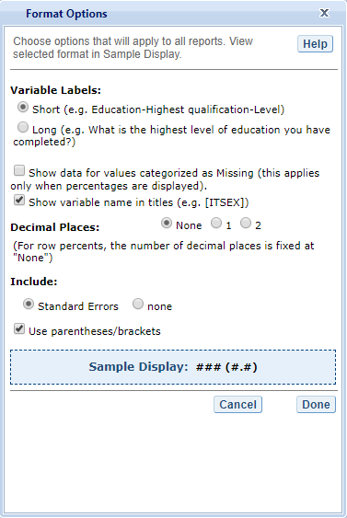

Exhibit 3-14 is a screenshot from the PIRLS IDE tool showing an example of the format options available in the Edit Reports tab.

Be advised that choices you make in the **Format Options** window will apply to all reports (i.e., they cannot be changed for individual reports). Use the **Reset** button located in the upper right portion of the screen (just below the **Help** button) to restore the **Format Options** to the default settings (a word of caution: as this will also delete any new reports that you have created).

### 3.3.7 3.G. Statistics Options

Available only from the main **Edit Reports** screen, clicking on **Statistics Options** allows you to designate up to two statistics. The selections made are applicable to *all* the reports listed, although you can also change the statistics for an individual report when you edit that report. (For further information, see Section 3.C. Edit Report, page 15.)

The following statistics options are available (see exhibit 3-15):

1. **Averages.** This statistic provides the average value for a selected continuous variable or the average scale score for the combined reading scale or one of the reading subscales. For the PIRLS assessment, student performance is reported on scales that range from 0 to 1,000. PIRLS reports the average scale score for a variety of demographic samples of the student population (e.g., the average scale score in reading for literary purposes for female students).
2. **Percentages.** This statistic shows the percentage of students as a row percentage. For example, if the first column lists countries, then each country will display its own percentage distribution across its row. If the table cell for Black female students in the United States is 9 percent, then Black females constituted 9 percent of U.S. fourth-graders. By default, percentage distributions do not include missing data. For information on how to show data for values categorized as missing, see Section 3.F. Format Options, above.
3. **Achievement levels—discrete.** Discrete achievement levels are reported as the percentage of students performing *at* each international benchmark (*low, intermediate, high,* or *advanced)*, counted separately from the other benchmarks:
   * *Below low*—below 400
   * *At* *low*—between 400 and 475
   * *At* *intermediate*—between 475 and 550
   * *At* *high*—between 550 and 625
   * *At* *advanced*—above 625
4. **Achievement levels—cumulative.** Cumulative achievement levels are reported as the percentage of students performing *at or above* each international benchmark:
   * *At or above* *low*—at or above 400
   * *At or above* *intermediate*—at or above 475
   * *At or above* *high*—at or above 550
   * *At advanced*—above 625
5. **Percentiles.** This statistic shows the threshold (or cutpoint) score for the following:
   * 10th percentile—the bottom 10 percent of students
   * 25th percentile—the bottom quarter of students
   * 50th percentile—the bottom half of students (half the students scored at or below the cutpoint and half scored above it)
   * 75th percentile—the top quarter of students
   * 90th percentile—the top 10 percent of students
6. **Standard deviations.** The standard deviation is a measure of how widely or narrowly dispersed scores are for a particular dataset. Under general normality assumptions,  
   95 percent of the scores are within two standard deviations of the mean. For example,  
   if the average score of a dataset is 500 and the standard deviation is 100, it means that  
   95 percent of the scores in this dataset fall between 300 and 700. The standard deviation is the square root of the variance.

Exhibit 3-15. Statistics options

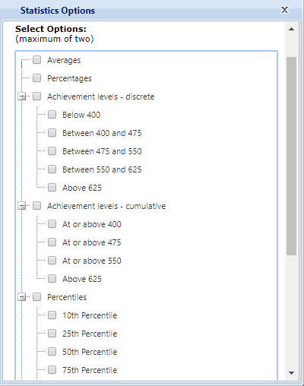

Exhibit 3-15 is a screenshot from the PIRLS IDE tool showing an example of the statistics options available in the Edit Reports tab.

The selections you make in **Statistics Options** will be applied automatically to all reports, although you can change the statistics for an individual report when you edit it. Be advised that if you use **Statistics Options** after editing the statistics in one or more of your individual reports, the statistics options selected will overwrite your previously edited selections. If you wish to use the same criteria and variables in a report with a different selection of statistics, consider using the **Create New Report** function to generate a new report with different statistics. (For further information, see Section 3.E. Create New Report, page 19.) You can also make a copy of an individual report.

You can use the **Reset** button located in the upper right portion of the screen (just below the **Help** button) to restore the **Statistics Options** to the default setting, which is **Averages** for all reports (this will also delete any new reports that you have created).

Not all statistics are available for all reports. Their availability depends on other selections you have made to define the content and format of your report:

* Percentages will not display if jurisdictions or years appear in columns.
* Achievement-level results cannot be displayed in both columns and rows.
* Achievement-level results are available only for the composite or overall scale.
* If achievement levels are selected as a variable, only percentages will be displayed.

Please note that the statistics produced by the IDE may not match the statistics shown in reports published by the International Association for the Evaluation of Educational Achievement (IEA) due to differences in certain statistical standards. In particular, organizations such as NCES and the IEA differ in the minimum sample sizes required for publishing student scores. Furthermore, in IEA reports, if a student has more than one teacher, estimates for teacher variables are calculated as an average of data reported by all of the teachers. In comparison, in the IDE, a student is randomly assigned one teacher, and the teacher estimate represents the data reported by the teacher assigned to the student.

### 3.3.8 3.H. Select Reports to Build

As you edit your reports, you can give them distinct names (up to 50 characters) to differentiate them, as well as make changes to the jurisdictions and variables previously selected, the statistics, and the layout of the rows and columns. (For further information, see Section 3.C. Edit Report, page 15.) You may make copies of reports with these changes. In order to proceed to step 4, **Build Reports**, each report for which you want to retrieve data should be previewed/inspected using the **Preview** function. To decrease processing time as you move to step 4, you can uncheck any reports for which you do not wish to retrieve data. By default, all reports are checked. To uncheck one or more reports, you can either uncheck the reports individually or click on the **All** box. Doing the latter will uncheck all of the reports and allow you to check only those for which you wish to retrieve data. In the example that follows (see exhibit 3-16), data will be retrieved only for the combined reading measure.

Exhibit 3-16. Selecting reports to build

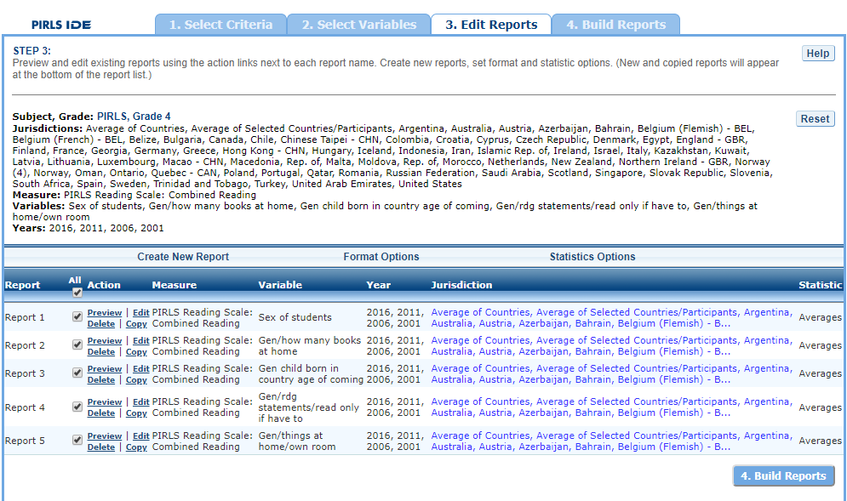

Exhibit 3-16 is a screenshot from the PIRLS IDE tool showing how to select reports to build in the Edit Reports tab.

If you wish to delete a report from the list of reports, click **Delete** (see 1 above) in the **Action** column. Use the **Reset** button (see 2 above) located in the upper right portion of the screen (just below the **Help** button) to restore the deleted reports (a word of caution: this will also delete any new reports that you have created and restore the Format Options and Statistics Options to the default settings).

To continue to the last step in the IDE, click the **Build Reports** button at the bottom of the page or the tab at the top of the page to go to the next screen (see 3 above).

## 3.4 4. Build Reports

### 3.4.1 4.A. Overview

You can access step 4, **Build Reports**, after choosing criteria at step 1, **Select Criteria**, in which case the default report built will provide **Averages** data for the **All Students** variable. After step 1, you may also go on to steps 2 and 3, where you can select additional variables and edit reports, before moving on to **Build Reports**. In **Build Reports**, you can do the following:

1. Generate a data table for each report selected in step 3, as shown by the **Select Reports** drop-down feature (see 1 in exhibit 3-17). By default, all reports are checked, though you can uncheck any reports for which you do not wish to retrieve data. (For further information, see Section 3.H. Select Reports to Build, page 24.)
2. Export and save data tables into various formats using the **Export Reports** button (see 2 in exhibit 3-17). The output formats include HTML (print-friendly), Microsoft Word, Microsoft Excel, and Adobe PDF.
3. Select the **Chart** tab (see 3 in exhibit 3-17) to create and customize charts for each report and save them for export in the above formats.
4. Select the **Significance Test** tab (see 4 in exhibit 3-17) to run a significance test on your results, customize it, and export it.

Exhibit 3-17. Building reports overview 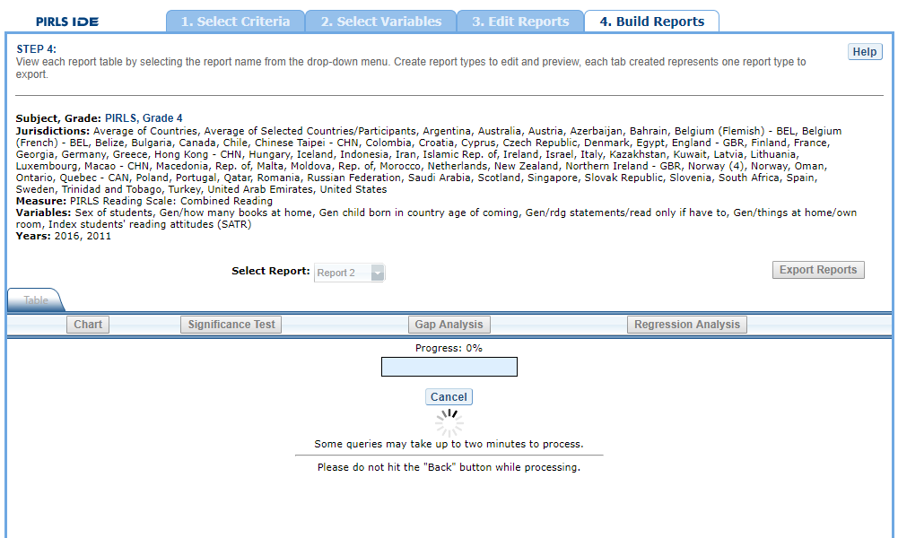

### 3.4.2 4.B. View Reports as Data Tables

Once you click on **Build Reports,** the words “Processing Data” will appear on your screen (see exhibit 3-17). Some reports will take longer than others to process, so please do not hit the “Back” button during this stage. To view a table, go to the **Select Report** drop-down menu (see 1 in exhibit 3-17) and choose a table of interest. Your table will appear once the processing is complete (see exhibit 3-18). To change the formatting or statistics options of a table or to generate a table from a report not included in your selection, return to step 3, **Edit Reports**.

Exhibit 3-18. Viewing reports as data tables

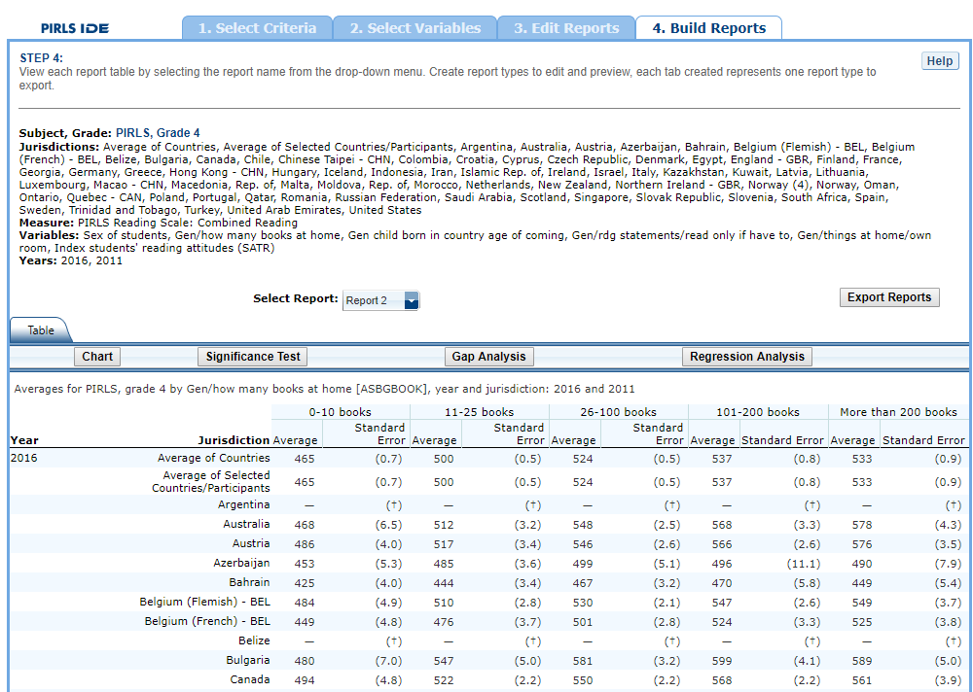

Exhibit 3-18 is a screenshot from the PIRLS IDE tool showing data processing in the Build Reports tab.

### 3.4.3 4.C. Charts

Go to **Select Report** to choose the report of interest from the drop-down menu, and then click the **Chart** link (see exhibit 3-19).

You will be able to create many types of charts and customize them. Section 4.E. Create Charts—Chart Options (page 29) provides a summary of the available features and how they can be customized.

Exhibit 3-19. Viewing reports as charts

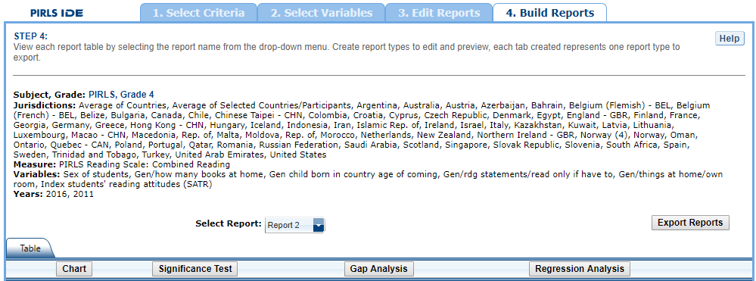

### 3.4.4 4.D. Create Charts—Data Options

When you click **Chart,** your screen will present **Data Options** pertaining to **Statistic, Year,** and **Jurisdiction.** All are selected by default, except that you can have only one statistic (see exhibit 3-20). Uncheck any of the criteria that you do not wish to chart, as long as you have one selected in each category.

Once you are finished with the Data Options, click the **Chart Options** button in the lower right corner of the screen.

Exhibit 3-20. Data options for charts

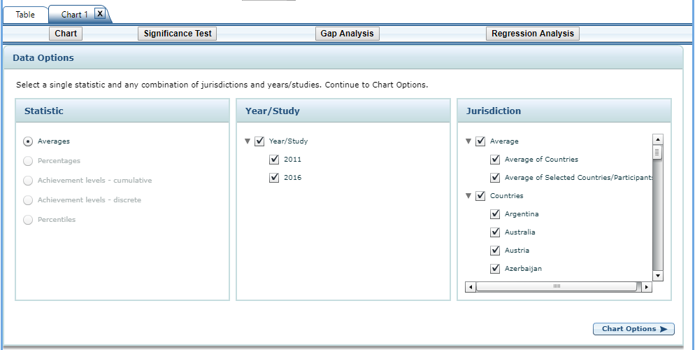

Exhibit 3-20 is a screenshot from the PIRLS IDE tool showing the data options available in the chart creating function in the Build Reports tab.

### 3.4.5 4.E. Create Charts—Chart Options

On the Chart Options screen, select **Bar Chart, Column Chart,** or **Line Chart** (see exhibit 3-21). For data on achievement levels, you also have the option of selecting a **Discrete** or **Cumulative Chart**.

After selecting a chart type, change any data dimensions from the drop-down menus for **Bar, Column,** or **Line Values** and **Values Grouped by.** Any new variables that you created at step 3, **Edit Reports**, will be available for selection, but only if you selected the variables (i.e., placed a check mark next to them) and clicked on **Done** after you edited the report.

Enter a **Chart Name** limited to 25 characters, using only letters, numbers, spaces, underscores, and hyphens (otherwise, the default name is “Chart 1”).

Preview your chart by clicking the **Preview** button in the lower right corner or go back to the data options and make different selections by clicking the **Data Options** button in the lower left corner.

Exhibit 3-21. Chart options 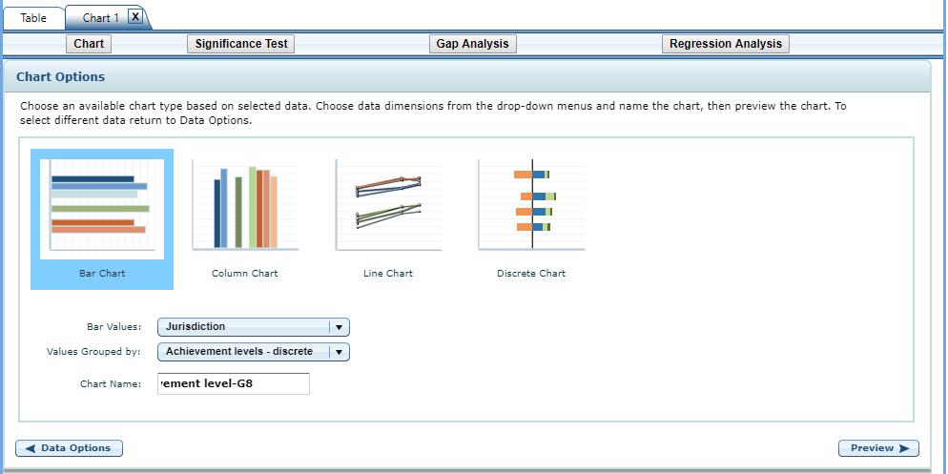

While previewing your chart, you can do the following (see exhibit 3-22 as an example of a **Discrete Chart** and exhibit 3-23 as an example of a **Bar Chart**):

1. Use the drop-down menus to change the jurisdiction and other variables as applicable. Notice that when you change your selection, the change occurs slowly enough that you get a sense of the size and direction of the change—particularly if you didn’t previously specify in the data dimensions how you want your values grouped.
2. For the **Discrete Chart,** you can select where you want the divider by clicking one of the achievement-level buttons above the bars. This makes it easier to compare the percentages at a given level(s). In the example shown in exhibit 3-22, the percentages of students at the high and advanced levels are shown to the right of the divider.
3. Place your cursor over the bars to see the data points and value label(s).
4. Choose between using colors or patterns for the bars by clicking the alternating **Pattern** or **Color** button located just below the **Chart** tab in the upper left portion of the screen. For the **Discrete Chart** and the **Cumulative Chart,** choose between **Color** or **Grayscale.**
5. Change the color of the bars with a single click on each level in the bars. That click brings up a thumbnail of a color chart. Click on the thumbnail to reveal a color grid, and then select the color you desire.
6. Change the pattern of the bars with a single click on each level in the bars. Continuous clicking brings up various patterns to choose from.

Exhibit 3-22. Preview of discrete chart

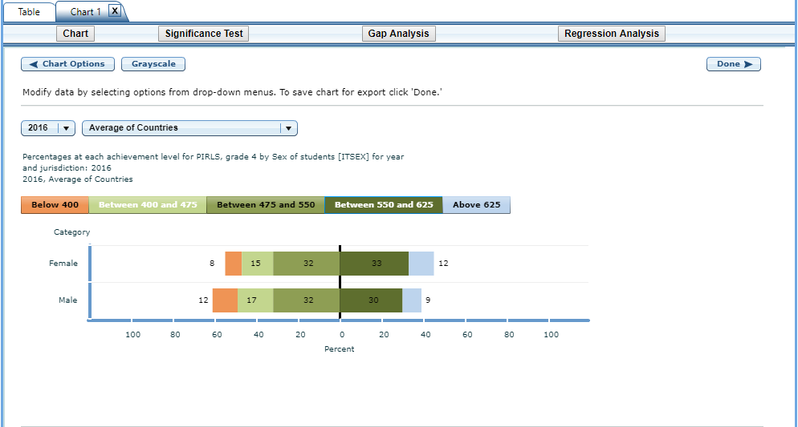

Exhibit 3-22 is a screenshot from the PIRLS IDE tool showing a preview of a discrete chart in the chart creating function in the Build Reports tab.

Exhibit 3-23. Preview of bar chart

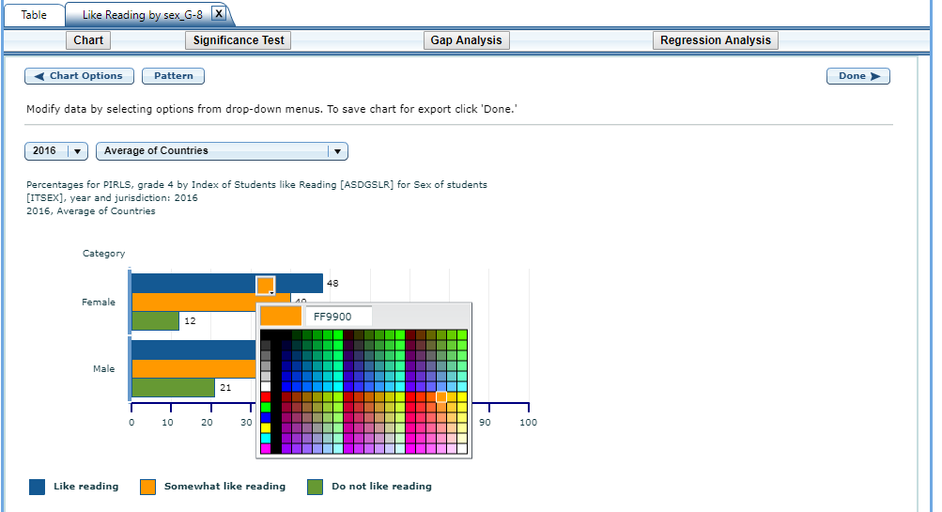

Exhibit 3-23 is a screenshot from the PIRLS IDE tool showing a preview of a bar chart in the chart creating function in the Build Reports tab.

Click the **Done** button located on the right side of the screen or click back to **Chart Options** and/or **Data Options** to change your selection criteria. You must click **Done** if you wish to later save and/or print your chart via **Export Reports**.

Clicking **Done** takes you to the exportable version of the chart (see exhibit 3-24). You can subsequently **“Click here to edit this chart”** (located in the upper left corner, below the **Chart** link) to make more changes. Alternatively, the entire chart area, if clicked, will take you to the edit screen.

Exhibit 3-24. Completed chart

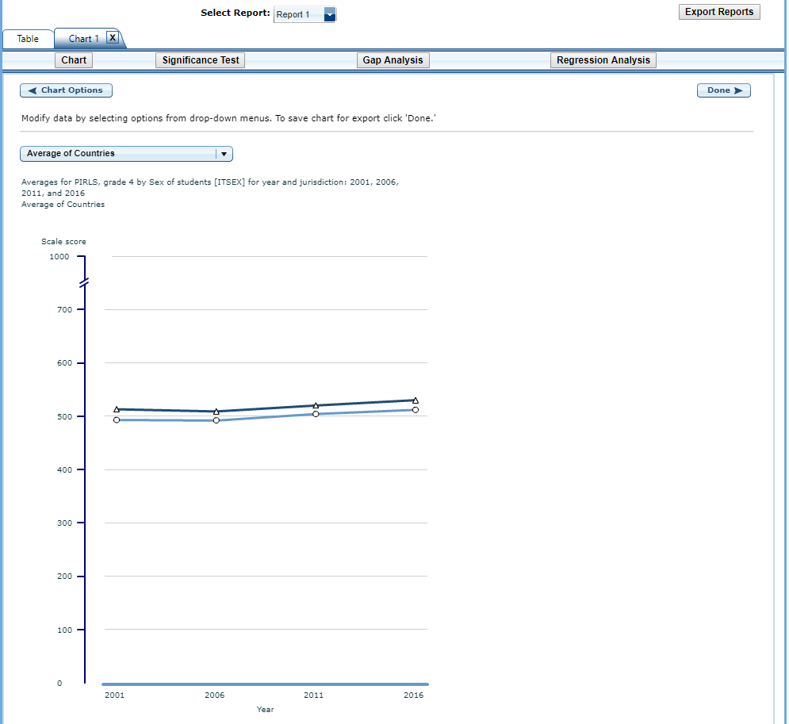

Exhibit 3-24 is a screenshot from the PIRLS IDE tool showing a preview of a completed chart in the chart creating function in the Build Reports tab.

To make an additional chart from the same report/table, click the Chart link to begin a new chart. It is recommended that you provide a new chart name (the default is Chart 1, Chart 2, etc.). If you don’t start the process again by clicking the Chart link, the new chart will overwrite the previous one.

If you wish to make charts from other reports, select “other report” in the **Select Report** drop-down list. If other reports were not checked in Step 3, **Edit Reports**, go back to step 3 and check the ones you want. Then, when you advance to step 4, **Build Reports**, the reports will appear in the **Select Report** drop-down list. If you need to create new reports, go back to step 1, **Select Criteria**, and/or step 2, **Select Variables**. Remember to export any completed charts you want to save by clicking **Done** and using the **Export Reports** function before leaving the **Build Reports** screen. (For further information, see Section 4.G. Export Reports, page 36.)

### 3.4.6 4.F. Significance Tests

Tests for statistical significance indicate whether observed differences between assessment results are likely to have occurred because of sampling error or chance. “Significance” here does not imply any judgment about absolute magnitude or educational relevance. It refers only to the statistical nature of the difference and whether that difference likely reflects a true difference in the population.

With your report of interest selected, click the **Significance Test** link, which is located to the right of the **Chart** link (see exhibit 3-24, above). You first need to decide which variable you want to test and the criterion by which you want to test it (i.e., within or between variable values or across years). You will compare or “look across” the variable’s range of values, so it must have more than one value. You can look across jurisdictions for a variable (that is, compare between two or more jurisdictions) or you can look across the values within a variable for a single jurisdiction. For example, with the variables shown in exhibit 3-25, you could choose to compare female scores between countries, or you could choose to compare male and female scores within a country. Once the primary criterion is chosen, all other criteria must be restricted to a single value.

The general steps for running significance tests are as follows (see exhibit 3-25):

1. In the **Significance Test** window, select either **Between Jurisdictions**, **Within Variables**, or **Across Years.** Then, select the appropriate jurisdiction(s), variable(s), and statistic(s). For **Between Jurisdictions**, select at least two jurisdictions. For **Within Variables**, select one or more jurisdictions. For **Across Years,** more than one year needs to be selected.
2. Enter a **Name** limited to 25 characters, using only letters, numbers, spaces, underscores, and **hyphens** (otherwise, the default name is “Sig Test 1”).
3. Select the **output** **type** as either **Table** or **Map**. The table option will show the significance test results as a matrix. The map option will show the significance test results on a world map, highlighting countries that have been selected. The map output is only available when “Between Jurisdictions” is selected in the first step.
4. Located under the output type, you can check **Show Score Details** to display the estimates and standard errors for the table cells. If you selected a map, this option is not applicable, as the map will automatically show score details.
5. Click the **Preview** tab located in the upper left corner of the screen or the **Preview** button located in the bottom left corner.
6. Click the **Edit** tab in the upper left corner of the screen if you wish to go back and make changes to the selections you made for running the significance tests.
7. Click the **Done** button in the upper or lower right corner of the screen to run the significance tests.

Exhibit 3-25. Significance test options

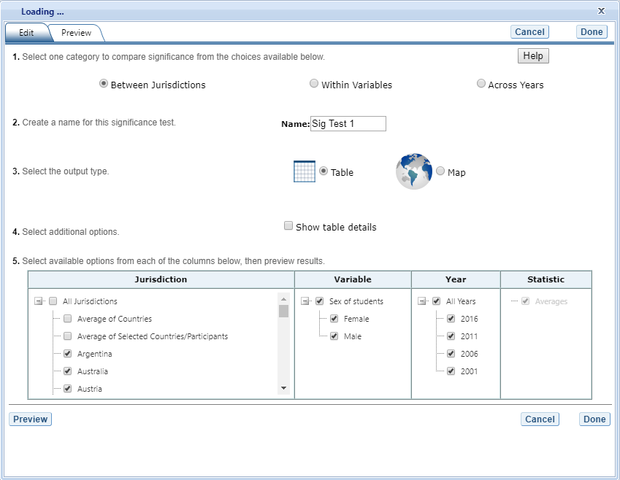

Exhibit 3-25 is a screenshot from the PIRLS IDE tool showing the significance test options available in the Build Reports tab.

When the table option is selected, you will get a significance test matrix in which you will see the differences and *p* values. Using the symbols shown in the legend of the matrix, an indication is also provided of whether one estimate is significantly lower or higher than another estimate or whether there is no significant difference (see exhibit 3-26).

The alpha level for all *t*-tests is .05. All comparisons within a jurisdiction, within the same year, are made using dependent *t*-tests. Comparisons between jurisdictions are treated as independent. Non-achievement comparisons across years are treated as independent. Comparisons of achievement across years are made using independent *t*-tests with a linking error taken into account. A part-whole adjustment is implemented for comparisons between a jurisdiction and a group that the jurisdiction is part of (e.g. Average of Countries).

Exhibit 3-26. Significance test table output

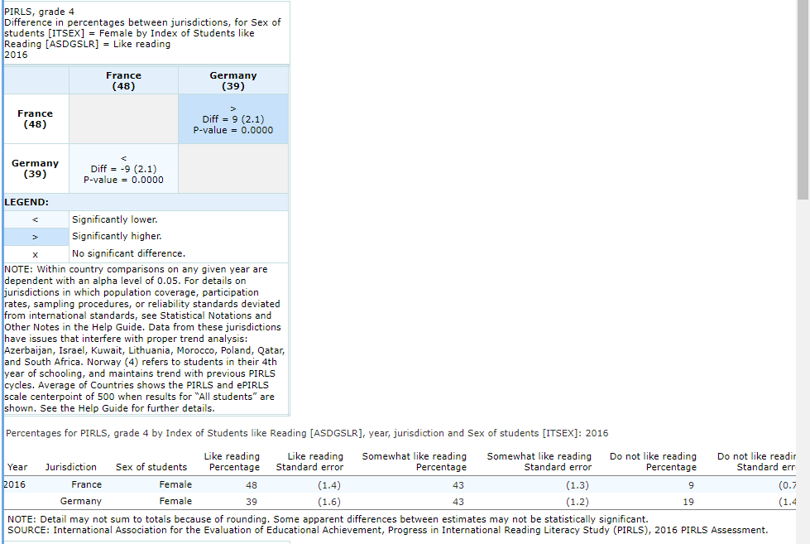

Exhibit 3-26 is a screenshot from the PIRLS IDE tool showing an example of a significance test table output in the Build Reports tab.

When the map option is selected, a global map is shown with the countries selected shaded (see exhibit 3-27). The focal jurisdiction is shaded in blue and represents a comparison for all the other countries. The other countries are shaded in colors that indicate whether they are higher, lower, or not significantly different from the focal jurisdiction on whatever measure has been selected. When you scroll over a country, a text bubble pops up describing the strength of the difference between that country and the focal jurisdiction. At any point you may choose a different focal jurisdiction by clicking on another country.

Exhibit 3-27. Significance test map output

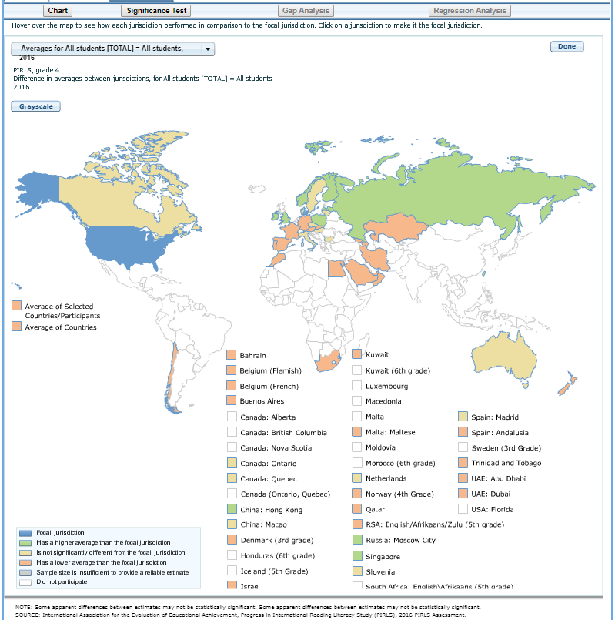

Exhibit 3-27 is a screenshot from the PIRLS IDE tool showing an example of a significance test map output in the Build Reports tab.

### 3.4.7 4.G. Gap Analysis

Gap Analysis is included in the IDE to compare differences in gaps shown in a map, table, or chart. These gap differences can be compared between jurisdictions and/or across years.

**Exhibit 3-28. Gap analysis link selection**

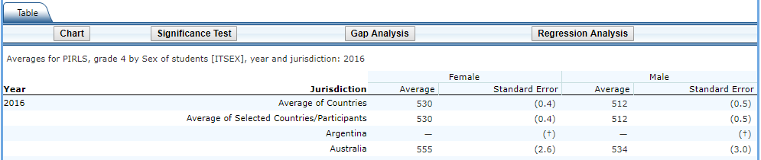

Exhibit 3-28 is a screenshot from the PIRLS IDE tool showing how to select the gap analysis function in the Build Reports tab.

With your report of interest selected, click on the **Gap Analysis** link, which is located to the right of the **Significance Test** link (see exhibit 3-28). You will need to decide which variable you would like to test (e.g., sex of students) and the criterion by which you want to test it (i.e., between jurisdictions or across years). The difference measure, or gap, can be viewed between groups, between years, between groups and years, or between percentiles within the selected variable. For example, if you compute average reading scores for two countries at two time points for males and females, you can:

* at one time point, compare the male-female gap in one country to the male-female gap in another country;
* compare the male-female gap at two time points within a country;
* compare the difference between the male-female gap at two time points in one country to the difference between the male-female gap at two time points in another country; or
* compare the gap for females at two time points in one country to the gap for females at two time points in another country.

**Exhibit 3-29. Gap analysis options**

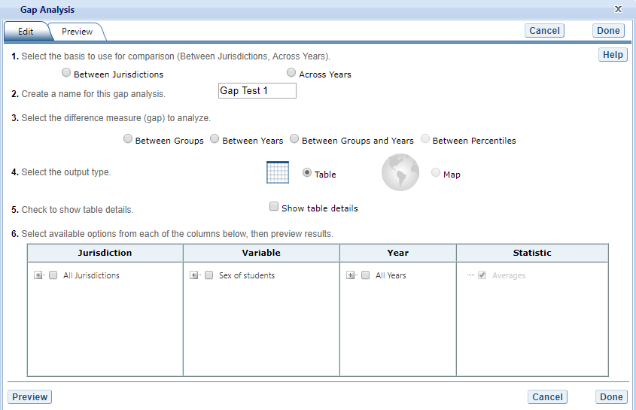

Exhibit 3-29 is a screenshot from the PIRLS IDE tool showing the gap analysis options available in the Build Reports tab.

The steps for running a gap analysis are similar to those for conducting a statistical significance test (see exhibit 3-29). Thus, to run a gap analysis, follow the instructions under section **4.F. Significance Tests**, noting the following differences:

1. The **Gap Analysis** link should be selected, not the **Significance Test** link.
2. The gap analysis does not have a **Within Variables** option for analysis; the options are **Between Jurisdictions** and **Across Years.**
3. The difference measure (gap) of analysis must be selected from the following: **Between Groups, Between Years, Between Groups and Years,** and **Between Percentiles** (if variables are selected for which a difference measure is not feasible, the difference measure option will not appear as available in the Gap Analysis menu).

The gap analysis output is presented in a format similar to that of the significance test output, with one difference: the difference estimate shown in the output is the difference between the gaps selected for analysis. Note that you will still see the significance of these differences just like in a significance test. For example, exhibit 3-30 shows the difference between jurisdictions in the average reading score gap between male and female 4th grade students in 2016.

The gap analysis function computes and statistically tests differences between average value/score, percentage, or percentile gaps. Note that the reference group for the gaps is kept constant during the analysis, as opposed to taking the absolute value of the gaps. Therefore, the gap analysis tests whether the magnitude of the gaps differ from each other only when the gaps go in the same direction (e.g., comparing a 5-point gender gap favoring females in one country with a 15-point gender gap favoring females in another country).

**Exhibit 3-30. Gap analysis output**

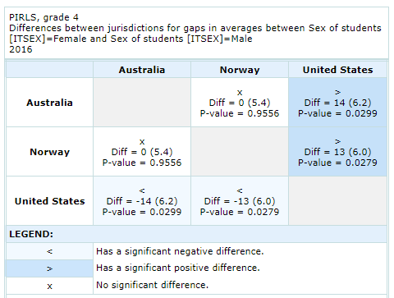

Exhibit 3-30 is a screenshot from the PIRLS IDE tool showing an example output report based on the gap analysis options.

**Note**: A gap analysis across years cannot be combined with the Between Years or Between Groups and Years difference measures, so you will select the difference measure Between Groups, or, if you have selected percentiles as one of your statistics, you may choose Between Percentiles.

### 3.4.8 4.H. Regression Analysis

Regression Analysis is included in the IDE to test for trends across more than two data points. The type of analysis performed in this feature of the IDE is referred to as linear regression within the field of statistics. To run a regression, first go to **Build Reports** and choose the report of interest from the drop-down **Select Report** menu. Then click on the **Regression Analysis** link, which is to the right of the **Gap Analysis** link (see exhibit 3-31).

**Exhibit 3-31. Regression analysis link selection**

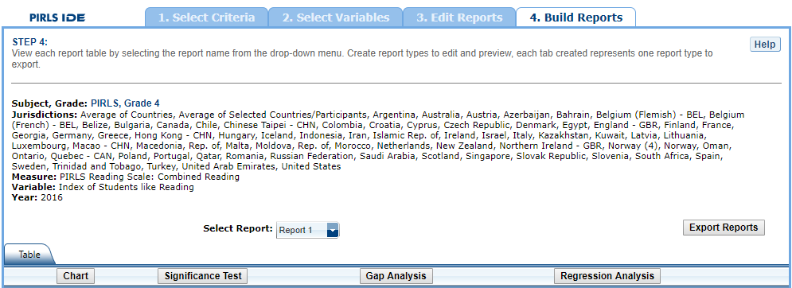

Exhibit 3-31 is a screenshot from the PIRLS IDE tool showing how to select the regression analysis function in the Build Reports tab.

The general steps for running a regression analysis are as follows (see exhibit 3-32):

1. In the **Regression Analysis** pop-up window, enter a **Name** limited to 25 characters, using only letters, numbers, spaces, underscores, and hyphens (otherwise, by default, the test will be named “Regression 1”).
2. Select the appropriate jurisdiction, year, and variable(s) for analysis. Please note that you may only choose one jurisdiction and year at a time, but you may choose up to 3 variables to be in your report. In order to use up to 3 variables, you must have already created and selected a cross-tabulated report (by selecting 3 variables in Step 2, **Select Variables**).
3. Click the **Preview** tab located in the upper-left corner to view the table format into which your output will be populated. In the Preview tab, an “X” denotes where the output will display.
4. Click the **Edit** tab in the upper-left corner of the screen if you wish to go back and make changes to the selections you made for running the analysis.
5. Click the **Done** button in the upper- or lower-right corner of the screen to run the regression analysis.

**Exhibit 3-32: Regression analysis options**

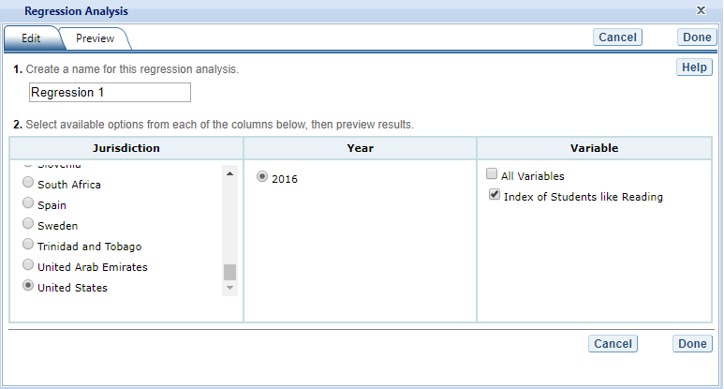

Exhibit 3-32 is a screenshot from the PIRLS IDE tool showing the options for the regression analysis output.

After you have clicked **Done**, your regression analysis output will load onto the screen (see exhibit 3-33). A 0-1 contrast coding is used to code the independent variable, where the first subgroup of the independent variable is the reference group. Using dummy-coded variables in a linear regression is useful for comparing each subgroup against a reference group. For example, in exhibit 3-33, if the subgroup "Like reading" is the reference group for the independent variable **Index of Students like Reading (2016) $ASDGSLR$** , the IDE creates a “Somewhat like reading” dummy variable (1 for respondents who answered “Somewhat like reading”, 0 otherwise), a “Do not like reading” dummy variable (1 for respondents who answered “Do not like reading”, 0 otherwise). Reference group “Like reading” is excluded from the regression analysis.

**Exhibit 3-33. Regression analysis output**

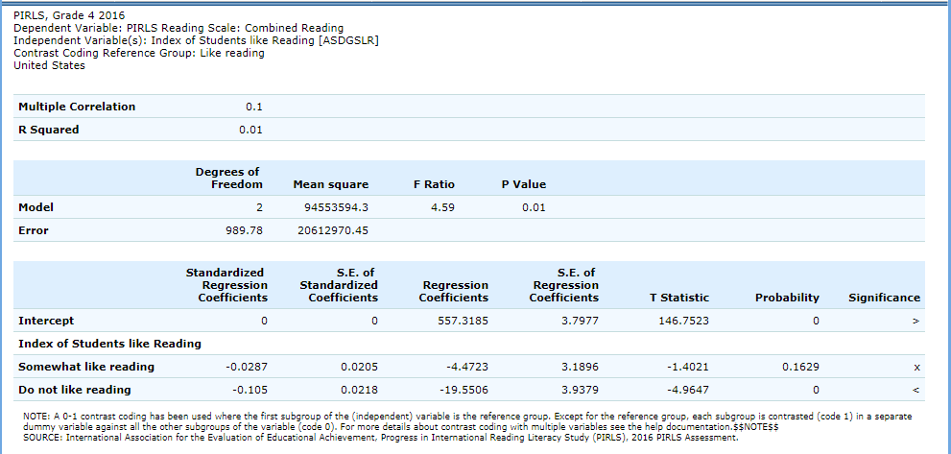

Exhibit 3-33 is a screenshot from the PIRLS IDE tool showing an example of the regression analysis output.

Using the output from exhibit 3-33 you can compare the mean reading score of 4th grade students who somewhat like reading or do not like reading to the mean reading score of those who like reading. When a single dummy-coded variable is used in a regression, the *intercept* is the mean of the reference group (e.g., 557.3185), and the *regression coefficient* is the difference between the mean of the reference group and the group identified (coded 1) with the dummy-coded variable (e.g., -4.4723 for Somewhat like reading). Since the regression coefficients are presented with a standard error and a *t* value, these can be used to test whether a difference between means is statistically significant. Under the Significance column in the output you will see 3 possible signs: 1) < signifies a significant negative difference, 2) > signifies a significant positive difference, and 3) x signifies the difference is not statistically significant.

### 3.4.9 4.I. Export Reports

Click on the **Export Reports** button/arrow located on the right side of the screen to save or print your tables, charts, and significance tests. The report names that appear in the **Export Reports** window are those that were checked off at step 3, **Edit Reports**.

Check the files you want to export, and select one of the file formats: **HTML** (print-friendly), **Excel, Word,** or **PDF** (see exhibit 3-34). All reports that you select at the same time will be exported in one file. In the Excel format, you will be able to increase the decimal places visible (wherever more precision is available in the database). Because there are many different operating systems in use, you may get an error message with Excel or one of the other formats. Usually, this will not affect your ability to export, so please wait for software “errors” to resolve themselves.

Charts for each report will only be available on this menu if you saved them by clicking **Done**  
on the last screen after you created them. If a chart that you wish to save or print is grayed out (not available for selection), cancel the **Export Reports** tool, go back to the chart, and be sure to click **Done** on the last screen. After that, it will be available for export.

Exhibit 3-34. Export report options

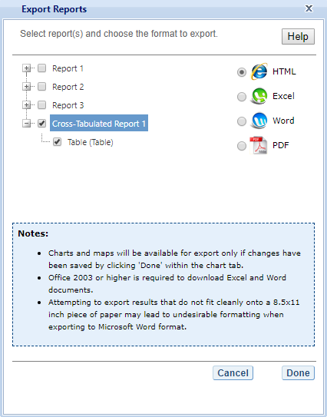

Exhibit 3-34 is a screenshot from the PIRLS IDE tool showing the export options, including HTML, Excel, Word, and PDF.

If you wish to edit tables or charts before saving or printing them, remember to do this via the **Export Reports** function before leaving the **Build Reports** screen. Returning to prior screens to edit report table formats or change variables or criteria will overwrite the report tables and charts.

# 4 TIMSS IDE Walkthrough

There are four general steps for exploring each IDE page (see exhibit 4-1). Each step is described in more detail in the following sub-sections.

Exhibit 4-1. What you will see in the IDE environment and what each step entails 

## *1. Select Criteria*

### 1.A. Overview

Your data query in the IDE (International Data Explorer) begins on the **Select Criteria** screen (see exhibit 4-2).

Choose one **Subject**, one **Grade**, and one or more **Measures**, **Years,** and **Jurisdictions** for the data you wish to view or compare.

Use the **Reset** button, located in the upper-right portion of the screen (just below the **Help** button), to cancel your selections and begin again.

Click on a red sideways-facing arrow (►) to open up a category and click on a red downward-facing arrow (▼) to close a category.

**Exhibit 4-2. Selecting criteria**

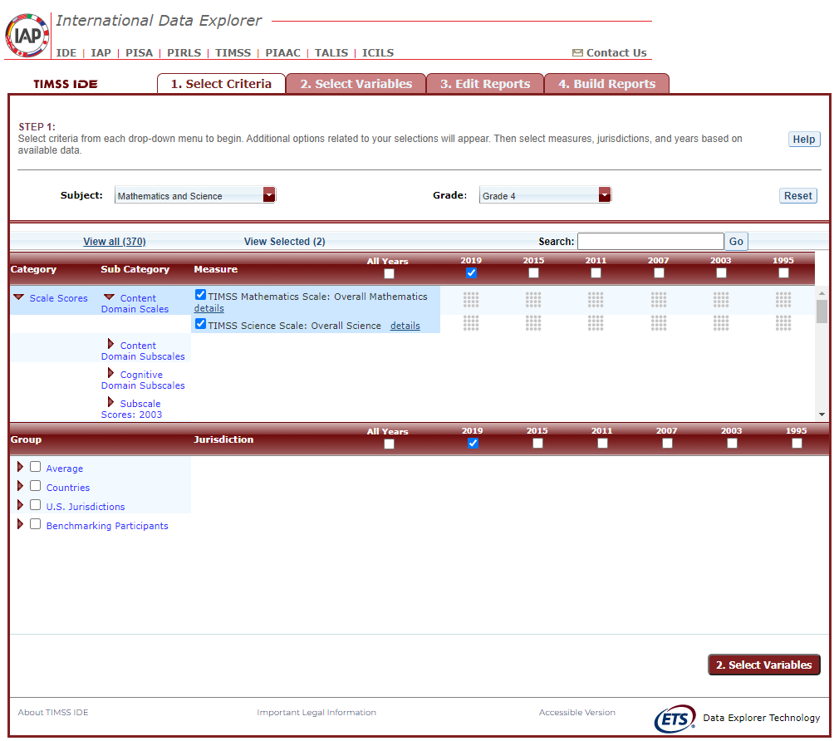

Exhibit 4-2 is a screenshot from the TIMSS IDE tool showing the Select Criteria tab.

### 1.B. Choose Subject

Under **Subject**, you have the choice of **Mathematics and Science**, **TIMSS Advanced: Advanced Mathematics**, or **TIMSS Advanced: Physics**.

### 1.C. Choose Grade

Under **Grade**, choose **Grade 4**, **Grade 8**, or **End of High School**. Once a grade is chosen, the screen resets and you can select **Year**(s), **Measure**(s), and **Jurisdiction**(s).

### 1.D. Choose Year

At the top of the **Measure** and **Jurisdiction** sections, you have the choice of selecting 2019, 2015, 2011, 2007, 2003, 1999, and/or 1995 by checking the appropriate box. To include data from all years, check the “All Years” box to the left of the individual years. Mathematics and science data are available for 2019, 2015, 2011, 2007, 2003, 1999, and 1995. In 1999, no data for grade 4 were collected in mathematics or science. Advanced mathematics and physics data are available for 2015 only.

### 1.E. Choose Measure

After choosing a subject, you can choose between the overall scale and/or any of the subject’s subscales. The overall scale and subscales can be used for trend analyses across years where applicable.

In addition, there are a number of continuous variables other than scale scores that you may choose as a measure of analysis. These variables fall under different categories, such as “Student and Family Characteristics” and “Teacher Background Characteristics, Formal Education, and Training” and include variables such as age, teaching experience, and class size.

### 1.F. Choose Jurisdiction

With your **Measure**(s) and **Year**(s) selected, next choose at least one **Jurisdiction**.

Jurisdictions are found under the following groups: **Countries**, **U.S. Jurisdictions**, and **Benchmarking Participants.** There is also a group category called **Average,** with options to display the **Average of Countries** and the **Average of Selected Countries/Participants. Average of Countries** displays the average statistic for all available jurisdictions under the “**Countries**” group, except when “**All students**” is selected at step 2, in which case **Average of Countries** displays the TIMSS scale centerpoint of 500.

The general procedures for selecting one or more jurisdictions are as follows:

1. To open or close jurisdictions, click on the arrow. Jurisdictions in the group are open and can be selected when the red arrow points down (see exhibit 4-3).
2. Click the checkboxes next to the specific jurisdictions that you are interested in, or uncheck those jurisdictions that you wish to deselect. If you click the checkbox next to the group name (e.g., “Countries”), you will select all the jurisdictions within that group. If desired, uncheck the group name to deselect all.
3. If you want to close a group (e.g., close the list of countries in order to readily see the benchmarking participants), click the red arrow next to the group name. The closed group’s arrow points to the right. Be advised that closing the group will not deselect your choices.

**Exhibit 4-3. Choosing jurisdictions** 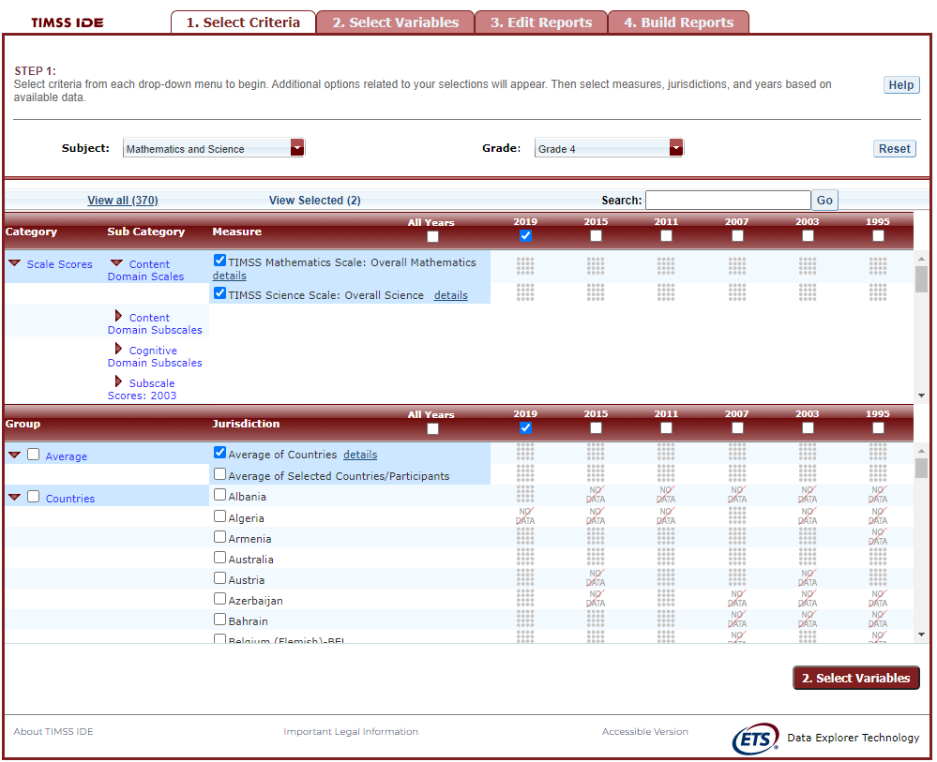

To continue in the IDE, click the **Select Variables** button at the bottom right of the page or the tab at the top of the page to go to the next screen (see exhibit 4-3).

## *2. Select Variables*

### 2.A. Overview

Step 2, **Select Variables,** can only be accessed after choosing criteria at step 1, **Select Criteria**.

To continue your data query and edit a report, you must choose at least one variable on this screen*.* You can browse for variables using the **Category** and **Sub Category** lists or by using the **Search** function (see exhibit 4-4). You can return to this screen to change variable selections at any time.

**Exhibit 4-4. Selecting variables overview**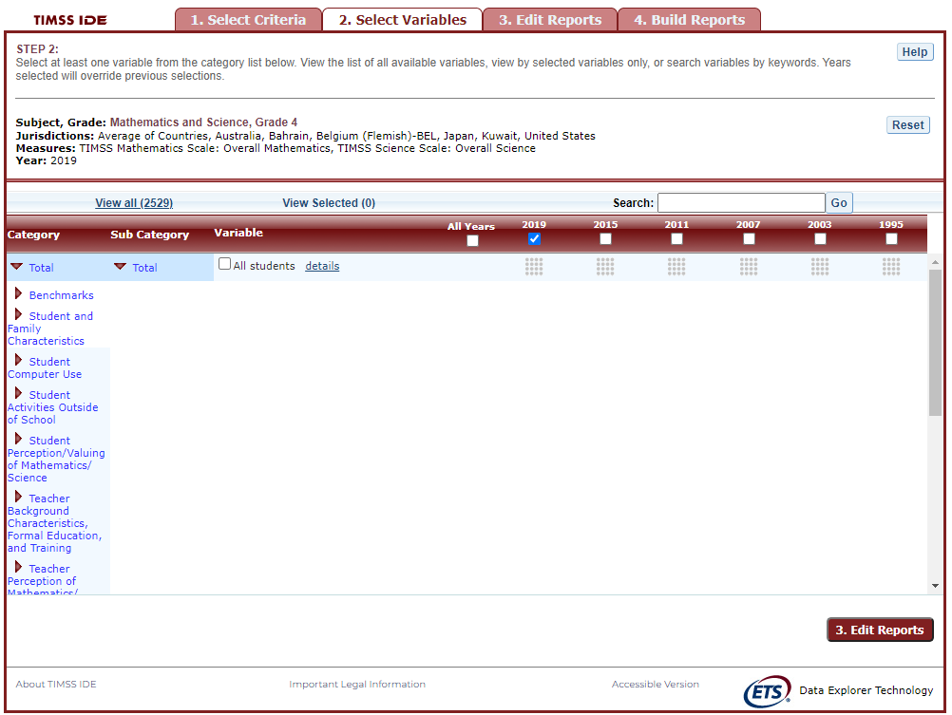

### 2.B. Search Using Category and Sub Category Lists

On the **Select Variables** screen, choose at least one variable for your report. One way to do this is to search for variables using the **Category** and **Sub Category** lists. If you don’t wish to choose from any of the specified categories and subcategories, select **All students** in the **Total** category.

The variables shown are tied to the criteria you selected at step 1 (**Subject, Grade,** **Jurisdiction, Measure,** and **Year**), which are indicated at the top of the screen. To change any of these criteria, return to step 1, **Select Criteria**.

To browse for variables, get details about them, select them, and view them:

1. Click the red arrows to open and close categories and subcategories of variables (see exhibit 4-5).
2. Click **details** or **hide details** to show or hide the full title of a given variable, the TIMSS ID, and the values (i.e., value labels). Note that some variables have the same or similar short titles, but comparing details will show you how they differ. See the example in exhibit 4-5 below, which shows two variables titled **Gen\speak language of test at home**. “Gen” refers to variables that are general cross-subject variables. The differences between these two variables are described in the details.
3. Click the checkbox next to a variable to select it for your analysis/report. You will see the count increase next to **View Selected**.
4. Click the **View Selected** tab to see the variables you have chosen. To return to the full list of variables by category, click the **View all** tab.
5. Remember to select the year for which you wish to build a report and make sure that data are available for your chosen year and variables.
6. Searching variables is an option from the **Search** box. See Section 2.C Search Function for more details about this function.

**Exhibit 4-5. Select variables using category and sub category lists**

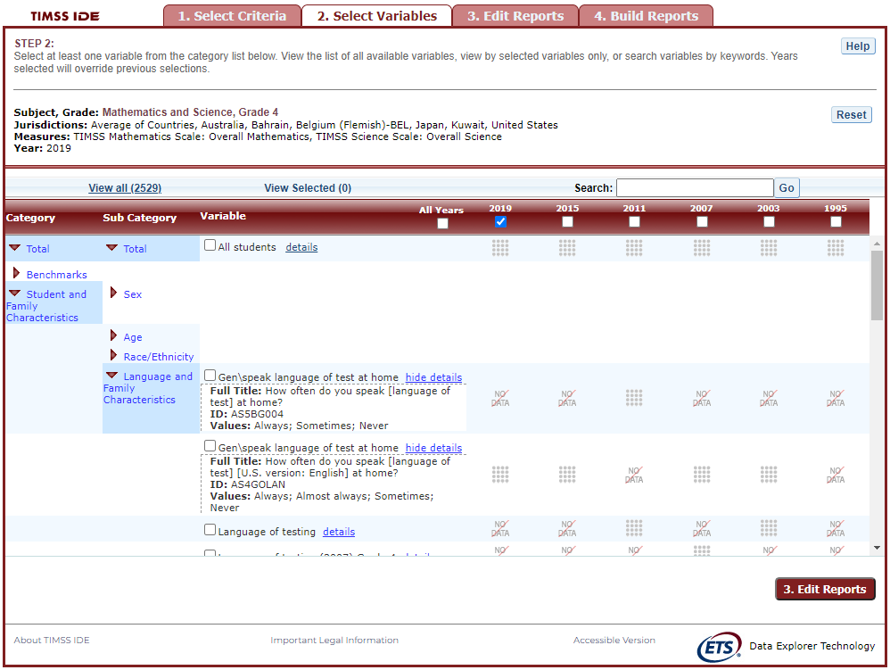

Exhibit 4-5 is a screenshot from the TIMSS IDE tool showing how to select a variable from the categories and sub categories listed in the Select Variables tab.

When you have selected the variable(s) you want to include, continue by clicking the **Edit Reports** button at the bottom of the page or the tab at the top of the page to go to the next screen.

### 2.C. Search Function

The second way to search for variables is to use the **Search** function on the **Select Variables** screen.

Type a term in the **Search** box and click **Go** (or hit “Enter” on your keyboard) to find variables by keywords in the question and/or details for the variable (see exhibit 4-6). If you use multiple keywords, “and” is assumed. You can narrow your search by using “or,” “not,” or “and not.” The search function operates on an exact phrase if it is contained in quotes. The variable(s) that include the search term(s) in the question or its details will be listed.

**Exhibit 4-6. Select variables using the search function**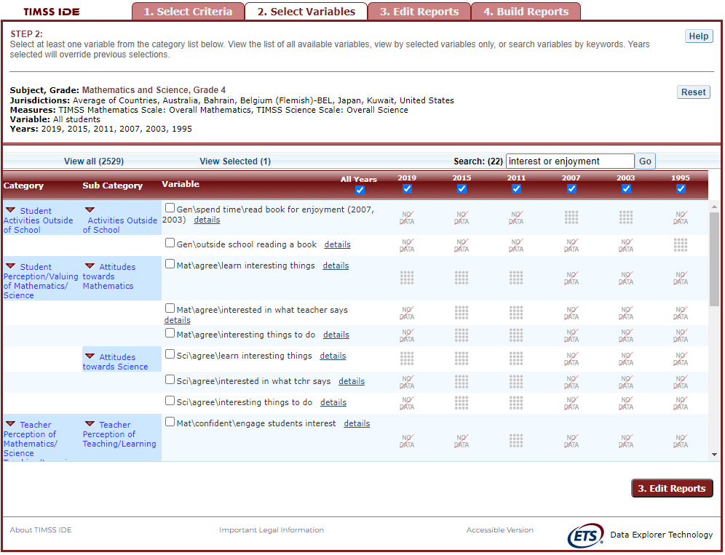

When you have selected the variable(s) you want to include, continue by clicking the **Edit Reports** button at the bottom of the page or the tab at the top of the page to go to the next screen.

## *3. Edit Reports*

### 3.A. Overview

You can access step 3, **Edit Reports,** after choosing criteria at step 1, **Select Criteria**, and choosing variables at step 2, **Select Variables**. The IDE will automatically build reports based on your selections from steps 1 and 2. However, at step 3, the **Edit Reports** phase, you may modify your selections for each report.

At this step, you can

* preview and edit the layout of your reports;
* copy reports or create new reports based on the variables selected;
* change formatting options, such as number of decimal places to display, for all reports (these may also be changed in individual reports, but format options can overwrite previous edits);
* change statistics options, such as averages, for all reports (these may also be changed in individual reports, but statistics options can overwrite previous edits);
* select reports to be built into tables and charts at step 4, **Build Reports**; and
* delete reports.

Using your chosen criteria, the IDE will return a separate data report for each variable you have chosen. If you have selected two or three variables (not counting **All students**), you will also see a cross-tabulated report for these variables. If you have chosen four or more variables, you will get tables for each variable, but you will not get the cross-tabulation. If your selected criteria include more than one measure (e.g., overall science scale and one or more science subscales or continuous variables), a separate set of data reports will be generated for each measure (see exhibit 4-7).

**Exhibit 4-7. Edit reports overview**

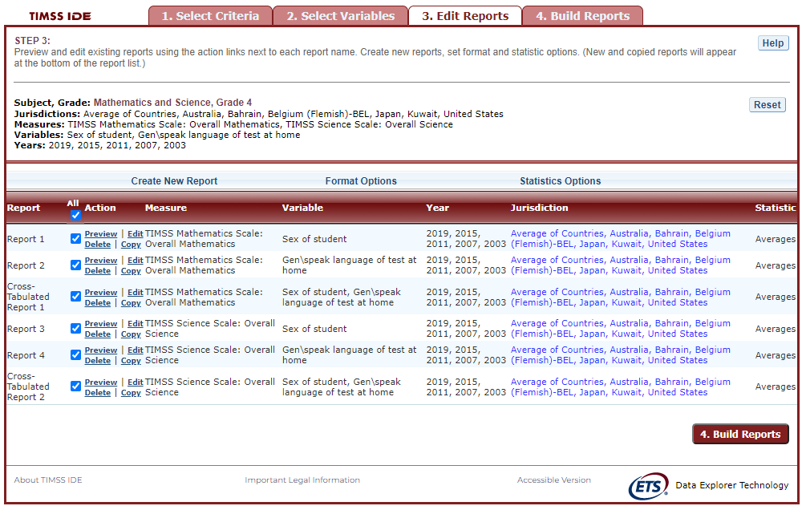

Exhibit 4-7 is a screenshot from the TIMSS IDE tool showing an overview of the Edit Reports tab.

The **Edit Reports** step shows detailed information on the layout of your reports. The **Report** column indicates the report, or cross-tabulation report, number based on the variable(s) chosen during the criteria selection. Under the **All** tab, reports may be chosen for the report-building phase, either by selecting **All** or selecting individual reports. The **Action** column gives you the option to **Preview**, **Edit**, **Delete**, or **Copy** the report. The **Measure** column shows which measure the report will portray. The **Variable** column indicates the variable(s) included in the report. The **Year** column shows which years you have selected for comparison. The **Jurisdiction** column shows the countries and subnational education systems selected for comparison, and the **Statistic** column provides the type of statistic output that will be generated in the report-building phase.

### 3.B. Preview Report

Select **Preview,** in the **Action** column (see exhibit 4-7), to see how your report will be laid out. The preview will not provide actual data, but will show how the data will be arranged in rows and columns (see exhibit 4-8). You can select **Preview** at any time to see how your changes will affect the report’s final layout.

**Exhibit 4-8. Using preview report**

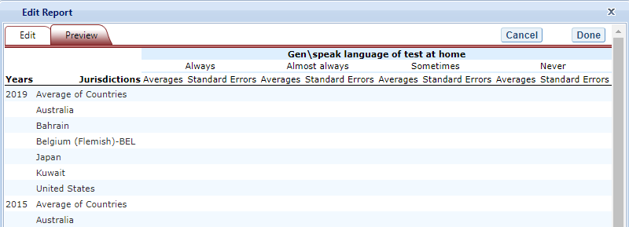

Exhibit 4-8 is a screenshot from the TIMSS IDE tool showing an example of the preview function that is available in the Edit Reports tab.

### 3.C. Edit Report

To edit the report, select the **Edit** command, in the **Action** column (see exhibit 4-7). (Another way to edit a report is to select the **Edit** tab when you are previewing a report.) The following can be done using the edit function (see exhibit 4-9):

1. Name your report. You have the option of giving each report a distinctive name, up to a limit of 50 characters, using only letters, numbers, spaces, underscores, and hyphens. (Otherwise, by default, the report is named Report 1, Report 2, etc., or Cross-Tabulated Report 1, Cross-Tabulated Report 2, etc.)
2. Select a measure. You can choose a measure if more than one was slected at step 1.
3. Select which jurisdictions, variables, years (if applicable), and statistics to include (out of the selections previously made at steps 1 and 2). You can select up to two statistics options from the following: averages, percentages, standard deviations, and percentiles. (For further information, see Section 3.G. Statistics Options.)
4. To create a new variable while editing a report, click on **Create New…** under the **Variable** heading. Section 3.D below explains the process for creating a new variable.
5. Change the table layout by dragging elements to determine which items will appear in rows and which will appear in columns. Some of the arrangements will not be permissible, but a pop-up alert will explain this.

**Exhibit 4-9. Editing reports**

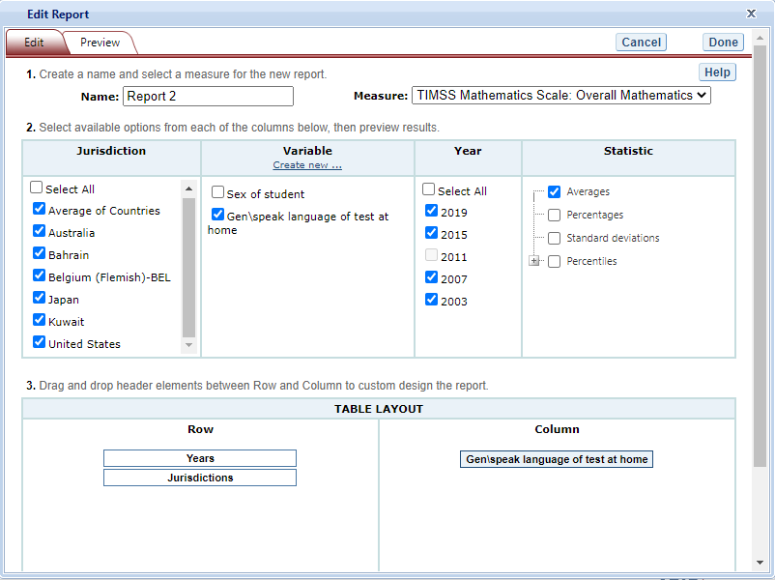

Exhibit 4-9 is a screenshot from the TIMSS IDE tool showing an example of the editing report function that is available in the Edit Reports tab.

To save changes, make sure to select **Done** in the upper-right portion of the screen before closing the **Edit Report** window.

### 3.D. Create New Variables

To create a new variable, select **Edit,** in the **Action** column, and select **Create new…** under **Variable** (see exhibit 4-9 above). The new variable is created by collapsing values for an existing variable. The steps are as follows:

1. Click **Create new...** under the **Variable** heading.
2. Select the variable for which you wish to collapse values.
3. Select the values you want to collapse by checking the boxes to the left of the values. In the example below (see exhibit 4-10a), “Always” and “Almost always” are checked
4. Create a name for the new value, and press **Create**. The collapsed values will appear in gray to indicate that they have already been used.
5. Repeat steps 3 and 4 to collapse other values if applicable. In the example below (see exhibit 4-10b), “Sometimes” and “Never” will be collapsed into “Sometimes or Never”. Note that it is also possible to leave “Sometimes” and “Never” uncollapsed, thus skipping step 5.
6. Press **Done** when the screen has refreshed.
7. The new variable will appear in the **Variable** list in the **Edit Report** window, designated as “collapsed.”
8. Check the box next to the new variable to view it in the report. You can click **Preview** to see how the table will be laid out before retrieving data.

**Exhibit 4-10a. Creating new variables**

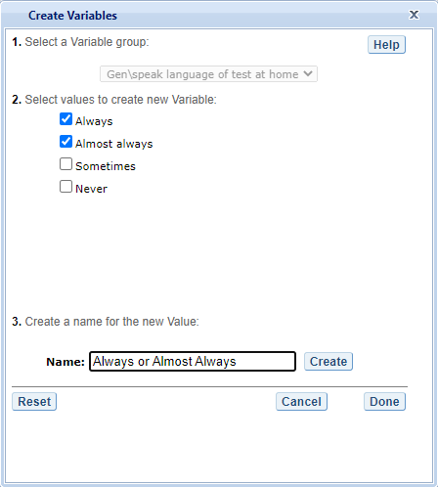

Exhibit 4-10a is a screenshot from the TIMS IDE tool showing an example of the creating new variable function that is available in the Edit Reports tab.

**Exhibit 10b. Creating new variables**

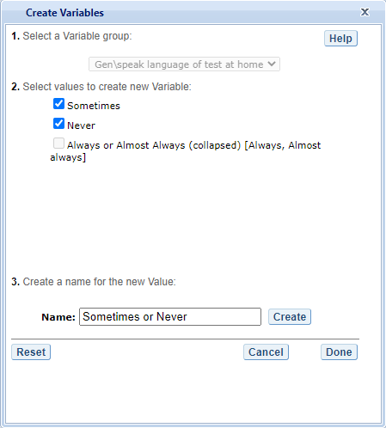

Exhibit 4-10b is a screenshot from the TIMSS IDE tool showing an example of how variables can be collapsed in the creating new variable function that is available in the Edit Reports tab.

A new variable that you create is applicable only to a specific report; it does not apply to the other reports listed on the **Edit Reports** screen. For example, if you selected multiple measures of science literacy for analysis, then you would need to create the new variable for each measure, or create a copy of the report and edit it accordingly. To do the latter, click on **Copy** report on the **Edit Reports** screen (copied reports appear at the end of the list of reports) and then, for the new copy, click on **Edit** (using the above example, you can change the measure and give the report a new name).

You can repeat the process and combine different values of a variable to create additional new variables. Using the **Create New Report** function, you can create a new report for each new variable that you create. (For further information, see section 3.E. Create New Report.)

If you selected two or three variables from which to create new variables, you can repeat the process for each of them. Using the **Create New Report** or **Edit Report** function, these collapsed variables will be listed and available for cross-tabulation (see exhibit 4-11). If you have chosen four or more variables (not counting **All Students**), you won’t get the cross-tabulation. You can click **Preview** to see how the table will be laid out before retrieving data.

**Exhibit 4-11. Edit reports with collapsed variables**

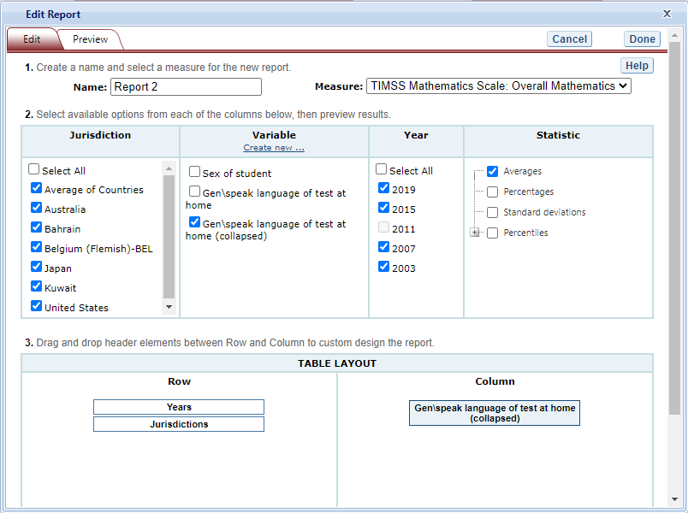

Exhibit 4-11 is a screenshot from the TIMSS IDE tool showing an example of the editing report with collapsed variables function that is available in the Edit Reports tab.

### 3.E. Create New Report

From the main **Edit Reports** screen, clicking on **Create New Report** brings up the same options as **Edit** **Report**, but with no checkboxes marked and without any new variables you may have created. Thus, **Create New Report** provides a clean slate for your selections from the first two steps, **Select Criteria** and **Select Variables** (see exhibit 4-12). Each new report you create will appear at the end of the list of reports. If you do not give the report a specific name, it will be called “New Report.”

**Exhibit 4-12. Creating new reports**

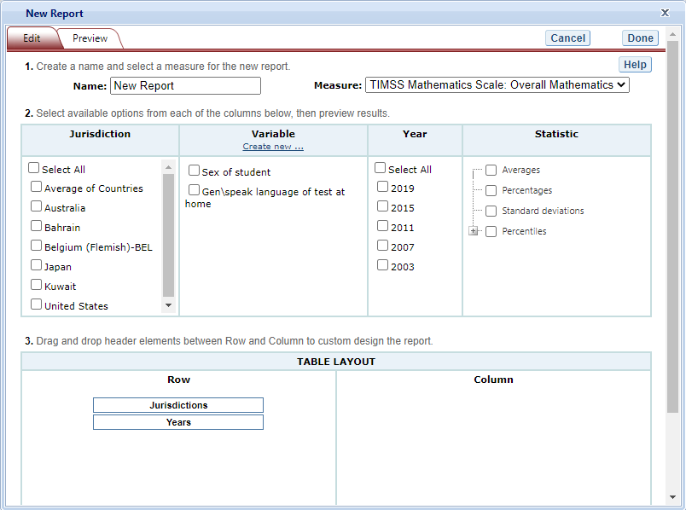

Exhibit 4-12 is a screenshot from the TIMSS IDE tool showing an example of the creating new report function that is available in the Edit Reports tab.

### 3.F. Format Options

From the main **Edit Reports** screen, clicking on **Format Options** will allow you to make formatting changes applicable to all the reports listed. The following formatting options are available using this function (see exhibit 4-13):

1. **Variable Labels** gives you the option to display a more detailed description of the variables selected in a query (**Long**) than the default label (**Short**). For variables from questionnaires, the full text of the question is displayed when **Long** is selected. Be advised that the length of the extra detail may sometimes interfere with table formatting.
2. **Show data for values categorized as Missing** will include the percentage of students in the total sample or in a reporting group for whom membership in a particular response category is unknown because no response was given by the students, their teacher, or their school. The percentage of “missing” will be shown in the right-most table column. Missing data are available only for queries that involve percentages as the statistic type. Unless you check this option, the default is for missing responses not to be included in the percentage distribution shown.
3. **Decimal Places** allows you to specify the level of precision for a particular statistic. Depending on the value range of the dependent variable (for example, the dependent variable “TIMSS Mathematics Scale: Overall Mathematics” ranges from 0 to 1000; the dependent variable “Students like learning mathematics scale $AS5BG071$” ranges from 4 to 13), the default decimal places for a report could be from zero to three. Also, standard errors will be shown to one more decimal place than is shown for a particular statistic. For example, if you request that average scores be displayed to one decimal place (by default, the average scores are displayed as whole numbers), the corresponding standard errors will be displayed to two decimal places. If you export to Excel, you will be able to increase the number of decimal places in most cases. Note that only integer-level precision is allowed for percentages; that is, the number of decimal places is fixed at “none” for percentages and the corresponding standard errors are shown to one decimal place.
4. **Include** gives you the option of showing standard errors. By default, standard errors are shown inside parentheses, but you have the option of choosing to show them without parentheses*.* You can preview the effects of your selection in the **Sample Display** area (see the blue-shaded box at the bottom of exhibit 4-13).

**Exhibit 4-13. Format options**

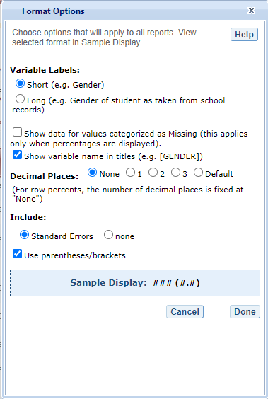

Exhibit 4-13 is a screenshot from the TIMSS IDE tool showing an example of the format options available in the Edit Reports tab.

Be advised that the choices you make in the **Format Options** window will apply to all reports and cannot be changed for individual reports. Use the **Reset** button, located in the upper-right portion of the main **Edit Reports** screen (just below the **Help** button), to restore the **Format Options** to the default settings (although caution is advised, as this will also delete any new reports that you have created).

### 3.G. Statistics Options

Available only from the main **Edit Reports** screen, clicking on **Statistics Options** allows you to designate up to two statistics. The selections you make are applicable to all the reports listed, although you can also change the statistics for an individual report when you edit it. (For further information, see Section 3.C. Edit Report.)

The following statistics options are available (see exhibit 4-14):

1. **Averages.** This statistic provides the average value for a selected continuous variable or score (i.e., overall score or subscale score). For the TIMSS assessment, student performance is reported on scales that range from 0 to 1,000. By default, the standard errors of the scores are shown in parentheses.
2. **Percentages.** This statistic shows the percentage of students as a row percentage. For example, if the first column lists countries, then each country will display its own percentage distribution across its row. By default, percentage distributions do not include missing data. For information on how to show data for values categorized as missing, see Section 3.F. Format Options.
3. **Standard deviations.** The standard deviation is a measure of how widely or narrowly dispersed scores are for a particular variable. Under general normality assumptions, 95 percent of the scores are within two standard deviations of the mean. For example, if the average score of a variable is 500 and the standard deviation is 100, it means that 95 percent of the scores in this variable fall between 300 and 700. The standard deviation is the square root of the variance.
4. **Percentiles.** This statistic shows the threshold (or cutpoint) score for the following:
   * 10th percentile—the bottom 10 percent of students
   * 25th percentile—the bottom quarter of students
   * 50th percentile—the median (half the students scored below the cutpoint and half scored above it)
   * 75th percentile—the top quarter of students
   * 90th percentile*—*the top 10 percent of students

**Exhibit 4-14. Statistics options**

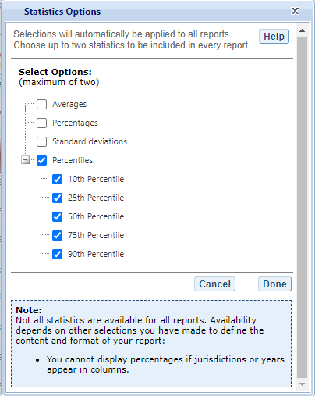

Exhibit 4-14 is a screenshot from the TIMSS IDE tool showing an example of the statistics options available in the Edit Reports tab.

As previously noted, the selections you make in **Statistics Options** will be applied automatically to all reports, although you can change the statistics for an individual report when you edit it. Be advised that if you use **Statistics Options** after editing the statistics in one or more of your individual reports, the statistics options selected will overwrite your previously edited selections. If you wish to use the same criteria and variables in a report with a different selection of statistics, consider using the **Create New Report** function to generate a new report with different statistics. (For further information, see Section 3.E. Create New Report.) You can also make a copy of an individual report.

You can use the **Reset** button, located in the upper-right portion of the main **Edit Reports** screen (just below the **Help** button), to restore the **Statistics Options** to the default setting, which is averages for all reports (this will also delete any new reports that you created).

Not all statistics are available for all reports. Their availability depends on other selections you have made to define the content and format of your report:

* Percentages will not display if jurisdictions or years appear in columns.
* If benchmarks are selected in the variable section, only average scores and percentages will be displayed.

Please note that results obtained from the IDE might not always match those published by the International Association for the Evaluation of Educational Achievement (IEA). This is due to the use of different reporting standards, such as suppression rules related to sample size, and suppression due to response rates. In addition, results published by the IEA using teacher data make use of all available teacher data for any one student, whereas results obtained from the IDE make use of only one teacher per student. In other words, in IEA published data, when a student has more than one teacher, the individual student weight is distributed evenly across all responding teachers of that student. In the IDE, under the same circumstances, the response of a single teacher is selected at random and assigned to the student. While the results are expected to be the same, there is some small variation due to the random selection of the teacher response. This affects results for teacher data, calculated for 4th and 8th graders, and is only noticeable in cases where students have multiple teachers.

### 3.H. Select Reports to Build

As you edit your reports, you can give them distinct names (up to 50 characters) to differentiate them, as well as make changes to the jurisdictions and variables previously selected, the statistics, and the layout of the rows and columns. (For further information, see section 3.C. Edit Report.) You may make copies of reports with these changes. In order to proceed to step 4, **Build Reports**, each report for which you want to retrieve data should be previewed using the **Preview** function. To decrease processing time as you move to step 4, you can uncheck any reports for which you do not wish to retrieve data. By default, all reports are checked. To uncheck one or more reports, you can either uncheck the reports individually or click on the **All** box. (Doing the latter will uncheck all of the reports and allow you to check only those for which you wish to retrieve data.) In the example that follows (see exhibit 4-15), data will be retrieved for all reports.

**Exhibit 4-15. Selecting reports to build**

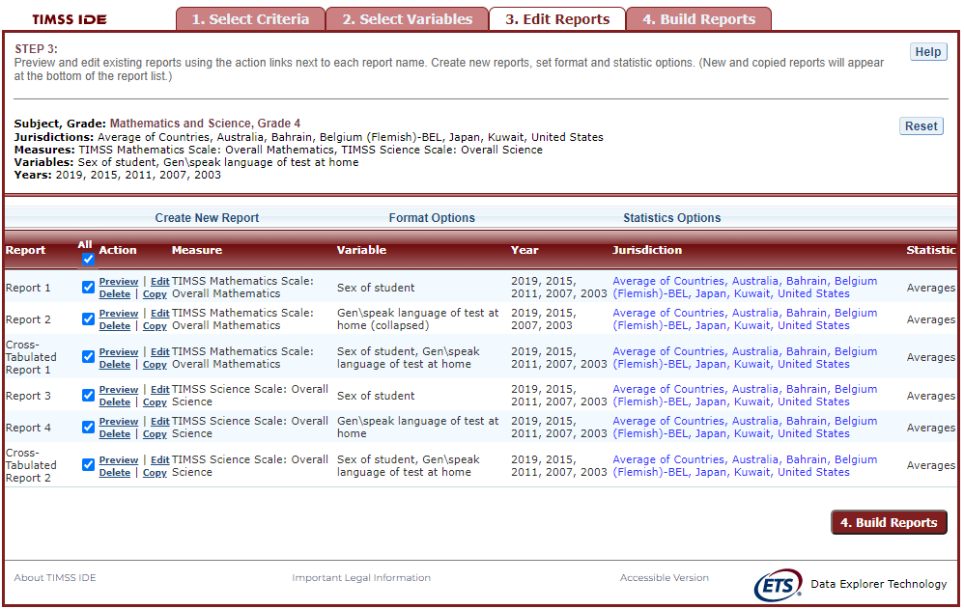

Exhibit 4-15 is a screenshot from the TIMSS IDE tool showing how to select reports to build in the Edit Reports tab.

If you wish to delete a report from the list of reports, click **Delete** (see 1 above) in the **Action** column. Use the **Reset** button (see 2 above), located in the upper-right portion of the screen (just below the **Help** button), to restore the deleted reports (although caution is advised, as this will also delete any new reports that you created and restore the **Format Options** and **Statistics Options** to the default settings).

To continue to the last step in the IDE, click the **Build Reports** button at the bottom of the page (see 3 above) or the tab at the top of the page to go to the next screen.

## *4. Build Reports*

### 4.A. Overview

You can access step 4, **Build Reports**, after choosing criteria at step 1, **Select Criteria**, in which case the default report built will provide data for just averages and for the **All Students** variable. After step 1, you may also go on to steps 2 and 3, where you can select additional variables and edit reports, before moving on to **Build Reports**. In **Build Reports**, you can do the following:

1. Generate a data table for each report, as shown in the **Select Report** drop-down feature (see 1 in exhibit 4-16). By default, all reports are checked, although you can uncheck any reports for which you do not wish to retrieve data. (For further information, see section 3.H. Select Reports to Build.)
2. Export and save data tables into various formats using the **Export Reports** button (see 2 in exhibit 4-16). The output formats include HTML (print-friendly), Microsoft Excel, Microsoft Word, and Adobe PDF.
3. Select the **Chart** tab (see 3 in exhibit 4-16) to create and customize charts for each report and save them for export in the above formats.
4. Select the **Significance Test** tab (see 4 in exhibit 4-16) to run a significance test on your results, customize it, and export it.

**Exhibit 4-16. Building reports overview**

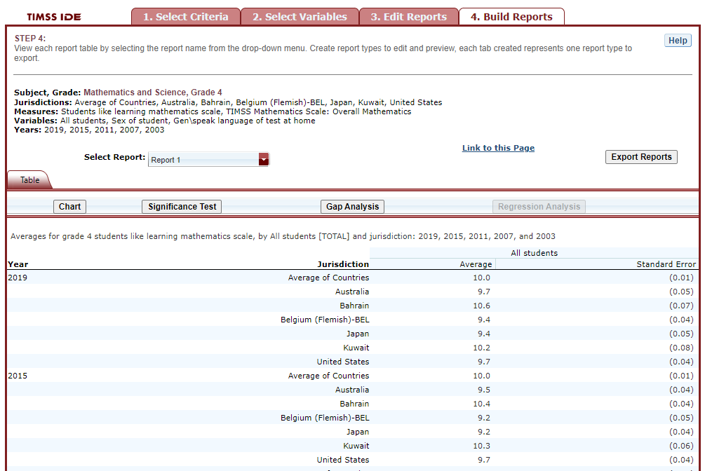

Exhibit 4-16 is a screenshot from the PIRLS IDE tool showing an overview of the Build Reports tab featuring the Select Report, Export Reports, Chart, and Significance Test options.

### 4.B. View Reports as Data Tables

Some reports will take longer than others to process, so please do not hit the “Back” button on your browser once you click on **Build Reports** (see exhibit 4-17). Your table will appear once the processing is complete. To select a different table to view, go to the **Select Report** drop-down menu (see 1 in exhibit 4-16) and choose the table of interest. To change the formatting or statistics options of a table or to generate a table from a report not included in your selection, return to step 3, **Edit Reports**.

**Exhibit 4-17. Processing data**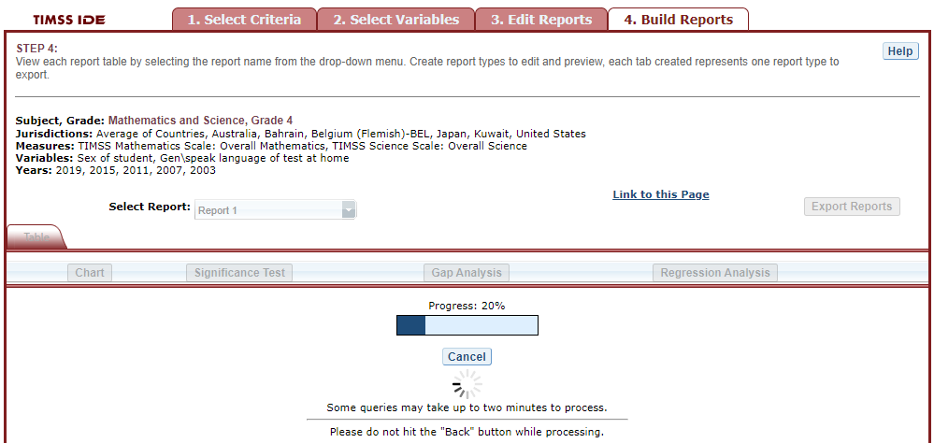

### 4.C. Charts

To create a chart, go to **Select Report** on the **Build Reports** screen to choose the report of interest from the drop-down menu, and then click the **Chart** link (see exhibit 4-18).

You will be able to create many types of charts and customize them. Section 4.E. Create Charts—Chart Options provides a summary of the available features and how they can be customized.

**Exhibit 4-18. Viewing reports as charts**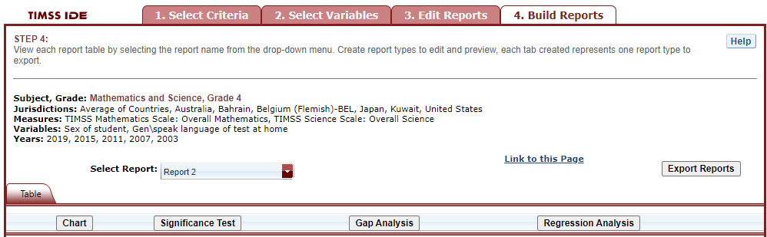

### 4.D. Create Charts—Chart Options

When you click **Chart,** your screen will present data options pertaining to **Jurisdiction, Year,** and **Statistic** (see exhibit 4-19). Only the statistics option(s) used to report data in the previous step will be presented, and only one statistics option can be selected at a time. For example, **Percentiles** will appear as the only data option to build the chart if the table created in the previous step is reporting data with only percentiles selected as the statistics option.

Below, you can select **Bar Chart, Column Chart,** or **Line Chart** (see exhibit 4-20). If all of the percentiles are chosen as the statistics option, you also have the option of selecting a **Percentile Chart**.

After selecting a chart type, change any data dimensions from the drop-down menus for **Bar**, **Column**, or **Line Values** and **Values Grouped by**. Any new variables that you created at step 3, **Edit Reports**, will be available for selection, but only if you selected the variables (by clicking the checkbox next to them) and pressed **Done** after you edited the report.

Once you are finished with the Chart Options, click the **Create Chart** button in the lower-right corner of the screen.

**Exhibit 4-19. Data options for charts**

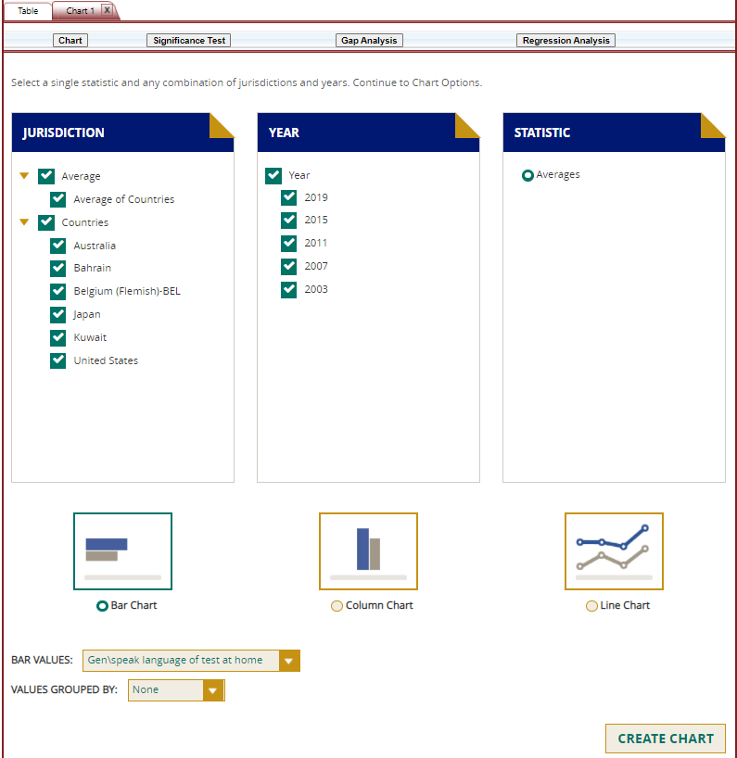

Exhibit 4-19 is a screenshot from the TIMSS IDE tool showing the data options available in the chart creating function in the Build Reports tab.

**Exhibit 4-20. Chart options**



Exhibit 4-20 is a screenshot from the TIMSS IDE tool showing the chart options available in the chart creating function in the Build Reports tab.

Clicking **Create Chart** takes you to the exportable version of the chart (see exhibit 4-21). You can subsequently click **“Back to Chart Options”** (located in the upper-left corner, below **Chart**) to make more changes.

**Exhibit 4-21. Completed chart**

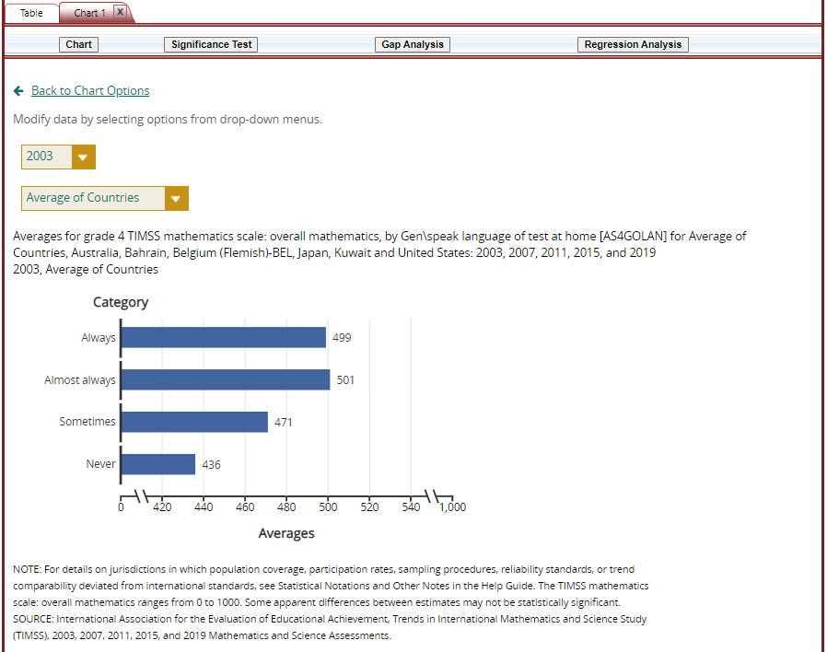

Exhibit 4-21 is a screenshot from the PIRLS IDE tool showing a preview of a completed chart in the chart creating function in the Build Reports tab.

To make an additional chart from the same report or table, click the **Chart** link on the **Build Reports** screen. If you don’t start the chart process again by clicking the **Chart** link, the new chart will overwrite the previous one.

If you wish to make charts from other reports, select another report in the **Select Report** drop-down list. (If other reports were not checked in step 3, **Edit Reports**, go back to step 3 and check the ones you want. Then, when you advance to step 4, **Build Reports**, the reports will appear in the **Select Report** drop-down list.) If you need to create new reports, go back to step 1, **Select Criteria**, and/or step 2, **Select Variables**. Remember to export any completed charts you want to save by using the **Export Reports** function before leaving the **Build Reports** screen. (For further information, see Section 4.H. Export Reports.)

### 4.E. Significance Tests

Tests for statistical significance indicate whether observed differences between estimates are likely to have occurred because of sampling error or chance. “Significance” here does not imply any judgment about absolute magnitude or educational relevance. It refers only to the statistical nature of the difference and whether that difference likely reflects a true difference in the population.

With your report of interest selected, click the **Significance Test** link, which is located to the right of the **Chart** link (see exhibit 4-16 and 4-21). You first need to decide which variable you want to test and the criterion by which you want to test it (i.e., between jurisdictions, within variables, or across years). You will compare or look across the variable’s range of values, so it must have more than one value. You can look across jurisdictions for a variable (that is, compare between two or more jurisdictions) or you can look across the values within a variable for a single jurisdiction. For example, with the variable shown in exhibit 4-22, you could choose to compare scores of female students between countries and subnational education systems, or you could choose to compare scores of female students and male students.

The general steps for running significance tests are as follows (see exhibit 4-22):

1. In the **Significance Test** window, select either **Between Jurisdictions**, **Within Variables**, or **Across Years**. Then, select the appropriate jurisdiction(s), variable(s), year(s), and statistic(s). For **Between Jurisdictions**, select at least two jurisdictions. For **Within Variables**, select at least two variable values. For **Across Years**, more than one year needs to be selected.
2. You can enter a **Name** limited to 25 characters, using only letters, numbers, spaces, underscores, and hyphens (otherwise, by default, the test is named “Sig Test 1”).
3. Select the output type as either **Table** or **Map**. The table option will show the significance test results as a matrix. The map option will show the significance test results on a world map, highlighting countries and subnational education systems that have been selected. The map output is only available when **Between Jurisdictions** is selected in the first step.
4. Additional options allow you to select **Show table details** to display the estimates and standard errors for the table cells. If you selected a map, this option is not applicable, as the map will automatically show score details.
5. Click the **Preview** tab located in the upper-left corner, or the **Preview** button located in the bottom-left corner.
6. Click the **Edit** tab in the upper-left corner of the screen if you wish to go back and make changes to the selections you made for running the significance tests.
7. Click the **Done** button in the upper- or lower-right corner of the screen to run the significance tests.

**Exhibit 4-22. Significance test options**

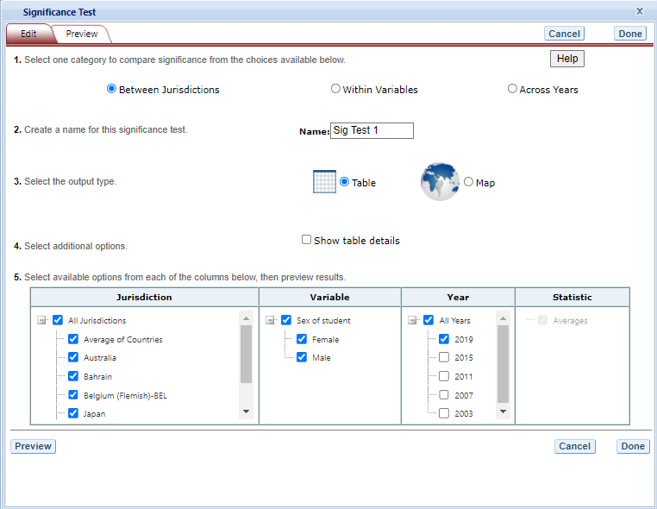

Exhibit 4-22 is a screenshot from the TIMSS IDE tool showing the significance test options available in the Build Reports tab.

When the table option is selected, you will get a significance test matrix in which you will see the differences and *p* values. Using the symbols shown in the legend of the matrix, an indication is also provided of whether one estimate is significantly lower or higher than another estimate or whether there is no significant difference (see exhibit 4-23).

The alpha level for all *t*-tests is .05. All comparisons within a jurisdiction, within the same year, are made using dependent *t*-tests. Comparisons between jurisdictions are treated as independent. Non-achievement comparisons across years are treated as independent. Comparisons of achievement across years are made using independent *t*-tests with a linking error taken into account. A part-whole adjustment is implemented for comparisons between a jurisdiction and a group that the jurisdiction is part of (e.g. Average of Countries).

**Exhibit 4-23. Significance test table output**

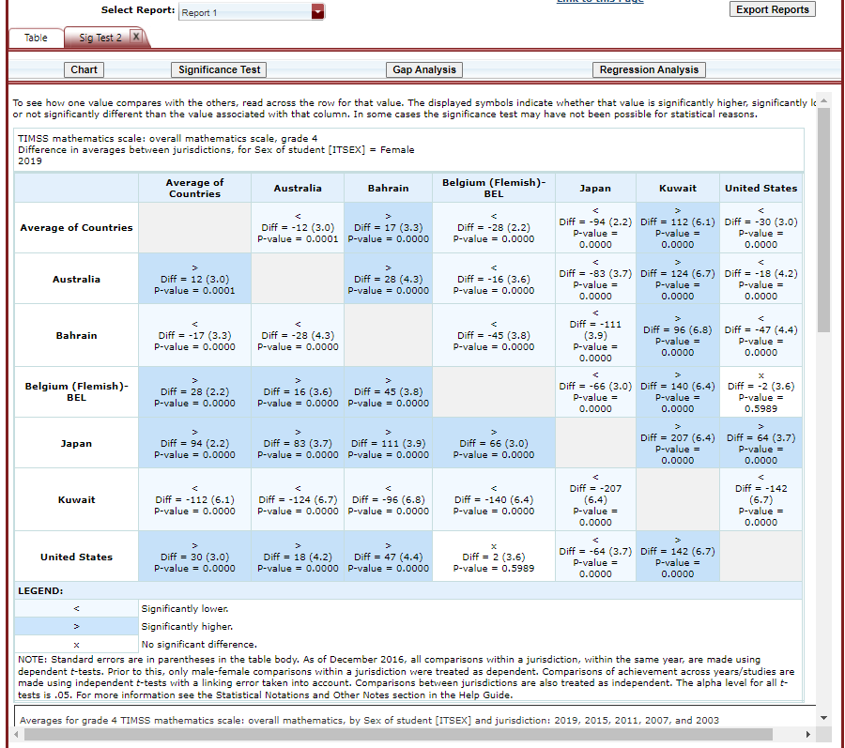

Exhibit 4-23 is a screenshot from the TIMSS IDE tool showing an example of a significance test table output in the Build Reports tab.

When the **map option** is selected, a global map is shown with the countries and subnational education systems that were previously selected shaded (see exhibit 4-24). The focal jurisdiction is shaded in green, with all other countries compared to it. The other countries are shaded in colors that indicate whether they are higher, lower, or not significantly different from the focal jurisdiction on whatever measure has been selected. (Note that grey is the default color for countries not selected for comparison.) When you hover over a country, a text bubble pops up indicating the point estimates for that country and the focal jurisdiction. At any point, you may choose a different focal jurisdiction by clicking on another country.

**Exhibit 4-24. Significance test map output**

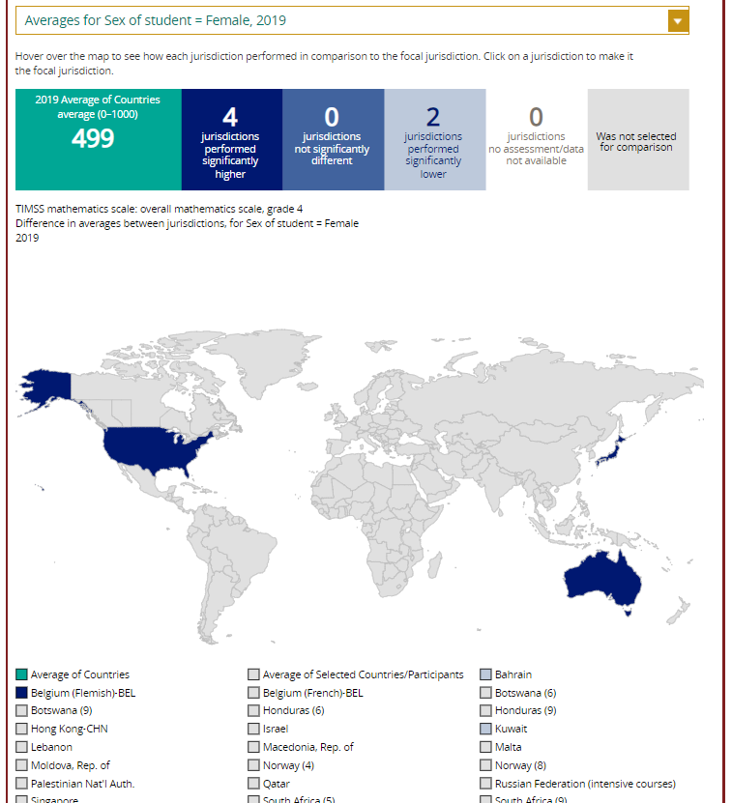

Exhibit 4-24 is a screenshot from the TIMSS IDE tool showing an example of a significance test map output in the Build Reports tab.

### 4.F. Gap Analysis

Gap Analysis is included in the IDE to compare differences in gaps shown in a map, table, or chart. These gap differences can be compared between jurisdictions and/or across years.

**Exhibit 4-25. Gap analysis link selection**

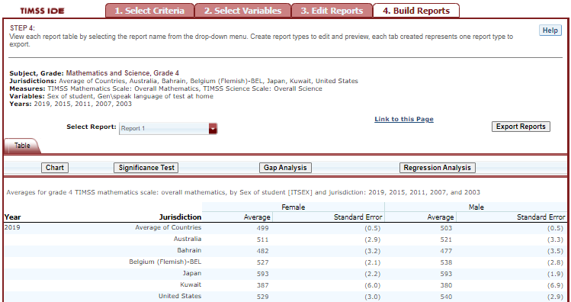

Exhibit 4-25 is a screenshot from the TIMSS IDE tool showing how to select the gap analysis function in the Build Reports tab.

With your report of interest selected, click on the **Gap Analysis** link, which is located to the right of the **Significance Test** link (see exhibit 4-25). You will need to decide which variable you would like to test (e.g., gender) and the criterion by which you want to test it (i.e., between jurisdictions or across years). The difference measure, or gap, can be viewed between groups, between years, between groups and years, or between percentiles within the selected variable. For example, if you compute average mathematics scores for two countries at two time points for males and females, you can:

* at one time point, compare the male-female gap in one country to the male-female gap in another country;
* compare the male-female gap at two time points within a country;
* compare the difference between the male-female gap at two time points in one country to the difference between the male-female gap at two time points in another country; or
* compare the gap for females at two time points in one country to the gap for females at two time points in another country.

**Exhibit 4-26. Gap analysis options**

![Exhibit 4-26 is a screenshot from the TIMSS IDE tool showing the gap analysis options available in the Build Reports tab.(images/chapter4/image26.png){width=“6.5in” height=“5.030555555555556in”}

The steps for running a gap analysis are similar to those for conducting a statistical significance test (see exhibit 4-26). Thus, to run a gap analysis, follow the instructions under section **4.E. Significance Tests**, noting the following differences:

1. The **Gap Analysis** link should be selected, not the **Significance Test** link.
2. The gap analysis does not have a **Within Variables** option for analysis; the options are **Between Jurisdictions** and **Across Years.**
3. The difference measure (gap) of analysis must be selected from the following: **Between Groups, Between Years, Between Groups and Years,** and **Between Percentiles** (if variables are selected for which a difference measure is not feasible, the difference measure option will not appear as available in the Gap Analysis menu).

The gap analysis output is presented in a format similar to that of the significance test output, with one difference: the difference estimate shown in the output is the difference between the gaps selected for analysis. Note that you will still see the significance of these differences just like in a significance test. For example, exhibit 4-27 shows cross-national differences between male-female score gaps among 8th grade students.

The gap analysis function computes and statistically tests differences between score, percentage, or percentile gaps. All gap comparisons are made using independent samples *t*-tests with an alpha level of 0.05. Note that the reference group for the gaps is kept constant during the analysis, as opposed to taking the absolute value of the gaps. Therefore, the gap analysis tests whether the magnitude of the gaps differ from each other only when the gaps go in the same direction (e.g., comparing a 5-point gender gap favoring females in one country with a 15-point gender gap favoring females in another country).

**Exhibit 4-27. Gap analysis output**

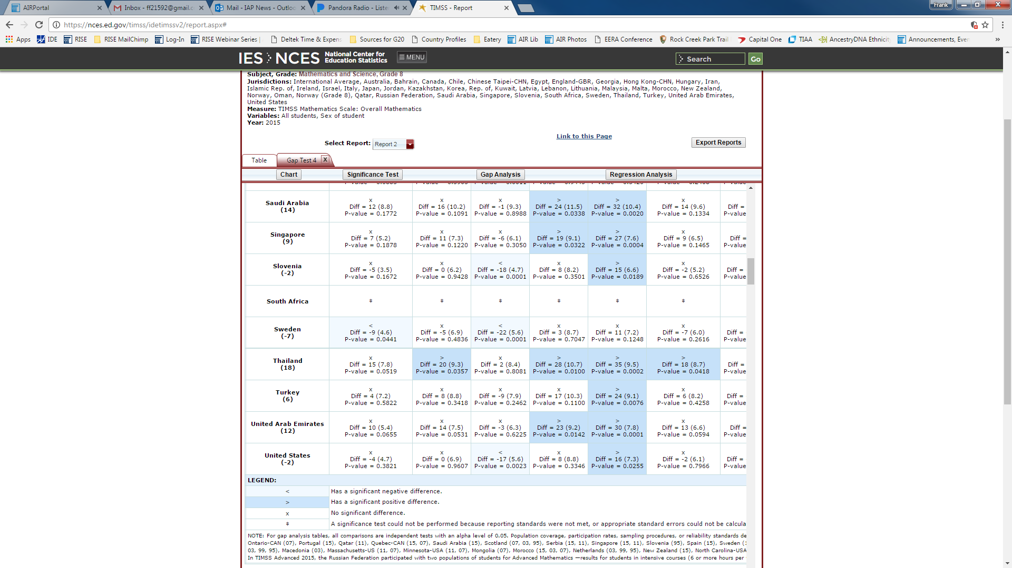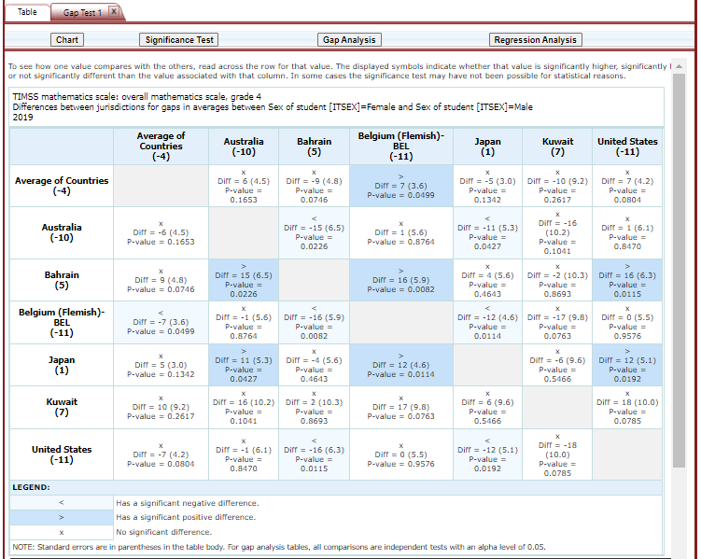

Note that a gap analysis across years cannot be combined with the Between Years or Between Groups and Years difference measures, so you will select the difference measure Between Groups, or, if you have selected percentiles as one of your statistics, you may choose Between Percentiles.

### 4.G. Regression Analysis

Regression Analysis is included in the IDE to test for the relationship between one or more independent variables with a dependent variable, with the independent variables controlling for each other. The type of analysis performed in this feature of the IDE is referred to as linear regression, with the dependent variable being a continuous variable selected at step 1.

**Exhibit 4-28. Regression analysis link selection**

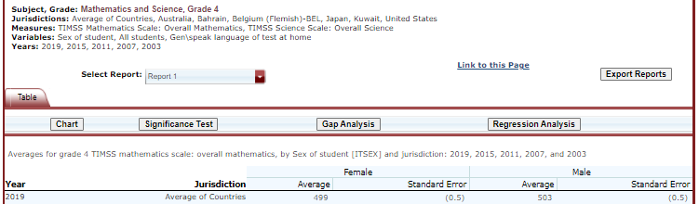

Exhibit 4-28 is a screenshot from the TIMSS IDE tool showing how to select the regression analysis function in the Build Reports tab.

A regression analysis can be performed based on the selections that were made to build your table in the IDE by selecting the **Regression Analysis** button above the table (see Exhibit 4-28). The **Measure**, or continuous variable, that you selected in Step 1 and that is displayed in your table will automatically become your dependent variable for the regression analysis (in Exhibit 4-28 this is “TIMSS Mathematics Scale: Overall Mathematics”). Please note that continuous variables cannot be used as independent variables. The variables that you selected in Step 2 and that are displayed in your table will become your independent variable options for the regression analysis (in Exhibit 4-28 this is “Sex of student”).

The general steps for running a regression analysis are as follows (see exhibit 4-29):

1. In the **Regression Analysis** pop-up window, you can enter a **Name** limited to 25 characters, using only letters, numbers, spaces, underscores, and hyphens (otherwise, by default, the test will be named “Regression 1”).
2. Select the appropriate jurisdiction, year, and variable(s) for analysis. Please note that you may only choose one jurisdiction and year at a time, but you may choose up to 3 independent variables to be in your report. In order to use up to 3 variables, you must have already created and selected a cross-tabulated report (by selecting 3 variables in Step 2, **Select Variables**).
3. Click the **Preview** tab located in the upper-left corner to view the table format into which your output will be populated. In the Preview tab, an “X” denotes where the output will display.
4. Click the **Edit** tab in the upper-left corner of the screen if you wish to go back and make changes to the selections you made for running the analysis.
5. Click the **Done** button in the upper- or lower-right corner of the screen to run the regression analysis.

**Exhibit 4-29. Regression analysis options**

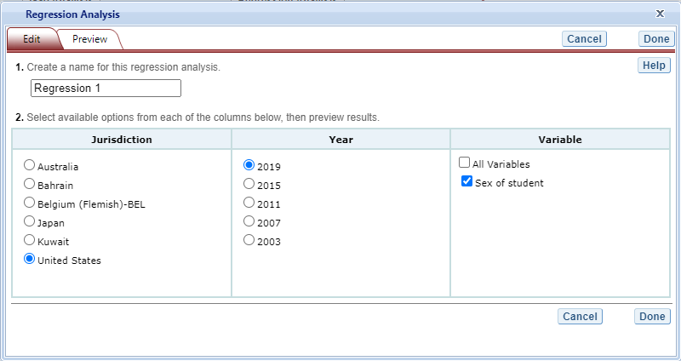

Exhibit 4-29 is a screenshot from the TIMSS IDE tool showing the options for the regression analysis output.

After you have clicked **Done**, your regression analysis output will load onto the screen (see exhibit 4-30). A 0-1 contrast coding is used to code the independent variable, where the first subgroup of the independent variable is the reference group. Using dummy-coded variables in a linear regression is useful for comparing each subgroup against a reference group. For example, in exhibit 4-30, if the subgroup “Female” is the reference group for the independent variable **Sex of student $ITSEX$** , the IDE creates a “Male” dummy variable (1 for respondents who answered “Male”, 0 otherwise). Reference group “Female” is excluded from the regression analysis.

**Exhibit 4-30. Regression analysis output**

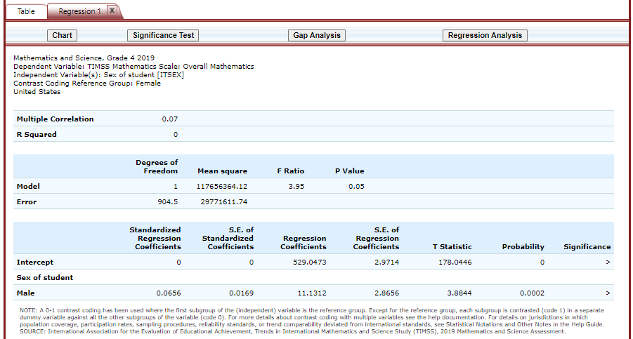

Exhibit 4-30 is a screenshot from the TIMSS IDE tool showing an example of the regression analysis output.

Using the output from exhibit 4-30 you can compare the average mathematics achievement of 8th grade students who are female to the average mathematics achievement of 8th grade students who are female. When a single dummy-coded variable is used in a regression, the *intercept* is the mean of the reference group (e.g., 529.0473), and the *regression coefficient* is the difference between the mean of the reference group and the group identified (coded 1) with the dummy-coded variable (e.g., 11.1312 for students who are Male). Since the regression coefficients are presented with a standard error and a *t* value, these can be used to test whether a difference between means is statistically significant. Under the Significance column in the output you will see 3 possible signs: 1) < signifies a significant negative difference, 2) > signifies a significant positive difference, and 3) x signifies the difference is not statistically significant.

### 4.H. Export Reports

Click on the **Export Reports** button located on the right side of the **Build Reports** screen to save or print your tables, charts, and significance tests. The report names that appear in the **Export Reports** window are those that were checked off at step 3, **Edit Reports**.

Check the files you want to export, and select one of the file formats: **HTML** (print-friendly), **Excel, Word,** or **PDF** (see exhibit 4-31). All reports that you select at the same time will be exported in one file. In the Excel format, you will be able to increase the visible decimal places visible wherever more precision is available. Because there are many different operating systems in use, you may get an error message with Excel or one of the other formats. Usually, this will not affect your ability to export, so please wait for the software “errors” to resolve.

Charts or maps for each report will only be available on the **Export Reports** menu if you saved them by clicking **Done** when you finished each one. If a chart or map that you wish to save or print is grayed out (not available for selection), cancel the **Export Reports** tool, go back to your chart or map, and be sure to click **Done** on the last screen. After that, it will be available for export.

**Exhibit 4-31. Export report options**

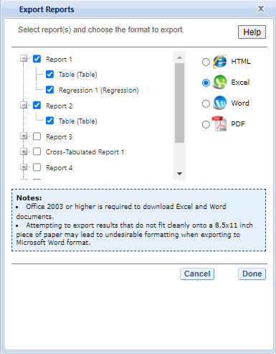

Exhibit 4-31 is a screenshot from the TIMSS IDE tool showing the export options, including HTML, Excel, Word, and PDF.

# 5 PIAAC IDE Walkthrough

There are four general steps for exploring each IDE page (see exhibit 5-1). Each step is described in more detail in the following sub-sections.

Exhibit 5-1. What you will see in the IDE environment and what each step entails 

## 5.1 1. Select Criteria

### 5.1.1 1.A. Overview

Your data query in the PIAAC IDE begins on the Step 1. **Select Criteria** screen (see exhibit 5-2, on next page).

Select a **Display** from the drop-down menus. Once the screen resets, you can choose one or more of the years and studies or **All Years/Studies**, **Measures,** and **Jurisdictions** for the data you wish to view or compare. Use the **Reset** button, located in the upper-right portion of the screen (just below the **Help** button), to clear selections and start over.

Click on a blue sideways-facing arrow (►) to open up a category, and click on a blue downward-facing arrow (▼) to close a category.

Exhibit 5-2. Selecting criteria

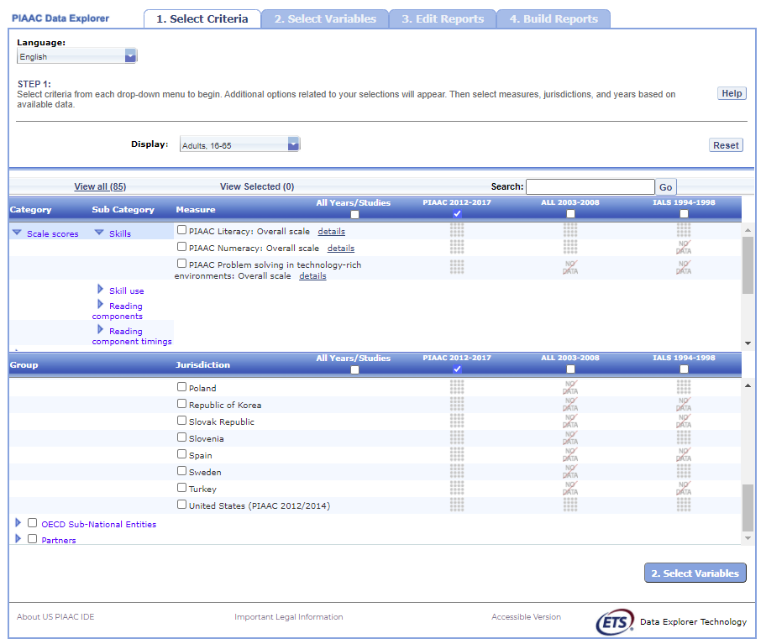

Exhibit 5-2 is a screenshot from the PIAAC IDE tool showing the Select Criteria tab.

### 5.1.2 1.B. Display

Under **Display**, choose one of the three different NCES PIAAC IDE adult sample populations:

**U.S. Adults, 16–74 (Household and Prison):** This display contains U.S.-only comparable data from the PIAAC, including the 2017 U.S. Household Data (for ages 16–74, and 16–65), combined 2012 and 2014 U.S. Household Data (for ages 16–74, and 16–65), and Prison Data (for ages 16–74).

**Young Adults, 16–34**: This display contains internationally comparable data from the  
3 international rounds of PIAAC (2012–2017 for all countries, except the U.S. which combined 2012–2014 data only) Household Data, ages 16–34. This display does not include the 2017 U.S. Household Data.

**Adults, 16–65**: This display contains internationally comparable data from the  
3 international rounds of PIAAC (2012–2017 for all countries, except the U.S. which combined 2012-2014 data only) Household Data, ages 16–65. This display does not include the 2017 U.S. Household Data.

Once a display is chosen, the screen resets and you can select one or more of the years and studies or **All Years/Studies**, **Measure**(s), and **Jurisdiction**(s).

### 5.1.3 1.C. Choose Year/Study(s)

In the same horizontal bar as the **Measure** and **Jurisdiction** sections, you have the choice of selecting **PIAAC 2017** and/or **PIAAC 2012/14** by checking the appropriate box if the Display chosen is **U.S. Adults, 16–74 (Household and Prison)**. You have the choice of selecting **PIAAC 2012–2017**, **ALL 2003–2008**, and/or **IALS 1994–1998** if the **Display** chosen is **Adults, 16–65**, or **Young Adults, 16–34**. To include data from all studies, check the **All Years/Studies** box to the left of the individual year and study options.

### 5.1.4 1.D. Choose Measure(s)

After choosing a **Display**, you can choose a **Measure** within the **Select Criteria** tab. Note that the **PIAAC overall scales** are the default and you can select more than one overall scale although analysis for each scale will be done separately. You can browse for other reporting scales using the **Category** and **Sub Category** lists or by using the **Search** function.

There are a number of continuous variables other than scale scores that you may choose as a measure of analysis. These variables are generally continuous variables from the international and U.S. national background questionnaires (such as earnings or hours of work per week) and derived variables from PIAAC, ALL, and IALS. Derived variables from PIAAC include indices of literacy, numeracy, and computer use at work and at home and imputed years of formal education, among others. Analysis of the continuous variables in terms of the continuous literacy, numeracy and problem solving TRE scale scores is not possible, but it is possible to analyze the continuous variables in terms of the literacy, numeracy, and problem solving proficiency level variables available in the list of **Variables**. For example, one cannot analyze the average number of hours of work per week in relationship to score, but one can analyze the average number of hours of work per week for adults at each proficiency level.

**Percentage across full sample**: The adults in the sample population that did not answer the assessment will be displayed along with those that did answer the assessment if you select the **Percentage across full sample** measure under the **Population** category and **Population** subcategory.

**Reading components**: There is a separate reporting scale for the Reading Components domain of the PIAAC survey. The Reading Components domain is used to measure literacy at the very low end of the spectrum, with components such as sentence completion, passage comprehension, and vocabulary. This domain was given to respondents who decided not to take the computer-based assessment or who did not pass a set of core information and computer technology tasks and failed a set of core literacy/numeracy tasks.

### 5.1.5 1.E. Choose Jurisdiction(s)

With your **Measure**(s), one or more of the years and studies or **All Years/Studies** selected, next choose at least one **Jurisdiction.**

Jurisdictions are found under **OECD National Entities**, **OECD Sub-National Entities** and **Partners.**

There is also a group category called **International**, with options to display the **Average of All Jurisdictions** and the **Average of the Selected Jurisdictions.** Please note that selecting **Average of All Jurisdictions** or **Average of the Selected Jurisdictions** increases the frequency of receiving an error message in the **Build Reports** step due to the high volume of information contained in these groups.

The general procedures for selecting one or more jurisdictions are as follows:

1. To open groups of jurisdictions, click on the arrow (►). Jurisdictions in the group are open and can be selected when the blue arrow points down (▼) (see exhibit 5-3).
2. Click the checkboxes next to the specific jurisdictions that you are interested in, or uncheck those jurisdictions that you wish to deselect. If you click the checkbox next to the group name (e.g., “**OECD National Entities**”), you will select all the jurisdictions within that group. If desired, uncheck the group name to deselect all.
3. If you want to close a group (for example, close the list of **OECD National Entities** jurisdictions in order to readily see the **OECD Sub-National Entities** jurisdictions), click the blue arrow pointing down (▼) next to the group name. The closed group’s arrow will now point to the right (►). Be advised that closing the group will not deselect your choices.

* NOTE: The U.S. Adults 16–74 (Household and Prison) Display only includes data for the United States. The U.S. Household (16–74 years old), U.S. Prison (16–74 years old), and U.S. Household (16–65) are the only selections available in the **Jurisdiction** menu. However, users may choose to work with the U.S. prison sample, or one of the U.S. household samples, or select more than one for analysis as jurisdictions.

Exhibit 5-3. Choosing jurisdictions

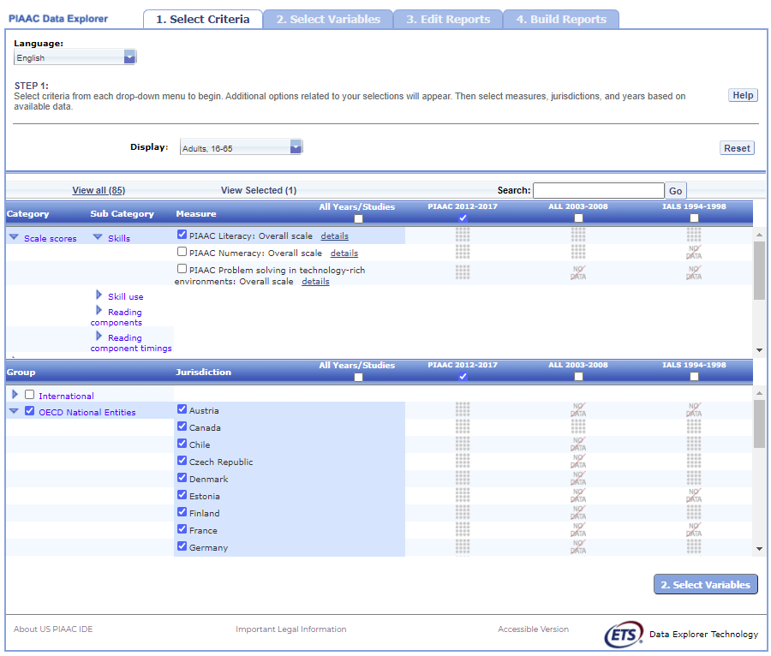

Exhibit 5-3 is a screenshot from the PIAAC IDE tool showing jurisdictions available in the Select Criteria tab.

To continue in the IDE, click the **Select Variables** button at the bottom right of the page or the tab at the top of the page to go to the next screen (see exhibit 5-3).

## 5.2 2. Select Variables

### 5.2.1 2.A. Overview

Step 2, **Select Variables,** can only be accessed after choosing criteria at step 1, **Select Criteria**.

To continue your data query and edit a report, *you must choose at least one variable on this screen.* You can browse for variables using the **Category** and **Sub Category** lists or by using the **Search** function (see exhibit 5-4). You can return to this screen to change variable selections at any time.

Exhibit 5-4. Select variables overview

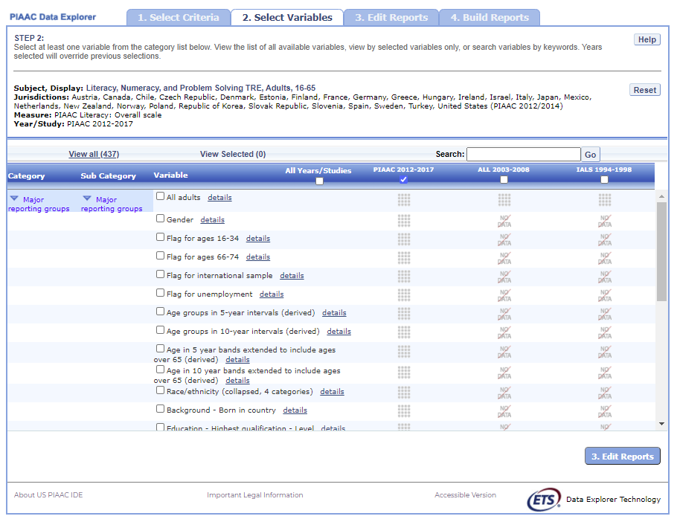

Exhibit 5-4 is a screenshot from the PIAAC IDE tool showing an overview of the Select Variables tab.

### 5.2.2 2.B. Search Using Category and Sub Category Lists

On the **Select Variables** screen, choose at least one variable for your report. One way to do this is to search for variables using the **Category** and **Sub Category** lists.

If you do not wish to choose from any of the specified categories and subcategories, then select **All adults** in the **Major reporting groups** sub category.

The variables shown are tied to the criteria you selected at step 1 (**Measure,** one or more of the years and studies or **All Years/Studies** selected**,** and **Jurisdiction**), which are indicated at the top of the screen. To change any of these criteria, return to step 1, by clicking on **Select Criteria**.

To browse for variables, get details about them, select them, and view them:

1. Click the blue arrows to open and close categories and subcategories > of variables (see exhibit 5-5).
2. Click **details** or **hide details** to show or hide the full title > of a given variable, the PIAAC ID (e.g., GENDERR), and the values > (i.e., variable labels). Note that some variables have the same or > similar short titles, but comparing details will show you how they > differ. See the example in exhibit 5-5, which shows **Last job - > Employee or self-employed** and **Last Job - Economic sector.** > The differences between these two variables are described in the > details.
3. Click the checkbox next to a variable to select it for your > analysis/report. You will see the count increase next to **View > Selected** that appears above the Variable list.
4. Click the **View Selected** tab to see the variables you have > chosen. To return to the full list of variables by category, click > the **View All** tab to the left of the **View Selected** tab.
5. Click **Reset** button in the upper-right portion of the screen if > you wish to deselect all the selected variables.

* NOTE: Remember to select the year/study for which you wish to build a report and make sure that data are available for your chosen year/study and variables.
* Searching variables is an option from the Search box. See **Section 2.C Search Function** (on next page) for more details about this function.

Exhibit 5-5. Select variables using category and sub category lists

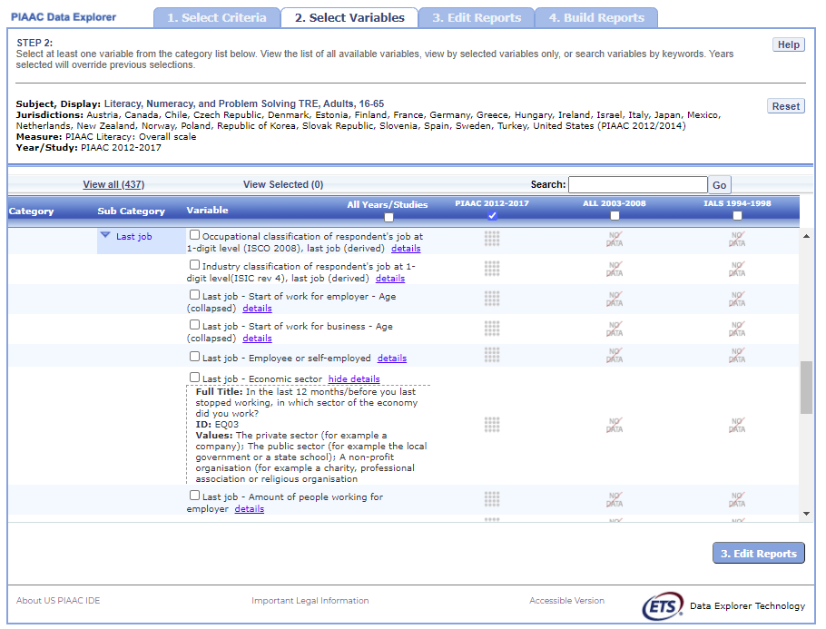

Exhibit 5-5 is a screenshot from the PIAAC IDE tool showing how to select a variable from the categories and sub categories listed in the Select Variables tab.

When you have selected the variable(s) you want to include, continue by clicking the **Edit Reports** button at the bottom of the page or the tab at the top of the page to go to the next screen.

### 5.2.3 2.C. Search Function

The second way to search for variables is to use the **Search** function on the **Select Variables** screen.

Type a term in the **Search** box and click **Go** (or hit “Enter” on your keyboard) to find variables by keywords in the question and/or details for the variable (see exhibit 5-6). The search function operates on whole words or on an exact phrase (if it is contained in quotes). To search for less than a whole word or exact phrase, include an asterisk (*) after the search term. If you use multiple keywords, “and” is assumed. You can narrow your search by using “or,” “not,” or “and not.”

Exhibit 5-6. Select variables using the search function

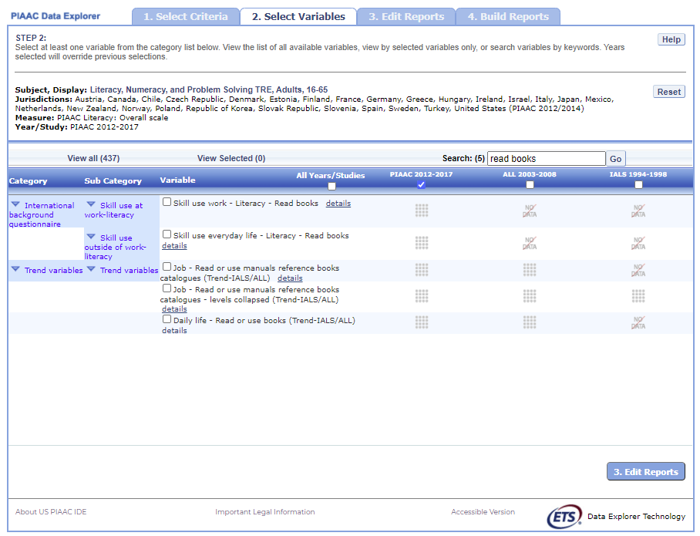

Exhibit 5-6 is a screenshot from the PIAAC IDE tool showing how to select a variable using the search function.

When you have selected the variable(s) you want to include, continue by clicking the **Edit Reports** button at the bottom of the page or the tab at the top of the page to go to the next screen.

## 5.3 3. Edit Reports

### 5.3.1 3.A. Overview

You can access step 3, **Edit Reports,** after choosing criteria at step 1, **Select Criteria**, and choosing variables at step 2, **Select Variables**. The IDE will automatically build reports based on your selections from steps 1 and 2. However, at step 3, the **Edit Reports** phase, you may modify your selections for each report. At this step, you can:

* preview and edit the layout of your reports;
* copy reports or create new reports based on the variables selected;
* change formatting options, such as number of decimal places to display, for all reports (these may also be changed in individual reports, but format options can overwrite previous edits);
* change statistics options, such as average scale scores and achievement levels, for all reports (these may also be changed in individual reports, but statistics options can overwrite previous edits);
* select reports to be built into tables and charts at step 4, **Build Reports**; and
* delete reports.

Using your chosen criteria, the PIAAC IDE will return a separate data report for each variable you have chosen. If you have selected two or three variables (not counting **All adults**), you will also see a **cross-tabulated report** for these variables. If you have chosen four or more variables you will get tables for each variable, but a cross-tabulation report will not be produced. If your selected criteria include more than one **Measure** (e.g., overall literacy scale and one or more continuous variable from step 1, **Select Criteria**), a separate set of data reports will be generated for each **Measure** (see exhibit 5-7).

Exhibit 5-7. Edit reports overview 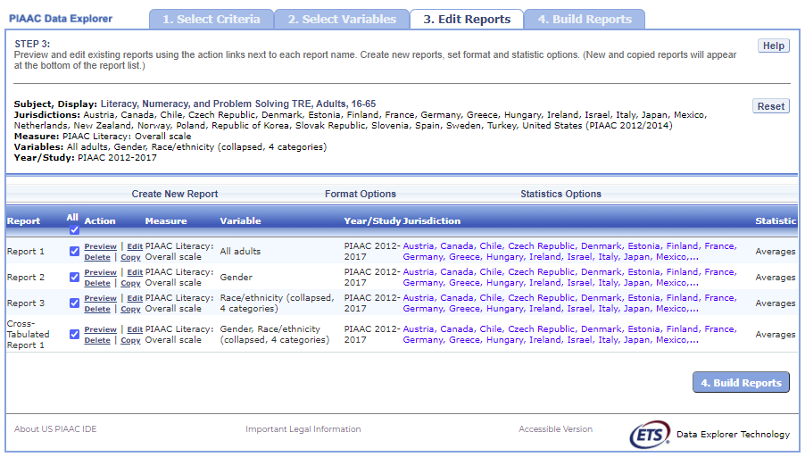

### 5.3.2 3.B. Preview Report

Select **Preview,** in the **Action** column (see exhibit 5-7), to see how your report will be laid out. The preview will not provide actual data but will show how the data will be arranged in rows and columns (see exhibit 5-8). You can select **Preview** at any time to see how your changes will affect the report’s final layout.

Exhibit 5-8. Using preview report

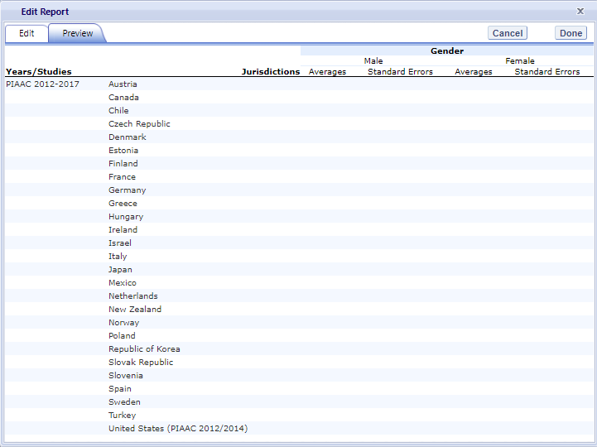

Exhibit 5-8 is a screenshot from the PIAAC IDE tool showing an example of the preview function that is available in the Edit Reports tab.

### 5.3.3 3.C. Edit Report

To edit the report, select the **Edit** command, in the **Action** column, next to the report number (see exhibit 5-7). (Another way to edit a report is to select the **Edit** tab when you are previewing a report.) The following can be done using the **Edit** command (see exhibit 5-9):

1. Name your report. You have the option of giving each > report a distinctive name, up to a limit of 50 characters, using > only letters, numbers, spaces, underscores, and hyphens. > (Otherwise, by default, the report is named Report 1, Report 2, > etc., or Cross-Tabulated Report 1, Cross-Tabulated Report 2, etc.)
2. Select a Measure. You can choose a measure if more > than one was selected at step 1, Select Criteria.
3. Select which jurisdictions, variables, years (if applicable), and > statistics to include (out of the selections > previously made at steps 1 and 2). You can select up to two > statistics options from the following: **averages**, > **percentages**, **standard deviations**, and **percentiles**. > (For further information, see **Section 3.G. Statistics > Options**.)
4. Create a new variable. To create a new variable while > editing a report, click on **Create New…** under the > **Variable** heading. Section 3.D explains the process for > creating a new variable.
5. Change the table layout. By dragging elements to > determine which items will appear in rows and which will appear in > columns. Some of the arrangements will not permissible, but a > pop-up alert will explain this.

Exhibit 5-9. Editing reports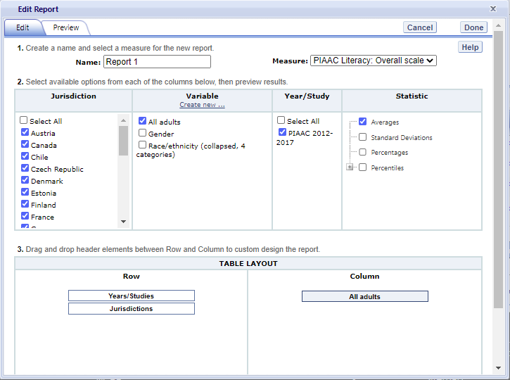

To save changes, make sure to select Done in the upper-right portion of the screen before closing the Edit Report window. If the Done button is not pressed before the Edit window is closed, you may encounter a system error.

### 5.3.4 3.D. Create New Variables

To create a new variable, select **Edit,** in the **Action** column, and select **Create new…** under **Variable** (see exhibit 5-9). The new variable is created by combining values for an existing variable. The steps are as follows:

1. Select the variable for which you wish to combine values.
2. Select the values you want to combine by checking the boxes to the left of the values (see exhibit 5-10).
3. Create a name for the new value, and press **Create**. The collapsed values will appear in gray to indicate that they have already been used.
4. Wait for the screen to refresh, and press **Done**.

Exhibit 5-10. Creating new variables

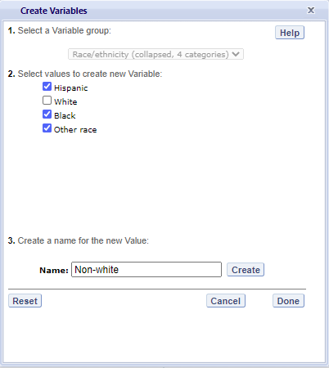

Exhibit 5-10 is a screenshot from the PIAAC IDE tool showing an example of the creating new variable function that is available in the Edit Reports tab.

1. The new variable will appear in the **Variable** list in the **Edit Report** window or **Create New Report** window, designated as “collapsed.”
2. Check the box next to the new variable to view it in the report. You can click **Preview** to see how the table will be laid out before retrieving data.

A new variable that you create is applicable *only* to a specific report; it does not apply to the other reports listed on the **Edit Reports** screen. For example, if you selected multiple measures of literacy for analysis, then you would need to create the new variable for each measure, or create a copy of the report and edit it accordingly. To do the latter, click on **Copy** report on the **Edit Reports** screen (copied reports appear at the end of the list of reports) and then, for the new copy, click on **Edit** (using the above example, you can change the measure and give the report a new name). You cannot save the new variable for reference or future use.

You can repeat the process and combine different values of a variable to create additional new variables. Using the **Create New Report** function, you can create a new report for each new variable that you create. (For further information, see section **3.E. Create New Report**.)

If you selected two or three variables from which to create new variables, you can repeat the process for each of them. Using the **Create New Report** or **Edit Report** function, these collapsed variables will be listed and available for cross-tabulation (see exhibit 5-11). If you have chosen four or more variables (not counting **All adults**) you will not get the cross-tabulation. You can click **Preview** to see how the table will be laid out before retrieving data.

Exhibit 5-11. Edit reports with collapsed variables

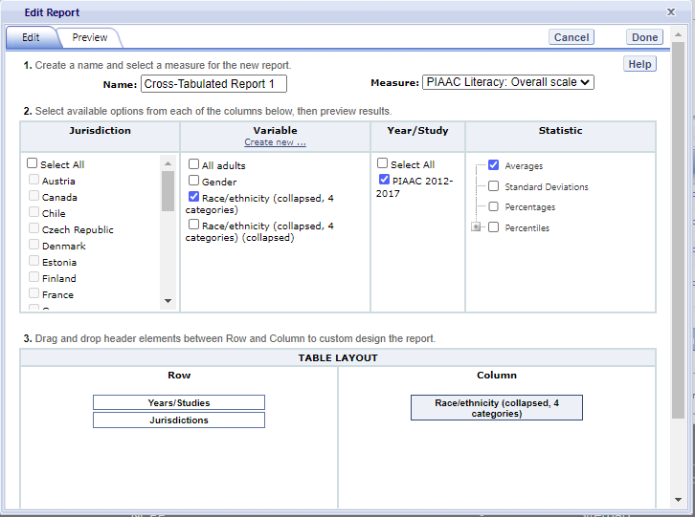

Exhibit 5-11 is a screenshot from the PIAAC IDE tool showing an example of the editing report with collapsed variables function that is available in the Edit Reports tab.

### 5.3.5 3.E. Create New Report

From the main **Edit Reports** screen, clicking on **Create New Report** brings up the same options as **Edit Report**, but with no checkboxes marked and without any new variables you may have created. Thus, **Create New Report** (see exhibit 5-12a and 5-12b) provides a clean slate for your selections from the first two steps, **Select Criteria** and **Select Variables**. Each new report you create will appear at the end of the list of reports. If you do not give the report a specific name, it will be called “New Report.” If you create a second new report, the system will attempt to save it with the “New Report” name again; however, it will fail and will prompt you to enter a different name in the Name text box.

Exhibit 5-12a. Creating new reports

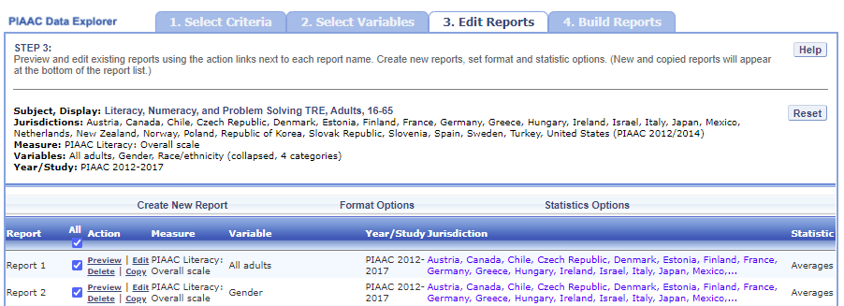

Exhibit 5-12a is a screenshot from the PIAAC IDE tool showing an example of the creating new report function that is available in the Edit Reports tab.

Exhibit 5-12b. Creating new reports

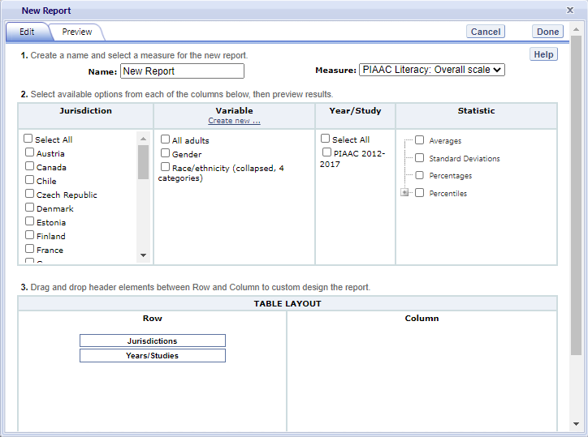

Exhibit 5-12b is a screenshot from the PIAAC IDE tool showing an example of the creating new report function that is available in the Edit Reports tab.

### 5.3.6 3.F. Format Options

From the main **Edit Reports** screen, clicking on **Format Options** will allow you to make formatting changes applicable to all the reports listed. The following formatting options are available using this function (see exhibit 5-13):

1. **Variable Labels (Long)** displays a more detailed description of the variables selected in a query than the default short label. For variables from the background questionnaire, the full text of the question is displayed. Be advised that the length of the extra detail may sometimes interfere with table formatting.
2. **Show data for values categorized as “missing”** will include the percentage of adults in the total sample or in a reporting group for whom membership in a particular response category is unknown because no response was given by the adults. The percentage of “missing” will be shown in the right-most table column. Missing data are available only for queries that involve percentages as the statistic type. Unless you check this option, the default is for missing responses not to be included in the percentage distribution shown.
3. **Year Order** allows you the option to display the most recent year first or the oldest year first.
4. **Decimal Places** allows you to specify the level of precision for a particular statistic. Depending on the value range of the dependent variable (for example, the dependent variable “PIAAC Literacy: Overall scale $PVLIT$” ranges from 0 to 1000; the dependent variable “Index of use of ICT skills at home (derived) $ICTHOME$” ranges from 0 to 4), the default decimal places for a report could be from zero to three. Also, standard errors will be shown to one more decimal place than is shown for a particular statistic. For example, if you request that average scores be displayed to one decimal place (by default, the average scores is displayed to be the whole number), the corresponding standard errors will be displayed to two decimal places. If you export to Excel, you will be able to increase the number of decimal places in most cases. Note that only integer-level precision is allowed for percentages; that is, the number of decimal places is fixed at “none” for percentages and the corresponding standard errors are shown to one decimal place.
5. **Include** gives you the option of showing standard errors. By default, standard errors are shown inside parentheses, but you have the option of choosing to show them without parentheses*.* You can preview the effects of your selection in the **Sample Display** area (see the blue-shaded box at the bottom of exhibit 5-13).

Exhibit 5-13. Format options

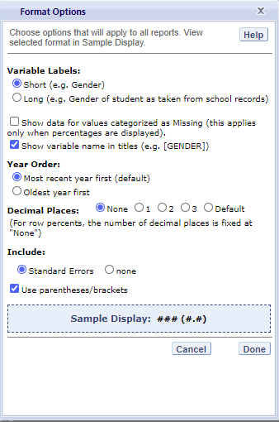

Exhibit 5-13 is a screenshot from the PIAAC IDE tool showing an example of the format options available in the Edit Reports tab.

Be advised that the choices you make in the **Format Options** window will apply to all reports and cannot be changed for individual reports. Use the **Reset** button, located in the upper-right portion of the main **Edit Reports** screen (just below the **Help** button), to restore the **Format Options** to the default settings (although caution is advised, as this will also delete any new reports that you have created).

### 5.3.7 3.G. Statistics Options

Available only from the main **Edit Reports** screen, clicking on **Statistics Options** allows you to designate up to two statistics. The selections you make are applicable to all the reports listed, although you can also change the statistics for an individual report when you edit it. (For further information, see **Section 3.C. Edit Report**.)

The following statistics options are available (see exhibit 5-14):

1. **Averages.** For the PIAAC assessment, adult performance is reported on scales that range from 0 to 500. PIAAC reports the average scale score for a variety of demographic samples of the adult population (e.g., the average scale score in literacy for female adults). Averages for other continuous variables are in the same units as the variables themselves (e.g., average hourly earnings for hourly earnings variable). By default, the standard errors of the scale scores are shown in parentheses.
2. **Percentages.** This statistic shows the percentage of adults as a row percentage. For example, if the first column lists jurisdictions, then each jurisdiction will display its own percentage distribution across its row. By default, percentage distributions do not include missing data. For information on how to show data for values categorized as missing, see **Section 3.F. Format Options**.
3. **Standard deviations.** The standard deviation is a measure of how widely or narrowly dispersed scores are for a particular variable. Under general normality assumptions, 95 percent of the scores are within two standard deviations of the mean. For example, if the average value of a variable is 500 and the standard deviation is 100, it means that 95 percent of the values in this variable fall between 300 and 700. The standard deviation is the square root of the variance.
4. **Percentiles.** This statistic shows the threshold (or cutpoint) for the following:
   * 10th percentile—the bottom 10 percent of adults
   * 25th percentile—the bottom quarter of adults
   * 50th percentile—the median (half the adults scored below the cutpoint and half scored above it)
   * 75th percentile—the top quarter of adults
   * 90th percentile—the top 10 percent of adults

Exhibit 5-14. Statistics options

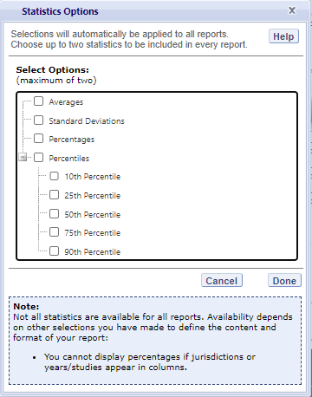

Exhibit 5-14 is a screenshot from the TIMSS IDE tool showing an example of the statistics options available in the Edit Reports tab.

As previously noted, the selections you make in **Statistics Options** will be applied automatically to all reports, although you can change the statistics for an individual report if you use the **Edit** command in the **Action** column. Be advised that if you use **Statistics Options** after editing the statistics in one or more of your individual reports, the statistics options selected will overwrite your previously edited selections. If you wish to use the same criteria and variables in a report with a different selection of statistics, consider using the **Create New Report** function to generate a new report with different statistics. (For further information, see **Section 3.E. Create New Report**.) You can also make a copy of an individual report.

You can use the **Reset** button, located in the upper-right portion of the main **Edit Reports** screen (just below the **Help** button), to restore the **Statistics Options** to the default setting, which is the average for all reports (this will also delete any new reports that you created).

Not all statistics are available for all reports. Their availability depends on other selections you have made to define the content and format of your report:

* Percentages will not display if jurisdictions or years appear in > columns.
* If proficiency levels are selected in the variable section, only > average scores and percentages will be displayed.

Please note that the statistics produced by the IDE may not match the statistics in reports published by the OECD or in the OECD PIAAC IDE, due to differences in certain statistical standards. In particular, NCES and the OECD may differ in the minimum sample sizes required for publishing adult scores, as well as in the requirements for stability of estimates for results to be reportable. For more details on the differences in statistical standards, refer to the technical notes in the NCES First Look report.[^1]

### 5.3.8 3.H. Select Reports to Build

As you edit your reports, you can give distinct names (up to 50 characters) to differentiate them, as well as make changes to the jurisdictions and variables previously selected, the statistics, and the layout of the rows and columns. (For further information, see **Section 3.C. Edit Report.)** You may make copies of reports with these changes.

Before proceeding to step 4, **Build Reports**, you can preview each report for which you want to retrieve data by using the **Preview** action. To decrease processing time as you move to step 4, you can uncheck any reports for which you do not wish to retrieve data. By default, all reports are checked. To uncheck one or more reports, you can either uncheck the reports individually or click on the **All** box. (Doing the latter will uncheck all of the reports and allow you to check only those for which you wish to retrieve data.) In the example that follows (see exhibit 5-15), data will be retrieved for all reports.

Exhibit 5-15. Selecting reports to build



Exhibit 5-15 is a screenshot from the PIAAC IDE tool showing how to select reports to build in the Edit Reports tab.

If you wish to delete a report from the list of reports, click **Delete** (see 1 in exhibit 5-15) in the **Action** column. Use the **Reset** button (see 2 in exhibit 5-15), located in the upper-right portion of the screen (just below the **Help** button), to restore the deleted reports with the criteria and variables selected in the previous steps (although caution is advised, as this will not restore any new reports or variables that you created in the session and will delete any new reports and variables that you most recently created; the **Reset** action will also restore the **Format Options** and **Statistics Options** to the default settings).

To continue to the last step in the IDE, click the **Build Reports** button at the bottom of the page (see 3 in exhibit 5-15) or the tab at the top of the page to go to the next screen.

## 5.4 4. Build Reports

### 5.4.1 4.A. Overview

You can access step 4, **Build Reports**, after choosing criteria at step 1, **Select Criteria**, in which case the default report built will provide average data for the **All Adults** variable. After step 1, you may also go on to steps 2 and 3, where you can select additional variables and edit reports, before moving on to **Build Reports**. In **Build Reports**, you can do the following:

* Generate a data table for each report selected in step 3, as shown > by the **Select Reports** drop-down feature. By default, all > reports are checked, although you can uncheck any reports for > which you do not wish to retrieve data. (For further information, > see **Section 3.H. Select Reports to Build**.)
* Export and save data tables into various formats using the **Export Reports** button. The output formats include HTML (print-friendly), Microsoft Word, Microsoft Excel, and Adobe PDF (in NCES PIAAC only)
* Select the **Chart** tab to create and customize charts for each report and save them for export in the above formats.
* Select the **Significance Test** tab to run a significance test on your results and customize it.

**Exhibit 5-16. Building reports overview** 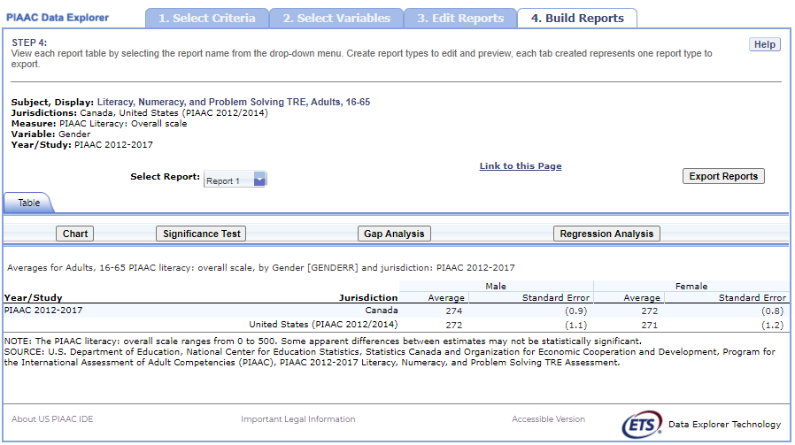

### 5.4.2 4.B. View Reports as Data Tables

Once you click on **Build Reports,** the sentence “Some queries may take up to two minutes to process.” will appear on your screen (see exhibit 5-17). Some reports will take longer than others to process, so please do not hit the “Back” button on your browser during this stage. Your table will appear once the processing is complete. To select a different table to view, go to the **Select Report** drop-down menu and choose the table of interest. To change the formatting or statistics options of a table or to generate a table from a report not included in your selection, return to step 3, **Edit Reports**.

Exhibit 5-17. Processing data

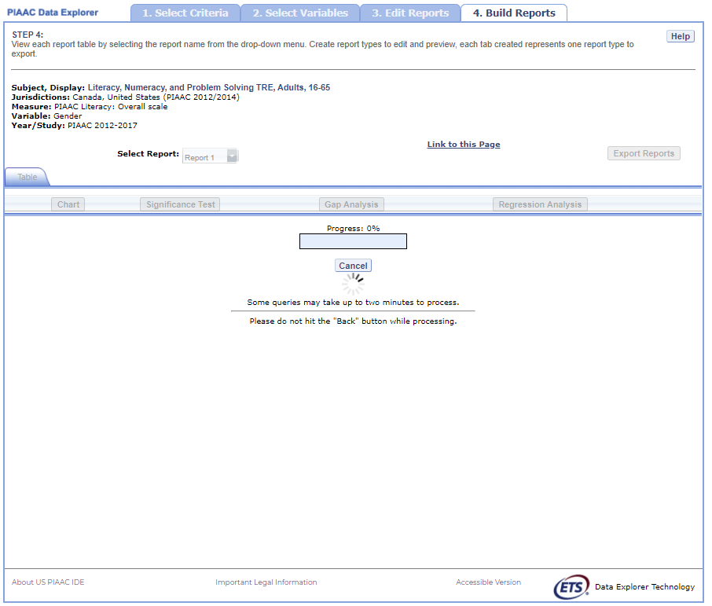

Exhibit 5-17 is a screenshot from the PIAAC IDE tool showing an overview of the building reports page while data is processing.

### 5.4.3 4.C. Charts

To create a chart, go to **Select Report** on the **Build Reports** screen to choose the report of interest from the drop-down menu, and then click the **Chart** link (see exhibit 5-18).

You will be able to create many types of charts and customize them. **Section 4.E. Create Charts – Chart Options** provides a summary of the available features and how they can be customized.

Exhibit 5-18. Viewing reports as charts

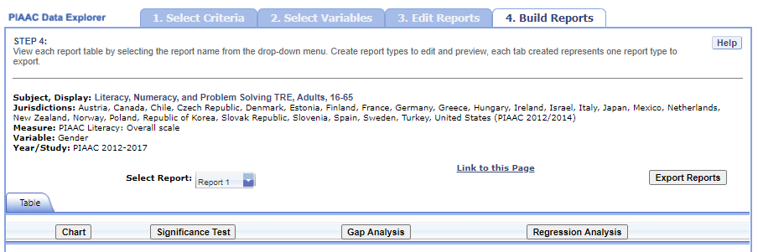

Exhibit 5-18 is a screenshot from the PIAAC IDE tool showing how to select the chart creating function in the Build Reports tab.

### 5.4.4 4.D. Create Charts

When you click **Chart,** you will first make selections pertaining to **Jurisdiction,** **Year/Study**, and **Statistic**, which are data options of the chart (see exhibit 5-19). All **Jurisdictions** and **Studies** are selected by default, while you can only choose one **Statistic**. Uncheck any of the criteria that you do not wish to chart, as long as you have one selected in each category.

**Exhibit 5-19. Data options for charts** 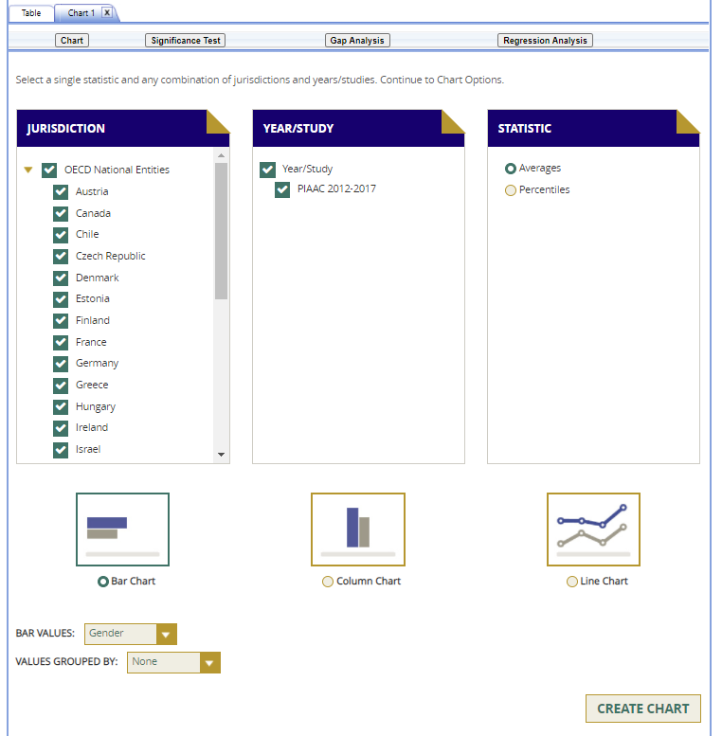

Next, you can make selections regarding the chart options located below on the same page.

1. Select **Bar Chart**, **Column Chart**, or **Line Chart** (see 1 in > exhibit 5-20). If the Percentiles Statistic is selected, you can > also select from a **Percentiles Chart** option.
2. After selecting a chart type, change any data dimensions from the > drop-down menus for **Bar**, **Column**, or **Line Values** and > **Values Grouped by** (see 2 in exhibit 5-20). Any new variables > that you created at step 3, **Edit Reports**, will be available > for selection, but only if you selected the variables (by clicking > the checkbox next to them) and pressed **Done** after you edited > the report.
3. Create your chart by clicking the **Create Chart** button in the > lower-right corner (see 3 in exhibit 5-20).

**Exhibit 5-20. Chart options**



Exhibit 5-20 is a screenshot from the PIAAC IDE tool showing the chart options available in the chart creating function in the Build Reports tab.

After creating your chart, you can do the following (see exhibit 5-21 as an example of a **Percentile Chart** and exhibit 5-22 as an example of a **Bar Chart**):

1. Use the drop-down menus to change the jurisdiction and other > variables as applicable (see 1 in exhibit 5-21).
2. Place your cursor over the bars of the chart to see the data points > and value label(s) (see 2 in exhibit 5-21).

Exhibit 5-21. Percentile chart 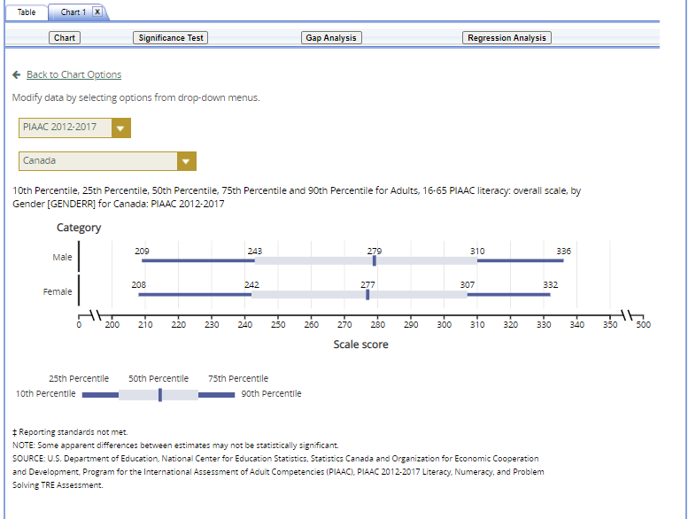

Exhibit 5-22. Bar chart

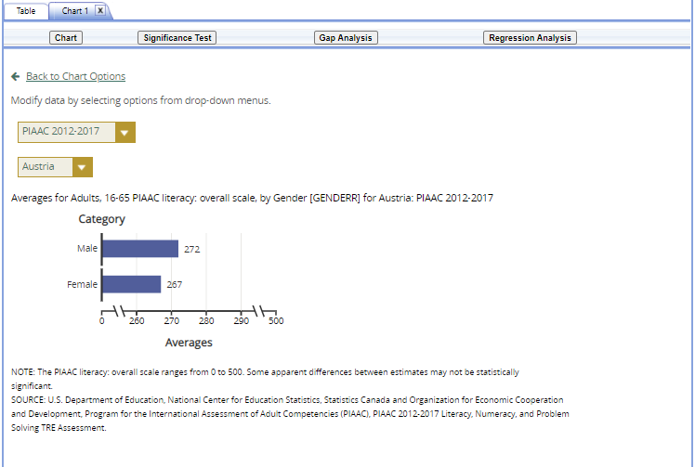

Exhibit 5-22 is a screenshot from the PIAAC IDE tool showing a preview of a bar chart in the chart creating function in the Build Reports tab.

You can choose **“Back to Chart Options”** (located in the upper-left corner, below the **Chart** link) to make more changes.

To make an additional chart from the same report or table, click the **Chart** link on the **Build Reports** screen. If you do not start the chart process again by clicking the **Chart** link, the new chart will overwrite the previous one.

If you wish to make charts from other reports, select a different report from the **Select Report** drop-down list. If you do not see the other reports that you would like to make charts from, they may not have been selected in step 3, **Edit Reports**. Go back to step 3 and check the reports you want to use for making charts. When you advance to step 4, **Build Reports**, the reports will appear in the **Select Report** drop-down list. If you need to create new reports, go back to step 1, **Select Criteria**, and/or step 2, **Select Variables**. Remember to export any completed charts you want to save using the **Export Reports** function before leaving the **Build Reports** screen. Otherwise, you will lose the charts you have created when going back to step 1, **Select Criteria**. (For further information, see **Section 4.H. Export Reports**.)

### 5.4.5 4.E. Significance Tests

Tests for statistical significance indicate whether observed differences between assessment results are likely to have occurred because of sampling error or chance. “Significance” here does not imply any judgment about absolute magnitude or educational relevance. It refers only to the statistical nature of the difference and whether that difference likely reflects a true difference in the population.

With your report of interest selected, click the **Significance Test** link, which is located to the right of the **Chart** link (see exhibit 5-22). You first need to decide which variable you want to test and the criterion by which you want to test it (i.e., between jurisdictions, within variables, or across years). You will compare or “look across” the variable’s range of values, so it must have more than one value. You can look across jurisdictions for a variable (that is, compare two or more jurisdictions) or you can look across the values within a variable for a single jurisdiction. Once the primary criterion is chosen, all other criteria must be restricted to a single value.

The general steps for running significance tests are as follows (see exhibit 5-23):

1. In the **Significance Test** window, select **Between > Jurisdictions**, **Within Variables**, or **Across Years**. Then, > select the appropriate jurisdiction(s), variable(s), one or more > of the years and studies, and statistic(s). For **Between > Jurisdictions**, select at least two jurisdictions. For **Within > Variables**, select one or more jurisdictions. For **Across > Years**, more than one year/study needs to be selected.
2. Enter a **Name** limited to 25 characters, using only letters, > numbers, spaces, underscores, and hyphens (otherwise, by default, > the test is named “Sig Test 1”).
3. Select the output type as either **Table** or **Map** or > **Comparison**. The table option will show the significance test > results as a matrix. The comparison option will show the > jurisdictions selected which are significantly higher, not > different, or lower to each other in score and statistical > significance. The map option will show the significance test > results on a world map, highlighting the selected jurisdictions > different from the one that has been identified as the benchmark. > Identifying a benchmark jurisdiction is done on the map itself > (see exhibit 5-25). The map output is only available when **Between > Jurisdictions** is selected in the first step.
4. Additional options allow you to select **Show Score Details** to > display the estimates and standard errors for the table cells. If > you selected a map, this option is not applicable, as the map will > automatically show score details.
5. Click the **Preview** tab located in the upper-left corner, or the > **Preview** button located in the bottom-left corner.
6. Click the **Edit** tab in the upper-left corner of the screen if you > wish to go back and make changes to the selections you made for > running the significance tests.
7. Click the **Done** button in the upper- or lower-right corner of the > screen to run the significance tests.

Exhibit 5-23. Significance test options

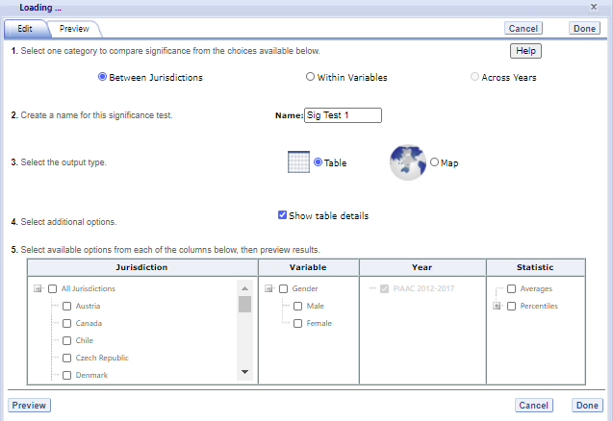

Exhibit 5-23 is a screenshot from the PIAAC IDE tool showing the significance test options available in the Build Reports tab.

When the table option is selected, you will get a significance test matrix in which you will see the differences and *p* values. Using the symbols shown in the legend of the matrix, an indication is also provided of whether one estimate is significantly lower or higher than another estimate or whether there is no significant difference (see exhibit 5-24).

The alpha level for all *t*-tests is .05. All comparisons within a jurisdiction, within the same year, are made using dependent *t*-tests. Comparisons between jurisdictions are treated as independent. Non-achievement comparisons across years are treated as independent. Comparisons of achievement across years are made using independent *t*-tests with a linking error taken into account. A part-whole adjustment is implemented for comparisons between a jurisdiction and a group that the jurisdiction is part of (e.g. Average of All Jurisdictions).

For more information on the significance testing between years/studies, see section **5. Statistical Notations and Other Notes** under *Linking error*.

Exhibit 5-24. Significance test table output

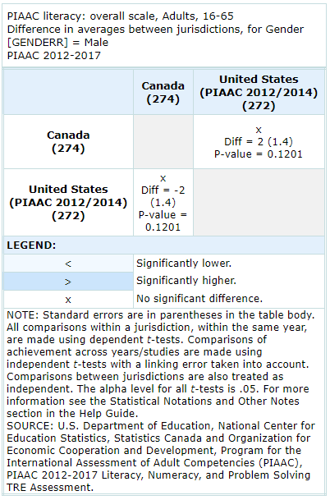

Exhibit 5-24 is a screenshot from the PIAAC IDE tool showing an example of a significance test table output in the Build Reports tab.

Exhibit 5-25. Map of significance tests

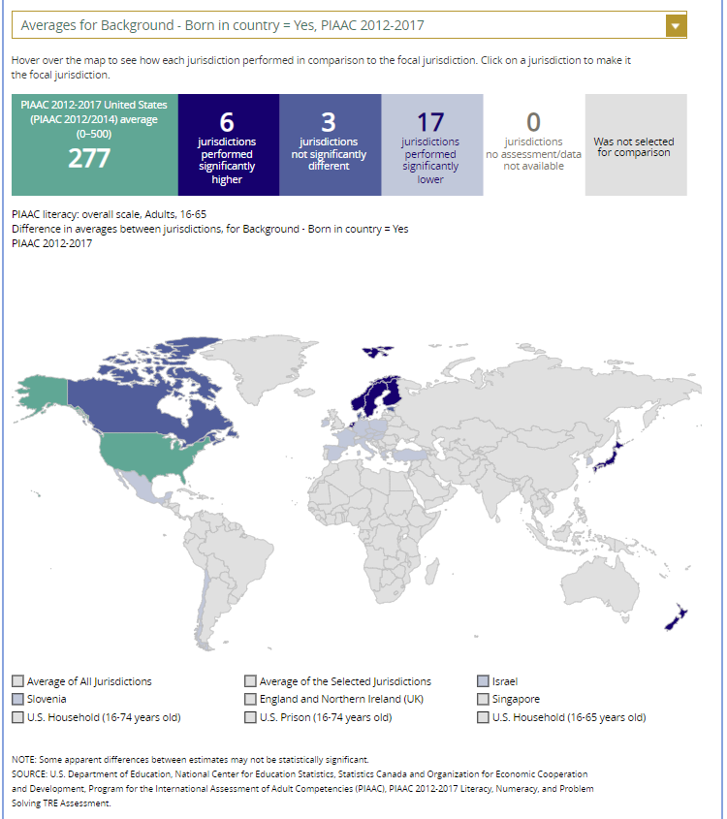

Exhibit 5-25 is a screenshot from the PIAAC IDE tool showing an example of a significance test map output in the Build Reports tab.

When the map option is selected, a global map is shown with the selected jurisdictions shaded (see exhibit 5-25). The focal jurisdiction is shaded in teal green and represents a comparison for all the other jurisdictions. The other jurisdictions are shaded in colors that indicate whether they are higher, lower, or not significantly different from the focal jurisdiction on whatever measure has been selected. (Note that a light shade of gray is the default color for jurisdictions categorized as “not selected for comparison.”) When you scroll over a jurisdiction a text bubble pops up describing the difference between that jurisdiction and the focal jurisdiction. At any point, you may choose a different focal jurisdiction by selecting another jurisdiction of your choosing. You may also choose a different variable category for comparison by using the drop down menu above the map.

### 5.4.6 4.F. Gap Analysis

Gap Analysis is included in the IDE to compare differences in gaps shown in a map, table, or chart. These gap differences can be compared between jurisdictions and/or across years.

**Exhibit 5-26. Gap analysis link selection**

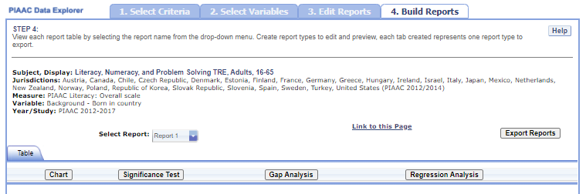

Exhibit 5-26 is a screenshot from the PIAAC IDE tool showing how to select the gap analysis function in the Build Reports tab.

With your report of interest selected, click on the **Gap Analysis** link, which is located to the right of the **Significance Test** link (see exhibit 5-26). You will need to decide which variable you would like to test (e.g., gender) and the basis to use for comparison (i.e., between jurisdictions or across years). The difference measure, or gap, can be viewed between groups, between years, between groups and years, or between percentiles within the selected variable. For example, if you compute average literacy scores for two jurisdictions at two time points for males and females, you can:

* at one time point, compare the male-female gap in one jurisdiction to the male-female gap in another jurisdiction;
* compare the male-female gap at two time points within a jurisdiction;
* compare the difference between the male-female gap at two time points in one jurisdiction to the difference between the male-female gap at two time points in another jurisdiction; or
* compare the gap for females at two time points in one jurisdiction to the gap for females at two time points in another jurisdiction.

**Exhibit 5-27. Gap analysis options**

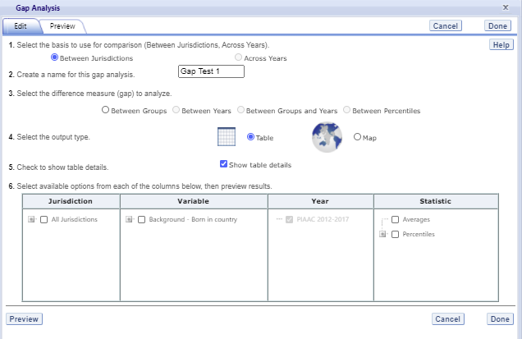

Exhibit 5-27 is a screenshot from the PIAAC IDE tool showing the gap analysis options available in the Build Reports tab.

The steps for running a gap analysis are similar to those for conducting a statistical significance test (see exhibit 5-27). Thus, to run a gap analysis, follow the instructions under **Section 4.E. Significance Tests**, noting the following differences:

* The **Gap Analysis** link should be selected, not the **Significance Test** link.
* The gap analysis does not have a **Within Variables** option for analysis; the options are **Between Jurisdictions** and **Across Years.**
* The difference measure (gap) of analysis must be selected from the following: **Between Groups, Between Years, Between Groups and Years,** and **Between Percentiles** (if variables are selected for which a difference measure is not feasible, the difference measure option will not appear as available in the Gap Analysis menu).

The gap analysis output is presented in a format similar to that of the significance test output, with one difference: the difference estimate shown in the output is the difference between the gaps selected for analysis. Note that you will still see the significance of these differences just like in a significance test. For example, exhibit 5-28 shows the difference between jurisdictions in the average problem solving in technology-rich environments score gap between males and females.

The gap analysis function computes and statistically tests differences between average value/score, percentage, or percentile gaps. Note that the reference group for the gaps is kept constant during the analysis, as opposed to taking the absolute value of the gaps. Therefore, the gap analysis tests whether the magnitude of the gaps differ from each other only when the gaps go in the same direction (e.g., comparing a 5-point gender gap favoring females in one jurisdiction with a 15-point gender gap favoring females in another jurisdiction).

**Exhibit 5-28. Gap analysis output**

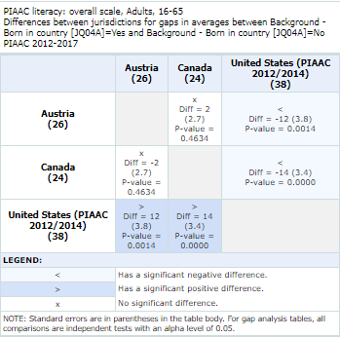

Exhibit 5-28 is a screenshot from the PIAAC IDE tool showing an example output report based on the gap analysis options.

NOTE: A gap analysis across years cannot be combined with the **Between Years** or **Between Groups** and **Years** difference measures, so you will select the difference measure **Between Groups**, or, if you have selected percentiles as one of your statistics, you may choose **Between Percentiles**.

### 5.4.7 4.G. Regression Analysis

Regression Analysis is included in the IDE to test for trends across more than two data points. The type of analysis performed in this feature of the IDE is referred to as linear regression within the field of statistics.

**Exhibit 5-29. Regression analysis link selection**

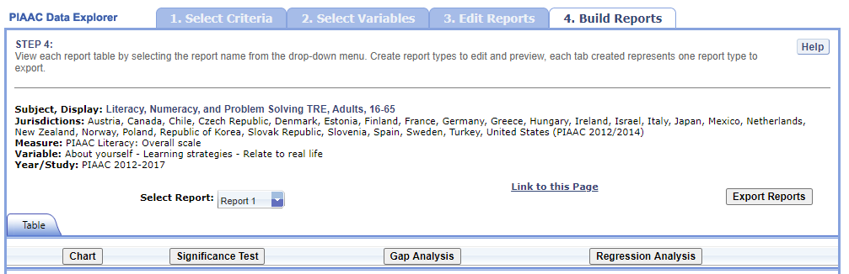

Exhibit 5-29 is a screenshot from the PIAAC IDE tool showing how to select the regression analysis function in the Build Reports tab.

A regression analysis can be performed based on the selections that were made to build your table in the IDE by selecting the **Regression Analysis** button above the table (see exhibit 5-29). The Measure, or continuous variable, that you selected in Step 1 and that is displayed in your table will automatically become your dependent variable for the regression analysis (in exhibit 5-29 this is “PIAAC Literacy: Overall scale”). Please note that continuous variables cannot be used as independent variables. The variables that you selected in Step 2 and that are displayed in your table will become your independent variable options for the regression analysis (in exhibit 5-29 this is “About yourself – Learning strategies – Relate to real life”).

**Exhibit 5-30. Regression analysis options**

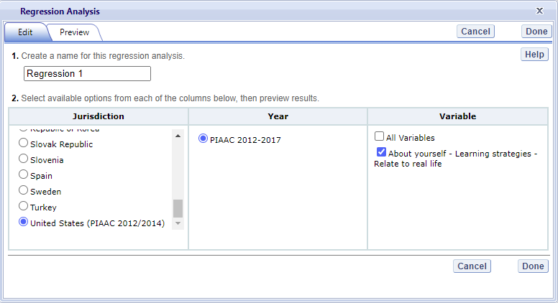

Exhibit 5-30 is a screenshot from the PIAAC IDE tool showing the options for the regression analysis output.

The general steps for running a regression analysis are as follows (see exhibit 5-30):

1. In the **Regression Analysis** pop-up window, enter a **Name** limited to 25 characters, using only letters, numbers, spaces, underscores, and hyphens (otherwise, by default, the test will be named “Regression 1”).
2. Select the appropriate jurisdiction, year, and independent variable(s) for analysis. Please note that you may only choose one jurisdiction and year at a time, but you may choose up to 3 independent variables to be in your report. In order to use up to 3 variables, you must have already created and selected a cross-tabulated report (by selecting 3 variables in Step 2, **Select Variables**).
3. Click the **Preview** tab located in the upper-left corner to view the table format into which your output will be populated. In the Preview tab, an “X” denotes where the output will display.
4. Click the **Edit** tab in the upper-left corner of the screen if you wish to go back and make changes to the selections you made for running the analysis.
5. Click the **Done** button in the upper- or lower-right corner of the screen to run the regression analysis.

After you have clicked **Done**, your regression analysis output will load onto the screen (see exhibit 5-31). A 0-1 contrast coding is used to code the independent variable, where the first subgroup of the independent variable is the reference group. Using dummy-coded variables in a linear regression is useful for comparing each subgroup against a reference group. For example, in exhibit 5-31, if the subgroup “Not at all” is the reference group for the independent variable **About yourself – Learning strategies – Relate to real life $IQ04B$** , the IDE creates a “Very little” dummy variable (1 for respondents who answered “Very little,” 0 otherwise), a “To some extent” dummy variable (1 for respondents who answered “To some extent,” 0 otherwise), a “To a high extent” dummy variable (1 for respondents who answered “To a high extent,” 0 otherwise), and a “To a very high extent” dummy variable (1 for respondents who answered “To a very high extent,” 0 otherwise).

**Exhibit 5-31. Regression analysis output**

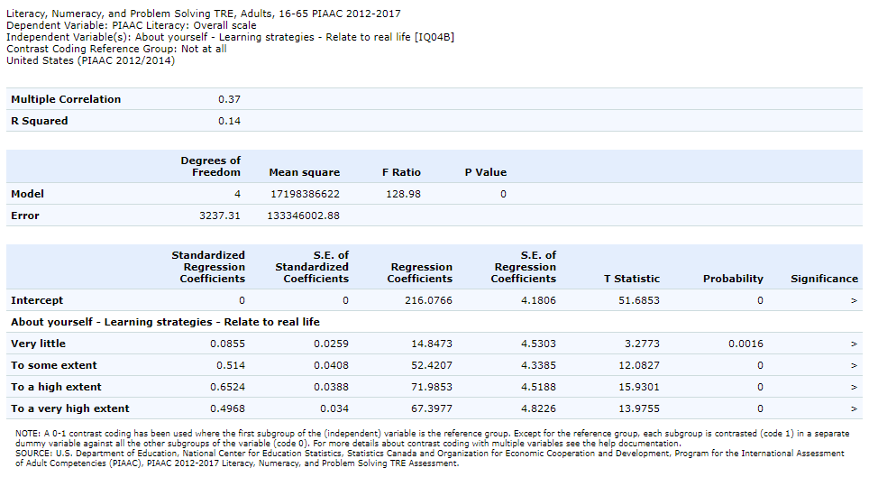

Exhibit 5-31 is a screenshot from the PIAAC IDE tool showing an example of the regression analysis output.

Using the output from exhibit 5-31 you can compare the average literacy scores of adults who report “Not at all” to the background question to average literacy scores of adults who report “Very little,” “To some extent,” “To a high extent,” or “To a very high extent” to the background question. When a single dummy-coded variable is used in a regression, the *intercept* is the mean of the reference group (e.g., 216.0766), and the *regression coefficient* is the difference between the mean of the reference group and the group identified (coded 1) with the dummy-coded variable (e.g., 14.8473 for adults who report “Very little” to the background question). Since the regression coefficients are presented with a standard error and a *t* value, these can be used to test whether a difference between means is statistically significant. Under the Significance column in the output you will see 3 possible signs: 1) < signifies a significant negative difference, 2) > signifies a significant positive difference, and 3) *x* signifies the difference is not statistically significant.

### 5.4.8 4.H. Export Reports

Click on the **Export Reports** button/arrow located on the right side of the **Build Reports** screen to save or print your tables, charts, and significance tests. The report names that appear in the **Export Reports** window are those that were checked off at step 3, **Edit Reports**.

Exhibit 5-32. Export report options

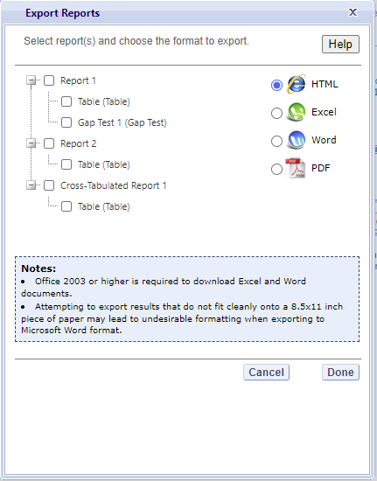

Exhibit 5-32 is a screenshot from the PIAAC IDE tool showing the export options, including HTML, Excel, Word, and PDF.

Check the files you want to export and select one of the file formats: **HTML** (print-friendly), **Excel**, **Word**, or **PDF** (see exhibit 5-32). All reports that you select at the same time will be exported in one file. In the Excel format, you will be able to increase the decimal places visible (wherever more precision is available in the database). Because there are many different operating systems in use, you may get an error message with Excel or one of the other formats. Usually, this will not affect your ability to export, so please wait for the software errors to resolve.

# 6 TALIS IDE Walkthrough

There are four general steps for exploring each IDE page (see exhibit 6-1). Each step is described in more detail in the following sub-sections.

Exhibit 6-1. What you will see in the IDE environment and what each step entails 

## 6.1 1. Select Criteria

### 6.1.1 1.A. Overview

Your data query in the TALIS IDE begins on the **Select Criteria** screen (see exhibit 6-2).

Select a **Subject** and **Education level** from the drop-down menus. Once the screen resets, you can choose one or more **Year**, **Measure,** and **Jurisdiction** for the data you wish to view or compare. Use the **Reset** button, located in the upper-right portion of the screen (just below the **Help** button), to cancel your selections and begin again.

Click on a blue sideways-facing arrow (►) to open up a category, and click on a blue downward-facing arrow (▼) to close a category.

Exhibit 6-2. Selecting criteria

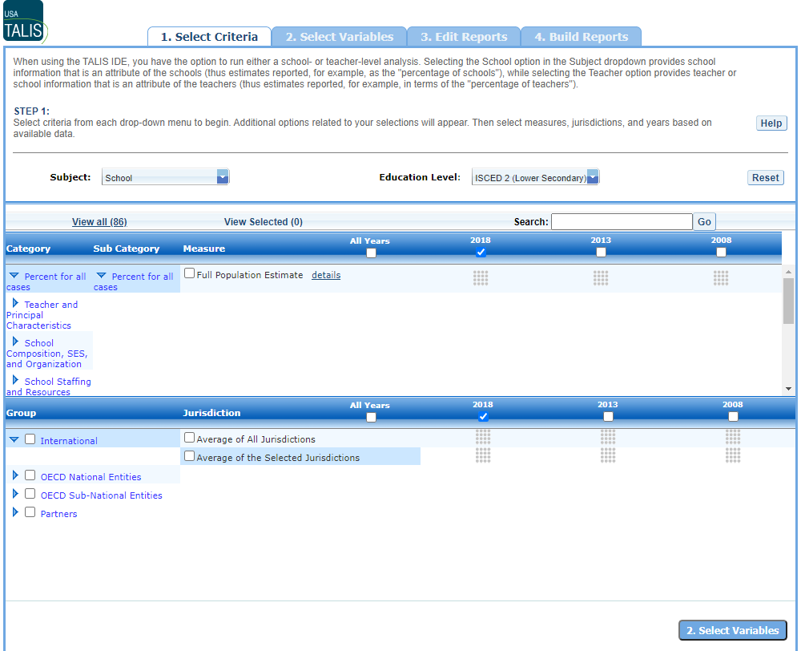

Exhibit 6-2 is a screenshot from the TALIS IDE tool showing the Select Criteria tab.

### 6.1.2 1.B. Choose a Subject

The first option you must choose in step 1, **Select Criteria,** is a **Subject**. When using the TALIS IDE, you have the option to run either a school- or teacher-level analysis. Click to open the drop-down menu next to Subject, which provides the choice of selecting either **School** or **Teacher**. Selecting the **School** option provides school information that is an attribute of *schools* (thus estimates are reported, for example, as the “percentage of schools”), while selecting the **Teacher** option provides teacher or school information that is an attribute of *teachers* (thus estimates are reported, for example, in terms of the “percentage of teachers”).

### 6.1.3 1.C. Choose an Education Level

The second option to choose in step 1, **Select Criteria,** is an **Education Level**. TALIS collects data on ISCED 1 (Primary), ISCED 2 (Lower Secondary), and ISCED 3 (Upper Secondary). Please note that the IDE default is ISCED 2.

### 6.1.4 1.D. Choose Year(s)

To the right of the **Measure** and **Jurisdiction** tab titles, you have the choice of selecting TALIS 2018, 2013, or 2008 data for analysis by checking the appropriate box underneath the year listed. To include data from all three years, check the “**All Years**” box to the left of the individual years.

### 6.1.5 1.E. Choose Measure(s)

After choosing a **Subject** and **Education Level**, you can then choose a **Measure** within the **Select Criteria** tab. Note that the Full Population Estimate is the default for selection, but instead of, or in addition to, the Full Population Estimate, you can select from among a number of continuous variables listed under Measure. You can search for continuous variables using the **Category** and **Sub Category** lists or by using the **Search** function. The continuous variables are first organized by **Category** (such as Teacher and Principal Characteristics, School Staffing and Resources, and Classroom Climate), then organized by **Sub Category** (such as Principal Demographics and Principal Work Experience). Finally, selecting a **Sub Category** will display a list of continuous variables you may select to use as a **Measure** in your analysis.

### 6.1.6 1.F. Choose Jurisdiction(s)

With your **Measure**(s) and **Year**(s) selected, next choose at least one **Jurisdiction.**

Jurisdictions are found under the following groups: **OECD National Entities**, **OECD Sub-National Entities**, and **Partners.** There is also a group category called **International,** with options to display the **Average of All Jurisdictions** and the **Average of the Selected Jurisdictions.**

The general procedures for selecting one or more jurisdictions are as follows:

1. To open or close jurisdictions, click on the arrow. Jurisdictions in the group are open and can be selected when the blue arrow points down (see exhibit 6-3).
2. Click the checkboxes next to the specific jurisdictions that you are interested in, or uncheck those jurisdictions that you wish to deselect. If you click the checkbox next to the group name (e.g., “OECD National Entities”), you will select all the jurisdictions within that group. If desired, uncheck the group name to deselect all.
3. If you want to close a group (for example, close the list of OECD countries), click the blue arrow next to the group name. The closed group’s arrow points to the right. Be advised that closing the group will not deselect your choices.

Exhibit 6-3. Choosing jurisdictions



Exhibit 6-3 is a screenshot from the TALIS IDE tool showing jurisdictions available in the Select Criteria tab.

To continue in the IDE, click the **Select Variables** button at the bottom right of the page or the tab at the top of the page to go to the next screen (see exhibit 6-3).

## 6.2 2. Select Variables

### 6.2.1 2.A. Overview

Step 2, **Select Variables,** can only be accessed after choosing criteria at step 1, **Select Criteria**.

To continue your data query and edit a report, *you must choose at least one variable on this screen.* You can browse for variables using the **Category** or **Sub-category lists** or by using the **Search** function (see exhibit 6-4). You can return to this screen to change variable selections at any time by clicking **Select Variables**.

**Exhibit 6-4. Select variables overview**

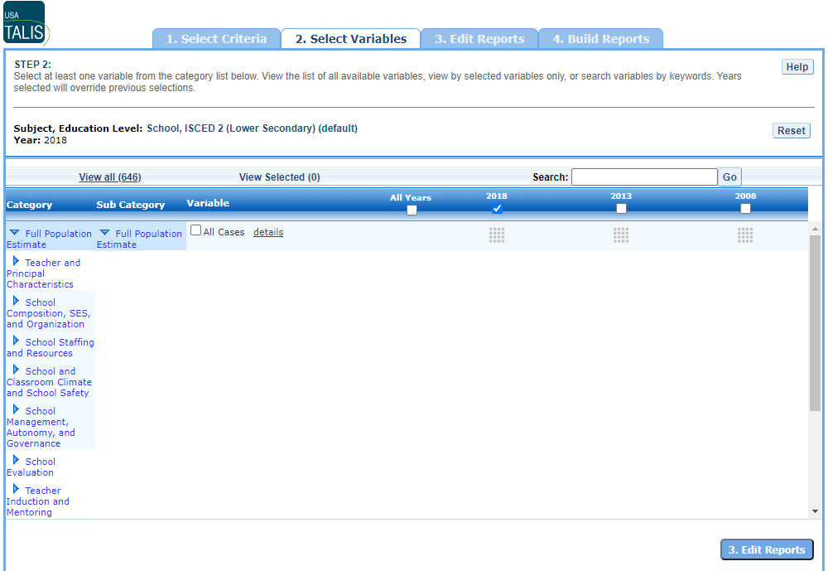

Exhibit 6-4 is a screenshot from the TALIS IDE tool showing an overview of the Select Variables tab.

### 6.2.2 2.B. Select Variables using Category and Sub Category Lists

On the **Select Variables** screen, choose at least one independent variable for your report. One way to do this is to search for independent variables using the **Category** and **Sub Category** lists. If you don’t wish to choose from any of the specified categories and subcategories, then select **All Cases** in the **Total** sub category (displayed as the default independent variable on the Select Variables screen).

The variables shown are tied to the criteria you selected at step 1 (**Subject, Education Level**, **Measure, Year,** and **Jurisdiction**), which are indicated at the top of the screen. To change any of these criteria, return to step 1 by clicking on **Select Criteria**.

To browse for variables and get details about them:

1. Click the blue arrows to open and close Category and Sub Category lists of variables (see exhibit 6-5).
2. Click **details** or **hide details** to show or hide the full title of a given variable, the TALIS IDE identification name (e.g., SC10012), and the values (i.e., variable labels). Note that some variables have similar short titles, but comparing details will show you how they differ. See the example in exhibit 6-5, which shows **School location** and **School location (2013)**. The differences between these two variables are further described in the details.
3. Click the checkbox next to a variable to select it for your analysis/report. You will see the count increase next to **View Selected**.
4. Click the **View Selected** tab to see the variables you have chosen. To return to the full list of variables by Category and Sub Category, click **View all.**
5. Remember to select the year for which you wish to build a report and make sure that data are available for your chosen year and variables.
6. Searching for variables is an option from the **Search** box. See **Section 2.C. Select Variables using the Search Function** on the next page for more details about this function.

Exhibit 6-5. Select variables using category and sub category lists

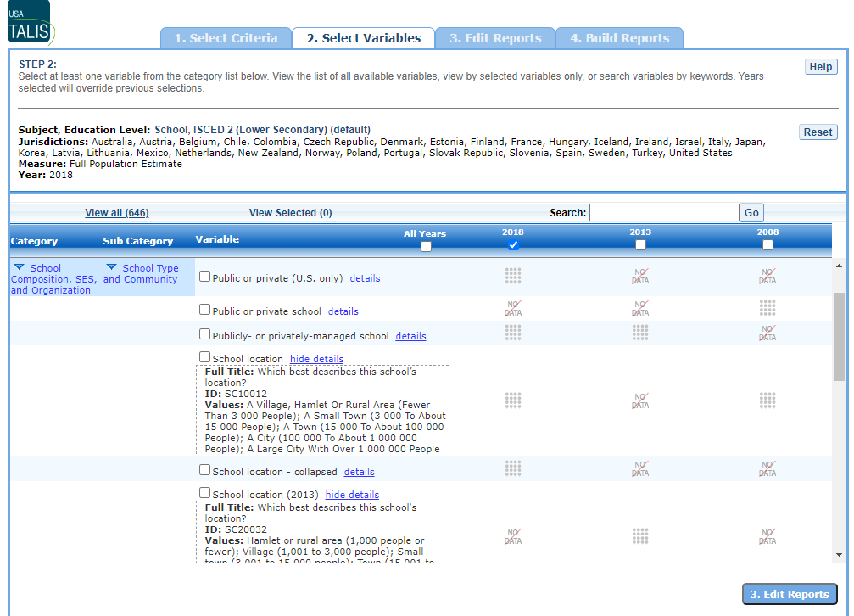

Exhibit 6-5 is a screenshot from the TALIS IDE tool showing how to select a variable from the categories and sub categories listed in the Select Variables tab.

### 6.2.3 2.C. Select Variables using the Search Function

The second way to search for variables is to use the **Search** function on the **Select Variables** screen.

Type a term in the **Search** box and click **Go** (or hit “Enter” on your keyboard) to find variables by keywords in the variable title and/or details for the variable (see exhibit 6-6). The search function operates on whole words or on an exact phrase (if it is contained in quotes). To search for less than a whole word or exact phrase, include an asterisk (*) after the search term. If you use multiple keywords, “and” is assumed. You can narrow your search by using “or,” “not,” or “and not.”

Exhibit 6-6. Select variables using the search function

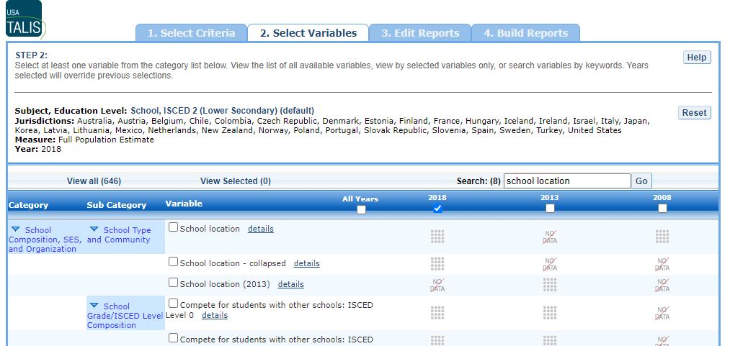

Exhibit 6-6 is a screenshot from the TALIS IDE tool showing how to select a variable using the search function.

When you have selected the independent variable(s) you want to include, continue by clicking the **Edit Reports** button at the bottom of the page or the tab at the top of the page to go to the next step.

## 6.3 3. Edit Reports

### 6.3.1 3.A. Overview

You can access step 3, **Edit Reports,** only after choosing criteria at step 1, **Select Criteria**, and then choosing variables at step 2, **Select Variables**. The IDE will automatically build reports based on your selections from steps 1 and 2. However, at step 3, you may modify your selections for each report.

At this step, you can

* preview and edit the layout of your reports;
* copy reports or create new reports based on the variables selected;
* change formatting options, such as year order or number of decimal places to display for all reports (these may also be changed in individual reports, but format options can overwrite previous edits);
* change statistics options, such as average scores and percentages, for all reports (these may also be changed in individual reports, but statistics options can overwrite previous edits). Please note that no more than two statistics can be included in every report;
* select reports to be built into tables and charts at step 4, **Build Reports**; and
* delete reports.

Using your chosen criteria, the TALIS IDE will return a separate data report for each variable you have chosen. If you have selected two or three independent variables (not counting **All Cases**), you will also see a **cross-tabulated report** for these variables (see exhibit 6-7). If you have chosen four or more variables, you will get data reports for each variable, but a cross-tabulation report will not be produced. If you have selected more than one **Measure** (e.g., a continuous variable from step 1, **Select Criteria**), a separate set of data reports will be generated for each **Measure**.

**Exhibit 6-7. Edit reports overview** 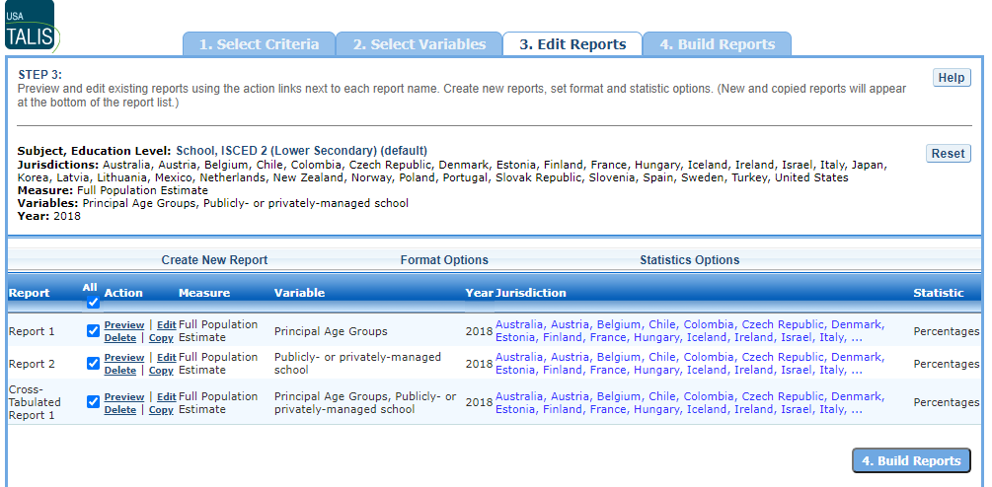

The **Edit Reports** step (see exhibit 6-7) shows detailed information on the layout of your reports.

* The **Report** column indicates the report, or cross-tabulation report, number based on the variable(s) chosen during the criteria selection.
* Under the **All** column, individual or multiple reports may be selected for report building (done in step 4, **Build Reports**), either by selecting **All** or selecting individual reports.
* The **Action** column gives you the option to **Preview**, **Edit, Delete**, or **Copy** the report.
* The **Measure** column shows which measure the report will portray.
* The **Variable** column indicates the variable(s) included in the report. The **Year** column shows which years you have selected for comparison.
* The **Jurisdiction** column labels the countries and subnational education systems selected for comparison.
* The **Statistic** column provides the type of statistic output that will be generated in the report-building phase.

### 6.3.2 3.B. Preview Report

Select **Preview,** in the **Action** column (see exhibit 6-7), to see how your report will be laid out. The preview will not provide actual data, but will show how the data will be arranged in rows and columns (see exhibit 6-8). You can select **Preview** at any time to see how the changes you made during step 3, **Edit Reports,** will affect the report’s final layout.

Exhibit 6-8. Using preview report

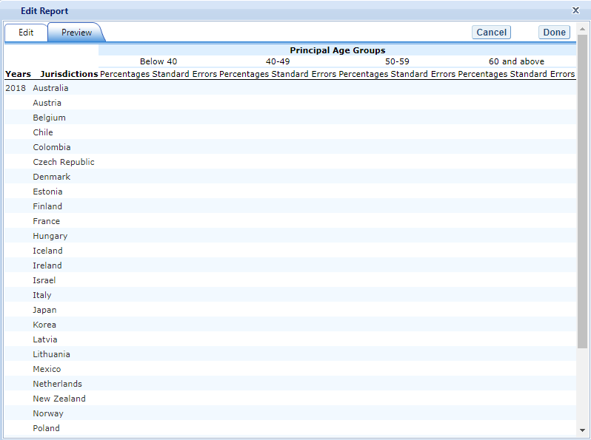

Exhibit 6-8 is a screenshot from the TALIS IDE tool showing an example of the preview function that is available in the Edit Reports tab.

### 6.3.3 3.C. Edit Report

To edit a report, select the **Edit** command in the **Action** column, next to the report number (see exhibit 6-7). (Another way to edit a report is to select the **Edit** tab when you are previewing a report.) The following can be done using the **Edit** command (see exhibit 6-9):

1. Name your report. You have the option of giving each report a distinctive name, up to a limit of 50 characters, using only letters, numbers, spaces, underscores, and hyphens. Otherwise, by default, the report is named Report 1, Report 2, etc., or Cross-Tabulated Report 1, Cross-Tabulated Report 2, etc.
2. Select a measure. You can choose a measure if more than one was selected at step 1.
3. Select which jurisdictions, variables, years (if applicable), and statistics to include (out of the selections previously made at step 1, **Select Criteria,** and step 2, **Select Variables**). You can select up to two statistics options from the following: **averages, percentages, percentiles** and **standard deviations.** (For further information, see **Section 3.G. Statistics Options**.)
4. To create a new variable while editing a report, click on **Create New…** under the **Variable** heading. **Section 3.D. Create New Variables** below explains the process for creating a new variable.
5. Change the table layout by dragging elements to determine which items will appear in rows and which will appear in columns. Some of the arrangements will not be permissible, but a pop-up alert will explain this.

Exhibit 6-9. Editing reports 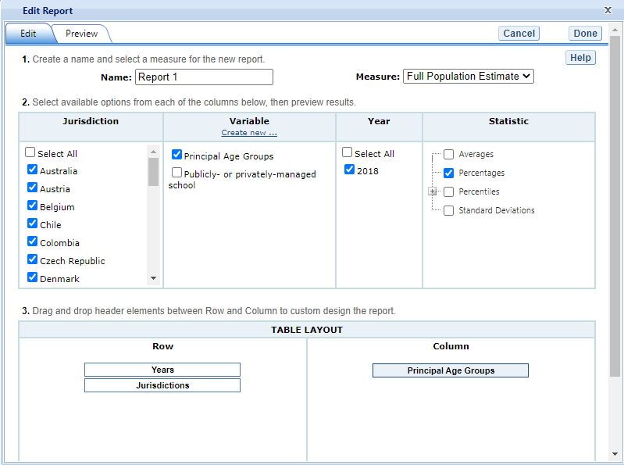

To save changes, make sure to select **Done** in the upper-right portion of the screen before closing the **Edit Report** window.

### 6.3.4 3.D. Create New Variables

To create a new variable, select **Edit,** in the **Action** column, and select **Create new…** under **Variable** (see exhibit 6-9). The new variable is created by combining values for an existing variable. The steps are as follows:

1. Select the variable for which you wish to combine values (see exhibit 6-10).
2. Select the values you want to combine by checking the boxes to the left of the value.
3. Create a name for the new value, and press **Create**. The collapsed values will appear in gray to indicate that they have already been used. The variable named can only be 25 characters long.
4. Wait for the screen to refresh, and press **Done.**

The new variable will appear in the **Variable** list in the **Edit Report** window or **Create New Report** window, designated as “collapsed” (see exhibit 6-11). Check the box next to the new variable to view it in the report. You can click **Preview** to see how the table will be laid out before retrieving data.

Exhibit 6-10. Creating new variables

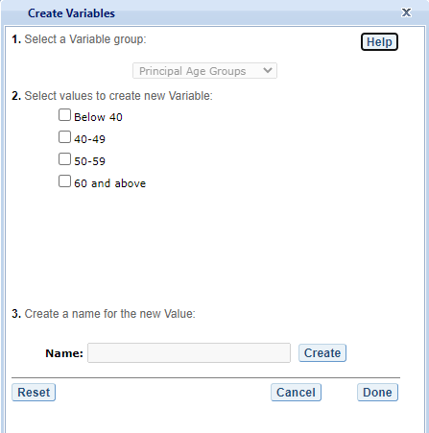

Exhibit 6-10 is a screenshot from the TALIS IDE tool showing an example of the creating new variable function that is available in the Edit Reports tab.

A new variable that you create is applicable *only* to a specific report; it does not apply to the other reports listed on the **Edit Reports** screen.

For example, if you selected multiple measures of teacher and principal characteristics for analysis, then you would need to create the new variable for *each* measure or create a copy of the report and edit it accordingly. To do the latter, click on **Copy** report on the **Edit Reports** screen (copied reports appear at the end of the list of reports) and then, for the new copy, click on **Edit** (using the above example, you can change the measure and give the report a new name).

You can repeat the process and combine different values of a variable to create additional new variables. Using the **Create New Report** function, you can create a new report for each new variable that you create. (For further information, see **Section 3.E. Create New Report** below.)

If you selected two or three variables from which to create new variables, you can repeat the process for each of them. Using the **Create New Report** or **Edit Report** function, these collapsed variables will be listed and available for cross-tabulation (see exhibit 6-11). If you have chosen four or more variables (not counting **All Cases**), you won’t get the cross-tabulation. You can click **Preview** to see how the table will be laid out before retrieving data.

Exhibit 6-11. Edit reports with collapsed variables

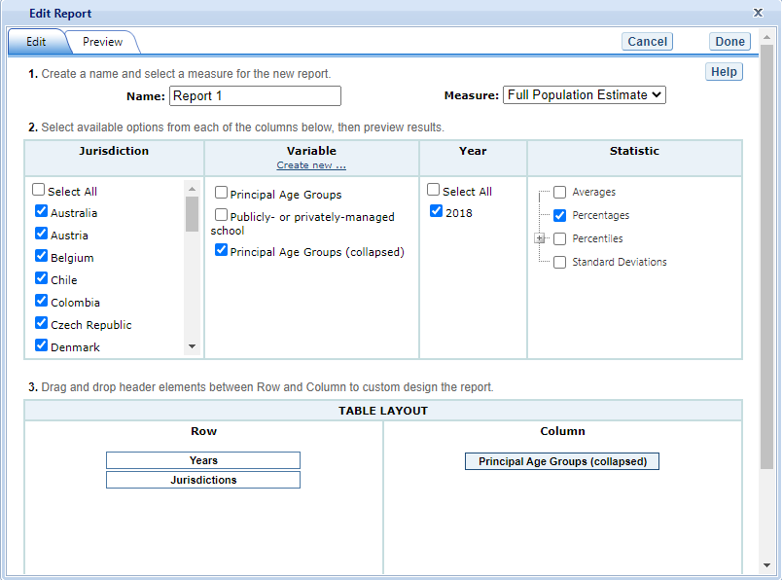

Exhibit 6-11 is a screenshot from the TALIS IDE tool showing an example of the editing report with collapsed variables function that is available in the Edit Reports tab.

### 6.3.5 3.E. Create New Report

From the main **Edit Reports** screen, clicking on **Create New Report** (see exhibit 6-12a) brings up the same options as **Edit Report**, but with no checkboxes marked and without any new variables you may have created. Thus, **Create New Report** provides a clean slate for your selections from the first two steps, **Select Criteria** and **Select Variables** (see exhibit 6-12b). Each new report you create will appear at the end of the list of reports. If you do not give the report a specific name, it will be called “New Report.”

**Exhibit 6-12a. Creating new reports**

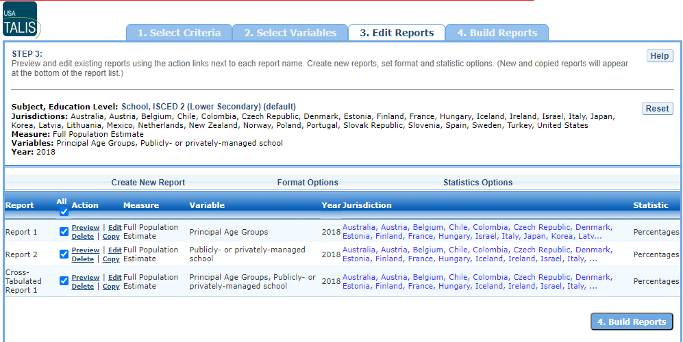

Exhibit 6-12a is a screenshot from the TALIS IDE tool showing an example of the creating new report function that is available in the Edit Reports tab.

**Exhibit 6-12b. Creating new reports**

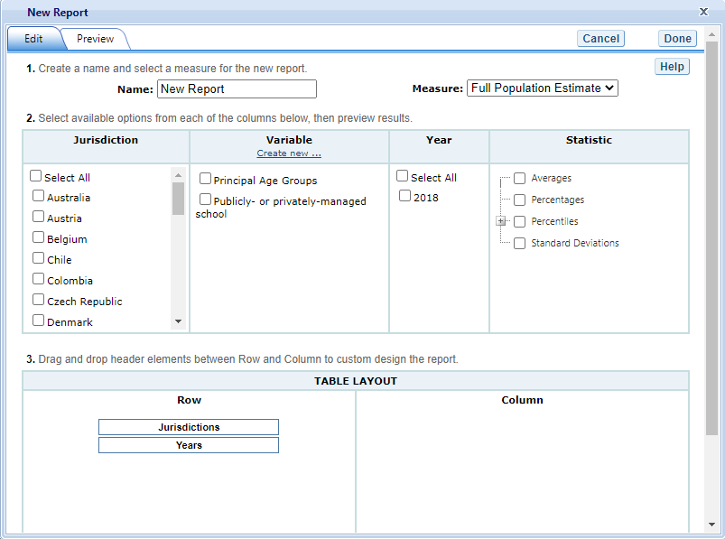

Exhibit 6-12b is a screenshot from the TALIS IDE tool showing an example of the creating new report function that is available in the Edit Reports tab.

### 6.3.6 3.F. Format Options

From the main **Edit Reports** screen, clicking on **Format Options** will allow you to make formatting changes applicable to all the reports listed. The following formatting options are available using this function (see exhibit 6-13):

1. **Variable Labels (Long)** displays a more detailed description of the variables selected in a query than the default short label. For variables from questionnaires, the full text of the question is displayed. Be advised that the length of the extra detail may sometimes interfere with table formatting.
2. **Show data for values categorized as “missing”** will include the percentage of students in the total sample or in a reporting group for whom membership in a particular response category is unknown because no response was given by the students, their teacher, or their school. The percentage of “missing” will be shown in the right-most table column. Missing data are available only for queries that involve percentages as the statistic type. Unless you check this option, the default is for missing responses not to be included in the percentage distribution shown.
3. **Year Order** will order the data tables in each report built, with either the most current year of data, or the oldest year of data, displaying first.
4. **Decimal Places** gives you the option of specifying a lower level of precision for a particular statistic (none or one decimal place) than does the default, which displays averages and percentages to two decimal places. Also, standard errors will be shown to one more decimal place than is shown for a particular statistic. For example, if you request that average scores be displayed to one decimal place, the corresponding standard errors will be displayed to two decimal places. If you export to Excel, you will be able to increase the number of decimal places in most cases.
5. **Include** gives you the option of showing standard errors. By default, standard errors are shown inside parentheses, but you have the option of choosing to show them without parentheses*.* You can preview the effects of your selection in the **Sample Display** area (see the blue-shaded box at the bottom of exhibit 6-13 below).

Exhibit 6-13. Format options

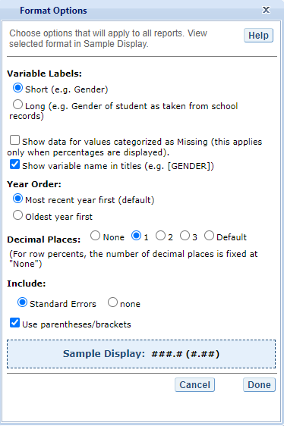

Exhibit 6-13 is a screenshot from the TALIS IDE tool showing an example of the format options available in the Edit Reports tab.

Be advised that the choices you make in the **Format Options** window will apply to *all* reports and cannot be changed for individual reports. Use the **Reset** button, located in the upper-right portion of the main **Edit Reports** screen (just below the **Help** button), to restore the **Format Options** to the default settings (although caution is advised, as this will also delete any new reports that you have created).

### 6.3.7 3.G. Statistics Options

Available only from the main **Edit Reports** screen, clicking on **Statistics Options** allows you to designate up to two statistics. The selections you make are applicable to all the reports listed, although you can also change the statistics for an individual report when you edit it. (For further information, see **Section 3.C. Edit Report**.)

The following statistics options are available (see exhibit 6-14):

1. **Averages.** For the TALIS assessment, teacher and principal averages for continuous variables are in the same units as the variables themselves (e.g., average age of teachers). By default, the standard errors of the averages are shown in parentheses. Averages will only display in the TALIS IDE if you have selected a continuous variable from step 1, **Select Criteria**.
2. **Percentages.** This statistic shows the percentage of teachers or schools as a row percentage. For example, if the first column lists countries or subnational education systems, then each country or subnational education system will display its own percentage distribution across its row. By default, percentage distributions do not include missing data. For information on how to show data for values categorized as missing, see **Section 3.F. Format Options**.
3. **Percentiles.** This statistic shows the threshold (or cut-point) score for the following:

10th percentile – the bottom 10 percent of schools or teachers

25th percentile – the bottom quarter of schools or teachers

50th percentile – the median (half scored below the cut-point and half scored above it)

75th percentile – the top quarter of schools or teachers

90th percentile – the top 10 percent of schools or teachers

1. **Standard deviations.** The standard deviation is a measure of how > widely or narrowly dispersed scores are. Under general normality > assumptions, 95 percent of the scores are within two standard > deviations of the mean. For example, if the average score is 35 > and the standard deviation is 5, it means that 95 percent of the > scores fall between 30 and 40. The standard deviation is the > square root of the variance.   
   **>**

Exhibit 6-14. Statistics options

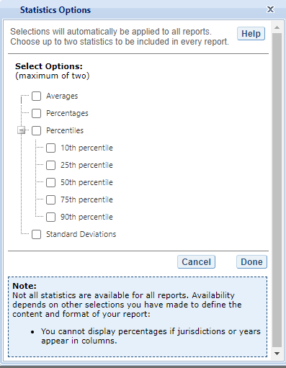

Exhibit 6-14 is a screenshot from the TALIS IDE tool showing an example of the statistics options available in the Edit Reports tab.

As previously noted, the selections you make in **Statistics Options** will be applied automatically to all reports, although you can change the statistics for an individual report if you use the **Edit** command in the **Action** column. Be advised that if you use **Statistics Options** after editing the statistics in one or more of your individual reports, the statistics options selected will overwrite your previously edited selections. If you wish to use the same criteria and variables in a report with a different selection of statistics, consider using the **Create New Report** function to generate a new report with different statistics. (For further information, see **Section 3.E. Create New Report**.) You can also make a copy of an individual report.

You can use the **Reset** button, located in the upper-right portion of the main **Edit Reports** screen (just below the **Help** button), to restore the **Statistics Options** to the default setting, which is average scale scores for all reports (this will also delete any new reports that you created).

Not all statistics are available for all reports. Their availability depends on other selections you have made to define the content and format of your report.

NOTE: The statistics produced by the IDE may not match the statistics in reports published by the OECD, due to differences in certain statistical standards. In particular, NCES and the OECD may differ in the minimum sample sizes required for publishing teacher and school reports.

### 6.3.8 3.H. Select Reports to Build

In order to proceed to step 4, **Build Reports**, each report for which you want to retrieve data should be previewed using the **Preview** function. To decrease processing time as you move to step 4, you can uncheck any reports for which you do not wish to retrieve data. By default, all reports are checked. To uncheck one or more reports, you can either uncheck the reports individually or click on the **All** box. (Doing the latter will uncheck all of the reports and allow you to check only those for which you wish to retrieve data.) In the example that follows (see exhibit 6-15), all reports are checked, and their data will be retrieved.

Exhibit 6-15. Selecting reports to build



Exhibit 6-15 is a screenshot from the TALIS IDE tool showing how to select reports to build in the Edit Reports tab.

1. **Delete** is used in the **Action** column if you wish to delete a > report from the list of reports.
2. You may use the **Reset** button to restore the deleted reports > (although caution is advised, as this will also delete any new > reports that you created and restore the **Format Options** and > **Statistics Options** to the default settings).

To continue to the last step in the IDE, click the **Build Reports** button at the bottom of the page or the tab at the top of the page to go to the next screen.

## 6.4 4. Build Reports

### 6.4.1 4.A. Overview

After step 1, **Select Criteria**, you may also go on to step 2, **Select Variables** and step 3, **Edit Reports** where you can select additional variables and edit reports, before moving on to step 4, **Build Reports**. In the **Build Reports** tab (see exhibit 6-16), you can do the following:

* Generate a data table for each report selected in step 3, **Edit Reports** as shown by the **Select Reports** drop-down feature. By default, all reports are checked, although you can uncheck any reports for which you do not wish to retrieve data. (For further information, see **Section** **3.H. Select Reports to Build**.)
* Export and save data tables into various formats using the **Export Reports** button. The output formats include HTML (print-friendly), Microsoft Word, Microsoft Excel, and Adobe PDF.
* Select the **Chart** tab to create and customize charts for each report and save them for export in the above formats.
* Select the **Significance Test** tab to run a significance test on your results, customize it, and export it.

Exhibit 6-16. Build Reports overview

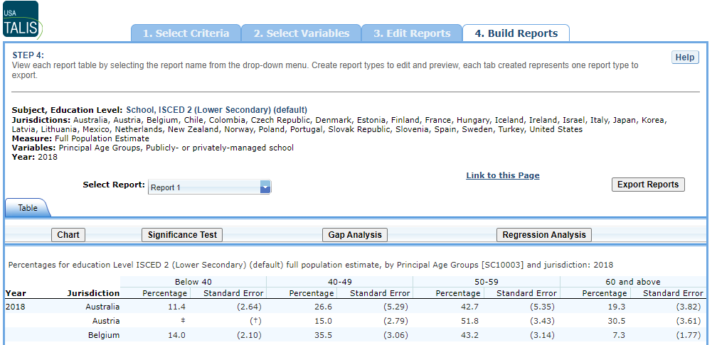

Exhibit 6-16 is a screenshot from the TALIS IDE tool showing an overview of the Build Reports tab featuring the Select Report, Export Reports, Chart, and Significance Test options.

### 6.4.2 4.B. View Reports as Data Tables

Once you click on **Build Reports,** the reports will be generated (evidenced by the “Progress” percentage bar) and then appear on your screen as they complete (see exhibit 6-17). Some reports will take longer than others to process, so please do not hit the “Back” button on your browser during this stage. To select a different report to view, go to the **Select Report** drop-down menu (see 4.B. in exhibit 6-16) and choose the report of interest. To change the formatting or statistics options of a table or to generate a report not included in your selection, return to step 3, **Edit Reports**.

Exhibit 6-17. Processing data

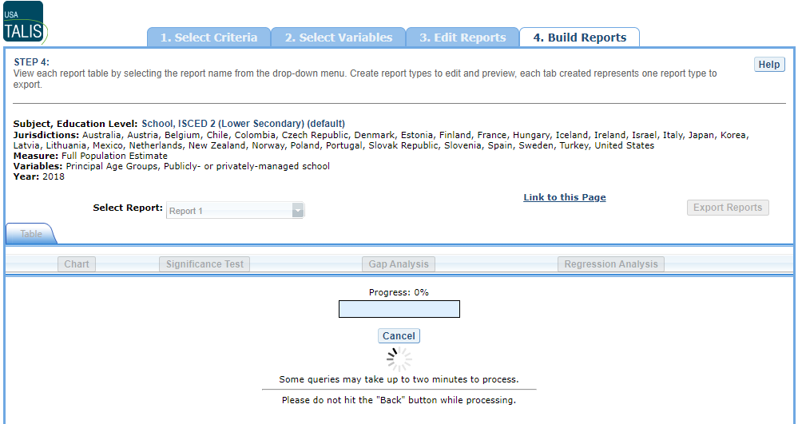

Exhibit 6-17 is a screenshot from the TALIS IDE tool showing an overview of the building reports page while data is processing.

### 6.4.3 4.C. Charts

To create a chart, go to **Select Report** on the **Build Reports** screen to choose the report of interest from the drop-down menu, and then click the **Chart** link (see exhibit 6-18).

You will be able to create many types of charts and customize them. **Section 4.E. Create Charts – Chart Options** provides a summary of the available features and how they can be customized.

Exhibit 6-18. Viewing reports as charts

### 6.4.4 4.D. Create Charts

When you click **Chart,** you will first make selections pertaining to **Jurisdiction, Year/Study,** and **Statistic** (see exhibit 6-19). All **Jurisdictions** and **Studies** are selected by default, while you can only choose one **Statistic**. You may uncheck any of the criteria that you do not wish to chart, as long as you have selected one in each category.

Only the statistics option(s) used to report data in the previous step will be presented, and only one statistics option can be selected at a time. For example, **Percentiles** will appear as the only data option to build the chart if the table created in the previous step is reporting data with only percentiles selected as the statistics option.

Once you are finished with the Data Options, click the **Create** **Chart** button in the lower-right corner of the screen.

Exhibit 6-19. Data options for charts

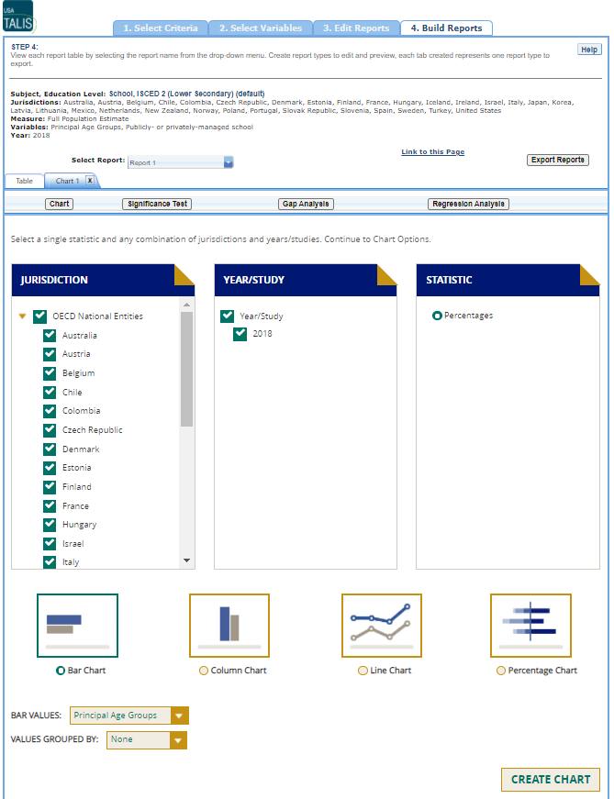

Exhibit 6-19 is a screenshot from the TALIS IDE tool showing the data options available in the chart creating function in the Build Reports tab.

### 6.4.5 4.E. Create Charts – Chart Options

Next, you can make selections regarding the chart options located below on the same page.

1. Select **Bar Chart**, **Column Chart**, **Line Chart,** or > **Percentage Chart** (see 1 in exhibit 6-20). If the Percentiles > Statistic is selected, you can also select from a **Percentile > Chart** option.
2. After selecting a chart type, change any data dimensions from the > drop-down menus for **Bar**, **Column**, or **Line Values** and > **Values Grouped by** (see 2 in exhibit 6-20). Any new variables > that you created at step 3, **Edit Reports**, will be available > for selection, but only if you selected the variables (by clicking > the checkbox next to them) and pressed **Done** after you edited > the report.
3. Create your chart by clicking the **Create Chart** button in the > lower-right corner (see 3 in exhibit 6-20).   
   **>**

**Exhibit 6-20. Chart options**



Exhibit 6-20 is a screenshot from the TALIS IDE tool showing the chart options available in the chart creating function in the Build Reports tab.

While previewing your chart, you can do the following (see exhibit 6-21 as an example of a **Percentile Chart** and exhibit 6-22 as an example of a **Bar Chart**):

1. Use the drop-down menus to change the jurisdiction and other variables as applicable.
2. Place your cursor over the bars of the chart to see the data points and value label(s).

Exhibit 6-21. Percentile chart 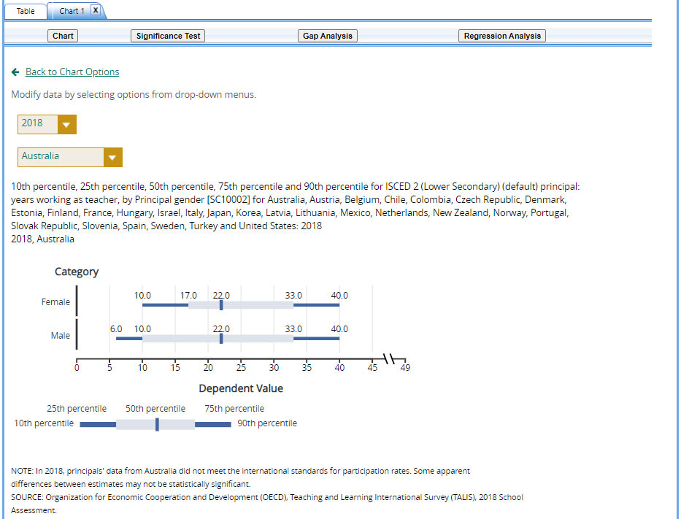

Exhibit 6-22. Bar chart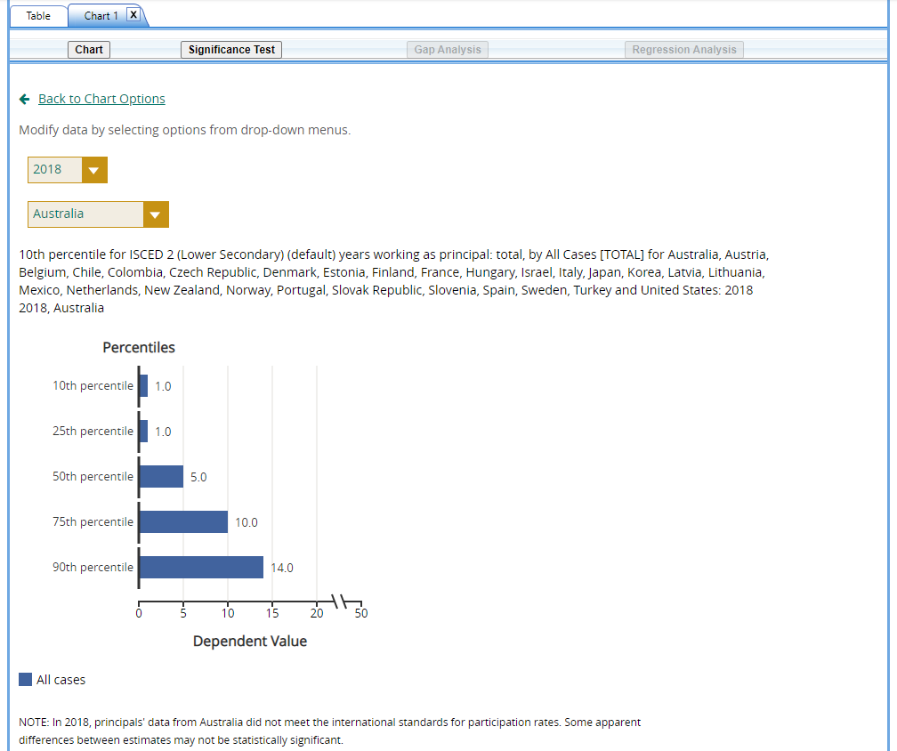

You can choose **“Back to Chart Options”** (located in the upper-left corner, below the **Chart** link) to make more changes.

To make an additional chart from the same report or table, click the **Chart** link on the **Build Reports** screen. It is recommended that you provide a new chart name (the default is Chart 1, Chart 2, etc.). If you don’t start the process again by clicking the **Chart** link, the new chart will overwrite the previous one.

If you wish to make charts from other reports, select another report in the **Select Report** drop-down list. If other reports were not checked in step 3, **Edit Reports**, go back to step 3 and check the ones you want. Then, when you advance to step 4, **Build Reports**, the reports will appear in the **Select Report** drop-down list. If you need to create new reports, go back to step 1, **Select Criteria**, and/or step 2, **Select Variables**. Remember to export any completed charts you want to save by clicking **Done** and using the **Export Reports** function before leaving the **Build Reports** screen. (For further information, see **Section 4.I. Export Reports**.)

### 6.4.6 4.F. Significance Tests

Tests for statistical significance indicate whether observed differences between assessment results are likely to have occurred because of sampling error or chance. “Significance” here does not imply any judgment about absolute magnitude or educational relevance. It refers only to the statistical nature of the difference and whether that difference likely reflects a true difference in the population.

With your report of interest selected, click the **Significance Test** link, which is located to the right of the **Chart** link (see exhibit 6-16). You first need to decide which variable you want to test and the criterion by which you want to test it (i.e., between jurisdictions, within variables, or across years). You will compare or “look across” the variable’s range of values, so it must have more than one value. You can look across jurisdictions for a variable (that is, compare between two or more jurisdictions) or you can look across the values within a variable for a single jurisdiction. For example, with the variables shown in exhibit 6-23, you could choose to compare percentages of female teachers between countries and subnational education systems, or you could choose to compare percentages of female teachers and male teachers. Once the primary criterion is chosen, all other criteria must be restricted to a single value.

The general steps for running significance tests are as follows (see exhibit 6-23):

1. In the **Significance Test** window, select either **Between Jurisdictions**, **Within Variables**, or **Across Years**. Then, select the appropriate jurisdiction(s), variable(s), year(s), and statistic(s). For **Between Jurisdictions**, select at least two jurisdictions. For **Within Variables**, select one or more jurisdictions. For **Across Years**, more than one year needs to be selected.
2. Enter a **Name** limited to 25 characters, using only letters, numbers, spaces, underscores, and hyphens (otherwise, by default, the test is named “Sig Test 1”).
3. Select the output type as either **Table** or **Map**. The table option will show the significance test results as a matrix. The map option will show the significance test results on a world map, highlighting the countries and subnational education systems that have been selected. The map output is only available when **Between Jurisdictions** is selected in the first step.
4. Additional options allow you to select **Show Table Details** to display the estimates and standard errors for the table cells. If you selected a map, this option is not applicable, as the map will automatically show statistical details.
5. Click the **Preview** tab located in the upper-left corner, or the **Preview** button located in the bottom-left corner.
6. Click the **Edit** tab in the upper-left corner of the screen if you wish to go back and make changes to the selections you made for running the significance tests.
7. Click the **Done** button in the upper- or lower-right corner of the screen to run the significance tests.

Exhibit 6-23. Significance test options

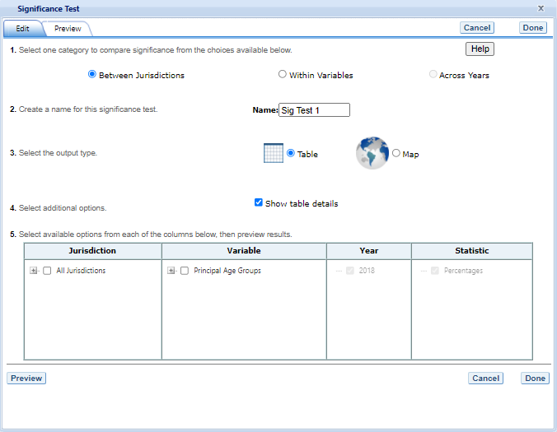

Exhibit 6-23 is a screenshot from the TALIS IDE tool showing the significance test options available in the Build Reports tab.

When the table option is selected, you will get a significance test matrix in which you will see the differences and *p* values. Using the symbols shown in the legend of the matrix, an indication is also provided of whether one estimate is significantly lower or higher than another estimate or whether there is no significant difference (see exhibit 6-24).

The alpha level for all *t*-tests is .05. All comparisons within a jurisdiction, within the same year, are made using dependent *t*-tests. Comparisons between jurisdictions are treated as independent. Comparisons across years are treated as independent. A part-whole adjustment is implemented for comparisons between a jurisdiction and a group that the jurisdiction is part of (e.g. Average of All Jurisdictions).

Exhibit 6-24. Significance test table output

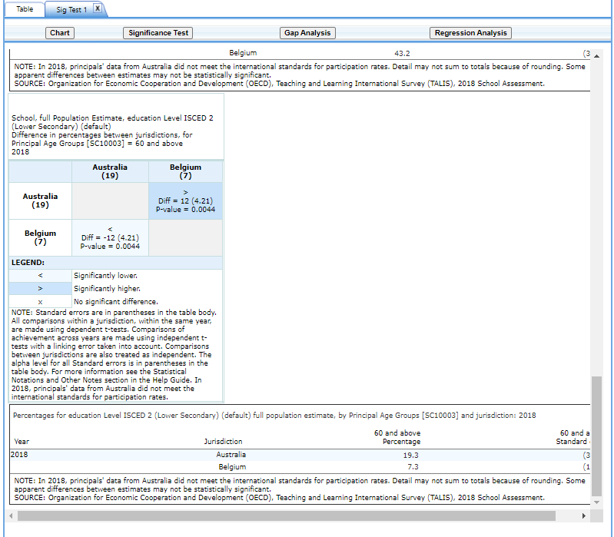

Exhibit 6-24 is a screenshot from the TALIS IDE tool showing an example of a significance test table output in the Build Reports tab.

When the **map option** is selected, a global map is shown with the countries and subnational education systems selected shaded (see exhibit 6-25). The focal jurisdiction is shaded in teal green, with all other countries compared to it. The other countries are shaded in colors that indicate whether they are higher, lower, or not significantly different from the focal jurisdiction on whatever measure has been selected. Note that a light shade of gray is the default color for jurisdictions not selected for comparison.

When you hover over a jurisdiction, a text bubble displays the numerical difference in estimates between that jurisdiction and the focal jurisdiction. At any point, you may choose a different focal jurisdiction by clicking on another country. You may also choose a different variable category for comparison by using the drop-down menu above the map.

Exhibit 6-25. Map of significance tests

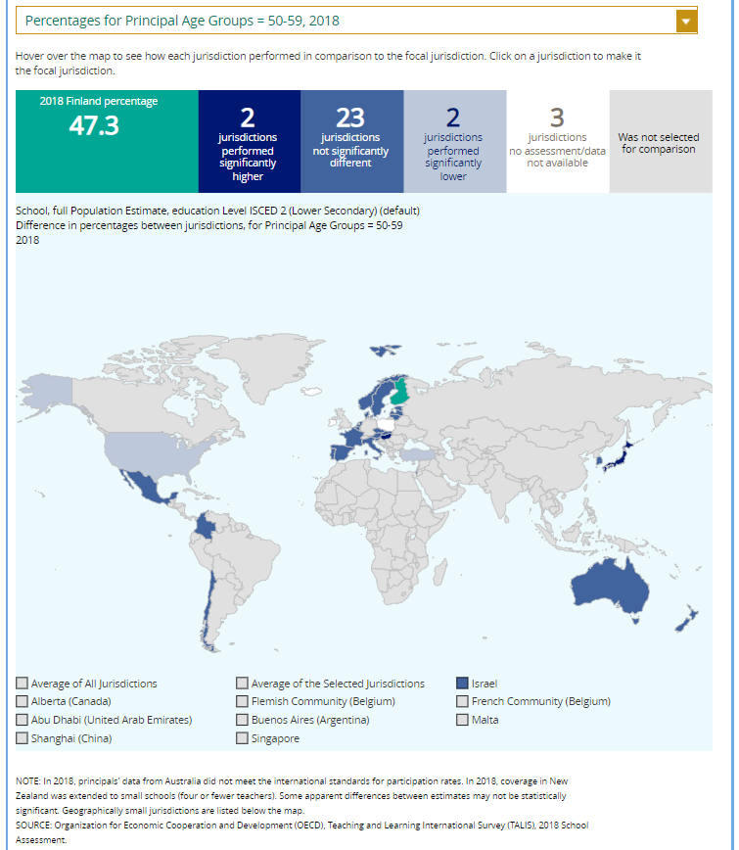

Exhibit 6-25 is a screenshot from the TALIS IDE tool showing an example of a significance test map output in the Build Reports tab.

Please note that the IDE does not apply adjustments for multiple comparisons. This is consistent with current NCES statistical standards and practice.

**4.G. Gap Analysis**

Gap analysis is included in the IDE to compare differences in gaps shown in a table, map, or chart. Gap differences can be compared between jurisdictions and/or across years.

**Exhibit 6-26. Gap analysis link selection**



Exhibit 6-26 is a screenshot from the TALIS IDE tool showing how to select the gap analysis function in the Build Reports tab.

With your report of interest selected, click on the **Gap Analysis** link, which is located to the right of the **Significance Test** link (see exhibit 6-26). You will need to decide which variable you would like to test (e.g., principal job satisfaction, good teacher-student relationships) and the criterion by which you want to test it (i.e., between jurisdictions or across years). The difference measure, or gap, can be viewed **Between Groups**, **Between Years**, **Between Groups and Years**, or **Between Percentiles** within the selected variable. For example, if you compute the difference in administrative and leadership tasks for principals from different age groups for two countries, you can:

* at one time point, compare the age-group (e.g., ages below 40 and between 40-49) gap in one country/subnational education system to the age-group gap in another country/  
  subnational education system;
* compare the age-group gap at two time points within a country/subnational education system;
* compare the difference between the age-group gap at two time points in country/  
  subnational education system to the difference between the age-group gap at two time points in another country/subnational education system; or
* compare the gap for ages below 40 at two time points in one country/subnational education system to the gap for ages below 40 at two time points in another country/subnational education system.

**Exhibit 6-27. Gap analysis options**

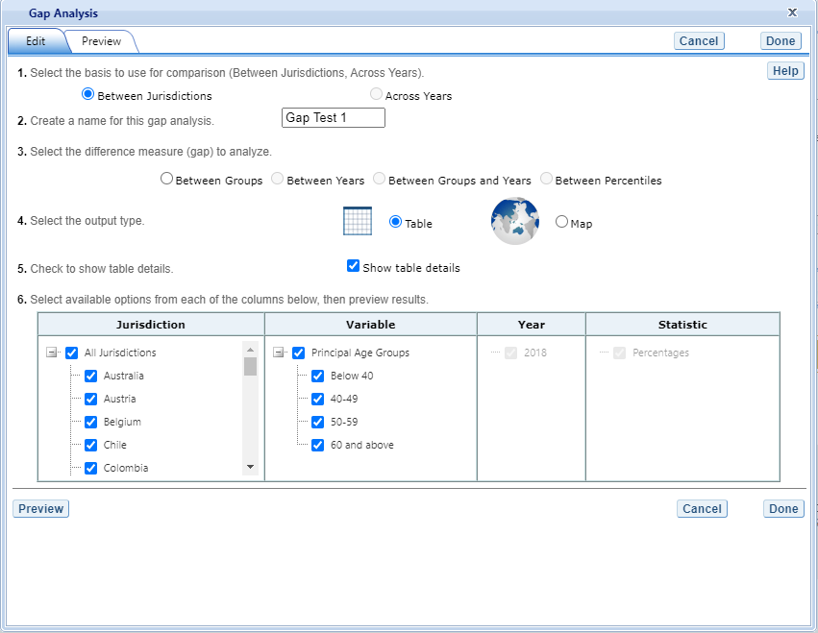

Exhibit 6-27 is a screenshot from the TALIS IDE tool showing the gap analysis options available in the Build Reports tab.

The steps for running a gap analysis (exhibit 6-27) are similar to those for conducting a statistical significance test. Thus, to run a gap analysis, follow the instructions under **Section 4.F. Significance Tests**, noting the following differences:

* The **Gap Analysis** link should be selected, not the **Significance Test** link.
* The gap analysis does not have a **Within Variables** option for analysis; the options are **Between Jurisdictions** and **Across Years.**
* The difference measure (gap) of analysis must be selected from the following: **Between Groups, Between Years, Between Groups and Years,** and **Between Percentages** (if variables are selected for which a difference measure is not feasible, the difference measure option will not appear as available in the **Gap Analysis** menu).

The gap analysis output is presented in a format similar to that of the significance test output, with one difference: the difference estimate shown in the output is the difference between the gaps selected for analysis. Note that you will still see the significance of these differences, just like in a significance test. For example, exhibit 6-28 shows cross-national differences in the percentage gaps between two age groups (principals who are below 40 and who are 60 and above).

The gap analysis function computes and statistically tests differences between average, percentage, or percentile gaps. Note that the reference group for the gaps is kept constant during the analysis, as opposed to taking the absolute value of the gaps. Therefore, the gap analysis tests whether the magnitude of the gaps differ from each other only when the gaps go in the same direction.

**Exhibit 28. Gap analysis output**

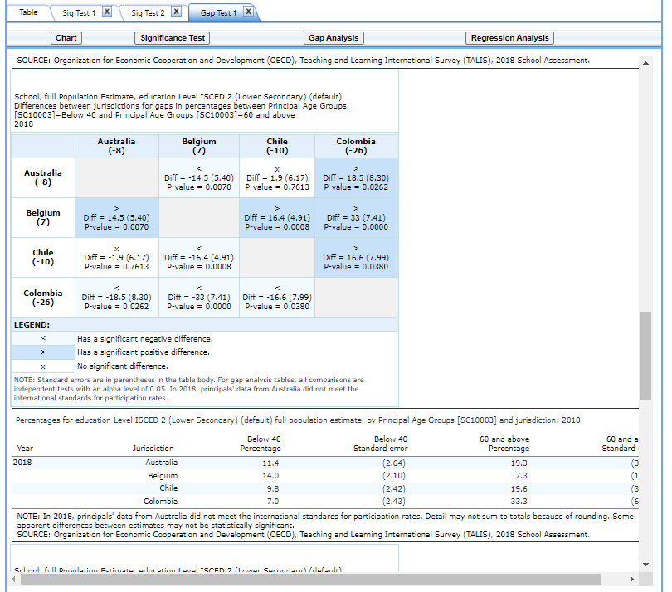

Exhibit 6-28 is a screenshot from the TALIS IDE tool showing an example output report based on the gap analysis options.

NOTE: A gap analysis across years cannot be combined with the **Between Years** or **Between Groups and** **Years** difference measures, so you will select the difference measure **Between Groups,** or, if you have selected percentiles as one of your statistics, you may choose **Between Percentiles.**

**4.H. Regression Analysis**

Regression analysis is included in the IDE to test for trends across more than two data points. The type of analysis performed in this feature of the IDE is referred to within the field of statistics as linear regression. To run a regression, first go to **Build Reports** and choose the report of interest from the drop-down **Select Report** menu. Then click on the **Regression Analysis** link, which is to the right of the **Gap Analysis** link (see exhibit 6-29).

**Exhibit 6-29. Regression analysis link selection**



Exhibit 6-29 is a screenshot from the TALIS IDE tool showing how to select the regression analysis function in the Build Reports tab.

The general steps for running a regression analysis are as follows (see exhibit 6-30):

1. In the **Regression Analysis** pop-up window, enter a **Name** limited to 25 characters, using only letters, numbers, spaces, underscores, and hyphens (otherwise, by default, the test will be named “Regression 1”).
2. Select the appropriate jurisdiction, year, and variable(s) for analysis. Please note that you may only choose one jurisdiction and year at a time to be in your report, but you may choose up to three variables. In order to use up to three variables, you must have already created and selected a cross-tabulated report (by selecting three variables in Step 2, **Select Variables**).
3. Click the **Preview** tab located in the upper-left corner to view the table format into which your output will be populated. In the Preview tab, an “X” denotes where the output will display.
4. Click the **Done** button in the upper- or lower-right corner of the screen to run the regression analysis.

Click the **Edit** tab in the upper-left corner of the screen if you wish to go back and make changes to the selections you made for running the analysis.

**Exhibit 6-30. Regression analysis options**

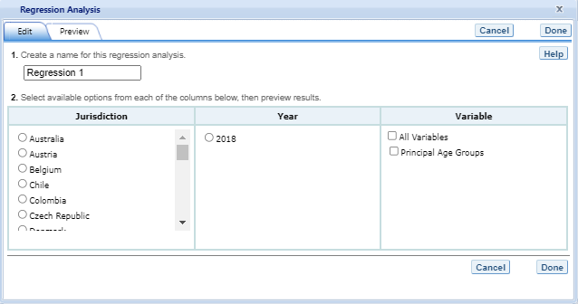

Exhibit 6-30 is a screenshot from the TALIS IDE tool showing the options for the regression analysis output.

After you have clicked **Done**, your regression analysis output will load onto the screen (see exhibit 6-31). A 0-1 contrast coding is used to code the independent variable, where the first subgroup of the independent variable is the reference group. Using dummy-coded variables in a linear regression is useful for comparing each subgroup against a reference group. For example, in exhibit 6-31, the reference group for the independent variable **Principal Age Groups (**SC10003**)** is the subgroup “Below 40,” and it is coded as 0. Except for the reference group, each subgroup (e.g., ages “40-49,” “50-59,” and “60 and above”) is contrast coded in a separate dummy variable (code 1) against all the other subgroups of the variable (coded 0).

Exhibit 6-31. Regression analysis output

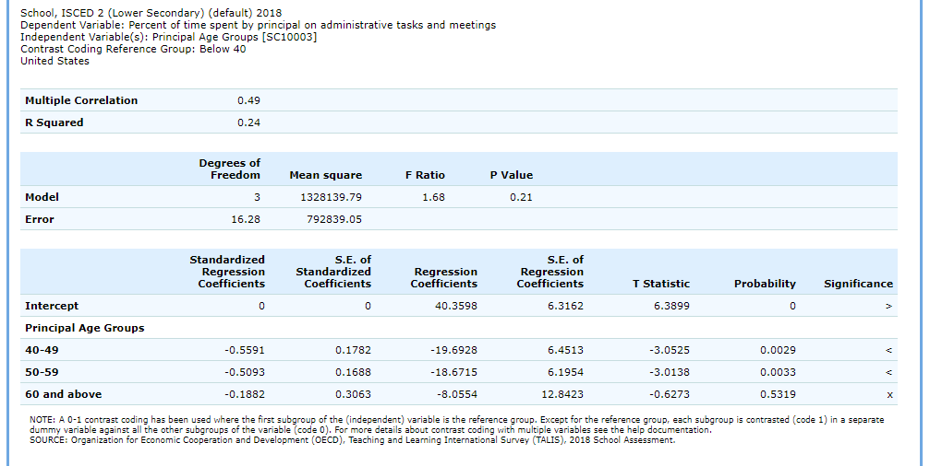

Exhibit 6-31 is a screenshot from the TALIS IDE tool showing an example of the regression analysis output.

Using the output from exhibit 6-31, you can compare the mean percentage of principals below age 40 to the mean percentage of those age 40 and above. When a single dummy-coded variable is used in a regression, the *intercept* is the mean of the reference group (e.g., 40.3598), and the *regression coefficient* is the difference between the mean of the reference group and the group identified (coded 1) with the dummy-coded variable (e.g., -19.6928 for 40 to 49 years old). Since the regression coefficients are presented with a standard error and a *t* value, they can be used to test whether a difference between means is statistically significant. Under the **Significance** column in the output, you will see three possible signs: (1) < signifies a significant negative difference, (2) > signifies a significant positive difference, and (3) x signifies the difference is not significant.

### 6.4.7 4.I. Export Reports

Click on the **Export Reports** button/arrow located on the right side of the **Build Reports** screen (see exhibit 6-29) to save or print your tables, charts, and significance tests. The report names that appear in the **Export Reports** window are those that were checked off at step 3, **Edit Reports**.

Check the files you want to export, and select one of the file formats: **HTML** (print-friendly), **Excel, Word,** or **PDF** (see exhibit 6-32). All reports that you select at the same time will be exported in one file. In the Excel format, you will be able to increase the decimal places visible (wherever more precision is available in the database). Because there are many different operating systems in use, you may get an error message with Excel or one of the other formats. Usually, this will not affect your ability to export, so please wait for the software errors to resolve.

Exhibit 6-32. Export report options

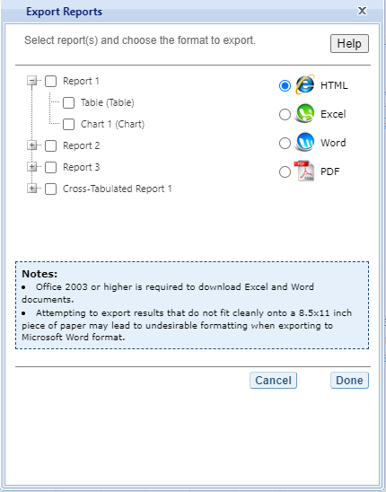

Exhibit 6-32 is a screenshot from the TALIS IDE tool showing the export options, including HTML, Excel, Word, and PDF.

If you wish to edit tables or charts before saving or printing them, remember to do this via the **Export Reports** function before leaving the **Build Reports** screen. If you return to prior screens to edit the table formats or change variables or criteria, you will overwrite the tables and charts.

# 7 ICILS IDE Walkthrough

There are four general steps for exploring each IDE page (see exhibit 7-1). Each step is described in more detail in the following sub-sections.

Exhibit 7-1. What you will see in the IDE environment and what each step entails 

## 7.1 1. Select Criteria

### 7.1.1 1.A. Overview

Your data query in the ICILS IDE begins on the **Select Criteria** screen (see exhibit 7-1).

Select a **Display** from the drop-down menu. Once the screen resets, you can choose one or more **Years**, **Measures**, and **Jurisdictions** for the data you wish to view or compare. Use the **Reset** button, located in the upper-right portion of the screen (just below the **Help** button), to cancel your selections and begin again.

Click on a blue sideways-facing arrow (►) to open up a category and click on a blue downward‑facing arrow (▼) to close a category.

Exhibit 7-2. Selecting criteria

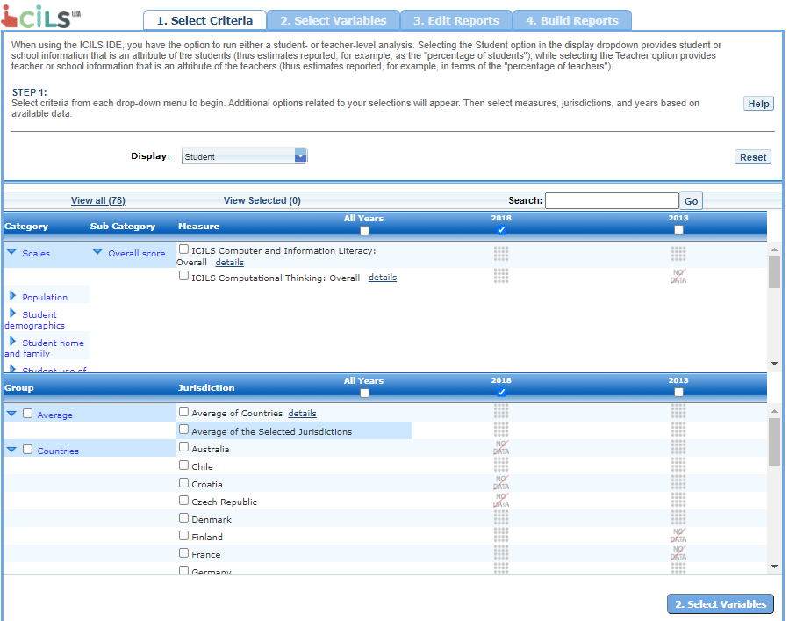

Exhibit 7-2 is a screenshot from the ICILS IDE tool showing the Select Criteria tab.

### 7.1.2 1.B. Choose Display

Under **Display**, you have the choice of **Student** and **Teacher**, which corresponds to running either a student- or teacher-level analysis. Selecting the Student option in the display drop-down list provides student or school information that is an attribute of students (with estimates reported, for example, as the “percentage of students”), while selecting the Teacher option provides teacher or school information that is an attribute of teachers (with estimates reported, for example, in terms of the “percentage of teachers”). Once a display is chosen, the screen resets and you can select **Year**(s), **Measure**(s), and **Jurisdiction**(s).

### 7.1.3 1.C. Choose Year

At the top of the **Measure** and **Jurisdiction** sections, you have the choice of selecting 2018 and/or 2013 by checking the appropriate box. To include data from both years, check the “All Years” box to the left of the individual years. CIL data is available for both years, and CT data is available for 2018.

### 7.1.4 1.D. Choose Measure

After choosing a display, you can choose one or more outcome variables under Measure, including the overall scales for CIL or CT (Student display only) and other continuous variables. These variables fall into different categories. For example, the variable “Age of student” can be found in the Student demographics category in the Student display, and the variable “About You/ Year Teaching Started” can be found in the Teacher demographics category in the Teacher display.

Some of the continuous variables may have missing values if there are cases that did not answer the assessment or the questionnaire. In both the Student and Teacher displays, selecting the variable “Percentage across full sample” under the *Population* category will allow you to calculate percentage statistics based on the full sample.

### 7.1.5 1.E. Choose Jurisdiction

With your **Measure**(s) and **Year**(s) selected, next choose at least one **Jurisdiction**.

Jurisdictions are found under the following groups: **Countries** and **Benchmarking participants.** There is also a group category called **Average**, with options to display the **Average of Countries** and the **Average of the Selected Jurisdictions**.

The general procedures for selecting one or more jurisdictions are as follows:

1. To open or close jurisdictions, click on the arrow. Jurisdictions in > the group are open and can be selected when the blue arrow points > down (see exhibit 7-3).
2. Click the checkboxes next to the specific jurisdictions that you are > interested in or uncheck those jurisdictions that you wish to > deselect. If you click the checkbox next to the group name (e.g., > “Countries”), you will select all the jurisdictions within that > group. If desired, uncheck the group name to deselect all.
3. If you want to close a group (for example, close the list of > countries in order to readily see the Benchmarking participant > jurisdictions), click the blue arrow next to the group name. The > closed group’s arrow points to the right. Be advised that closing > the group will not deselect your choices.

Exhibit 7-3. Choosing jurisdictions

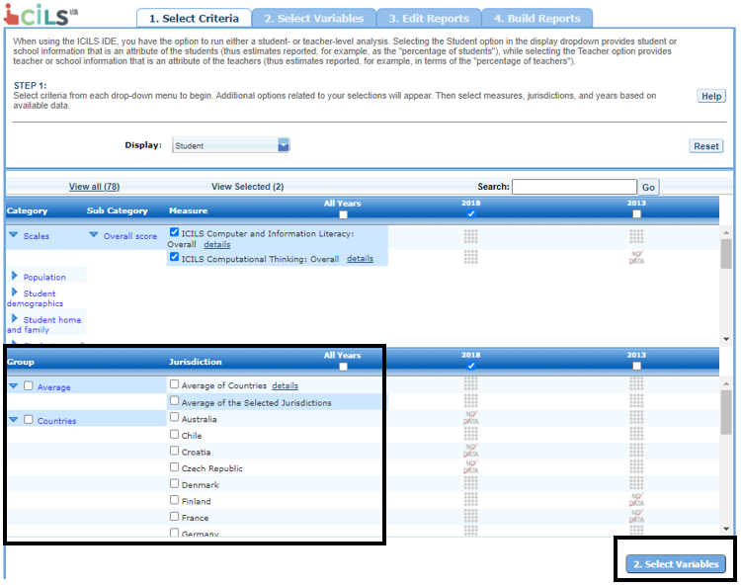

Exhibit 7-3 is a screenshot from the ICILS IDE tool showing jurisdictions available in the Select Criteria tab.

To continue in the IDE, click the **Select Variables** button at the bottom right of the page or the tab at the top of the page to go to the next screen (see exhibit 7-3).

## 7.2 2. Select Variables

### 7.2.1 2.A. Overview

Step 2, **Select Variables**, can only be accessed after choosing criteria at step 1, **Select Criteria**.

To continue your data query and edit a report, *you must choose at least one variable on this screen.* You can browse for variables using the **Category** and **Sub Category** lists or by using the **Search** function (see exhibit 7-4). You can return to this screen to change variable selections at any time.

Exhibit 7-4. Select variables overview

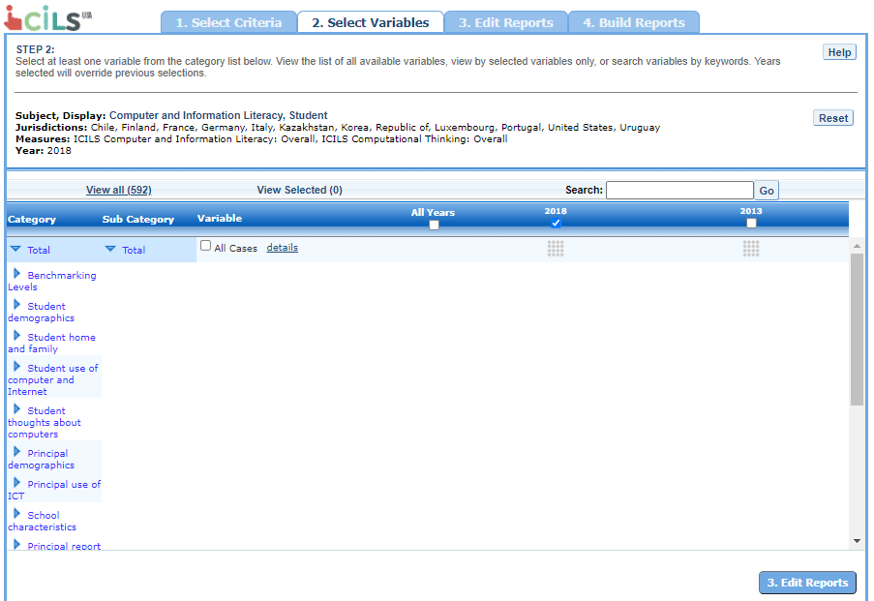

Exhibit 7-4 is a screenshot from the ICILS IDE tool showing an overview of the Select Variables tab.

### 7.2.2 2.B. Search Using Category and Sub Category Lists

On the **Select Variables** screen, choose at least one variable for your report. One way to do this is to search for variables using the **Category** and **Sub Category** lists. If you don’t wish to choose from any of the specified categories and subcategories, then select **All students** in the **All Students** category.

The variables shown are tied to the criteria you selected at step 1 (**Measure**, **Year**, and **Jurisdiction**), which are indicated at the top of the screen. To change any of these criteria, return to step 1, **Select Criteria**.

To browse for variables, get details about them, select them, and view them:

1. Click the blue arrows to open and close categories and subcategories > of variables (see exhibit 7-5).
2. Click **details** or **hide details** to show or hide the full title > of a given variable, the ICILS ID, and the values (i.e., value > labels). Note that some variables have the same or similar short > titles, but comparing details will show you how they differ. See > the example in exhibit 7-5, which shows two **Immigration status** > variables (SIMMIG and SIMMBGR). The differences between these two > variables are described in the details.
3. Click the checkbox next to a variable to select it for your > analysis/report. You will see the count increase next to **View > Selected**.
4. Click the **View Selected** tab to see the variables you have > chosen. To return to the full list of variables by category, click > the **View All** tab.
5. Remember to select the year for which you wish to build a report and > make sure that data are available for your chosen year and > variables.
6. Searching for variables is an option from the **Search** box. See > **Section 2.C. Search Function** for more details about this > function.

Exhibit 7-5. Select variables using category and sub category lists

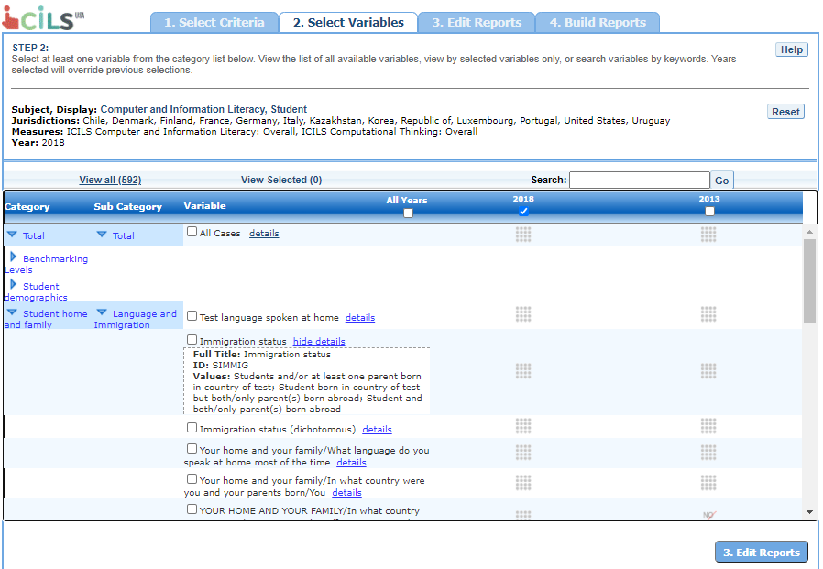

Exhibit 7-5 is a screenshot from the ICILS IDE tool showing how to select a variable from the categories and sub categories listed in the Select Variables tab.

When you have selected the variable(s) you want to include, continue by clicking the **Edit Reports** button at the bottom of the page or the tab at the top of the page to go to the next screen.

### 7.2.3 2.C. Search Function

The second way to search for variables is to use the **Search** function on the **Select Variables** screen.

Type a term in the **Search** box and click **Go** (or hit “Enter” on your keyboard) to find variables by keywords in the question and/or details for the variable (see exhibit 7-6). If you use multiple keywords, “and” is assumed. You can narrow your search by using “or,” “not,” or “and not.” The search function operates on an exact phrase if it is contained in quotes. The variable(s) that include the search term(s) in the question or its details will be listed in the search results.

Exhibit 7-6. Select variables using the search function

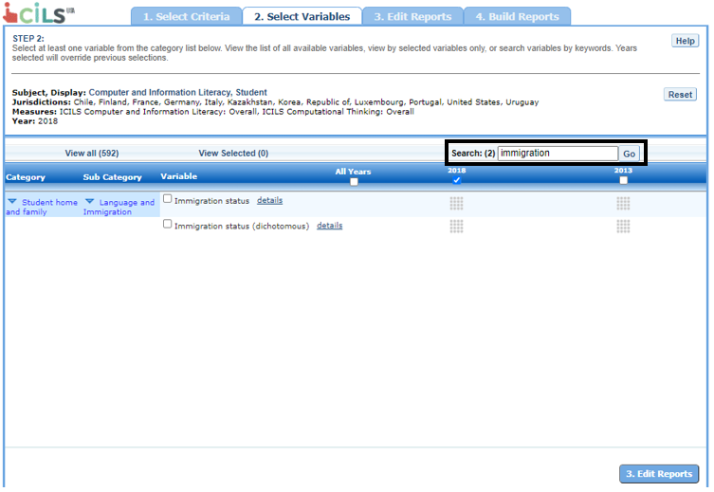

Exhibit 7-6 is a screenshot from the ICILS IDE tool showing how to select a variable using the search function.

When you have selected the variable(s) you want to include, continue by clicking the **Edit Reports** button at the bottom of the page or the tab at the top of the page to go to the next screen.

## 7.3 3. Edit Reports

### 7.3.1 3.A. Overview

You can access step 3, **Edit Reports**, after choosing criteria at step 1, **Select Criteria**, and choosing variables at step 2, **Select Variables**. The IDE will automatically build reports based on your selections from steps 1 and 2. However, at step 3, you may modify your selections for each report.

At this step, you can

* preview and edit the layout of your reports;
* copy reports or create new reports based on the variables selected;
* change formatting options, such as the number of decimal places to display, for all reports (these may also be changed in individual reports);
* change statistics options, such as averages, for all reports (these may also be changed in individual reports, but statistics options can overwrite previous edits);
* select reports to be built into tables and charts at step 4, **Build Reports**; and
* delete reports.

Using your chosen criteria, the IDE will return a separate data report for each variable you have chosen. If you have selected two or three variables (not counting **All Cases**), you will also see a cross-tabulated report for these variables. If you have chosen four or more variables, you will get tables for each variable, but you won’t get the cross-tabulation. If your selected criteria include more than one measure (e.g., an overall scale and one or more continuous variables), a separate set of data reports will be generated for each measure (see exhibit 7-7).

**Exhibit 7-7. Edit reports overview**

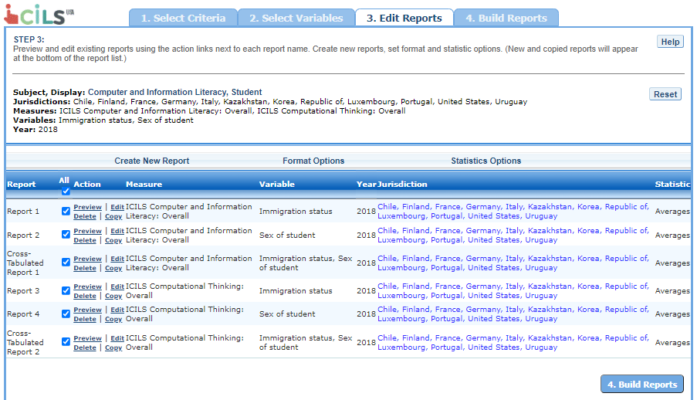

Exhibit 7-7 is a screenshot from the ICILS IDE tool showing an overview of the Edit Reports tab.

The **Edit Reports** step shows overview information of your reports. The **Report** column indicates the report, or cross-tabulation report, number based on the variable(s) chosen during the criteria selection. Under the **All** tab, reports may be chosen for the report-building phase, either by selecting **All** or selecting individual reports. The **Action** column gives you the option to **Preview**, **Edit**, **Delete**, or **Copy** the report. The **Measure** column shows which measure the report will portray. The **Variable** column indicates the variable(s) included in the report. The **Year** column shows which years you have selected for comparison. The **Jurisdiction** column shows the countries and subnational education systems selected for comparison, and the **Statistic** column provides the type of statistic output that will be generated in the report-building phase.

### 7.3.2 3.B. Preview Report

Select **Preview**, in the **Action** column (see exhibit 7-7), to see how your report will be laid out. The preview will not provide actual data but will show how the data will be arranged in rows and columns (see exhibit 7-8). You can select **Preview** at any time to see how your changes will affect the report’s final layout.

Exhibit 7-8. Using preview report

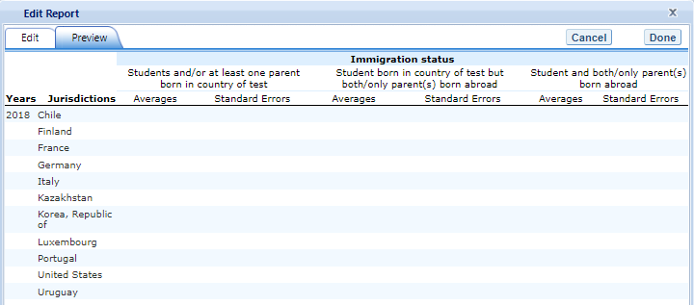

Exhibit 7-8 is a screenshot from the ICILS IDE tool showing an example of the preview function that is available in the Edit Reports tab.

### 7.3.3 3.C. Edit Report

To edit the report, select the **Edit** command, in the **Action** column, next to the report number (see exhibit 7-7). (Another way to edit a report is to select the **Edit** tab when you are previewing a report.) The following can be done using the edit function (see exhibit 7-9):

1. Name your report. You have the option of giving each report a > distinctive name, up to a limit of 50 characters, using only > letters, numbers, spaces, underscores, and hyphens. (Otherwise, by > default, the report is named Report 1, Report 2, etc., or > Cross-Tabulated Report 1, Cross-Tabulated Report 2, etc.)
2. Select a measure. You can choose a measure if more than one was > selected at step 1.
3. Select which jurisdictions, variables, years (if applicable), and > statistics to include (out of the selections previously made at > steps 1 and 2). You can select up to two statistics options from > the following: averages, standard deviations, percentages, and > percentiles. (For further information, see **Section 3.G. > Statistics Options**.)
4. To create a new variable while editing a report, click on **Create > New…** under the **Variable** heading. Section 3.D. below > explains the process for creating a new variable.
5. Change the table layout by dragging elements to determine which > items will appear in rows and which will appear in columns. Some > of the arrangements will not be permissible, but a pop-up alert > will explain this.

Exhibit 7-9. Editing reports

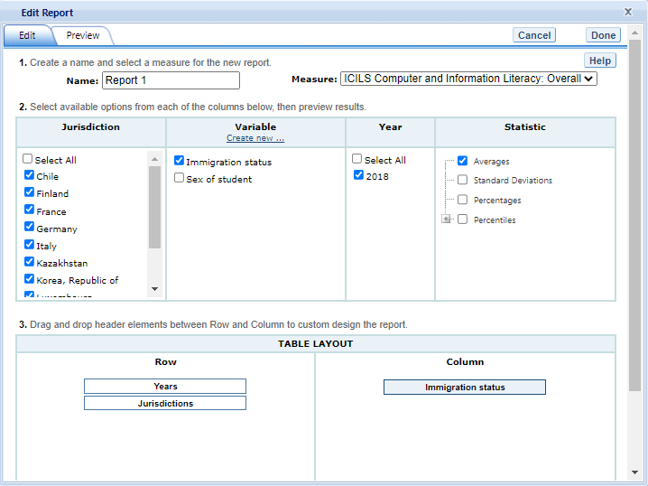

Exhibit 7-9 is a screenshot from the ICILS IDE tool showing an example of the editing report function that is available in the Edit Reports tab.

To save changes, make sure to select **Done** in the upper-right portion of the screen before closing the **Edit Report** window.

### 7.3.4 3.D. Create New Variables

The levels of a categorical variable can be collapsed to create a new variable. To do so, select **Edit**, in the **Action** column, and select **Create new…** under **Variable** (see exhibit 7-9). The new variable is created by combining values for an existing variable. The steps are as follows:

1. Click **Create new...** under the **Variable** heading.
2. Select the variable for which you wish to combine values.
3. Select the values you want to combine by checking the boxes to the > left of the values (see exhibit 7-10).
4. Create a name for the new value, and press **Create**. The collapsed > values will appear in gray to indicate that they have already been > used.
5. Wait for the screen to refresh, and press **Done**.
6. The new variable will appear in the **Variable** list in the **Edit > Report** window or **Create New Report** window, designated as > “collapsed.”
7. Check the box next to the new variable to view it in the report. You > can click **Preview** to see how the table will be laid out before > retrieving data.

Exhibit 7-10. Creating new variables

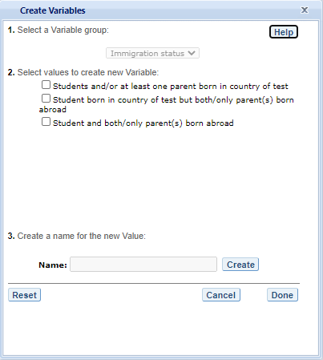

Exhibit 7-10 is a screenshot from the ICILS IDE tool showing an example of the creating new variable function that is available in the Edit Reports tab.

A new variable that you create is applicable only to a specific report; it does not apply to the other reports listed on the **Edit Reports** screen. For example, if you selected multiple measures of the overall scale CIL for analysis, then you would need to create the new variable for each measure, or create a copy of the report and edit it accordingly. To do the latter, click on **Copy** report on the **Edit Reports** screen (see exhibit 7-7). The copied report will appear at the end of the list of reports. Then, for the new copy, click on **Edit** (using the above example, you can change the measure and give the report a new name).

You can repeat the process and combine different values of a variable to create additional new variables. Using the **Create New Report** function, you can create a new report for each new variable that you create. (For further information, see **Section 3.E. Create New Report**, below.)

If you selected two or three variables from which to create new variables, you can repeat the process for each of them. Using the **Create New Report** or **Edit Report** function, these collapsed variables will be listed and available for cross-tabulation (see exhibit 7-11). If you have chosen four or more variables (not counting **All Cases**), you won’t get the cross-tabulation. You can click **Preview** to see how the table will be laid out before retrieving data.

Exhibit 7-11. Edit reports with collapsed variables

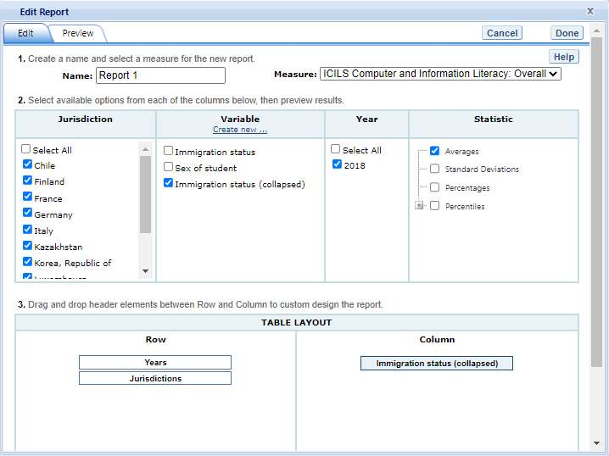

Exhibit 7-11 is a screenshot from the ICILS IDE tool showing an example of the editing report with collapsed variables function that is available in the Edit Reports tab.

### 7.3.5 3.E. Create New Report

From the main **Edit Reports** screen, clicking on **Create New Report** brings up the same options as **Edit Report**, but with no checkboxes marked and without any new variables you may have created. Thus, **Create New Report** provides a clean slate for your selections from the first two steps, **Select Criteria** and **Select Variables** (see exhibit 7-12). Each new report you create will appear at the end of the list of reports. If you do not give the report a specific name, it will be called “New Report.”

Exhibit 7-12. Creating new reports

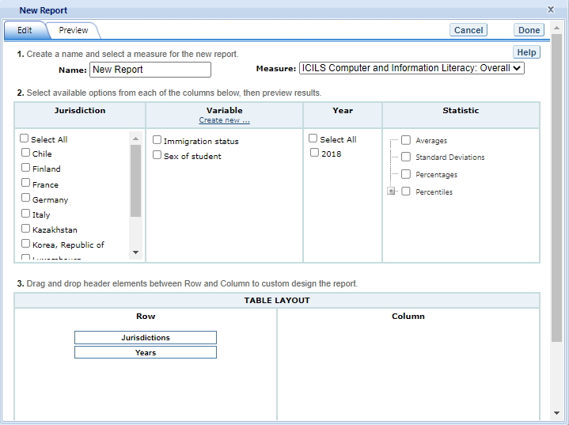

Exhibit 7-12 is a screenshot from the ICILS IDE tool showing an example of the creating new report menu that is available in the Edit Reports tab.

### 7.3.6 3.F. Format Options

From the main **Edit Reports** screen, clicking on **Format Options** will allow you to make formatting changes applicable to all the reports listed. The following formatting options are available using this function (see exhibit 7-13):

1. **Variable Labels (Long)** displays a more detailed description of > the variables selected in a query than the default short label. > For variables from questionnaires, the full text of the question > is displayed. Be advised that the length of the extra detail may > sometimes interfere with table formatting.
2. **Show data for values categorized as “missing”** will include the > percentage of students in the total sample or in a reporting group > for whom membership in a particular response category is unknown > because no response was given by the students, their teacher, or > their school. The percentage of “missing” will be shown in the > right-most table column. Missing data are available only for > queries that involve percentages as the statistic type. Unless you > check this option, the default is for missing responses not to be > included in the percentage distribution shown.
3. **Year Order** gives you the option to display either the most > recent year first or the oldest year first.
4. **Decimal Places** allows you to specify the level of precision for > a particular statistic. Depending on the value range of the > dependent variable—for example, the dependent variable “ICILS > Computer and Information Literacy: Overall $PVCIL$” ranges from > 100 to 700; the dependent variable “Computer experience in years > $SEXCOMP$” ranges from 0 to 4—the default number of decimal > places for a report can vary from zero to three. Also, standard > errors will be shown to one more decimal place than is shown for > their respective statistic. For example, if you request that > average scores be displayed to one decimal place (by default, > average scores are rounded to the nearest whole number), the > corresponding standard errors will display two decimal places. If > you export to Excel, you will be able to increase the number of > decimal places in most cases. Note that only integer-level > precision is allowed for percentages; that is, the number of > decimal places is fixed at “none” for percentages, and the > corresponding standard errors are shown to one decimal place.
5. **Include** gives you the option of showing standard errors. By > default, standard errors are shown inside parentheses, but you can > choose to show them without parentheses*.* You can preview the > effects of your selection in the **Sample Display** area (see the > blue‑shaded box at the bottom of exhibit 7-13 below).

Exhibit 7-13. Format options

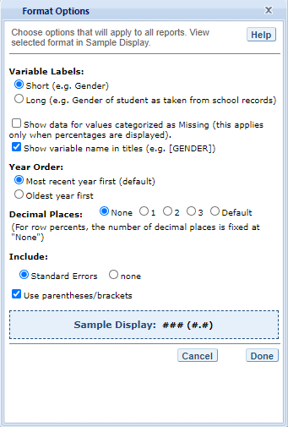

Exhibit 7-13 is a screenshot from the ICILS IDE tool showing an example of the format options available in the Edit Reports tab.

Be advised that the choices you make in the **Format Options** window will apply to all reports and cannot be changed for individual reports. Use the **Reset** button, located in the upper-right portion of the main **Edit Reports** screen (just below the **Help** button), to restore the **Format Options** to the default settings (although caution is advised, as this will also delete any new reports that you have created).

### 7.3.7 3.G. Statistics Options

Available only from the main **Edit Reports** screen, clicking on **Statistics Options** allows you to designate up to two statistics. The selections you make are applicable to all the reports listed, although you can also change the statistics for an individual report when you edit it. (For further information, see **Section 3.C. Edit Report**.)

The following statistics options are available (see exhibit 7-14):

1. **Averages.** This statistic provides the average value for a selected continuous variable or score (i.e., the overall scale for CIL or CT). For the ICILS assessment, student performance is reported on scales that range from 100 to 700. By default, the standard errors of the scores are shown in parentheses.
2. **Standard deviations.** The standard deviation is a measure of how widely or narrowly dispersed scores are for a particular dataset. Under general normality assumptions, 95 percent of the scores are within two standard deviations of the mean. For example, if the average score of a dataset is 500 and the standard deviation is 100, it means that 95 percent of the scores in this dataset fall between 300 and 700. The standard deviation is the square root of the variance.
3. **Percentages.** This statistic shows the percentage of students as a row percentage. For example, if the first column lists countries, then each country will display its own percentage distribution across its row. By default, percentage distributions do not include missing data. For information on how to show data for values categorized as missing, see **Section 3.F. Format Options**.
4. **Percentiles.** This statistic shows the threshold (or cutpoint) score for the following:

* 10th percentile – the bottom 10 percent of students
* 25th percentile – the bottom quarter of students
* 50th percentile – the median (half the students scored below the cutpoint and half scored above it)
* 75th percentile – the top quarter of students
* 90th percentile – the top 10 percent of students

Exhibit 7-14. Statistics options

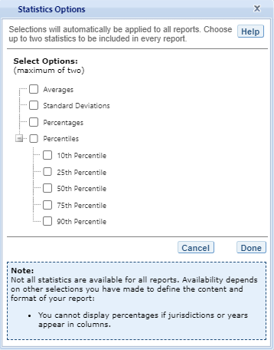

Exhibit 7-14 is a screenshot from the ICILS IDE tool showing an example of the statistics options available in the Edit Reports tab.

As previously noted, the selections you make in **Statistics Options** will be applied automatically to all reports, although you can change the statistics for an individual report when you edit it. Be advised that if you use **Statistics Options** after editing the statistics in one or more of your individual reports, the statistics options selected will overwrite your previously edited selections. If you wish to use the same criteria and variables in a report with a different selection of statistics, consider using the **Create New Report** function to generate a new report with different statistics. (For further information, see **Section 3.E. Create New Report**.) You can also make a copy of an individual report.

You can use the **Reset** button, located in the upper-right portion of the main **Edit Reports** screen (just below the **Help** button), to restore the **Statistics Options** to the default setting, which is averages for all reports (this will also delete any new reports that you created).

Not all statistics are available for all reports. Their availability depends on other selections you have made to define the content and format of your report:

* Percentages will not display if jurisdictions or years appear in columns.
* If proficiency levels are selected in the variable section, only average scores and percentages will be displayed.

Please note that results obtained from the IDE might not always match those published by IEA or NCES. This is due to the use of different reporting standards, such as suppression rules related to sample size and suppression due to response rates.

### 7.3.8 3.H. Select Reports to Build

As you edit your reports, you can give them distinct names (up to 50 characters) to differentiate them, as well as make changes to the jurisdictions and variables previously selected, the statistics, and the layout of the rows and columns. (For further information, see **Section 3.C. Edit Report**.) You may make copies of reports with these changes. To proceed to step 4, **Build Reports**, each report for which you want to retrieve data should be previewed using the **Preview** function. To decrease processing time as you move to step 4, you can uncheck any reports for which you do not wish to retrieve data. By default, all reports are checked. To uncheck one or more reports, you can either uncheck the reports individually or click on the **All** box. (Doing the latter will uncheck all of the reports and allow you to check only those for which you wish to retrieve data.) In the example that follows (see exhibit 7-15), data will be retrieved for all reports.

Exhibit 7-15. Selecting reports to build

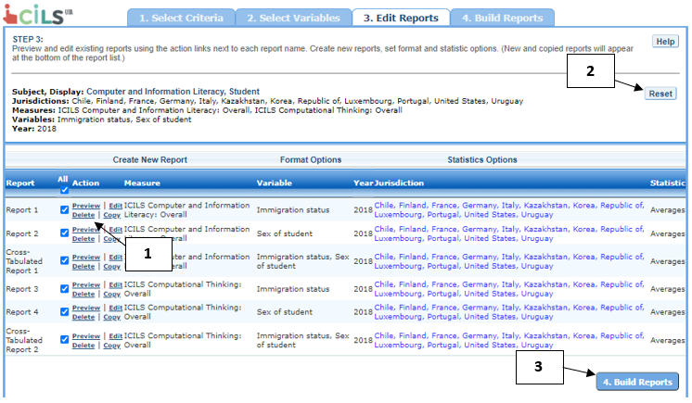

Exhibit 7-15 is a screenshot from the ICILS IDE tool showing how to select reports to build in the Edit Reports tab.

If you wish to delete a report from the list of reports, click **Delete** (see 1 above) in the **Action** column. Use the **Reset** button, located in the upper-right portion of the screen (see 2 above), to restore the deleted reports (although caution is advised, as this will also delete any new reports that you created and restore the **Format Options** and **Statistics Options** to the default settings).

To continue to the last step in the IDE, click the **Build Reports** button at the bottom of the page (see 3 above) or the tab at the top of the page to go to the next screen.

## 7.4 4. Build Reports

### 7.4.1 4.A. Overview

You can access step 4, **Build Reports**, after choosing criteria at step 1, **Select Criteria**, in which case the default report built will provide data for just averages and for the **All Cases** variable. After step 1, you may also go on to steps 2 and 3, where you can select additional variables and edit reports, before moving on to **Build Reports**. In **Build Reports**, you can do the following:

1. Generate a data table for each report as shown in the **Select > Report** drop-down feature (see 1 in exhibit 7-16). By default, all > reports are checked at step 3, although you can uncheck any > reports for which you do not wish to retrieve data. (For further > information, see **Section 3.H. Select Reports to Build**.)
2. Export and save data tables into various formats using the **Export > Reports** button (see 2 in exhibit 7-16). The output formats include > HTML (print-friendly), Microsoft Excel, Microsoft Word, and Adobe > PDF.
3. Select the **Chart** tab (see 3 in exhibit 7-16) to create and > customize charts for each report and save them for export in the > above formats.
4. Select the **Significance Test** tab (see 4 in exhibit 7-16) to run a > significance test on your results, customize it, and export it.
5. Select the **Gap Analysis** tab (see 5 in exhibit 7-16) to run a gap > analysis on your results, customize it, and export it.
6. Select the **Regression Analysis** tab (see 6 in exhibit 7-16) to run > a regression analysis on your results, customize it, and export > it.

Exhibit 7-16. Building reports overview

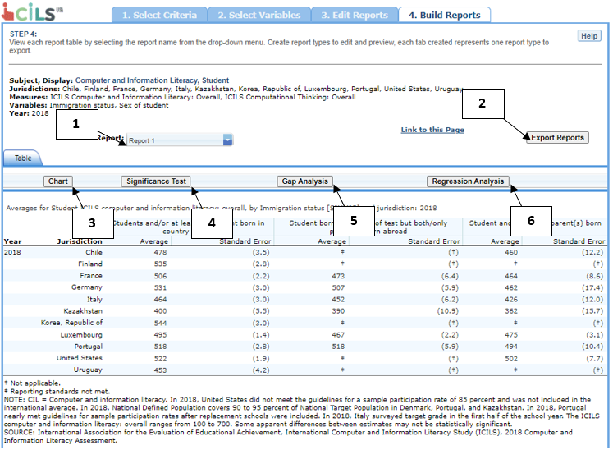

Exhibit 7-16 is a screenshot from the ICILS IDE tool showing an overview of the Build Reports tab featuring the Select Report, Export Reports, Chart, Significance Test, Gap Analysis, and Regression Analysis options.

### 7.4.2 4.B. View Reports as Data Tables

Some reports will take longer than others to process, so do not hit the “Back” button on your browser once you have clicked on **Build Reports** (see exhibit 7-17). Your table will appear once the processing is complete. To select a different table to view, go to the **Select Report** drop‑down menu (see 1 in exhibit 7-16) and choose the table of interest. To change the formatting or statistics options of a table or to generate a table from a report not included in your selection, return to step 3, **Edit Reports**.

Exhibit 7-17. Processing data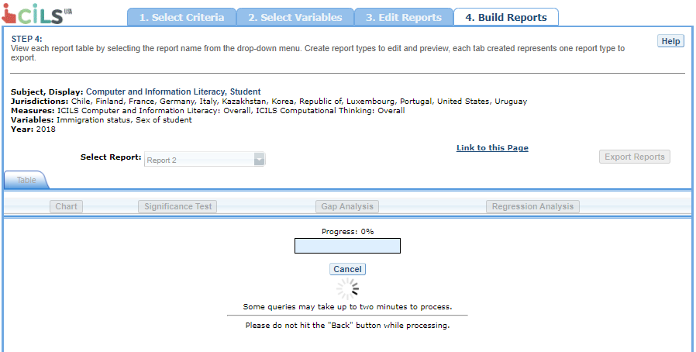

### 7.4.3 4.C. Charts

To create a chart, go to **Select Report** on the **Build Reports** screen to choose the report of interest from the drop-down menu, and then click the **Chart** link (see exhibit 7-18).

You will be able to create many types of charts and customize them. **Section 4.E. Create Charts – Chart Options** provides a summary of the available features and how they can be customized.

Exhibit 7-18. Viewing reports as charts

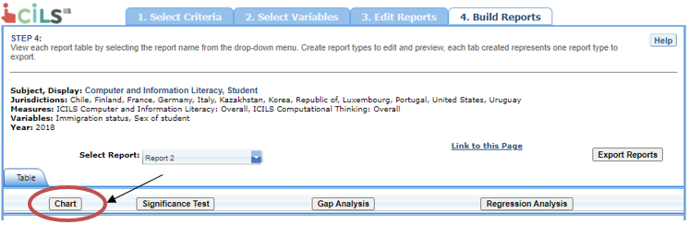

Exhibit 7-18 is a screenshot from the ICILS IDE tool showing how to select the chart creating function in the Build Reports tab.

### 7.4.4 4.D. Create Charts

When you click **Chart**, you will first make selections of **Jurisdiction**, **Year**, **and** **Statistic** (see exhibit 7-19). All **Jurisdictions** and **Years** are selected by default, while you can only choose one **Statistic**. Uncheck any of the criteria that you do not wish to chart, as long as you have one selected in each category.

Only the statistics option(s) used to report data in the previous step will be presented, and only one statistics option can be selected at a time. For example, **Percentiles** will appear as the only data option to build the chart if the table created in the previous step is reporting data with only percentiles selected as the statistics option.

Once you are finished with the Data Options, click the **Create** **Chart** button in the lower-right corner of the screen.

Exhibit 7-19. Data options for charts

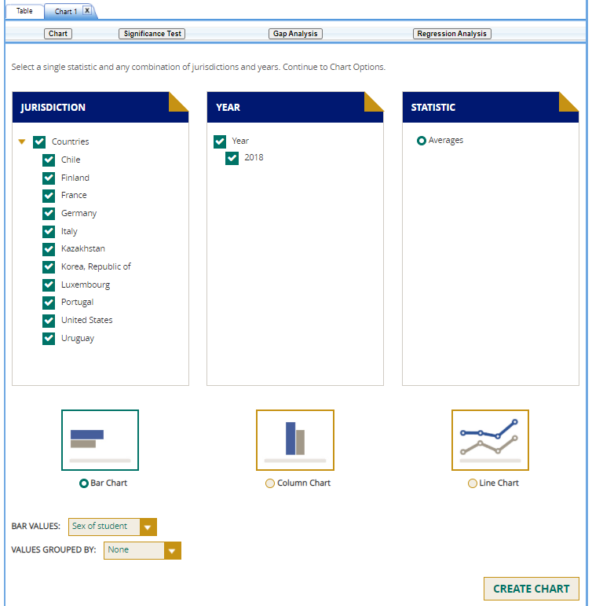

Exhibit 7-19 is a screenshot from the ICILS IDE tool showing the data options available in the chart creating function in the Build Reports tab.

### 7.4.5 4.E. Create Charts – Chart Options

Next, you can make selections regarding the chart options located at the bottom of the same window.

1. Select **Bar Chart**, **Column Chart**, or **Line Chart** (see 1 in > exhibit 7-20). If the Percentages Statistic is selected, you can > select from a **Percentage Chart** option. If the Percentiles > Statistic is selected, you can also select from a **Percentiles > Chart** option.
2. After selecting a chart type, change any data dimensions from the > drop-down menus for **Bar**, **Column**, or **Line Values** and > **Values Grouped by** (see 2 in exhibit 7-20). Any new variables > that you created at step 3, **Edit Reports**, will be available > for selection, but only if you selected the variables (by clicking > the checkbox next to them) and clicked **Done** after you edited > the report.
3. Create your chart by clicking the **Create Chart** button in the > lower-right corner (see 3 in exhibit 7-20).

**Exhibit 7-20. Chart options**

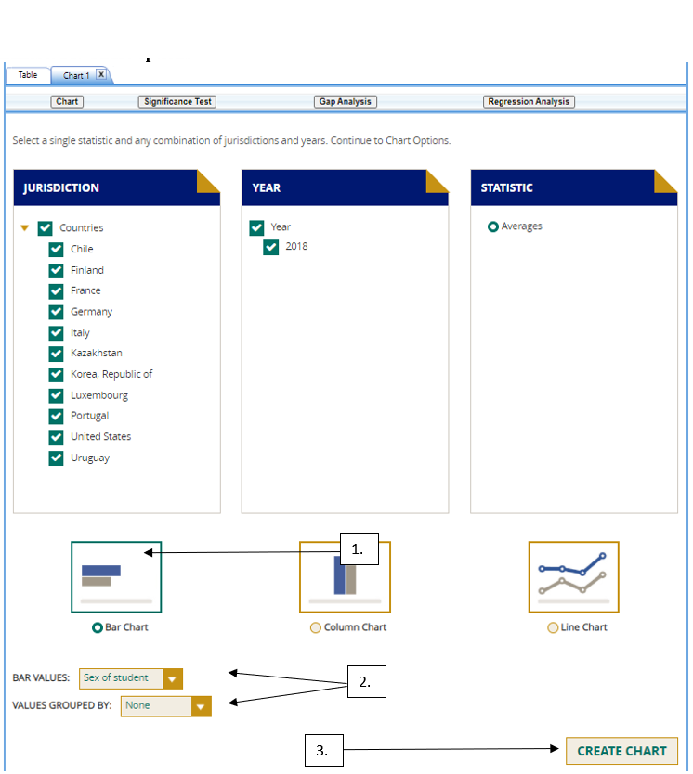

Exhibit 7-20 is a screenshot from the ICILS IDE tool showing the chart options available in the chart creating function in the Build Reports tab.

While previewing your chart, you can do the following (see exhibit 7-21 as an example of a **Percentile Chart** and exhibit 23 as an example of a **Bar Chart**):

1. Use the drop-down menus to change the jurisdiction and other > variables as applicable.
2. Place your cursor over the bars of the chart to see the data points > and value label(s).

Exhibit 7-21. Percentile chart

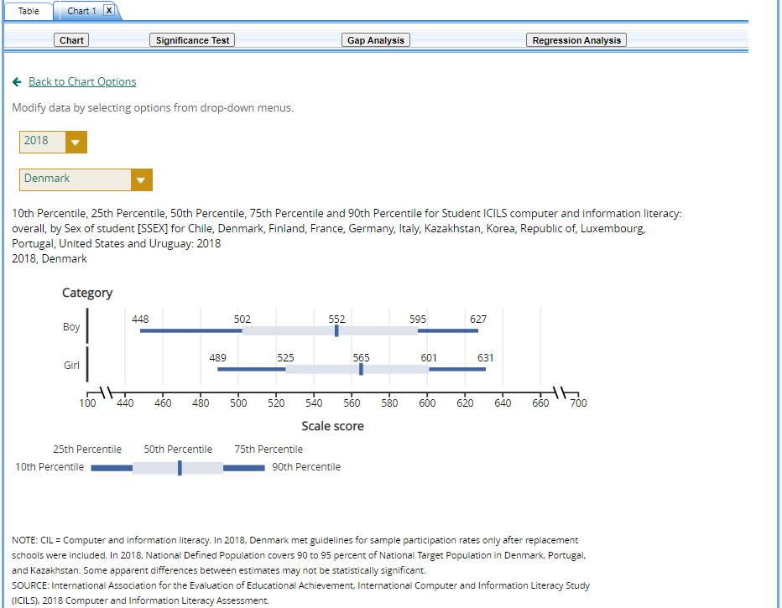

Exhibit 7-21 is a screenshot from the ICILS IDE tool showing a preview of a percentile chart in the chart creating function in the Build Reports tab.

Exhibit 7-22. Bar chart

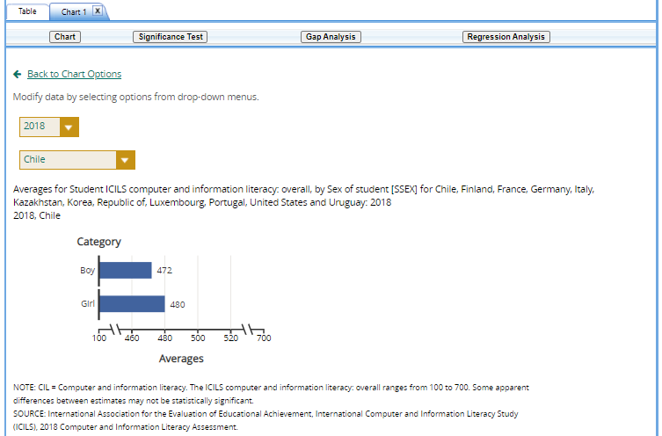

Exhibit 7-22 is a screenshot from the ICILS IDE tool showing a preview of a bar chart in the chart creating function in the Build Reports tab.

You can choose “**Back to Chart Options**” (located in the upper-left corner, below the **Chart** link) to make more changes.

To make an additional chart from the same report or table, click the **Chart** link on the **Build Reports** screen. It is recommended that you provide a new chart name (the default is Chart 1, Chart 2, etc.). If you don’t start the process again by clicking the **Chart** link, the new chart will overwrite the previous one.

If you wish to make charts from other reports, select another report in the **Select Report** drop‑down list. If other reports were not checked in step 3, **Edit Reports**, go back to step 3, and check the ones you want. Then, when you advance to step 4, **Build Reports**, the reports will appear in the **Select Report** drop-down list. If you need to create new reports, go back to step 1, **Select Criteria**, and/or step 2, **Select Variables**. Remember to export any completed charts you want to save by clicking **Done** and using the **Export Reports** function before leaving the **Build Reports** screen. (For further information, see **Section 4.I. Export Reports**.)

### 7.4.6 4.F. Significance Tests

Tests for statistical significance indicate whether observed differences between estimates are likely to have occurred because of sampling error or chance. “Significance” here does not imply any judgment about absolute magnitude or educational relevance. It refers only to the statistical nature of the difference and whether that difference likely reflects a true difference in the population.

With your report of interest selected, click the **Significance Test** link, which is located to the right of the **Chart** link (see exhibit 7-16), which will take you to the **Significance Test** window (exhibit 7-23). You first need to decide which variable you want to test and the criterion by which you want to test it (i.e., between jurisdictions, within variables, or across years). You will compare or look across the variable’s range of values, so it must have more than one value. You can look across jurisdictions for a variable (that is, compare between two or more jurisdictions) or you can look across the values within a variable for a single jurisdiction. For example, with the variable shown in exhibit 7-23, you could choose to compare scores of female students between countries and subnational education systems, or you could choose to compare scores of female students and male students.

The general steps for running significance tests are as follows (see exhibit 7-23):

1. In the **Significance Test** window, select either **Between > Jurisdictions**, **Within Variables**, or **Across Years**. Then, > select the appropriate jurisdiction(s), variable(s), year(s), and > statistic(s). For **Between Jurisdictions**, select at least two > jurisdictions. For **Within Variables**, select at least two > variables. For **Across Years**, more than one year needs to be > selected.
2. You can enter a **Test Title** limited to 25 characters, using only > letters, numbers, spaces, underscores, and hyphens (otherwise, by > default, the test is named “Sig Test 1”).
3. Select the output type as either **Table** or **Map**. The table > option will show the significance test results as a matrix. The > map option will show the significance test results on a world map, > highlighting the countries and subnational education systems that > have been selected. The map output is only available when > **Between Jurisdictions** is selected in the first step.
4. Additional options allow you to select **Show Table Details** to > display the estimates and standard errors for the table cells. If > you selected a map, this option is not applicable, as the map will > automatically show score details.
5. Click the **Preview** tab located in the upper-left corner or the > **Preview** button located in the bottom-left corner.
6. Click the **Edit** tab in the upper-left corner of the screen if you > wish to go back and make changes to the selections you made for > running the significance tests.
7. Click the **Done** button in the upper- or lower-right corner of the > screen to run the significance tests.

Exhibit 7-23. Significance test options

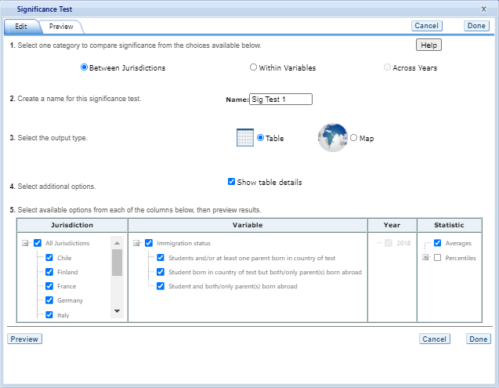

Exhibit 7-23 is a screenshot from the ICILS IDE tool showing the significance test options available in the Build Reports tab.

When the table option is selected, you will get a significance test matrix in which you will see the differences and *p* values. Using the symbols shown in the legend of the matrix, an indication is also provided of whether one estimate is significantly lower or higher than another estimate or whether there is no significant difference (see exhibit 7-24).

The alpha level for all *t*-tests is .05. All comparisons within a jurisdiction, within the same year, are made using dependent *t*-tests. Comparisons between jurisdictions are treated as independent. Non-achievement comparisons across years are treated as independent. Comparisons of achievement across years are made using independent *t*-tests with a linking error taken into account. A part-whole adjustment is implemented for comparisons between a jurisdiction and a group that the jurisdiction is part of (e.g. Average of Countries).

ICILS assessments are linked across years. That is, the sets of items used to assess computer and information literacy (CIL) across years include a subset of common items, referred to as link items. To establish common reporting metrics for ICILS, the difficulty of the link items, measured on different occasions, is compared. The comparison of the item difficulties on the different occasions is used to determine a score transformation that allows the reporting of the data on a common scale. As each item provides slightly different information about the link transformation, it follows that the chosen sample of link items will influence the estimated transformation. The consequence is an uncertainty in the transformation due to the sampling of link items, just as there is an uncertainty in the country means due to the sampling of students. The uncertainty that results from the link-item sampling is referred to as the linking error, and this error must be taken into account when making certain comparisons using the ICILS assessment data. As with sampling errors, the likely range of magnitude for the errors is represented as a standard error. Significance tests for scores across years within the IDE take into account the linking errors applicable to each display.

Exhibit 7-24. Significance test table output

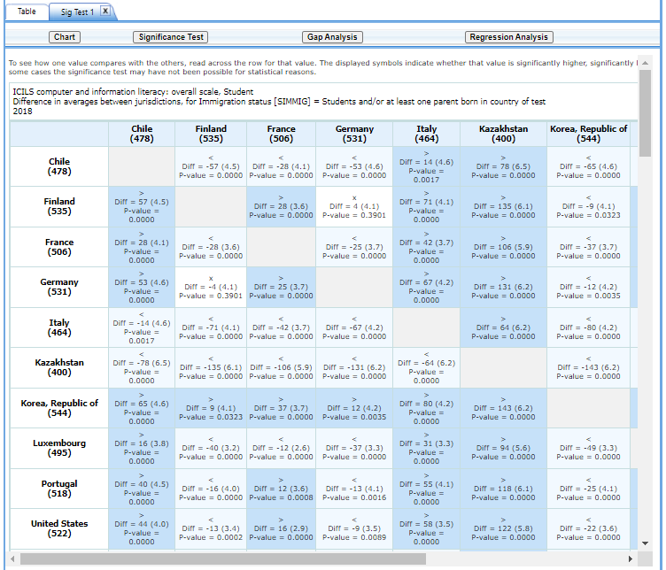

Exhibit 7-24 is a screenshot from the ICILS IDE tool showing an example of a significance test table output in the Build Reports tab.

When the **map option** is selected, a global map is shown with the countries and subnational education systems selected shaded in different colors (see exhibit 7-25). The focal jurisdiction is shaded in teal green, with all other countries compared to it. The other countries are shaded in colors that indicate whether they are higher, lower, or not significantly different from the focal jurisdiction on whatever measure has been selected. (Note that a light shade of gray is the default color for jurisdictions not selected for comparison.) When you hover over a jurisdiction, a text bubble displays the numerical difference in estimates between that jurisdiction and the focal jurisdiction. At any point, you may choose a different focal jurisdiction by clicking on another country. You may also choose a different variable category for comparison by using the drop‑down menu above the map.

Exhibit 7-25. Map of significance tests

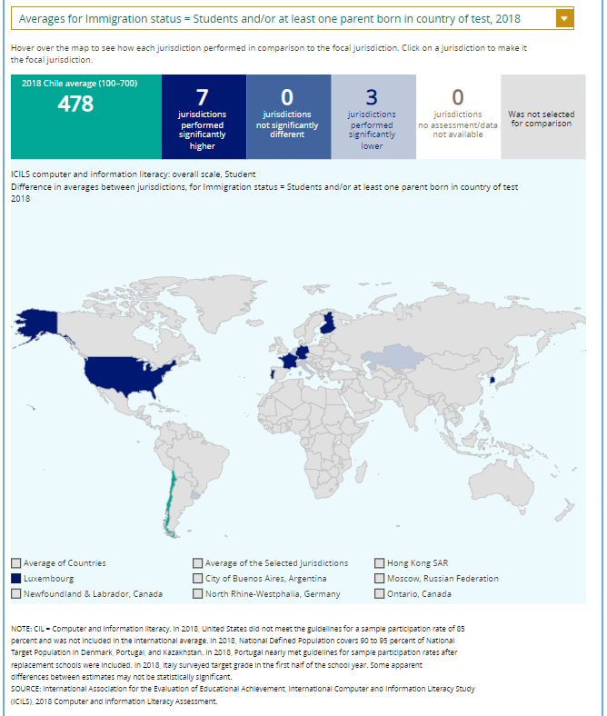

Exhibit 7-25 is a screenshot from the ICILS IDE tool showing an example of a significance test map output in the Build Reports tab.

### 7.4.7 4.G. Gap Analysis

Gap analysis is included in the IDE to compare differences in gaps shown in a map, table, or chart. Gap differences can be compared between jurisdictions and/or across years.

Exhibit 7-26. Gap analysis link selection

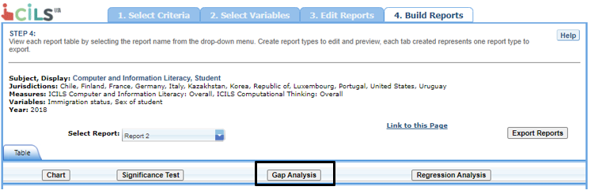

Exhibit 7-26 is a screenshot from the ICILS IDE tool showing how to select the gap analysis function in the Build Reports tab.

With your report of interest selected, click on the **Gap Analysis** link, which is located to the right of the **Significance Test** link (see exhibit 7-26). You will need to decide which variable you would like to test (e.g., gender) and the criterion by which you want to test it (i.e., between jurisdictions or across years). The difference measure, or gap, can be viewed between groups, between years, between groups and years, or between percentiles within the selected variable. For example, if you compute average CIL scores for two countries at two time points for males and females, you can:

* at one time point, compare the male-female gap in one country to the male-female gap in another country;
* compare the male-female gap at two time points within a country;
* compare the difference between the male-female gap at two time points in one country to the difference between the male-female gap at two time points in another country; or
* compare the gap for females at two time points in one country to the gap for females at two time points in another country.

Exhibit 7-27. Gap analysis options

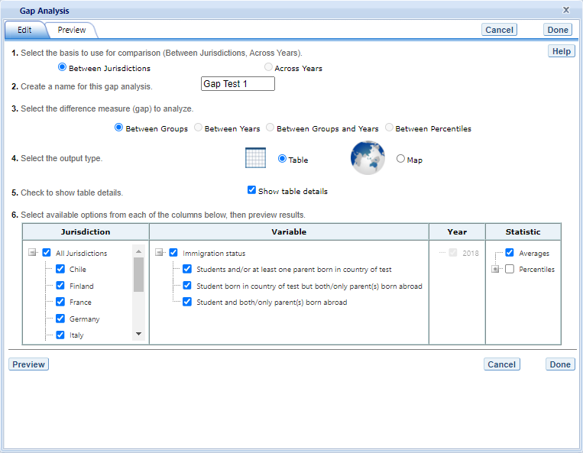

Exhibit 7-27 is a screenshot from the ICILS IDE tool showing the gap analysis options available in the Build Reports tab.

The steps for running a gap analysis are similar to those for conducting a statistical significance test (see exhibit 7-27). Thus, to run a gap analysis, follow the instructions under **Section 4.F. Significance Tests**, noting the following differences:

1. The **Gap Analysis** link should be selected, not the **Significance > Test** link.
2. The gap analysis does not have a **Within Variables** option for > analysis; the options are **Between Jurisdictions** and **Across > Years**.
3. The difference measure (gap) of analysis must be selected from the > following: **Between Groups**, **Between Years**, **Between Groups > and Years**, and **Between Percentiles** (if variables are > selected for which a difference measure is not feasible, the > difference measure option will not appear as available in the Gap > Analysis menu).

The gap analysis output is presented in a format similar to that of the significance test output, with one difference: the difference estimate shown in the output is the difference between the gaps selected for analysis. Note that you will still see the significance of these differences, just like in a significance test. For example, exhibit 7-28 shows cross-national differences between male-female score gaps.

The gap analysis function computes and statistically tests differences between score, percentage, or percentile gaps. For gap analysis tables, all comparisons are independent tests with an alpha level of .05. Note that the reference group for the gaps is kept constant during the analysis, as opposed to taking the absolute value of the gaps. Therefore, the gap analysis tests whether the magnitude of the gaps differ from each other only when the gaps go in the same direction (e.g., comparing a 5-point gender gap favoring females in one country with a 15-point gender gap favoring females in another country).

Exhibit 7-28. Gap analysis output

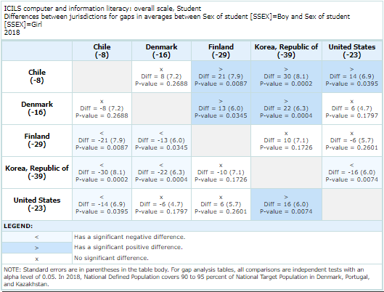

Exhibit 7-28 is a screenshot from the ICILS IDE tool showing an example output report based on the gap analysis options.

Note that a gap analysis across years cannot be combined with the Between Years or Between Groups and Years difference measures, so you will select the difference measure Between Groups, or, if you have selected percentiles as one of your statistics, you may choose Between Percentiles.

### 7.4.8 4.H. Regression Analysis

Regression analysis is included in the IDE to test for the relationship between one or more independent variables with a dependent variable, with the independent variables controlling for each other. The type of analysis performed in this feature of the IDE is referred to as linear regression, with the dependent variable being a continuous variable selected at step 1. To run a regression, first, go to **Build Reports** and choose the report of interest from the drop-down **Select Report** menu. Then click on the **Regression Analysis** link, which is to the right of the **Gap Analysis** link (see exhibit 7-29).

Exhibit 7-29. Regression analysis link selection

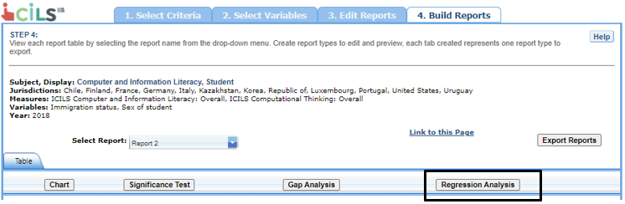

Exhibit 7-29 is a screenshot from the ICILS IDE tool showing how to select the regression analysis function in the Build Reports tab.

The general steps for running a regression analysis are as follows (see exhibit 7-30):

1. In the **Regression Analysis** pop-up window, you can enter a **Name** limited to 25 characters, using only letters, numbers, spaces, underscores, and hyphens (otherwise, by default, the test will be named “Regression 1”).
2. Select the appropriate jurisdiction, year, and variable(s) for analysis. Please note that you may only choose one jurisdiction and year at a time, but you may choose up to three independent variables to be in your report. In order to use up to three independent variables, you must have already created and selected a cross-tabulated report (by selecting three variables in Step 2, **Select Variables**).
3. Click the **Preview** tab located in the upper-left corner to view the table format into which your output will be populated. In the Preview tab, an “X” denotes where the output will display.
4. Click the **Edit** tab in the upper-left corner of the screen if you wish to go back and make changes to the selections you made for running the analysis.
5. Click the **Done** button in the upper- or lower-right corner of the screen to run the regression analysis.

Exhibit 7-30: Regression analysis options

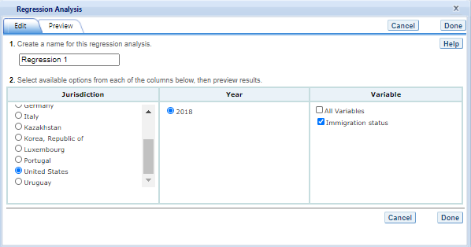

Exhibit 7-30 is a screenshot from the ICILS IDE tool showing the options for the regression analysis output.

After you have clicked **Done**, your regression analysis output will load onto the screen (see exhibit 7-31). A 0-1 contrast coding is used to code the independent variable, where the first subgroup of the independent variable is the reference group. Using dummy-coded variables in linear regression is useful for comparing each subgroup against a reference group. For example, in exhibit 32, if the subgroup “Students and/or at least one parent born in country of test” is the reference group for the independent variable **Immigration status (SIMMIG)**, the IDE creates a “Student born in country of test but both/only parent(s) born abroad” dummy variable (1 if yes, 0 if no) and a “Student and both/only parent(s) born abroad” dummy variable (1 if yes, 0 if no). The reference group is excluded from the regression analysis.

Exhibit 7-31. Regression analysis output

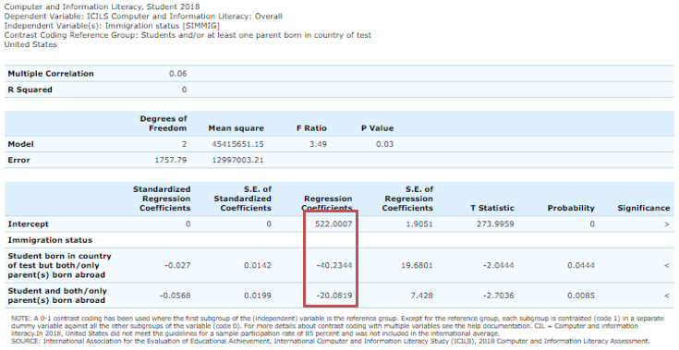

Exhibit 7-31 is a screenshot from the ICILS IDE tool showing an example of the regression analysis output.

Using the output from the regression analysis, you can compare the average CIL scores of first‑generation (Student and both/only parent(s) born abroad) and second-generation (Student born in country of test but both/only parent(s) born abroad) students to scores of native-born (Students and/or at least one parent born in country of test) students. When a single dummy‑coded variable is used in a regression, the *intercept* is the mean of the reference group (e.g., 522.0007), and the *regression coefficient* is the difference between the mean of the reference group and the group identified (coded 1) with the dummy-coded variable (e.g., −40.2344 for second generation and −20.0819 for first generation). Since the regression coefficients are presented with a standard error and a *t* value, they can be used to test whether a difference between means is statistically significant. Under the Significance column in the output, you will see three possible signs: (1) < signifies a significant negative difference, (2) > signifies a significant positive difference, and (3) x signifies the difference is not statistically significant.

### 7.4.9 4.I. Export Reports

Click on the **Export Reports** button/arrow located on the right side of the **Build Reports** screen to save or print your tables, charts, and significance tests. The report names that appear in the **Export Reports** window are those that were checked off at step 3, **Edit Reports**.

Check the files you want to export and select one of the file formats: **HTML** (print-friendly), **Excel**, **Word**, or **PDF** (see exhibit 7-32). All reports that you select at the same time will be exported in one file. In the Excel format, you will be able to increase the decimal places visible wherever more precision is available. Because there are many different operating systems in use, you may get an error message with Excel or one of the other formats. Usually, this will not affect your ability to export, so please wait for the software errors to resolve.

Exhibit 7-32. Export report options



Exhibit 7-32 is a screenshot from the ICILS IDE tool showing the export options, including HTML, Excel, Word, and PDF.

# 8 IDE definitions by study

This section provides an overview of the definitions in each IDE, including the kinds of criteria and variables that are used to form data queries, as well as the kinds of data that are available and the statistical methods used to assess them. Each of the subsections below covers the same topics and provides a detailed description of the definitions used in each IDE study.

* Criteria
  + Subject
  + Grade
  + Years
  + Measures
  + Jurisdictions
* Variables
  + Proficiency levels or benchmarks
  + Index Variables
* Statistics options
  + Averages
  + Percentages
  + Standard deviations
  + Percentiles
* Cross-tabulations
* Statistical notations and other notes

## 8.1 PISA IDE

### 8.1.1 Criteria

Each data query must include at least one selection from five criteria choices: language, subject, year(s), measure(s), and jurisdiction(s). Shown below is an outline of these selection criteria followed by a brief description.

1. Language:
   * English
   * Spanish
2. Subject:
   * Science literacy
   * Reading literacy
   * Mathematics literacy
   * Financial literacy
   * Problem solving
   * Collaborative problem solving
3. Year:
   * 2018 (data available for reading, reading subscales, mathematics, science, and financial literacy)
   * 2015 (data available for science, science subscales, reading, mathematics, financial literacy, and collaborative problem solving)
   * 2012 (data available for mathematics, mathematics subscales, reading, science, financial literacy, and problem solving)
   * 2009 (data available for reading, reading subscales, mathematics, and science)
   * 2006 (data available for reading, mathematics, science, and science subscales)
   * 2003 (data available for reading, mathematics, mathematics subscales, and science)
   * 2000 (data available for reading, reading subscales, mathematics, and science)
4. Measure:
   * Mathematics scale: Overall mathematics
   * Reading scale: Overall reading
   * Science scale: Overall science
   * Mathematics subscale: Employ
   * Mathematics subscale: Formulate
   * Mathematics subscale: Interpret
   * Mathematics subscale: Space and shape
   * Mathematics subscale: Change and relationships
   * Mathematics subscale: Quantity
   * Mathematics subscale: Uncertainty
   * Reading subscale: Locate information
   * Reading subscale: Understand
   * Reading subscale: Evaluate and reflect
   * Reading subscale: Access and retrieve
   * Reading subscale: Integrate and interpret
   * Reading subscale: Reflect and evaluate
   * Reading subscale: Continuous text
   * Reading subscale: Noncontinuous text
   * Science subscale: Identifying scientific issues
   * Science subscale: Explaining phenomena scientifically
   * Science subscale: Using scientific evidence
   * Science competency subscale: Evaluate and design scientific enquiry
   * Science competency subscale: Explain phenomena scientifically
   * Science competency subscale: Interpret data and evidence scientifically
   * Science knowledge subscale: Content Knowledge
   * Science knowledge subscale: Procedural and Epistemic Knowledge
   * Science system subscale: Earth and space
   * Science system subscale: Living systems
   * Science system subscale: Physical systems
   * Attitude scale: Interest in science
   * Attitude scale: Support for scientific inquiry
   * Financial literacy scale
   * Problem-solving scale
   * Collaborative problem-solving scale
5. Jurisdiction:
   * International average (OECD countries)
   * Average of the selected jurisdictions
   * OECD
   * Non-OECD
   * U.S. states

#### 8.1.1.1 Language

The PISA IDE currently provides the option to view all steps of the IDE and build reports in English or Spanish. The Help Guide currently is only offered in English.

#### 8.1.1.2 Subject

PISA assesses reading literacy, mathematics literacy, and science literacy at each administration. In addition, the IDE contains data from the administration of the 2012, 2015, and 2018 PISA financial literacy assessments, the 2012 PISA problem-solving assessments, and the 2015 PISA collaborative problem-solving assessment.

#### 8.1.1.3 Measures

The PISA IDE includes measures for each subject when selected, such as an overall scale, subscales (if applicable), and continuous variables.

Although each administration of PISA assesses mathematics, reading, and science, one of these subjects is assessed in depth in each administration. You can choose between the overall scale and/or any of the subject’s subscales as your measure. However, subscales are only available for a subject area in the years in which it was the major domain. The major subject area assessed in 2000 was reading literacy; in 2003, mathematics literacy; and in 2006, science literacy. The cycle fully repeated itself in 2009 and began again in 2018. Subscales are constituent parts of the major overall subject scale for an assessment and are specified by the PISA assessment frameworks. In the years when a subject area is a minor domain, only an overall scale is available, and it is based on a set of items of varying difficulty that represent the range of topics covered by the full assessment. Only overall scale scores are reported in the IDE for financial literacy, problem solving, and collaborative problem solving. Please see Section I. Background, for more information.

In 2015 and 2006, science was the major domain, and reading and mathematics were minor domains. Therefore, for these years, subscales are only available for science data; only single composite scales are available for PISA reading and mathematics data.

In 2012 and 2003, mathematics was the major domain, and reading and science were minor domains. Therefore, for these years, subscales are only available for mathematics data; only single composite scales are available for PISA reading and science data.

In 2018, 2009, and 2000, reading was the major domain, and mathematics and science were minor domains. Therefore, for these years, subscales are only available for reading data; only single composite scales are available for PISA mathematics and reading data.

In addition, there are continuous variables other than scale scores that you may choose as a measure of analysis. These variables fall under different categories, such as Student and Family Characteristics and School and Classroom Climate, and include variables such as student age in years, size of class, and an index of computer availability.

#### 8.1.1.4 Years

Currently, data availability in the IDE is dependent on the measure selected. If the measure chosen is an overall literacy scale, you can choose one or multiple years: 2018, 2015, 2012, 2009, 2006, 2003, and 2000. If the measure chosen is one of the science subscales, you can choose 2015 and/or 2006. If you choose between any of the mathematics subscales, you can choose 2012 and/or 2003. If you choose any of the reading subscales, you can choose 2018, 2009, and/or 2000. Subscales are not available for financial literacy, problem solving, or collaborative problem solving.

#### 8.1.1.5 Jurisdictions

All listed jurisdictions can be selected for any analyses, provided data are available for the selected year. In 2018, a total of 79 jurisdictions participated in the mathematics, reading, and science literacy PISA assessments: 37 Organization for Economic Cooperation and Development (OECD) countries and 42 non-OECD jurisdictions. The non-OECD jurisdictions include some subnational education systems, such as Hong Kong-China. Data are not available for some of these 79 jurisdictions for 2015, 2012, 2009, 2006, 2003, and/or 2000, either because they did not participate in that PISA cycle or because their data were suppressed due to reporting standards not being met (for example, PISA 2018 data for Vietnam were suppressed due to international reporting standards not being met, and PISA 2015 data for Argentina, Malaysia, and Kazakhstan were suppressed due to international reporting standards not being met).

Data are available for 73 jurisdictions (35 OECD and 38 non-OECD) in 2015, 65 jurisdictions (35 OECD and 30 non-OECD) in 2012, 65 jurisdictions (35 OECD and 30 non-OECD) in 2009, 57 jurisdictions (35 OECD and 22 non-OECD) in 2006, 41 jurisdictions (31 OECD and 10 non-OECD) in 2003, and 38 jurisdictions (29 OECD and 9 non-OECD) in 2000.

Also included in the IDE are the 5 U.S. states or territories that participated in PISA 2012 and PISA 2015. Data from the 43 jurisdictions that participated in the administration of the problem-solving assessment in 2012 are included in the IDE, as well as the 51 jurisdictions that participated in the 2015 collaborative problem-solving assessment. All jurisdictions that participated in the financial literacy assessment in at least one year (2012, 2015, 2018) are included in the IDE.

Jurisdictions for which data are not available for a selected year are identified by the icon representing “no data”. Note that the IDE contains a few U.S.-specific background variables (e.g., race/ethnicity) that, when selected, will not yield information for any other jurisdictions.

Jurisdictions listed in the IDE as OECD countries are those that are currently members of the OECD. In some cases, countries which are current members of the OECD were not members during a prior administration or release of PISA. For example, Latvia was an OECD country at the time of the 2015 PISA release, but not during earlier PISA cycles. The IDE recalculates OECD averages for previous PISA cycles based on the current count of 37 OECD countries as of the 2018 release. Please note that the recalculation of the OECD average based on the current count explains why OECD averages calculated by the IDE for earlier years (e.g., 2015 or 2012) do not match the OECD averages from OECD and NCES reports published in earlier years.

### 8.1.2 Variables

In the PISA IDE, questions from two types of questionnaires (student and school), as well as variables that are derived from background information, are organized into categories that have shared characteristics and can be selected as a group when examining and generating tables.

Content category and subcategory titles may overlap, but specific variables appear only once in a subcategory. Use Search in the Select Variables step to locate variables.

Note that some variables might be similar in content, but not comparable over the years, either due to differences in the question asked or differences in their response categories. For example, an index variable for students’ family structure is available for 2012, 2009, 2003, and 2000. Each index variable is based on students’ responses to the same question asking who usually lived at home with them. However, these three variables (STP5437 in 2012, FAMSTR09 in 2009 and FAMSTR00 in 2003 and 2000) are not comparable due to differences in response categories. In 2012, the response categories were “single-parent (natural or otherwise),” “two parents (natural or otherwise),” and “other”; in 2009, the categories were “single-parent family,” “two-parent family,” and “other”; and in 2003 and 2000, the categories were “single-parent family,” “two-parent family,” “mixed,” and “other.” The icon representing “no data”— —will help in identifying the year for which the variable has data available for analysis.

#### 8.1.2.1 Proficiency levels

Achievement results for PISA are reported using discrete proficiency levels for reading, mathematics, science, financial literacy, problem solving, and collaborative problem solving. Increasing levels represent the knowledge, skills, and capabilities needed to perform tasks of increasing complexity. Based on the statistics option chosen, IDE can report the average scores of students at each proficiency level or the percentage of students performing at each of the predefined levels for the chosen jurisdictions. Two statistics options, standard deviations and percentiles, will not generate reports as proficiency levels are not reportable using these statistical analyses. Proficiency levels for any subject should be analyzed with the scale of that same subject; for example, the reading literacy proficiency levels should be analyzed with the reading literacy scale.

Mathematics literacy: Administered in all cycles (2000, 2003, 2006, 2009, 2012, 2015, 2018). In 2000, an interim scale was used, and cut-off points between mathematics literacy proficiency levels were not established. Thus, proficiency levels cannot be analyzed in the IDE for 2000 mathematics literacy. From 2003 to 2018, mathematics literacy results were reported using 6 proficiency levels (level 1–level 6); the IDE shows 7 categories (below level 1, level 1, level 2, level 3, level 4, level 5, level 6).

Science literacy: Administered in all cycles (2000, 2003, 2006, 2009, 2012, 2015, 2018). Proficiency levels did not have strict definitions until 2006, when science literacy was the major domain and had a non-interim scale for the first time. Thus, proficiency levels cannot be analyzed in the IDE for 2000 and 2003 science literacy. In 2006, 2009, and 2012, science literacy results were reported using 6 proficiency levels. In 2015 and 2018, science literacy results were reported using 7 proficiency levels, as level 1 was broken into level 1b and level 1a. The cutpoint score for level 1a in 2015 and 2018 is the same as level 1 in 2006, 2009, and 2012; the cutpoint score for level 1b is set significantly lower. IDE programmers have retroactively calculated level 1b for 2006, 2009, and 2012 to allow for trend comparisons, so the IDE shows 8 categories for all years (below level 1b, level 1b, level 1a, level 2, level 3, level 4, level 5, level 6).

Reading literacy: Administered in all cycles (2000, 2003, 2006, 2009, 2012, 2015, 2018). In 2000, 2003, and 2006, 5 proficiency levels were used (level 1–level 5). Starting in 2009 and continuing in 2012 and 2015, reading literacy results were reported using 7 proficiency levels, with level 1 broken into level 1b and level 1a, followed by level 2 through 5 and a new top level (level 6). In 2018, a new lowest proficiency level (level 1c) was added, and the full list of 8 reading literacy proficiency levels became level 1c, level 1b, level 1a, level 2, level 3, level 4, level 5, and level 6. The cut point for level 1a from 2009 to 2018 is the same as for level 1 from 2000 to 2006. IDE programmers have retroactively calculated level 1c for pre-2018 years and level 1b and level 6 for pre-2009 years to allow for trend comparisons, so the IDE shows 9 categories for all years (below level 1c, level 1c, level 1b, level 1a, level 2, level 3, level 4, level 5, level 6).

Financial literacy: Administered in 2012, 2015, and 2018. In all 3 years, financial literacy results were reported using 5 proficiency levels (level 1–level 5); the IDE shows 6 categories (below level 1, level 1, level 2, level 3, level 4, level 5). Problem solving: Administered in 2012. Problem-solving results were reported using 6 proficiency levels (level 1–level 6); the IDE shows 7 categories (below level 1, level 1, level 2, level 3, level 4, level 5, level 6).

Collaborative problem solving: Administered in 2015. Collaborative problem solving results were reported using 4 proficiency levels (level 1–level 4); the IDE shows 5 categories (below level 1, level 1, level 2, level 3, level 4).

As noted above, the IDE also provides available data for students performing below proficiency level 1 for mathematics literacy, financial literacy, problem solving, and collaborative problem solving; below level 1b for science; and below level 1c for reading literacy. Patterns of responses for students in the proficiency levels below each subject’s lowest level (e.g., below level 1 for mathematics literacy, below level 1c for reading literacy, etc.) suggest that these students are unable to answer at least half of the items from those levels correctly; for this reason, the cognitive capabilities of students scoring below these levels are unclear and not defined by OECD. Proficiency at and below these low levels is sometimes combined in reports and referred to as below level 2 (e.g., for reading literacy, below level 2 refers to levels 1a, 1b, lc, and below level 1c.) Descriptions that characterize typical student performance at each proficiency level are shown in the following tables for reading, mathematics, and science literacy, as well as financial literacy, problem solving, and collaborative problem solving.

For more information on benchmarks, please visit <https://nces.ed.gov/surveys/pisa/2018technotes-6.asp>.

#### 8.1.2.2 Index Variables

In addition to scale scores representing performance in various subjects, PISA uses indices derived from the student, parent, teacher, and school questionnaires to contextualize PISA results or to estimate trends that account for demographic changes over time.

Information on indices for each year of administration can be found in the chapters referenced in the summary table below. The PISA technical reports can be found on the OECD PISA publications page (<http://www.oecd.org/pisa/publications/>).

| Year of PISA administration | PISA technical report | Links |
| --- | --- | --- |
| 2018 | Chapter 16 | [Link](http://www.oecd.org/pisa/data/33688233.pdf) |
| 2015 | Chapter 16 | [Link](http://www.oecd.org/pisa/data/pisa2003technicalreport.htm) |
| 2012 | Chapter 16 | [Link](http://www.oecd.org/pisa/data/42025182.pdf) |
| 2009 | Chapter 16 | [Link](http://www.oecd.org/pisa/data/pisa2009technicalreport.htm) |
| 2006 | Chapter 16 | [Link](http://www.oecd.org/pisa/data/pisa2012technicalreport.htm) |
| 2003 | Chapter 17 | [Link](http://www.oecd.org/pisa/data/2015-technical-report/) |
| 2000 | Chapter 17 | [Link](http://www.oecd.org/pisa/data/pisa2018technicalreport/) |

### 8.1.3 Statistics Options

The IDE reports PISA data with several statistics options:

• Averages • Percentages • Standard deviations • Percentiles

#### 8.1.3.1 Averages

This statistic provides the average value for a selected continuous variable or overall score for the combined literacy scale (for example, science literacy) or score for one of the subscales corresponding to the subject chosen (for example, the science competency subscale: interpret data and evidence scientifically).

For the PISA assessment, student performance is reported on scales that range from 0 to 1,000. PISA scales are produced using item response theory (IRT) to estimate average scores for mathematics, reading, science, financial literacy, and problem solving for each jurisdiction. IRT identifies patterns of response and uses statistical models to predict the probability of answering an item correctly as a function of the students’ proficiency in answering other questions. That is, student responses to the assessment questions are analyzed to determine the percentage of students responding correctly to each multiple-choice question and the percentage of students achieving each of the score categories for constructed-response questions.

#### 8.1.3.2 Percentages

This statistic shows the percentage of students as a row percentage. For example, if a categorical variable is selected and the jurisdictions are listed in the table stub, the percentage data for the response categories will sum to 100 percent in each jurisdiction. By default, the percentage distributions do not include missing data, although there is an option to include them.

#### 8.1.3.3 Standard deviations

The standard deviation is a measure of how widely or narrowly dispersed scores are for a particular dataset. Under general normality assumptions, 95 percent of the scores are within two standard deviations of the mean. For example, if the average score of a dataset is 500 and the standard deviation is 100, it means that 95 percent of the scores in this dataset fall between 300 and 700. The standard deviation is the square root of the variance.

#### 8.1.3.4 Percentiles

This statistic shows the threshold score (or cut point) for the following:

• 10th percentile – the bottom 10 percent of students • 25th percentile – the bottom quarter of students • 50th percentile – the median (half the students scored below the cut point and half scored above it) • 75th percentile – the top quarter of students • 90th percentile – the top 10 percent of students

### 8.1.4 Cross-tabulations

Cross-tabulation is a method of combining separate variables into a single table. Normally, each variable has its own table. If you have selected two or three variables (not counting *All students*) and when you go to the *Edit Reports* step, you will automatically get a list with one table for each variable (including one for *All students*); at the end of that list you will get one cross-tabulation for the two or three variables selected.

If you have chosen four or more variables (not counting *All students*), you will get tables for each variable, but you won’t get the cross-tabulation. Be advised that if you go back to add another variable without subtracting one to keep the total under four, you will lose any edits you might have made to the cross-tabulation.

### 8.1.5 Statistical Notations and Other Notes

Statistical notations and other notes are found at the end of a data table, as applicable to that table:

* — Not available.
* † Not applicable. (For instance, the standard error for the statistic cannot be reported because the statistic does not meet reporting standards.)
* # The statistic rounds to zero.
* ‡ Reporting standards not met. (For instance, the sample size is insufficient to permit a reliable estimate.)
* NOTE: A general note pertains to any special characteristics of the data in the table.
* SOURCE: Source information is listed for all PISA data and should be cited when data are used in a publication or presentation.

#### 8.1.5.1 Calculation of OECD averages

The IDE generates the OECD average for the selected measures and variables if “International Average (OECD Countries)” is clicked under “Jurisdiction.”

Jurisdictions listed in the IDE as OECD countries are those that are currently members of the OECD. In some cases, countries which are current members of the OECD were not members during a prior administration or release of PISA. For example, Latvia was an OECD country at the time of the 2015 PISA release, but not during earlier PISA cycles. The IDE recalculates OECD averages for previous PISA cycles based on the current count of 35 OECD countries as of the 2015 release. Please note that the recalculation of the OECD average based on the current count explains why OECD averages calculated by the IDE for earlier years (e.g., 2012 or 2009) do not match the OECD averages from OECD and NCES reports published in earlier years.

Furthermore, there are certain OECD countries that are excluded from the OECD averages both in the IDE and published OECD reports due to issues listed below:

• Four current OECD countries (Estonia, the Slovak Republic, Slovenia, and Turkey) did not participate in 2000 and 2003. • Data for the Netherlands and the United Kingdom were suppressed in 2000 due to international reporting standards not being met.  
• The reading literacy scores are not reported in the 2006 cycle for the United States due to a printing error in the test booklets.[1] • The OECD average for the optional financial literacy assessment is calculated based on the average scores of the 14 participating countries in 2012. • The OECD average for the optional problem-solving assessment is calculated based on the 28 participating countries in 2012. • Data for Vietnam were suppressed in 2018 due to international reporting standards not being met. • The reading literacy scores for Spain were not reported in 2018 due to sub-optimal response behaviors from students.

Please note that OECD averages are affected by data suppression rules (discussed on the next page). This means that in some cases the OECD average generated by the IDE when a variable is chosen may not match the PISA 2018 OECD and NCES reports for that variable. This occurs when an OECD country’s data is suppressed in either the IDE or the OECD or NCES reports, but not both. If a country’s data is suppressed in the IDE, it will not be included in the calculation of the average score. For example, the OECD excluded Spain’s reading data from its first report presenting the results of the PISA 2018 survey (OECD, PISA 2018 Results (Volume I): What Students Know and Can Do, available at <http://www.pisa.oecd.org>) because of a concern over sub-optimal response behaviors from students. NCES also excluded these data from its 2018 report. After further investigation, the OECD decided to release all available PISA 2018 data for Spain, but this change was not reflected in the NCES report.

#### 8.1.5.2 Statistical Comparisons

The alpha level for all *t*-tests is .05. All comparisons within a jurisdiction, within the same year, are made using dependent *t*-tests. Comparisons between jurisdictions are treated as independent. Non-achievement comparisons across years are treated as independent. Comparisons of achievement across years are made using independent *t*-tests with a linking error taken into account. A part-whole adjustment is implemented for comparisons between a jurisdiction and a group that the jurisdiction is part of (e.g. International Average (OECD Countries)).

#### 8.1.5.3 Data Suppression

Data suppression may be handled slightly differently in the PISA IDE and the OECD PISA International Reports. For the IDE, the Rule of 62 is applied to suppress data to avoid reporting results for groups about which little of interest could be said due to lack of power. The Rule of 62 is borrowed from the IDE’s counterpart, the National Assessment of Educational Progress (NAEP) Data Explorer (NDE). This rule states that statistics for a group are suppressed if they are based on less than 62 cases. These statistics are means, standard errors, standard deviations, and a set of percentiles. The rule serves to assure a minimum power requirement to detect moderate differences at nominal significance level (.05). The minimum power is 0.80 and the moderate effect size is 0.5 standard deviation units. A design effect of 2 is assumed to derive an appropriate complex sample standard deviation.

## 8.2 PIRLS IDE

### 8.2.1 Criteria

Each data query must include at least one selection from three criteria choices: measure(s), year(s), and jurisdiction(s). Shown below is an outline of these selection criteria followed by a brief description.

1. Subject
   * PIRLS
   * ePIRLS
2. Measure
   * Scale scores
     1. PIRLS
        + PIRLS Reading Scale: Combined Reading
        + PIRLS Reading Scale: Acquire and Use Information
        + PIRLS Reading Scale: Literary Experience
        + PIRLS Reading Scale: Interpreting, Integrating, and Evaluating
        + PIRLS Reading Scale: Retrieving and Straightforward Inferencing
     2. ePIRLS
        + ePIRLS Reading Scale: Online Informational Reading
        + ePIRLS Reading Scale: Online Interpreting, Integrating, and Evaluating
        + ePIRLS Reading Scale: Online Retrieving and Straightforward Inferencing
   * Student and Family Characteristics
   * Student Perception of Reading
   * Student Perception of School
   * Student Characteristics (Teacher)
   * English Language and Reading Instruction (Teacher)
   * Class Resources (Teacher)
   * Teacher Characteristics
   * School Characteristics
   * School Instruction Time
   * Curriculum (School)
   * Reading Instruction (School)
   * School Resources
   * School Climate and Behavior Problems
   * Teacher Collaboration
   * Principal Characteristics
3. Jurisdiction
   * Average of Countries
   * Average for Selected Countries/Participants
   * Countries
   * Benchmarking Participants
   * Off-Grade Participants
4. Years
   * 2001
   * 2006
   * 2011
   * 2016
   * All Years

#### 8.2.1.1 Subject

PIRLS is a study of the reading literacy, and ePIRLS is a study of online informational reading. Both are subjects that can be selected in the IDE.

#### 8.2.1.2 Measures

PIRLS focuses on overall reading literacy, but within this broad category, four subscales are available: two focusing on the purposes of reading (literary experience and acquire and use information) and two focusing on the processes used for reading (interpreting, integrating, and evaluating and retrieving and straightforward inferencing). The 2001 and 2006 reading subscales have been rescaled to allow for comparisons to 2011 and later years. Subscales are constituent parts of the composite subject scale for an assessment and are specified by the assessment framework. The weighted average of these is the basis for the reading composite scale, as described in the PIRLS framework. Subscales are based on fewer observations than the combined scale and, as a result, may have larger standard errors. ePIRLS which focuses on online informational reading does not include subscales focusing on the purposes of reading, since the entire assessment focuses on reading to acquire and use information. ePIRLS does include two subscales focusing on the processes used for reading (interpreting, integrating, and evaluating and retrieving and straightforward inferencing). Similar to PIRLS, ePIRLS also includes a composite online reading scale. In addition, there are a number of dependent (or continuous) variables, other than scale scores, that you may choose as a measure. These variables fall under different categories, such as Student and Family Characteristics and School Characteristics.

#### 8.2.1.3 Years

Currently 2001, 2006, 2011, and 2016 PIRLS data, 2016 ePIRLS data are available through the IDE. Each year can be selected separately or all years can be selected together, by selecting All Years.

#### 8.2.1.4 Jurisdictions

In 2001, there were 35 countries and subnational education systems that participated in PIRLS. Two benchmarking jurisdictions also participated, the Canadian provinces of Ontario and Quebec. In addition, Sweden assessed a smaller sample of 3rd-graders. In 2006, there were 45 countries and subnational education systems that participated in PIRLS, and 5 benchmarking jurisdictions that participated. In addition, Norway and Iceland assessed a smaller sample of 5th-graders. In 2011, there were 57 countries and subnational education systems that participated in PIRLS, and 9 benchmarking jurisdictions that participated. The total of 57 includes 4 education systems that only gave the 4th-grade assessment to 5th- or 6th-graders. In 2016, there were 50 countries and subnational education systems that participated in PIRLS, and 11 benchmarking jurisdictions that participated. Denmark administered the 4th-grade assessment to both 3rd- and 4th-graders. South Africa administered the 4th-grade assessment to 5th-graders who spoke English, Afrikaans, and Zulu. In 2016, Norway chose to assess fifth and ninth grades to obtain better comparisons with Sweden and Finland, but also collected benchmark data at fourth and eighth grades to maintain trend with previous PIRLS cycles. At the 4th grade, five education systems participated in PIRLS Literacy (Egypt, Iran, Kuwait, Morocco, and South Africa), and two of these education systems completed both PIRLS and PIRLS Literacy (Iran and Morocco). Because Iran and Morocco participated both in PIRLS and PIRLS Literacy, their data reported is based on the average of both assessments. There were 14 countries and subnational education systems that participated in ePIRLS, and 2 benchmarking jurisdictions that participated. All listed jurisdictions can be selected for any analyses. However, the IDE contains a few U.S.-specific background variables (e.g., race/ethnicity) that, when selected, will not yield information for any other jurisdictions.

### 8.2.2 Variables

In the PIRLS IDE, questions from three types of questionnaires (student, teacher, and school) as well as variables that are derived from background information are organized into categories that have shared characteristics and can be selected as a group when designing and generating tables. Content category and subcategory titles may overlap, but specific variables appear only once in a subcategory. Use “Search” in the Select Variables step to locate variables.

#### 8.2.2.1 Achievement Levels

In addition to average scale scores, achievement results for PIRLS and ePIRLS are reported using achievement levels. The achievement levels are international benchmarks based on collective judgments about what students should know and be able to do relative to the body of content reflected in each subject-area assessment. The overall reading literacy scale is divided into international benchmarks. International benchmarks for the reading levels are as follows:

• Below low—below 400 • At low—between 400 and 474 • At intermediate—between 475 and 549 • At high—between 550 and 624 • At advanced—at or above 625

For more information on benchmarks, please visit <https://nces.ed.gov/surveys/pirls/pirls2016/technotes_intlbenchmarks.asp>.

#### 8.2.2.2 Index Variables

In addition to scale scores representing performance in various subjects, PIRLS uses indices derived from the student, teacher, and school questionnaires to contextualize PIRLS results or to estimate trends that account for demographic changes over time.

Information on indices for each year of administration can be found in the chapters referenced in the summary table below.

| **Year of PIRLS administration** | **PIRLS User Guide** | **Links** |
| --- | --- | --- |
| 2021 | Supplement 3 | <https://pirls2021.org/data/> |
| 2016 | Supplement 1 | <https://timssandpirls.bc.edu/pirls2016/international-database/index.html> |
| 2011 | Supplement 1 | <https://timssandpirls.bc.edu/pirls2011/international-database.html> |
| 2006 | Supplement 1 | <https://timssandpirls.bc.edu/pirls2006/user_guide.html/> |
| 2001 | Supplement 1 | <https://timssandpirls.bc.edu/pirls2001i/PIRLS2001_Pubs_UG.html> |

### 8.2.3 Statistics Options

The IDE reports PIRLS data with several statistics options:

• Averages • Percentages • Percentiles • Standard deviations

#### 8.2.3.1 Averages

This statistic provides the average value for a selected continuous variable or the average scale score for the combined reading scale or one of the reading subscales. For the PIRLS assessment, student performance is reported on scales that range from 0 to 1,000, with the scale centerpoint fixed at 500 and a standard deviation of 100. PIRLS scales are produced using item response theory (IRT) to estimate average scores for reading literacy for each jurisdiction. IRT identifies patterns of response and uses statistical models to predict the probability of answering an item correctly as a function of students’ proficiency in answering other questions. That is, student responses to the assessment questions are analyzed to determine the percentage of students responding correctly to each multiple-choice question and the percentage of students achieving in each of the score categories for constructed-response questions.

#### 8.2.3.2 Percentages

This statistic shows the percentage of students as a row percentage. For example, if the first column lists countries, then each country will display its own percentage distribution across its row. If the table cell for Black female students in the United States is 9 percent, then Black females constituted 9 percent of U.S. fourth-graders. By default, percentage distributions do not include missing data, though there is an option to include the missing data.

#### 8.2.3.3 Standard deviations

The standard deviation is a measure of how widely or narrowly dispersed scores are for a particular dataset. Under general normality assumptions, 95 percent of the scores are within two standard deviations of the mean. For example, if the average score of a dataset is 500 and the standard deviation is 100, it means that 95 percent of the scores in this dataset fall between 300 and 700. The standard deviation is the square root of the variance. In the IDE, you may obtain standard deviations as one of your two choices for “Statistics Options” in the Edit Reports step.

#### 8.2.3.4 Percentiles

This statistic shows the threshold (or cutpoint) score for the following: • 10th percentile—the bottom 10 percent of students • 25th percentile—the bottom quarter of students • 50th percentile—the bottom half of students (half the students scored at or below the cutpoint and half scored above it) • 75th percentile—the top quarter of students • 90th percentile—the top 10 percent of students

### 8.2.4 Cross-tabulations

Cross-tabulation is a method of combining separate variables into a single table. Normally, each variable has its own table. If you have selected two or three variables (not counting All Students), when you go to the Edit Reports step, you will automatically get one table for each variable (including one for All Students); at the end of that list, you will get one cross-tabulation for the two or three variables selected. If you have chosen four or more variables (not counting All Students), you will get tables for each variable, but you won’t get the cross-tabulation. Be advised that if you go back to add another variable without subtracting one to keep the total under four, you will lose any edits you might have made to the cross-tabulation.

### 8.2.5 Statistical Notations and Other Notes

Statistical notations and other notes are found at the end of a data table, as applicable to that table:

• — Not available. • † Not applicable. (For instance, the standard error for the statistic cannot be reported because the statistic does not meet reporting standards.) • # The statistic rounds to zero. • ‡ Reporting standards not met. (For instance, the sample size is insufficient to permit a reliable estimate.) • NOTE: A general note pertains to any special characteristics of the data in the table. • SOURCE: Source information is listed for all PIRLS data and should be cited when data are used in a publication or presentation.

The general note (NOTE) warns users of jurisdiction-specific changes in population coverage, participation rates, or sampling procedures which deviated from international standards. Data from these jurisdictions have issues that interfere with proper trend analysis: Azerbaijan, Israel, Kuwait, Lithuania, Morocco, Poland, Qatar, and South Africa. Please be aware of these concerns for the following jurisdictions (years in parentheses): Alberta-CAN (11), Austria (16), Azerbaijan (11), Belgium (Flemish) (06), Belgium (French) (16, 11), Bulgaria (06), Canada (16, 11), Croatia (11), Denmark (16, 11, 06), England (11, 01), Florida-USA (11), Georgia (16, 11, 06), Greece (01), Hong Kong (16, 11), Israel (16, 11, 06, 01), Latvia (16), Lithuania (11, 01), Malta (16), Morocco (11, 01), the Netherlands (16, 11, 06, 01), Northern Ireland (11), Norway (11, 06), Oman (11), Ontario-CAN (11), Portugal (16), Qatar (11), Russian Federation (06, 01), Scotland (06, 01), Singapore (16, 11), the United States (16, 11, 06, 01), Quebec-CAN(16), and Madrid-ESP(16). Exclusion rates for Azerbaijan and Georgia for 2011 are slightly underestimated as some conflict zones were not covered and no official statistics were available. The TIMSS & PIRLS International Study Center has reservations about the reliability of the average 2011 achievement scores of Morocco and Oman because the percentage of students with achievement too low for estimation exceeds 15 percent. Results for Canada (Ontario) in 2006 may differ slightly from the IEA PIRLS 2006 International Report because the 2006 data shown include public and private schools, whereas the IEA report excluded private schools from trend analysis for Canada (Ontario) in 2006 to match its 2001 sample.

#### 8.2.5.1 Linking Teacher Data

Results shown in the PIRLS IDE may differ slightly from those in the International Association for the Evaluation of Educational Achievement (IEA) PIRLS International Reports because of a slightly different procedure used in linking teacher data to the students. In the IEA report, when a student has more than one teacher, the student’s weight is distributed equally amongst the teachers, and all the teacher data are used in the analysis. For the same case, the IDE randomly selects one of the teachers for the student, and the entire weight for the student is assigned to this teacher.

#### 8.2.5.2 Statistical Comparisons

The alpha level for all *t*-tests is .05. All comparisons within a jurisdiction, within the same year, are made using dependent *t*-tests. Comparisons between jurisdictions are treated as independent. Non-achievement comparisons across years are treated as independent. Comparisons of achievement across years are made using independent *t*-tests with a linking error taken into account. A part-whole adjustment is implemented for comparisons between a jurisdiction and a group that the jurisdiction is part of (e.g. Average of Countries).

#### 8.2.5.3 Data Suppression

Finally, data suppression may be handled slightly differently in the PIRLS IDE and the IEA PIRLS International Reports. For the IDE, the Rule of 62 is applied to suppress data to avoid reporting results for groups about which little of interest could be said due to lack of power. The Rule of 62 is borrowed from the IDE’s counterpart, the National Assessment of Educational Progress (NAEP) Data Explorer (NDE). This rule states that statistics for a group are suppressed if they are based on less than 62 cases. Statistics are: means, standard errors, standard deviations, a set of percentiles, and a set of achievement-level percentages. The rule serves to assure a minimum power requirement to detect moderate differences at nominal significance level (0.05). The minimum power is 0.80 and the moderate effect size is 0.5 standard deviation units. A design effect of 2 is assumed to derive an appropriate complex sample standard deviation.

## 8.3 TIMSS IDE

### 8.3.1 Criteria

Each data query must include at least one selection from four criteria choices: subject, grade, measure(s), and jurisdiction(s). Shown below is an outline of these selection criteria followed by a brief description.

1. Subject:
   * Mathematics and Science
   * TIMSS Advanced: Advanced Mathematics
   * TIMSS Advanced: Physics
2. Grade:
   * Grade 4
   * Grade 8
   * End of High School
3. Years
   * 2019
   * 2015
   * 2011
   * 2007
   * 2003
   * 1999
   * 1995
4. Measure:
   * TIMSS scale scores
     + Mathematics: Grade 4
       - Overall scale
       - Subscales
     + Mathematics: Grade 8
       - Overall scale
       - Subscales
     + Science: Grade 4
       - Overall scale
       - Subscales
     + Science: Grade 8
       - Overall scale
       - Subscales
     + TIMSS Advanced: Advanced Mathematics: End of High School
       - Overall scale
       - Subscales
     + TIMSS Advanced: Physics: End of High School
       - Overall scale
       - Subscales
   * Student and Family Characteristics
   * Student Computer Use
   * Student Activities Outside of School
   * Student Perception/Valuing of Mathematics/Science
   * Teacher Background Characteristics, Formal Education, and Training
   * Teacher Perception of Mathematics/Science Teaching/Learning
   * Teacher Preparation and Collaboration
   * Teacher Activities Outside of School (when Mathematics and Science is selected)
   * Classroom Characteristics
   * Classroom Instruction
   * Role of Homework (Teacher)
   * School Characteristics
   * School Resources
   * Home Involvement (School)
   * School Climate and Safety
5. Jurisdiction:
   * Average of Countries
   * Average of the Selected Countries/Participants
   * Countries
   * U.S. Jurisdiction (when Mathematics and Science is selected)
   * Benchmarking Participants (when Mathematics and Science is selected)

#### 8.3.1.1 Subject & Grade

TIMSS is a study of mathematics and science, and those are the subjects that can be selected. The Mathematics and Science subject can only be selected with either Grade 4 or Grade 8 options. TIMSS Advanced is a study of advanced mathematics and physics, and those are the subjects that can be selected. The TIMSS Advanced: Advanced Mathematics and the TIMSS Advanced: Physics options can only be selected with the End of High School grade option.

#### 8.3.1.2 Measures

TIMSS focuses on overall mathematics and science knowledge, but within these broad categories a variety of subscales are available each year, including the environmental awareness subscale introduced in TIMSS 2019. Subscales are constituent parts of the composite subject scale for an assessment, and are specified by the assessment framework for that year. The weighted average of these is the basis for the mathematics and science composite scales, as described in the TIMSS and TIMSS Advanced frameworks. Subscales are based on fewer observations than the composite scales and, as a result, may have larger standard errors. In addition, there are a number of continuous variables other than scale and subscale scores that you may choose as a measure of analysis. These variables fall under different categories, such as Student and Family Characteristics and School Characteristics, and include variables such as age, teaching experience, and class size.

#### 8.3.1.3 Jurisdictions & Years

Note that some country counts overlap because some countries participated at both the fourth- and eighth-grade levels. Also, benchmarking participants are currently available in the IDE for 2019, 2015, 2011, 2007, and 2003. So they are only listed below for those years. In 2019, a total of 64 education systems participated in TIMSS at the 4th grade, while 46 systems participated at the 8th grade. Most of these education systems are member countries of the International Association for the Evaluation of Educational Achievement (IEA), the group that sponsors TIMSS internationally; a small number at each grade are nonmember subnational entities that joined TIMSS 2019 as “benchmarking participants”. In 2015, there were 49 countries and subnational education systems, as well as 6 benchmarking participants that participated in TIMSS at the fourth-grade level. At the eighth-grade level, 38 countries and subnational education systems participated along with 6 benchmarking participants. Nine countries participated in TIMSS Advanced at the end of high school. Also, for TIMSS 2015, countries where students were expected to find the TIMSS assessments too difficult for their fourth- or eighth-grade students were given the option to assess students at a higher grade. Accordingly, one country (South Africa) administered the fourth grade assessment to fifth grade students and two countries (Bostwana and South Africa) administered the eighth grade assessment to ninth grade students. All off-grade participants (i.e., countries that tested students at grades other than four and eight) have the tested grade in parentheses within the IDE system. For example, South Africa’s label is “South Africa (5)” and “South Africa (9)”. In 2015, Norway chose to assess fifth and ninth grades to obtain better comparisons with Sweden and Finland, but also collected benchmark data at fourth and eighth grades to maintain trend with previous TIMSS cycles. In 2019, Norway continued assessing at the fifth and ninth grade level and did not test grades four and eight. Additionally, for TIMSS 2015, 7 countries and 1 benchmarking education system participated in the Numeracy assessment (newly developed TIMSS Numeracy assessment, a less difficult version of the fourth grade mathematics assessment), including Bahrain, Indonesia, Iran, Kuwait, Jordan, Morocco, and South Africa as well as Buenos Aires. Each of these participants gave the fourth-grade assessments in mathematics and science as well as the Numeracy assessment, except for Jordan and South Africa, which each participated exclusively in Numeracy. In 2011, there were 52 countries and subnational education systems, as well as 7 benchmarking participantsthat participated in TIMSS at the fourth-grade level. At the eighth-grade level, 45 countries and subnational education systems participated along with 14 benchmarking participants. Also, for TIMSS 2011, countries where students were expected to find the TIMSS assessments too difficult for their fourth- or eighth-grade students were given the option to assess students at a higher grade. Accordingly, three countries administered the fourth grade assessment to their sixth grade students and the eighth grade assessment to their ninth grade students. In 2007, there were 37 countries and subnational education systems, as well as 7 benchmarking participantsthat participated in TIMSS at the fourth-grade level. At the eighth-grade level, 50 countries and subnational education systems participated along with 7 benchmarking participants. In 2003, there were 25 countries and subnational education systems, as well as 3 benchmarking participantsthat participated in TIMSS at the fourth-grade level. At the eighth-grade level, 48 countries and subnational education systems participated along with 4 benchmarking participants. In 1999, there were 38 countries and subnational education systems that participated in TIMSS at the eighth-grade level. Fourth-grade students were not assessed in TIMSS 1999. In 1995, there were 29 countries and subnational education systems that participated in TIMSS at the fourth-grade level. At the eighth-grade level, 46 countries and subnational education systems participated.

### 8.3.2 Variables

In the TIMSS IDE, questions from three types of questionnaires (student, teacher, and school) as well as variables that are derived from background information are organized into categories that have shared characteristics and can be selected as a group when examining and generating tables. Content category and subcategory titles may overlap, but specific variables appear only once in a subcategory. Use *Search* in the *Select Variables* step to locate variables.

#### 8.3.2.1 Benchmarks

In addition to average scale scores, achievement results for TIMSS and TIMSS Advanced are reported using benchmarks. The benchmarks are internationally set levels based on collective judgments about what students should know and be able to do relative to the body of content reflected in each subject-area assessment. Using score cutpoints, the average scale scores are divided into four international benchmarks for TIMSS (low, intermediate, high, and advanced) and three international benchmarks for TIMSS Advanced (intermediate, high, and advanced). TIMSS benchmark data for grades 4 and 8 are presented in a discrete format. This “discrete” format presents the percentage of students performing at each international benchmark: at low, at intermediate, at high, and at advanced, with an additional category created for those students scoring below the low benchmark (below low). (Note that there is simply too little information to know what students scoring below the low benchmark can actually do.) TIMSS Advanced benchmark data are presented in a discrete format. This “discrete” format presents the percentage of students performing at each international benchmark: at intermediate, at high, and at advanced, with an additional category created for those students scoring below the intermediate benchmark (below intermediate). Please note that the TIMSS assessment is not designed to assess students scoring below the intermediate benchmark. For more information on benchmarks, please visit <https://nces.ed.gov/timss/technotes.asp#_Toc94791995>.

#### 8.3.2.2 Index Variables

In addition to scale scores representing performance in various subjects, TIMSS and TIMSS Advanced use indices derived from the student, teacher, and school questionnaires to contextualize results or estimate trends that account for demographic changes over time. Information on indices for each year of administration can be found in the chapters referenced in the summary table below.

| Study Name | Study Year | Links |
| --- | --- | --- |
| TIMSS | 2019 | [Link](https://timss2019.org/international-database/downloads/T19_UG_Supp3-derived-context-variables.pdf) |
| TIMSS | 2015 | [Link](http://timssandpirls.bc.edu/timss2015/international-database/downloads/T15_UG_Supplement3.pdf) |
| TIMSS | 2011 | [Link](https://timssandpirls.bc.edu/timss2011/downloads/T11_UG_Supplement3.pdf) |
| TIMSS | 2007 | [Link](https://timssandpirls.bc.edu/TIMSS2007/PDF/T07_UserGuide_Supp3.zip) |
| TIMSS | 2003 | [Link](https://timssandpirls.bc.edu/timss2003i/PDF/t03_ug_s3.pdf) |
| TIMSS | 1999 | [Link](https://timssandpirls.bc.edu/timss1999i/data/bm2_supplement3.pdf) |
| TIMSS | 1995 | [Link](https://timssandpirls.bc.edu/timss1995i/database/UG1_Sup4.pdf) |
| TIMSS Advanced | 2015 | [Link](https://timssandpirls.bc.edu/timss2015/advanced-international-database/downloads/TA15_UG_Supplement3.pdf) |
| TIMSS Advanced | 1995 | [Link](https://timssandpirls.bc.edu/timss1995i/database/UG3_Sup3.pdf) |

### 8.3.3 Statistics Options

The IDE reports TIMSS data with several statistics options:

• Averages • Percentages • Standard deviations • Percentiles

#### 8.3.3.1 Averages

This statistic provides the average value for a selected continuous variable or overall score for the combined scale (e.g., TIMSS Mathematics Scale: Overall Mathematics) or score for one of the subscales corresponding to the subject chosen (e.g., TIMSS Mathematics Scale: Algebra). For the TIMSS and TIMSS Advanced assessment, student performance is reported on scales that range from 0 to 1,000, with the TIMSS scale centerpoint fixed at 500 and a standard deviation of 100. Scale scores can show the standard error and are often accompanied by data showing percentages and standard deviations.

TIMSS scales are produced using item response theory (IRT) to estimate average scores for mathematics, science, advanced mathematics, and physics for each jurisdiction. IRT identifies patterns of response and uses statistical models to predict the probability of answering an item correctly as a function of students’ proficiency in answering other questions. That is, student responses to the assessment questions are analyzed to determine the percentage of students responding correctly to each multiple-choice question and the percentage of students achieving in each of the score categories for constructed-response questions.

The TIMSS achievement scale was established in 1995 based on the combined achievement distribution of all countries that participated in TIMSS 1995. To provide a point of reference for country comparisons, the scale centerpoint of 500 was located at the mean of the combined achievement distribution. The units of the scale were chosen so that 100 scale score points corresponded to the standard deviation of the distribution. In the IDE, Average of Countries shows the TIMSS scale centerpoint when “All students” is selected at Step 2 as the independent variable.

#### 8.3.3.2 Percentages

This statistic shows the percentage of students as a row percentage. For example, if the first column lists countries, then each country will display its own percentage distribution across its row. By default, percentage distributions do not include missing data, although there is an option to include them.

#### 8.3.3.3 Standard deviations

The standard deviation is a measure of how widely or narrowly dispersed scores are for a particular dataset. Under general normality assumptions, 95 percent of the scores are within two standard deviations of the mean. For example, if the average score of a dataset is 500 and the standard deviation is 100, it means that 95 percent of the scores in this dataset fall between 300 and 700. The standard deviation is the square root of the variance.

#### 8.3.3.4 Percentiles

This statistic shows the threshold (or cutpoint) score for the following:

• 10th percentile—the bottom 10 percent of students • 25th percentile—the bottom quarter of students • 50th percentile—the median (half the students scored below the cutpoint and half scored above it) • 75th percentile—the top quarter of students • 90th percentile—the top 10 percent of students

### 8.3.4 Cross-tabulations

Cross-tabulation is a method of combining separate variables into a single table. Normally, each variable has its own table. If you have selected two or three variables (not counting *All students*) and when you go to the *Edit Reports* step, you will automatically get one table for each variable (including one for *All students*); at the end of that list, you will get one cross-tabulation for the two or three variables selected. If you have chosen four or more variables (not counting *All students*), you will get tables for each variable, but you won’t get the cross-tabulation. Be advised that if you go back to add another variable without subtracting one to keep the total under four, you will lose any edits you might have made to the cross-tabulation.

### 8.3.5 Statistical Notations and Other Notes

Statistical notations and other notes are found at the end of a data table, as applicable to that table:

• — Not available. • † Not applicable. (For instance, the standard error for the statistic cannot be reported because the statistic does not meet reporting standards.) • # The statistic rounds to zero. • ‡ Reporting standards not met. (For instance, the sample size is insufficient to permit a reliable estimate.) • NOTE: A general note pertains to any special characteristics of the data in the table. Population coverage, participation rates, sampling procedures, reliability standards, and trend comparability issues are addressed here. See details below. • SOURCE: Source information is listed for all TIMSS and TIMSS Advanced data and should be cited when data are used in a publication or presentation.

Population coverage, participation rates, sampling procedures, or reliability standards deviated from international standards in the following jurisdictions:

*Grade 4*:

| Region/Country | Years Participated |
| --- | --- |
| Abu Dhabi-UAE | 15 |
| Alberta-CAN | 11, 07 |
| Australia | 03, 95 |
| Austria | 95 |
| Azerbaijan | 11 |
| Bahrain | 15 |
| Belgium (Flemish)-BEL | 19, 15 |
| British Columbia-CAN | 07 |
| Canada | 19, 15 |
| Croatia | 11 |
| Denmark | 19, 15, 11, 07 |
| Dubai-UAE | 19, 07 |
| England-GBR | 19, 03, 95 |
| Florida-USA | 15, 11 |
| Georgia | 19, 15, 11, 07 |
| Hong Kong-CHN | 19, 15, 11, 03 |
| Hungary | 95 |
| Israel | 95 |
| Italy | 15 |
| Kazakhstan | 19, 11, 07 |
| Kosovo | 19 |
| Kuwait | 15, 11, 95 |
| Latvia | 19, 07, 95 |
| Lithuania | 19, 15, 11, 07, 03 |
| Massachusetts-USA | 07 |
| Minnesota-USA | 07 |
| Mongolia | 07 |
| Morocco | 19, 15 |
| Netherlands | 19, 15, 11, 07, 03, 95 |
| New Zealand | 19 |
| North Carolina-USA | 11 |
| Northern Ireland-GBR | 19, 15, 11 |
| Norway | 19, 11 |
| Ontario-CAN | 19, 07 |
| Pakistan | 19 |
| Philippines | 19 |
| Portugal | 19, 15 |
| Qatar | 11 |
| Quebec-CAN | 15, 07 |
| Russian Federation | 19 |
| Saudi Arabia | 19, 15 |
| Scotland-GBR | 07, 03, 95 |
| Serbia | 19, 15, 11 |
| Singapore | 19, 15, 11 |
| Slovak Republic | 19 |
| Slovenia | 95 |
| South Africa | 19 |
| Spain | 15 |
| Sweden | 15 |
| Thailand | 95 |
| Turkey | 19 |
| United States | 19, 15, 11, 07, 03 |

*Grade 8*:

| Region/Country | Years Participated |
| --- | --- |
| Abu Dhabi-UAE | 19 |
| Alabama-US | 11 |
| Alberta-CAN | 11 |
| Australia | 95 |
| Austria | 95 |
| Belgium (Flemish)-BEL | 99, 95 |
| Belgium (French)-BEL | 95 |
| British Columbia-CAN | 07 |
| Buenos Aires-ARG | 15 |
| California-USA | 11 |
| Canada | 15 |
| Chile | 19, 15 |
| Colombia | 95 |
| Colorado-USA | 11 |
| Connecticut-USA | 11 |
| Denmark | 95 |
| Dubai-UAE | 19, 07 |
| Egypt | 19, 15 |
| England-GBR | 11, 07, 03, 99, 95 |
| Florida-USA | 15, 11 |
| Gauteng-ZAF | 19 |
| Georgia | 19, 15, 11, 07 |
| Greece | 95 |
| Honduras-Grade 9 | 11 |
| Hong Kong-CHN | 19, 07, 03, 99 |
| Indiana-USA | 11 |
| Indonesia | 03 |
| Iran, Islamic Rep. of | 15 |
| Israel | 19, 15, 11, 07, 03, 99, 95 |
| Italy | 15 |
| Jordan | 19, 15 |
| Kazakhstan | 19 |
| Kuwait | 19, 15, 95 |
| Latvia | 99, 95 |
| Lithuania | 15, 11, 07, 03, 99, 95 |
| Macedonia | 03 |
| Massachusetts-USA | 11, 07 |
| Minnesota-USA | 11, 07 |
| Mongolia | 07 |
| Morocco | 19, 15, 03, 07 |
| Netherlands | 03, 99, 95 |
| New Zealand | 19, 15 |
| North Carolina-USA | 11 |
| Norway | 19 |
| Oman | 19, 15 |
| Ontario-CAN | 11, 07 |
| Qatar | 19, 15 |
| Quebec-CAN | 19, 15, 07 |
| Romania | 95 |
| Russian Federation | 19, 11 |
| Saudi Arabia | 19, 15 |
| Scotland-GBR | 07, 03, 95 |
| Serbia | 07, 03 |
| Singapore | 19, 15, 11 |
| Slovak Republic | 19 |
| Slovenia | 95 |
| South Africa | 19 |
| Sweden | 19 |
| Switzerland | 95 |
| Thailand | 95 |
| United States | 19, 15, 11, 07, 03, 95 |
| Western Cape-ZAF | 19 |

*TIMSS Advanced*:

| Region/Country | Years Participated |
| --- | --- |
| Lebanon | 15 |
| Portugal | 15 |
| United States | 15 |

Jurisdictions with a number after their name (for instance, Norway (5) and Norway (9)) have participated with a grade different than most other jurisdictions. The number in parentheses indicate the grade.

TIMSS Advanced assesses the advanced mathematics and physics knowledge and skills of students in their final year of secondary school who were taking or had taken courses in advanced mathematics and physics; the percentage of the age cohort enrolled in these courses and considered eligible for the TIMSS Advanced study varied across participating jurisdictions (ranging from 2% to 34% in 2015, and was 11% in the United States for advanced mathematics and 5% for physics).

In TIMSS Advanced 2015, the Russian Federation participated with two populations of students for Advanced Mathematics —results for students in intensive courses (6 or more hours per week) are reported separately from the results for other students from the Russian Federation taking courses that involve 4.5 hours per week.

In 2015, Armenia tested the same cohort of students as other countries, but later in the assessment year.

Data from these jurisdictions have issues that interfere with proper trend analysis: Armenia, Australia, Botswana, Canada, Finland, Indonesia, Israel, Italy, Kazakhstan, Kuwait, Latvia, Morocco, Norway, Philippines, Poland, Qatar, Saudi Arabia, Slovenia, South Africa, Syrian Arab Republic, Thailand, Turkey, and Yemen. For more details on trends with 2019 data, see Appendix A in the IEA [TIMSS 2019 International Reports](https://timss2019.org/reports/), which lists all countries with previous years of data not comparable for measuring trends to 2019, primarily due to countries improving translations or increasing population coverage.

See the [IEA TIMSS 2015 International Reports](http://timssandpirls.bc.edu/timss2015/), [IEA TIMSS 2011 International Reports](http://timssandpirls.bc.edu/timss2011/index.html), the [IEA TIMSS 2007 International Reports](http://timss.bc.edu/TIMSS2007/intl_reports.html), and the [IEA TIMSS 2003 International Reports](http://timss.bc.edu/timss2015-advanced/frameworks.html) for further information on specific trend issues in previous years.

Because of national-level changes in the starting age/date of school, 1999 data for Australia and Slovenia cannot be compared to 2003 data. Because of changes in the population tested, 1995 data for Israel, Italy, New Zealand, and South Africa and 1999 data for Morocco cannot be used for trend analyses. Because only Latvian-speaking schools were included in 1995 and 1999 data for Latvia, 1995 and 1999 data cannot be compared to 2003, 2007, and 2011 data. Data for Kuwait, Indonesia, Saudi Arabia, Morocco, and Turkey cannot be used for trend analyses because comparable data across years are not available.

The Syrian Arab Republic participated in TIMSS 2003 at the 8th grade and Yemen participated in TIMSS 2003 at the 4th grade, but because the characteristics of their sample are not completely known, they were shown in an appendix in the TIMSS 2003 International Report and their 2003 data are excluded from the IDE.

South Africa and Bulgaria participated in TIMSS 1995 at the 8th grade, but due to problems with their background data, their 1995 data are excluded from the IDE.

#### 8.3.5.1 Linking teacher data

Results shown in the TIMSS IDE may differ slightly from those in the International Association for the Evaluation of Educational Achievement (IEA) TIMSS International Reports because of a slightly different procedure used in linking teacher data to the students. For Grade 4 and Grade 8, some students (mostly for Grade 8) may be assigned more than one science or mathematics teacher. Each teacher is asked to complete the teacher questionnaire, and the IEA TIMSS International Reports present results that are based on averaged data for these teachers. For the TIMSS IDE, if a student has more than one teacher for each subject, a student is linked to data from a single teacher for mathematics and science. The teacher is chosen randomly from the group of teachers (mathematics or science) who answered the questionnaire for each student.

#### 8.3.5.2 Statistical Comparisons

The alpha level for all *t*-tests is .05. All comparisons within a jurisdiction, within the same year, are made using dependent *t*-tests. Comparisons between jurisdictions are treated as independent. Non-achievement comparisons across years are treated as independent. Comparisons of achievement across years are made using independent *t*-tests with a linking error taken into account. A part-whole adjustment is implemented for comparisons between a jurisdiction and a group that the jurisdiction is part of (e.g. Average of Countries).

#### 8.3.5.3 Data Suppression

Data suppression may be handled slightly differently in the TIMSS IDE and the IEA TIMSS International Reports. For the IDE, the Rule of 62 is applied to suppress data to avoid reporting results for groups about which little of interest could be said due to lack of power. The Rule of 62 is borrowed from the IDE’s counterpart, the National Assessment of Educational Progress (NAEP) Data Explorer (NDE). This rule states that statistics for a group are suppressed if they are based on less than 62 cases. Statistics are: means, standard errors, standard deviations and a set of percentiles. The rule serves to assure a minimum power requirement to detect moderate differences at a nominal significance level (0.05). The minimum power is 0.80 and the moderate effect size is 0.5 standard deviation units. A design effect of 2 is assumed to derive an appropriate complex sample standard deviation.

For information on creating and interpreting the TIMSS 2019 context questionnaire scales, see [Methods and Procedures: TIMSS 2019 Technical Report](https://timssandpirls.bc.edu/timss2019/methods/chapter-16.html).

## 8.4 PIAAC IDE

### 8.4.1 Criteria

Each data query must include at least one selection from four criteria choices: display, years/studies, measure, and jurisdiction. Shown below is an outline of these selection criteria followed by a brief description.

1. Display
   * U.S. Adults, 16–74 (Household and Prison) (data available for U.S. PIAAC 2017 and 2012/2014)
   * Young Adults, 16–34
   * Adults, 16–65
2. Years/Studies:
   * PIAAC 2017 (data available for literacy, numeracy and problem solving in technology-rich environments)
   * PIAAC 2012/2014 (data available for literacy, numeracy and problem solving in technology-rich environments)
   * ALL 2003–2008 (data available for literacy and numeracy)
   * IALS 1994–1998 (data available for literacy)
3. Measure:
   * PIAAC Literacy: Overall scale
     + PIAAC Reading Components scale
   * PIAAC Numeracy: Overall scale
   * PIAAC Problem solving in technology-rich environments: Overall scale
   * Other continuous variables from the background questionnaire, including international variables, derived variables, and U.S. national adaptations and additions to the International background questionnaire.
4. Jurisdiction:
   * Within U.S. Adults, 16–74 (Household and Prison) Display:
     + U.S. Household (16–74 years old)
     + U.S. Prison (16–74 years old)
     + U.S. Household (16–65 years old)
   * Within Young Adults, 16–34 or Adults, 16–65 Display
     + Average of All Jurisdictions
     + Average of the Selected Jurisdictions
     + OECD National Entities
     + OECD Sub-National Entities
     + Partners

#### 8.4.1.1 Display

The PIAAC IDE contains three different adult sample populations which can be selected for analysis from the *Display* drop down menu.

* *U.S. Adults, 16–74 (Household and Prison)*: This display contains U.S.-only comparable data from the PIAAC, including the 2017 U.S. Household Data (for ages 16–74, and 16–65), combined 2012 and 2014 U.S. Household Data (for ages 16–74, and 16–65), and Prison Data (for ages 16–74).
* *Young Adults, 16–34*: This display contains internationally comparable data from the 3 international rounds of PIAAC (2012-2017 for all countries, except the U.S. which combined 2012-2014 data only) Household Data, ages 16–34. This display does not include the 2017 U.S. Household Data.
* *Adults, 16–65*: This display contains internationally comparable data from the 3 international rounds of PIAAC (2012–2017 for all countries, except the U.S. which combined 2012–2014 data only) Household Data, ages 16–65. This display does not include the 2017 U.S. Household Data.

#### 8.4.1.2 Measures

You can choose the overall scale, which is each subject’s default measure in the PIAAC IDE or there are also a number of continuous variables other than scale scores that you may choose as a measure of analysis. These variables are continuous variables from the international and U.S. national background questionnaire (such as earnings or hours of work per week) and derived variables from PIAAC, ALL, and IALS. Derived variables from PIAAC include indices of literacy, numeracy, and computer use at work and at home and imputed years of formal education, among others. A fourth domain, called Reading Components, measures literacy at the very low end of the spectrum, in areas such as sentence completion, passage comprehension, and vocabulary. This domain was given to respondents who decided not to take the computer-based assessment or who did not pass a set of core information and computer technology tasks and a set of core literacy/numeracy tasks. The adults in the sample population that did not answer the assessment will be displayed along with those that did answer the assessment if you select *Percentage across full sample* under the *Population* category.

#### 8.4.1.3 Years/Studies

Currently, data availability in the PIAAC IDE is dependent on the *Display* and *Measure* selected in step 1, *Select Criteria*. If the *Display* chosen is *U.S. Adults, 16–74 (Household and Prison)* you can choose one or more years and studies between *PIAAC 2017* and *PIAAC 2012/14*. If the *Display* chosen is *Adults, 16–65* or *Young Adults, 16–34* you can choose one or more years and studies between *PIAAC 2012-2017*, *ALL 2003–2008*, and *IALS 1994–1998*.

#### 8.4.1.4 Jurisdictions

All listed jurisdictions can be selected for any analyses, provided data are available for the selected years/studies range. When PIAAC was first administered in 2012, a total of 24 jurisdictions participated, including the United States. Nine additional jurisdictions administered PIAAC in 2014 and five additional jurisdictions administered PIAAC in 2017. Data for these jurisdictions, with the exception of three, are available within the Adults, age 16–65 and Adults, age 16–34 displays. Data for three jurisdictions, Australia, Jakarta (Indonesia), and Russian Federation, are not available: Australia’s data are suppressed in the PIAAC IDE because of national restrictions on the use of their data; Jakarta’s data are suppressed because their data file is not publicly available; and Russian Federation’s data are suppressed in the PIAAC IDE because the data do not represent the entire resident population aged 16–65 years in Russia. Jurisdictions include some subnational entities, such as England/Northern Ireland. Data are not available for some of the 33 PIAAC-participating jurisdictions for ALL 2003–2008 or IALS 1994–1998, either because they did not participate in that assessment or because their data were suppressed due to reporting standards not being met (see Table 2). Data are available for 6 jurisdictions in ALL 2003–2008, and 15 jurisdictions in IALS 1994–1998. Jurisdictions for which data are not available for a selected year are identified by the icon representing “no data”— .

Table 2. PIAAC IDE jurisdictions with available data by year/study

| Jurisdiction Groups | PIAAC 2012–2017 | ALL 2003–2008 | IALS 1994–1998 |
| --- | --- | --- | --- |
| OECD National Entities | 27 | 7 | 16 |
| OECD Sub-National Entities | 4[2] | 0 | 4[3] |
| Partners | 6 | 0 | 0 |
| Total Jurisdictions[4] | 37 | 7 | 20 |

*NOTE: In the U.S. Adults 16-74 (Household and Prison) Display, data for the U.S. Household (16–74 years old), U.S. Prison (16–74 years old), and U.S. Household (16–65) are the only selections available in the Jurisdiction menu. However, users may choose to work with the U.S. prison sample, or one of the U.S. household samples, or select more than one for analysis as jurisdictions.*

### 8.4.2 Variables

PIAAC requires in-person interviews to complete the background questionnaire before administering the direct assessments (i.e., literacy, numeracy, reading components, and/or problem solving in technology-rich environments (PS-TRE)). In the PIAAC IDE, measures are derived from two instruments: the computer-based assessment (CBA), given to respondents who were comfortable taking the assessment on a computer, and the paper-based assessment (PBA), given to respondents that were not familiar with computers or chose not to take the assessment on a computer. Variables derived from the background questionnaire were administered to each participating adult. Variables are organized into categories that have shared characteristics and can be selected as a group (category) when examining and generating tables. Content category and subcategory titles may overlap, but specific variables appear only once in a subcategory. Use *Search* in the *Select Variables* step to locate variables. Note that some variables might be similar in content, but not comparable over the years, either due to differences in the question asked or differences in their response categories. The icon representing “no data”— —will help in identifying the year for which the variable has data available for analysis. Except for the estimates for *All Adults*, the variables that can be compared across years are located under a special category called *Trend Variables*, sub-category *Trends to IALS and ALL*. Note that common variables such as age and gender, among others, can appear in other categories and sub-categories with the “no data” icon, but have data when selected under the *Trends Variables* category.

#### 8.4.2.1 Proficiency levels

Proficiency levels are available in the Proficiency Levels sub-category in the Major Reporting Groups category. Achievement results for PIAAC are reported using achievement levels for literacy, numeracy, and problem solving in technology-rich environments (PS-TRE). Increasing levels represent the knowledge, skills, and capabilities needed to perform tasks of increasing complexity. As a result, the findings are reported in terms of percentages of the adult population at each of the predefined levels. Based on the statistics option chosen, the IDE can report the average scores of adults at each proficiency level or the percentage of the adults performing at each of the predefined levels for the chosen jurisdictions. The statistics options to choose standard deviations and percentiles will not generate reports as proficiency levels are not reportable using these statistical analyses. The IDE can report percentage distributions of variables among the adults at each proficiency level (for example, the percentage distribution of adult population that are employed, unemployed, and out of the labor force [employment status] within each proficiency level). To conduct this type of analysis, you can select the relevant Overall scale or Percentage across full sample at step 1, Select Criteria. At step 2, Select Criteria, you can select the relevant proficiency levels in addition to other variable(s) of interest. At the Edit Reports step, you can select the Edit command for the cross-tabulated report to change the table layout and move the proficiency levels variable to the row and one (or both) of the other selected variables to the column (this step may not be necessary depending on the order of the selected variables) and to select Percentages as the Statistic. Results for combined proficiency levels (for example, the combined level 4/5 proficiency level used in most reporting of PIAAC literacy and numeracy results) can be produced by creating a new variable within the Edit Report page. (For further information, see section 3.D. Create Variables.) You can then proceed to the Build Reports step. Literacy and numeracy results in PIAAC 2012–2017 and ALL 2003–2008, and literacy results in IALS 1994–1998 were reported using six achievement levels: below level 1, level 1, level 2, level 3, level 4, and level 5. Literacy related non-response is also available. The number of achievement levels in problem solving in technology-rich environments (PS-TRE) differs from the number in literacy and numeracy for PIAAC 2012–2017 where four achievement levels were used: below level 1, level 1, level 2, and level 3. Four other levels are also available in problem solving in technology-rich environments (PS-TRE) achievement levels: no computer experience, failed ICT core, refused CBA, and literacy related non-response (which are further explained in the Description of PIAAC problem solving in technology-rich environments (PS-TRE) achievement levels table below.) For more information on proficiency levels, please visit <https://nces.ed.gov/surveys/piaac/measure.asp>.

### 8.4.3 Statistics Options

The IDE reports PIAAC data with several statistics options:

• Averages • Percentages • Standard deviations • Percentiles

#### 8.4.3.1 Averages

This statistic provides the average value for a selected continuous variable or the average scale score. For the PIAAC assessment, adult performance is reported on scales that range from 0 to 500. PIAAC scales are produced using item response theory (IRT) to estimate average scores for literacy, numeracy, and problem solving in technology-rich environments (PS-TRE) for each jurisdiction. IRT identifies patterns of response and uses statistical models to predict the probability of answering an item correctly as a function of the adults’ achievement in answering other questions. That is, all participants’ responses to the assessment questions are compiled and analyzed to determine the percentage of adults responding correctly to each multiple-choice question and the percentage of adults achieving each of the score categories for constructed-response questions.

#### 8.4.3.2 Percentages

This statistic shows the percentage of adults as a row percentage. For example, if the first column lists jurisdictions, then each jurisdiction will display its own percentage distribution across its row. By default, percentage distributions do not include missing data, although there is an option to include them. The adults in the sample population that did not answer the assessment will be displayed along with those that did answer the assessment if you select Percentage across full sample under the Population category.

#### 8.4.3.3 Standard deviations

The standard deviation is a measure of how widely or narrowly dispersed scores are for a particular variable. Under general normality assumptions, 95 percent of the scores are within two standard deviations of the mean. For example, if the average value of a variable is 500 and the standard deviation is 100, it means that 95 percent of the values in this variable fall between 300 and 700. The standard deviation is the square root of the variance.

#### 8.4.3.4 Percentiles

This statistic shows the threshold score (or cut point) for the following:

• 10th percentile – the bottom 10 percent of students • 25th percentile – the bottom quarter of students • 50th percentile – the median (half the students scored below the cut point and half scored above it) • 75th percentile – the top quarter of students • 90th percentile – the top 10 percent of students

### 8.4.4 Cross-tabulations

Cross-tabulation is a method of combining separate variables into a single table. Normally, each variable has its own table. If you have selected two or three variables (not counting All Adults), when you go to the Edit Reports step, you will automatically get a list with one table for each variable (including one for All Adults); at the end of that list, you will get one cross-tabulation for the two or three variables selected. If you have chosen four or more variables (not counting All Adults) you will get tables for each variable, but you will not get the cross-tabulation. Be advised that if you go back to add another variable without removing one variable (to keep the total under four) you will lose any edits you might have made to the cross-tabulation.

### 8.4.5 Statistical Notations and Other Notes

Statistical notations and other notes are found at the end of a data table, as applicable to that table:

* — Not available.
* † Not applicable. (Data were not collected or not reported.)
* # The statistic rounds to zero.
* ‡ Reporting standards not met. (Did not meet reporting standard.)
* NOTE: A general note pertains to any special characteristics of the data in the table.
* SOURCE: Source information is listed for all PIAAC data and should be cited when data are used in a publication or presentation.

#### 8.4.5.1 Calculation of OECD averages

The IDE generates the average of all jurisdictions included in the IDE for the selected measures and variables if Average of All Jurisdictions is chosen under Jurisdiction. This average generated by the IDE is based on 27 OECD national and 2 sub-national entities [Flanders (Belgium), England and Northern Ireland (UK)] and 6 partner jurisdictions in PIAAC 2012–2017, 6 OECD national or sub-national entities in ALL 2003–2008, and 18 OECD national or sub-national entities in IALS 1994–1998.

Please note that there might be differences between the averages generated by the IDE and the OECD averages for literacy, numeracy and problem solving in technology-rich environments (PS-TRE) published in the PIAAC 2012/2014 OECD and NCES reports. Furthermore, the Average of All Jurisdictions generated by the IDE might differ from previously published results in OECD and NCES reports using PIAAC 2012–2017, ALL 2003–2008, and IALS 1994–1998 data. These differences might be due to the jurisdiction composition of the averages.

#### 8.4.5.2 Linking error

PIAAC 2012–2017, ALL 2003–2008, and IALS 1994–1998 are linked assessments. That is, the sets of items used to assess literacy and numeracy in these years and studies include a subset of common items, referred to as trend items. To establish common reporting metrics for PIAAC, the difficulty of the link items, measured on different occasions, is compared. The comparison of the item difficulties on the different occasions is used to determine a score transformation that allows the reporting of the data on a common scale. As each item provides slightly different information about the link transformation, it follows that the chosen sample of link items will influence the estimated transformation. The consequence is an uncertainty in the transformation due to the sampling of link items, just as there is an uncertainty in jurisdiction means due to the sampling of adults. The uncertainty that results from the link-item sampling is referred to as linking error, and this error must be taken into account when making certain comparisons using the PIAAC 2012–2017, ALL 2003–2008, and IALS 1994–1998 data. As with sampling errors, the likely range of magnitude for the errors is represented as a standard error. Significance tests for scores across years within the IDE take into account the linking errors applicable to each subject.

## 8.5 TALIS IDE

### 8.5.1 Criteria

Each data query must include at least one selection from four criteria choices: subject, education level, year(s), measure(s), and jurisdiction(s). Shown below is an outline of these selection criteria followed by a brief description.

1. Subject:
   * School
   * Teacher
2. Education Level:
   * ISCED 2 (Lower Secondary, default)
   * ISCED 1 (Primary)
   * ISCED 3 (Upper Secondary)
3. Year(s):
   * TALIS 2018 (data available for U.S.)
   * TALIS 2013 (data available for U.S.)
   * TALIS 2008 (data not available for U.S.)
4. Measure(s):
   * Full population estimate
   * Continuous variables from the school and teacher questionnaires, including international variables, derived variables, combined item scales, and U.S. national adaptations and additions to the international questionnaires.
5. Jurisdiction(s):
   * Average of All Jurisdictions
   * Average of Selected Jurisdictions
   * OECD National Entities
   * OECD Sub-National Entities
   * Partners

#### 8.5.1.1 Subject

Only one subject (either school level or teacher level) can be selected at a time in the IDE. Selecting the School option in the drop-down list provides school information that is an attribute of schools (thus estimates are reported, for example, as the “percentage of schools”), while selecting the Teacher option provides teacher or school information that is an attribute of teachers (thus estimates are reported, for example, in terms of the “percentage of teachers”).

#### 8.5.1.2 Education Level

Only one education level (ISCED 1, 2, or 3) can be selected at a time in the IDE. For more information on data availability by ISCED level, please see Jurisdiction(s) below.

#### 8.5.1.3 Measures

You can choose the full population estimate, which is the default measure at each education level in the TALIS IDE, or there are a number of continuous variables that you may choose as a measure of analysis. These continuous variables are from the international and U.S. national teacher and school questionnaires.

#### 8.5.1.4 Years

The TALIS IDE includes data from 2018, 2013, and 2008, the three years in which TALIS was administered to teachers and principals. Some of the variables included across years may differ; for example, the “culture of sharing success” variable under the School Climate and Safety (reported by Principal) subcategory has data available in TALIS 2013, but not in TALIS 2018 or 2008.

When a certain variable is not available for a corresponding year in the TALIS IDE, it will be noted with the symbol “ ”. The participating countries and subnational education systems across years also vary (more information provided under Jurisdiction(s) below).

To select both years of TALIS for analysis, check the box for “All Years.”

#### 8.5.1.5 Jurisdictions

All listed jurisdictions can be selected for any analysis, provided data are available for the selected year of TALIS. Please note the following inclusions and exclusions of TALIS participating country and subnational education system data in the OECD TALIS international reports and the NCES TALIS IDE:

• The Netherlands participated in TALIS 2008 but did not meet the sampling standards. Their data are not included in the TALIS IDE or in the OECD TALIS international report. • Cyprus’s data for TALIS 2013 were included in the OECD TALIS international report but were not made publicly available for use in the data files provided on the OECD website. Cyprus’s data for TALIS 2013 are not included in the TALIS IDE. • Iceland’s data for TALIS 2013 and 2018 were included in the OECD TALIS international report but were not made publicly available for use in the data files provided on the OECD website. Iceland’s data for TALIS 2013, but not for TALIS 2018, are included in the TALIS IDE. • In the OECD TALIS 2013 international report, all ISCED 2 estimates for the United States are shown separately from those for the other participating education systems. This is because the United States did not achieve an acceptable level of response based on the international response rate standards established for TALIS 2013. (To read more about the U.S. response rate, the steps taken to determine the level of bias in the estimates, and caveats about the U.S. data, see <https://nces.ed.gov/surveys/talis/talis2013/index.asp>.) However, in the TALIS IDE, report outputs do not show U.S. estimates separately from the estimates of all other jurisdictions.

### 8.5.2 Variables

In the TALIS IDE, variables are derived from two types of questionnaires: the school questionnaire (answered by school principals) and the teacher questionnaire (answered by teachers). TALIS gives teachers and school principals the opportunity to provide their perspectives on the state of education in their own countries in six reporting areas: (1) Learning environment, (2) Appraisal and feedback, (3) Teaching practices and classroom environment, (4) Development and support, (5) School leadership, and (6) Self-efficacy and job satisfaction. Variables are organized into categories (and subcategories) that have shared characteristics and can be selected as a group when examining and generating tables. Note that variable titles in the TALIS IDE may overlap or be repeated under categories or subcategories, but specific variables appear only once. Some variables might be similar in title and content, but not comparable over the years, either due to differences in the question asked or differences in their response categories. Use *Search* in the *Select Variables* step to locate and select variables in the TALIS IDE.

#### 8.5.2.1 Index Variables

TALIS uses indices derived from the teacher and school questionnaires to contextualize TALIS results and to estimate trends that account for demographic changes over time. Information on the indices available for each year of administration can be found in the chapters referenced in the summary table below.

| Year of TALIS administration | TALIS report chapter | TALIS technical report links |
| --- | --- | --- |
| 2018 | Chapter 11 | [Link](https://www.oecd.org/education/talis/TALIS_2018_Technical_Report.pdf) |
| 2013 | Chapter 10 | [Link](https://www.oecd.org/education/school/TALIS-technical-report-2013.pdf) |
| 2008 | Chapter 11 | [Link](https://www.oecd.org/education/school/44978960.pdf) |

### 8.5.3 Statistics Options

The IDE reports TALIS data with several statistics options:

• Averages • Percentages • Standard deviations • Percentiles

#### 8.5.3.1 Averages

For the TALIS assessment, teacher and principal averages for continuous variables are in the same units as the variables themselves (e.g., average age of teachers). By default, the standard errors of the averages are shown in parentheses. Note that averages will only display in the TALIS IDE if you have selected a continuous variable as a measure.

#### 8.5.3.2 Percentages

Percentages are the default statistic used for analysis in the TALIS IDE. This statistic shows the percentage of teachers or schools as a row percentage. For example, if the first column lists countries, then each country will display its own percentage distribution of teachers or principals across its row. By default, percentage distributions do not include missing data, although there is an option to include them.

#### 8.5.3.3 Standard deviations

The standard deviation is a measure of how widely or narrowly dispersed scores are. Under general normality assumptions, 95 percent of the scores are within two standard deviations of the mean. Thus, if the average score is 35 and the standard deviation is 5, it means that 95 percent of the scores fall between 30 and 40. The standard deviation is the square root of the variance.

#### 8.5.3.4 Percentiles

This statistic shows the threshold (or cut-point) for the following:

• 10th percentile – Bottom 10 percent of teachers or schools • 25th percentile – Bottom quarter of teachers or schools • 50th percentile – Median (i.e., half the teachers or schools reported values below the cut-point and half reported values above it) • 75th percentile – Top quarter of teachers and schools • 90th percentile – Top 10 percent of teachers and schools

### 8.5.4 Cross-tabulations

Cross-tabulation is a method of combining separate variables into a single table. Normally, each variable has its own table. If you have selected two or three variables (not counting *All cases*) and when you go to the *Edit Reports* step, you will automatically get a list with one table for each variable (including one for *All cases*); at the end of that list you will get one cross-tabulation for the two or three variables selected.

If you have chosen four or more variables (not counting *All cases*), you will get tables for each variable, but you won’t get the cross-tabulation. Be advised that if you go back to add another variable without subtracting one to keep the total under four, you will lose any edits you might have made to the cross-tabulation.

### 8.5.5 Statistical Notations and Other Notes

Statistical notations and other notes are found at the end of a data table, as applicable to that table:

* — Not available.
* † Not applicable. (For instance, the standard error for the statistic cannot be reported because the statistic does not meet reporting standards.)
* # The statistic rounds to zero.
* ‡ Reporting standards not met. (For instance, the sample size is insufficient to permit a reliable estimate.)
* NOTE: A general note pertains to any special characteristics of the data in the table.
* SOURCE: Source information is listed for all TALIS data and should be cited when data are used in a publication or presentation.

#### 8.5.5.1 Calculation of Average of All Jurisdictions in the TALIS IDE

For each ISCED level, the *Average of All Jurisdictions* option under *Jurisdiction* within step 1, *Select Criteria*, includes all jurisdictions with data for the year of interest.

#### 8.5.5.2 Statistical Comparisons

The alpha level for all *t*-tests is .05. All comparisons within a jurisdiction, within the same year, are made using dependent *t*-tests. Comparisons between jurisdictions are treated as independent. Comparisons across years are treated as independent. A part-whole adjustment is implemented for comparisons between a jurisdiction and a group that the jurisdiction is part of (e.g. Average of All Jurisdictions).

#### 8.5.5.3 Data Suppression

Data suppression may be handled slightly differently in the TALIS IDE and the OECD TALIS international reports. For the IDE, the Rule of 62 is applied to suppress data to avoid reporting results for groups about which little of interest could be said due to lack of statistical power from the data. The Rule of 62 is borrowed from the IDE’s counterpart, the National Assessment of Educational Progress (NAEP) Data Explorer. This rule states that statistics for a group—i.e., means, standard errors, standard deviations, and a set of percentiles—are suppressed if they are based on less than 62 cases. The rule serves to assure a minimum power requirement to detect moderate differences at a nominal significance level (.05). The minimum power is 0.80 and the moderate effect size is 0.5 standard deviation units. A design effect of 2 is assumed to derive an appropriate complex sample standard deviation.

#### 8.5.5.4 ISCED

The International Standard Classification of Education (ISCED) is an internationally comparable method for describing levels of education across countries, created by the United Nations Educational, Scientific and Cultural Organization (UNESCO). TALIS used the ISCED classification system for all administration cycles. ISCED levels are defined as follows:

• Level 0 – The initial stage of organized instruction, designed primarily to introduce very young children to a school-type environment. ISCED level 0 programs can either be center or school based. Preschool and kindergarten programs in the United States fall into the level 0 category. • Level 1 – Consists of primary education, which usually lasts 4 to 6 years. ISCED level 1 typically begins between ages 5 and 7, and is the stage where students begin to study basic subjects, such as reading, writing, and mathematics. In the United States, elementary school (grades 1 through 6) is classified as level 1. • Level 2 – Also known as lower secondary education. Students continue to learn the basic subjects taught at level 1, but this level is typically more subject specific than level 1 and may be taught by specialized teachers. ISCED level 2 usually lasts 2 to 6 years and begins around the age of 11. Middle school and junior high (grades 7 through 9) in the United States are classified as level 2. • Level 3 – Also known as upper secondary education, student coursework at this level is generally subject specific and often taught by specialized teachers. Students often enter upper secondary education at the age of 15 or 16 and attend anywhere from 2 to 5 years. ISCED level 3 can prepare students for university, further schooling, or the labor force. Senior high school (grades 10 through 12) is considered level 3 in the United States. • Level 4 – Consists primarily of vocational education, and courses are taken after the completion of secondary school, although the content is not more advanced than the content of secondary school courses. ISCED level 4 programs in the United States are often in the form of 1-year certificate programs. • Level 5 – Divided into levels 5A and 5B, this level focuses on tertiary education. ISCED level 5A refers to academic higher education below the doctoral level. Level 5A programs are intended to provide sufficient qualifications to gain entry into advanced research programs and professions with high skill requirements. In the United States, bachelor’s, master’s, and first-professional degree programs are classified as ISCED level 5A. ISCED level 5B refers to vocational higher education. Level 5B programs provide a higher level of career and technical education and are designed to prepare students for the labor market. In the United States, associate’s degree programs are classified as level 5B. • Level 6 – Refers to the doctoral level of academic higher education. Level 6 programs usually require the completion of a research thesis or dissertation.

## 8.6 ICILS IDE

### 8.6.1 Criteria

Each data query must include at least one selection from five criteria choices: subject, year(s), measure(s), and jurisdiction(s). Shown below is an outline of these selection criteria followed by a brief description.

1. Display:
   * Student
   * Teacher
2. Measure(s):
   * Computer and Information Literacy (CIL): Overall
   * Computational Thinking (CT): Overall
3. Year(s):
   * 2018 (data available for CIL and CT)
   * 2013 (data available for CIL)
4. Jurisdiction(s):
   * Average of Countries
   * Average of the Selected Jurisdictions
   * Countries
   * Benchmarking participants

#### 8.6.1.1 Display

ICILS participating countries selected a nationally representative sample of 8th-grade students and teachers. As a result, when using the ICILS IDE, you have the option to run either a student- or teacher-level analysis. Selecting the Student option in the display drop-down list provides student or school information that is an attribute of students (thus estimates are reported, for example, as the “percentage of students”), while selecting the Teacher option provides teacher or school information that is an attribute of teachers (thus estimates are reported, for example, in terms of the “percentage of teachers”).

#### 8.6.1.2 Measures

The ICILS IDE includes measures for each display when selected, including overall scales (Student display only) and continuous variables. There are continuous variables other than scale scores that you may choose as a measure of analysis. These variables fall under different categories, such as Population and Student demographics, and include variables such as student age in years, ratio of school size and teachers, and an index of computer experience in years. Some of the continuous variables may have missing values if there are cases that did not answer the assessment or the questionnaire. In both the Student and Teacher displays, selecting the variable “Percentage across full sample” under the Population category will allow you to calculate percentage statistics based on the full sample.

#### 8.6.1.3 Years

Data from ICILS 2013 and 2018 are available in the IDE. Currently, data availability in the IDE is dependent on the measure selected. For example, if the measure chosen is CIL: Overall scale, you can choose one or both years: 2018 and 2013. If the measure chosen is CT: Overall scale, you can choose 2018.

#### 8.6.1.4 Jurisdictions

All listed jurisdictions can be selected for any analyses, provided data are available for the selected year. In 2018, a total of 12 countries and 2 benchmarking participants took part in the ICILS CIL assessment. Of those participants, 8 countries and 1 benchmarking participant opted into the ICILS CT assessment. In 2013, some 18 countries and 3 benchmarking participants took part in the ICILS CIL assessment. Jurisdictions for which data are not available for a selected year are identified by the icon representing “no data”— . Note that the IDE contains a few U.S.-specific background variables (e.g., race/ethnicity, or NATRACE-COLLAPSED) that, when selected, will not yield information for any non-U.S. jurisdictions.

### 8.6.2 Variables

In the ICILS IDE, variables from the student, teacher, principal, and ICT coordinator questionnaires are organized into categories that have shared characteristics. Content category and subcategory titles may overlap, but specific variables appear only once in a subcategory. Use Search in the Select Variables step to locate variables. Note that some variables might be similar in content, but not comparable over the years, either due to differences in the question asked or differences in their response categories. For example, a student background questionnaire variable, “In what country were you and your parents born/Mother or [female guardian]”, which is only available in 2013, is similar but not comparable to the variable “In what country were you and your parents born/[Parent or guardian 1]”, which is only available in 2018. The icon representing “no data”— —will help in identifying the year for which the variable has data available for analysis.

#### 8.6.2.1 Proficiency levels

Achievement results for ICILS are reported using discrete proficiency levels for CIL and CT. Higher levels represent the knowledge, skills, and capabilities needed to perform tasks of increasing complexity. Based on the statistics option chosen, IDE can report the average scores of students at each proficiency level or the percentage of students performing at each of the predefined levels for the chosen jurisdictions. Two statistics options, standard deviations and percentiles, will not generate reports as proficiency levels are not reportable using these statistical analyses. Proficiency levels for any subject should be analyzed with the scale of that same subject; for example, the CIL proficiency levels should be analyzed with the overall CIL scale. Computer and Information Literacy: Administered in 2013 and 2018. In both years, CIL results were reported using four proficiency levels (levels 1–level 4); the IDE shows five categories (below level 1, level 1, level 2, level 3, level 4). Computational Thinking: Administered in 2018. CT results were reported using three proficiency levels (lower region, middle region, upper region); the IDE shows these three categories. Descriptions that characterize typical student performance at each proficiency level are shown in the following tables for CIL and CT. For more information about the development of the proficiency levels, please see the [ICILS 2018 Technical Report](<https://www.iea.nl/sites/default/files/2020-05/ICILS> 2018 Technical Report-FINAL_0.pdf.

#### 8.6.2.2 Index Variables

In addition to scale scores representing performance in various subjects, ICILS uses indices derived from the student, teacher, principal, and ICT coordinator questionnaires to contextualize ICILS results or to estimate trends that account for demographic changes over time. Information on indices for each year of administration can be found in the IEA publication chapters referenced in the summary table below.

| Year of ICILS administration | ICILS IEA User Guide chapters | Links |
| --- | --- | --- |
| 2018 | Appendix C | [Link](https://www.iea.nl/publications/user-guides/icils-2018-user-guide-international-database) |
| 2013 | Appendix 3 | [Link](https://www.iea.nl/publications/user-guides/icils-2013-user-guide-international-database) |

### 8.6.3 Statistics Options

The IDE reports ICILS data with several statistics options:

• Averages • Percentages • Standard deviations • Percentiles

#### 8.6.3.1 Averages

This statistic provides the average value for a selected continuous variable or overall scale. For the ICILS assessment, student performance is reported on scales that range from 100 to 700. ICILS scales are produced using item response theory (IRT) to estimate average scores for CIL and CT for each jurisdiction. IRT identifies patterns of response and uses statistical models to predict the probability of answering an item correctly as a function of the student’s proficiency in answering other questions. That is, student responses to the assessment questions are analyzed to determine the percentage of students responding correctly to each multiple-choice question and the percentage of students achieving each of the score categories for constructed-response questions.

#### 8.6.3.2 Percentages

This statistic shows the percentage of students as a row percentage. For example, if a categorical variable is selected and the jurisdictions are listed in the table stub, the percentage data for the response categories will sum to 100 percent in each jurisdiction. By default, percentage distributions do not include missing data, although there is an option to include them.

#### 8.6.3.3 Standard deviations

The standard deviation is a measure of how widely or narrowly dispersed scores are for a particular dataset. Under general normality assumptions, 95 percent of the scores are within two standard deviations of the mean. For example, if the average score of a dataset is 500 and the standard deviation is 100, it means that 95 percent of the scores in this dataset fall between 300 and 700. The standard deviation is the square root of the variance.

#### 8.6.3.4 Percentiles

This statistic shows the threshold score (or cut point) for the following:

• 10th percentile – the bottom 10 percent of students • 25th percentile – the bottom quarter of students • 50th percentile – the median (half the students scored below the cut point and half scored above it) • 75th percentile – the top quarter of students • 90th percentile – the top 10 percent of students

### 8.6.4 Cross-tabulations

Cross-tabulation is a method of combining separate variables into a single table. Normally, each variable has its own table. If you have selected two or three variables (not counting *All Cases*) and when you go to the *Edit Reports* step, you will automatically get a list with one table for each variable (including one for *All Cases*); at the end of that list you will get one cross-tabulation for the two or three variables selected.

If you have chosen four or more variables (not counting *All Cases*), you will get tables for each variable, but you won’t get the cross-tabulation. Be advised that if you go back to add another variable without subtracting one to keep the total under four, you will lose any edits you might have made to the cross-tabulation.

### 8.6.5 Statistical Notations and Other Notes

Statistical notations and other notes are found at the end of a data table, as applicable to that table:

* — Not available.
* † Not applicable. (For instance, the standard error for the statistic cannot be reported because the statistic does not meet reporting standards.)
* # The statistic rounds to zero.
* ‡ Reporting standards not met. (For instance, the sample size is insufficient to permit a reliable estimate.)
* NOTE: A general note pertains to any special characteristics of the data in the table.
* SOURCE: Source information is listed for all ICILS data and should be cited when data are used in a publication or presentation.

#### 8.6.5.1 Statistical Comparisons

The alpha level for all *t*-tests is .05. All comparisons within a jurisdiction, within the same year, are made using dependent *t*-tests. Comparisons between jurisdictions are treated as independent. Non-achievement comparisons across years are treated as independent. Comparisons of achievement across years are made using independent *t*-tests with a linking error taken into account. A part-whole adjustment is implemented for comparisons between a jurisdiction and a group that the jurisdiction is part of (e.g. Average of Countries).

#### 8.6.5.2 Data Suppression

Data suppression may be handled slightly differently in the ICILS IDE and the reports from IEA or NCES. For the IDE, the Rule of 62 is applied to suppress data to avoid reporting results for groups about which little of interest could be said due to lack of power. The Rule of 62 is borrowed from the IDE’s counterpart, the National Assessment of Educational Progress (NAEP) Data Explorer (NDE). This rule states that statistics for a group are suppressed if they are based on less than 62 cases. These statistics are means, standard errors, standard deviations, and a set of percentiles. The rule serves to assure a minimum power requirement to detect moderate differences at nominal significance level (.05). The minimum power is 0.80 and the moderate effect size is 0.5 standard deviation units. A design effect of 2 is assumed to derive an appropriate complex sample standard deviation. In addition, the IDE does not support the calculation of the coefficient of variation.

# 9 Resources

Here are some resources that can help you use the IDE tool and learn more about the international studies supported by the IDE:

* [Tutorial videos](https://www.youtube.com/playlist?list=PLt49-vlHOevgWERUv3Mrb2EmCt8utnsgy): The [IEA-ETS Research Institute](https://ierinstitute.org/ieri-home) has created a series of tutorial videos that provide a comprehensive walk-through of the IDE tool. These videos use TIMSS, PIRLS, and PIAAC as examples to illustrate how to use the tool. Watching these videos can be a great way to learn how to use the IDE tool effectively and efficiently.
* [IDE Brochure](https://nces.ed.gov/surveys/international/ide/Helpfiles/ide-brochure-2023.pdf): The IDE Brochure provides a general overview of how to use the IDE tool. It explains the main features of the tool and provides step-by-step instructions on how to access and use data from the international studies supported by the IDE. The brochure is a great resource for those who are new to the IDE tool and want to learn more about how it works.
* [Distance Learning modules](https://nces.ed.gov/training/datauser/#/international): The Distance Learning modules provide in-depth information about the international studies supported by the IDE. These modules cover a wide range of topics, including study design, sampling procedures, and data collection methods. They are a great resource for those who want to learn more about the studies, which will be helpful when using the IDE tool to analyze the data.
* [IAP Publications and Products](https://nces.ed.gov/pubsearch/getpubcats.asp?sid=051): NCES publishes a wide range of publications and products related to the international studies supported by the IDE. These publications include research reports, technical manuals, and user guides. They are a great resource for those who want to learn more about the studies and the data that is available through the IDE tool.

We welcome your suggestions on how to improve the IDE tool. If you have any feedback or suggestions, please send an email to [NCESinternational@ed.gov](mailto:NCESinternational@ed.gov). We are committed to continuously improving the IDE tool and ensuring that it meets the needs of our users.

1. While the Netherlands’ 2000 data were suppressed for the OECD release of the PISA 2000 results, the United Kingdom’s 2000 data were suppressed retroactively by the OECD after the release of the PISA 2000 results.
2. Includes England/Northern Ireland both combined and individually.
3. Includes England/Northern Ireland both combined and individually.
4. The count of countries and subnational education systems which have data in the PIAAC IDE is different from those listed as participating in the OECD PIAAC International Report. This is due to the omission of Australia, Jakarta (Indonesia), and Russian Federation data from the PIAAC IDE and the inclusion of England and Northern Ireland as individual entities in the PIAAC IDE.